
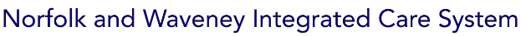
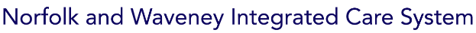
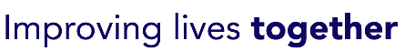

Find support available to you as a Carer
https://improvinglivesnw.org.uk/our-work/healthier-communities/carers-support/
If you would be interested in a Carers ID Passport, please contact info@carersvoice.org

Find support available to you as a Carer
https://improvinglivesnw.org.uk/our-work/healthier-communities/carers-support/
If you would be interested in a Carers ID Passport, please contact info@carersvoice.org

Find support available to you as a Carer
https://improvinglivesnw.org.uk/our-work/healthier-communities/carers-support/
If you would be interested in a Carers ID Passport, please contact info@carersvoice.org

Find support available to you as a Carer
https://improvinglivesnw.org.uk/our-work/healthier-communities/carers-support/
If you would be interested in a Carers ID Passport, please contact info@carersvoice.org

Find support available to you as a Carer
https://improvinglivesnw.org.uk/our-work/healthier-communities/carers-support/
If you would be interested in a Carers ID Passport, please contact info@carersvoice.org

Find support available to you as a Carer
https://improvinglivesnw.org.uk/our-work/healthier-communities/carers-support/
If you would be interested in a Carers ID Passport, please contact info@carersvoice.org

