This is the area you need to keep clear for docmail to add the name and address into.

The size of the area is 7cm wide and 4cm deep.

1.3cm

Dear <<fullname>> <<date2>>
<<Address1>>

RE: “NHS Digital Weight Management Programme.”

GP practices and the local NHS Norfolk and Waveney Integrated Care System are currently working together to offer you the opportunity to access the free NHS Digital Weight Management Programme.

Who can be referred?
Referrals to the programme are only for people who meet all of the following criteria:
- are 18 or over
- have a body mass index (BMI) greater than 30 (this is lowered to 27.5 for people from black, Asian, and ethnic minority backgrounds who are at an increased risk of conditions such as Type 2 diabetes at a lower BMI).
- have diabetes, high blood pressure, or both.
- have a smartphone, tablet or computer with internet access.

You can check your BMI with this link: https://www.nhs.uk/live-well/healthy-weight/bmi-calculator/

The programme involves support about behavioural and lifestyle improvements that can be done by logging into an app on your phone. It has three levels of support and choice of providers personalised to your needs. It involves a 12-week plan, which can be done easily in the comfort of your home.

If you want to read more about the Digital Weight Management Programme you can look here: https://www.england.nhs.uk/digital-weight-management/

There might be a possibility you are already on a waiting list for another weight management programme, do not worry if this is the case, please do call us on 01603 257034 and leave your name, date of birth, NHS number and say you would like to discuss your options and a member of staff will call you as soon as possible.

If you are NOT on a waiting list for any other weight management programmes you have a choice to self-refer by accessing an online questionnaire at www.nhspatient.org. You log in by inputting your date of birth and your NHS number, which is listed below. The questionnaire can be completed in a few minutes.

Your NHS number is: <<NHS number>>

If you would like to opt out from this please call the number 01603 257034 and leave your name, date of birth, NHS number and say you wish to opt out and we won’t call you.

Alternatively, you can wait for a member of our NHS Virtual Support Team to contact you to answer any questions you may have and refer you to the Digital Weight Management Programme if you wish.

To check the authenticity of this letter, please go to https://improvinglivesnw.org.uk/our-work/healthier-communities/reducing-health-inequalities/phm-projects/

Why are you receiving this letter?

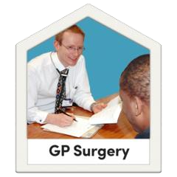 | Your GP (doctor) is working with the (Weight management specialists)
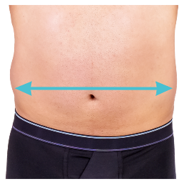  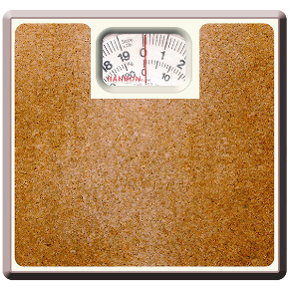  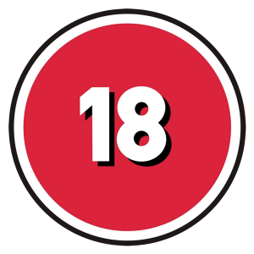 | Referrals to the programme are only for people who:  - are 18 or over  - have a body mass index (BMI) greater than 30 (this is lowered to 27.5 for people from black, Asian, and ethnic minority backgrounds who are at an increased risk of conditions such as Type 2 diabetes at a lower BMI).  - have diabetes, high blood pressure, or both.  - have a smartphone, tablet, or computer with internet access.

Do you want to ask questions?

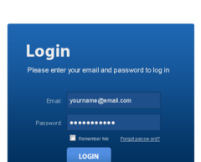 | Please log on to this website:  www.nhspatient.org
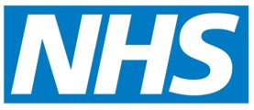  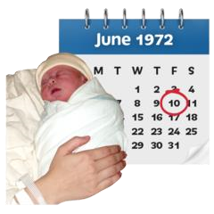 | To open the form you will need to put in:  - your NHS number  - your date of birth  You can find your NHS number in the letter we have sent you with this leaflet
 | After you have put in your NHS number and your date of birth, click the button that says ‘Go to My Homepage’
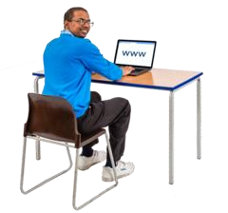 | This will take you to an online form.  You can ask questions or get help.  You can ask to speak to someone.
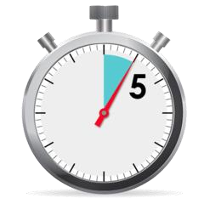 | It will only take you about 5 minutes to fill in the form

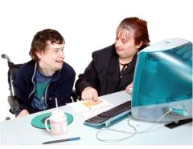 | If you cannot fill in the form yourself, ask a family member or friend if they can help you
Here’s what you should do if you can’t fill in the form online

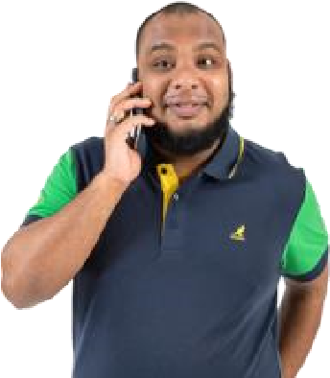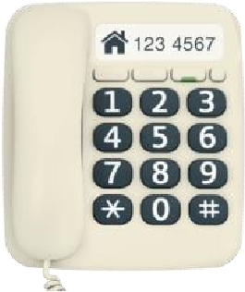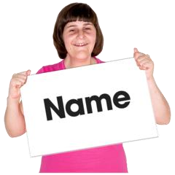 | Please phone: 01603 257034  Leave a message on our answerphone telling us:  - your name  - your phone number  - your NHS number

