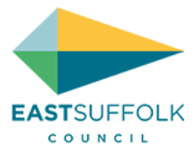


<<date>>

Dear <<First Name>> <<Surname>>

RE: Keep warm and well

Your local NHS service is working together with East Suffolk Council to ensure individuals receive all the financial support they are eligible for, to help to stay warm at home. We understand living in a cold home can mean some people are at increased risk of poor health. As a result of cost of living pressures, we are aware that households are struggling to pay for essential fuel to be able to stay warm.

We are writing to you to let you know about some financial support options which may be able to help. One of our experienced NHS team members will call you to describe the offers and to briefly talk through the eligibility for the different options.

We will be telephoning over the coming few weeks, so please do expect our call.

Keeping warm in colder months is really important as this can help prevent colds, flu and more serious health problems such as heart attacks, strokes, pneumonia and depression. To stay well, heat your home to a temperature that's comfortable for you. If you can, this should be at least 18°C in the rooms that you regularly use, such as your living room and bedroom. This is particularly important if you have an existing health condition.

Another step you can take to protect your health is having your coronavirus (COVID-19) first or second dose. When we call, we can offer advice about vaccines if you haven’t yet accessed them.

If you are a smoker, why not take up the offer of smoking cessation support with One Life Suffolk by following the link https://myclientgenius.com/self-referral/suffolk/new or contacting them on 01473 718193.

Kind regards,
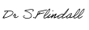
Dr Sarah Flindall
Project Clinical Lead

Keep Warm and Well
Why are you receiving this letter?

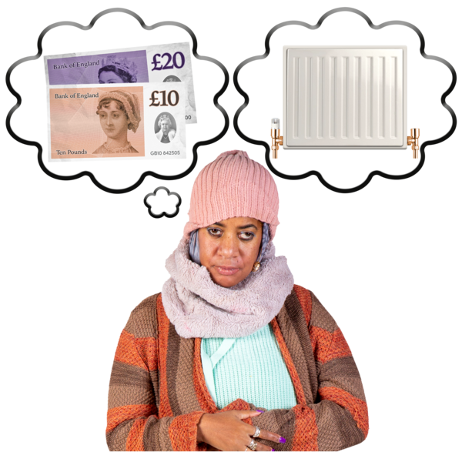 | East Suffolk Council and the NHS are supporting people to keep warm this year. You might be able to access some support.
   | It is normal to feel worried or stressed especially during this time
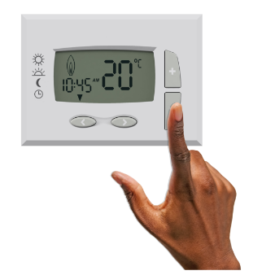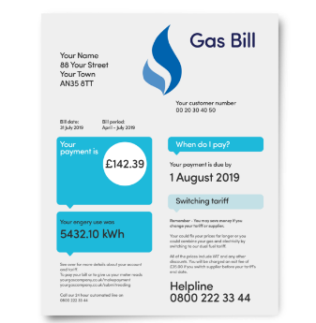 | Your local NHS and East Suffolk Council will try to support you by advising you about possible money help for your energy, or other costs of living

What you should do after receiving the letter
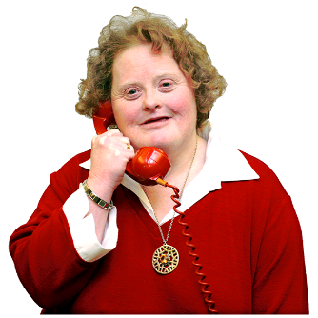  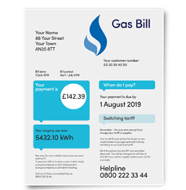 | Read the letter and reach out to your energy provider/ services available
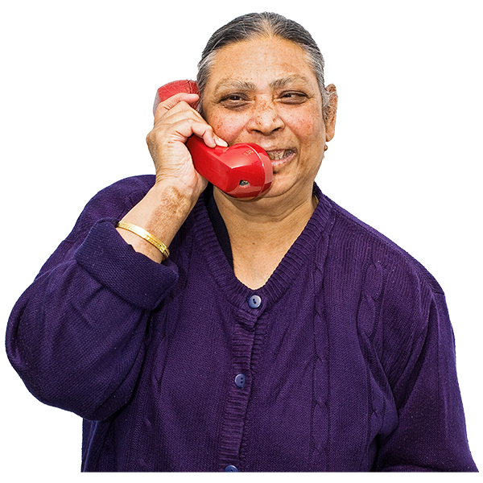 | A member of our NHS team will be contacting you about useful financial support
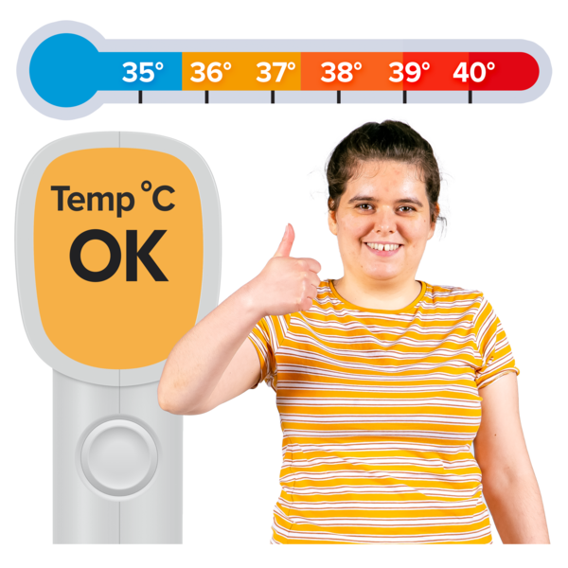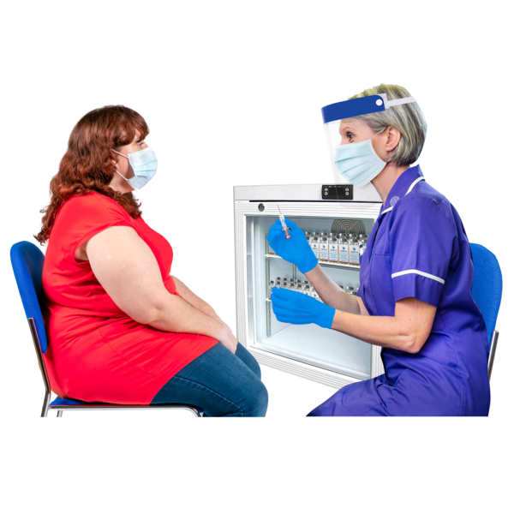 | In the meantime, please keep your house heated at 18 degrees and if you haven’t had your COVID-19 vaccination, please book by calling 119 or going online  https://www.nhs.uk/conditions/coronavirus-covid-19/coronavirus-vaccination/book-coronavirus-vaccination/
  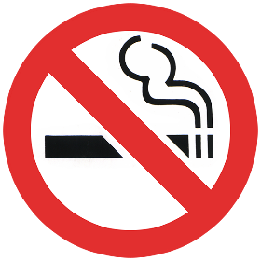 | If you are a smoker, you could also consider getting support to stop with One Life Suffolk  by contacting them on 01473 718193.
 | Thank you

Additional Information
Your energy supplier can offer additional support for those facing severe hardship, please contact them directly to discuss options below:
- A full payment plan review
- Affordable debt repayment plans
- Payment breaks (though this won't be right for everyone)
- Payment reductions
- More time to pay

On prepay and struggling to pay? Your supplier must help as well
If you prepay for your energy, and you find yourself struggling to top up and facing self-disconnection, there's also plenty of help available from your supplier – so do contact them as soon as you can.
Other Support Available

To help ease financial costs there are ways that you can look to increase what is coming in and reduce outgoings.

- Anglian water Extra Care support - The easiest way to get started is by completing an extra care assessment online: https://betteroffcalculator.co.uk/calculator/new/stetp1 or check Anglian Water on https://www.anglianwater.co.uk/help-and-advice/water-care/ or Google Anglian Water Extra Care. Or you can speak to their Extra Care Support team on 0800 169 3630. Their website has other options for support as well.

- Energy help and grant specialists
The charities below offer help and advice on most energy bill problems if you're struggling to pay, including help with finding Government grants and schemes you might be eligible for, help applying for support through energy supplier's charitable trusts, and help with complaints.
  - NEA is a national fuel poverty and energy efficiency charity that offers a free support service known as WASH (Warm and Safe Homes) please visit https://www.nea.org.uk/get-help/wash-advice/ . It provides energy advice to households in England and Wales. You can contact it on 0800 304 7159, or fill in an https://www.nea.org.uk/get-help/wash-advice/wash-referral/
- Royal British Legion can support member of the Royal Navy, British Army, Royal Air Force, veterans, and their families, contact 0808 802 8080

