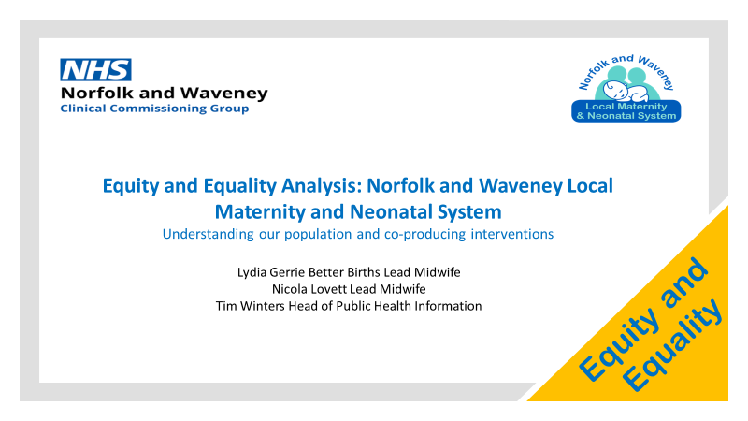
Intervention 1: Understanding the local population’s maternal and perinatal health needs
In February 2021, a heat mapping exercise was conducted in partnership with Public Health colleagues to support the co-production of interventions required within the Maternity transformation portfolio. Within Norfolk and Waveney LMNS there has been an intentional focus on reducing Health inequalities and this has formed a golden thread throughout our workstreams since March 2021.

A general summary of the needs assessment for Norfolk and Waveney indicates the following key points, and further details and analysis are included:
- General fertility rate generally lower in Norfolk and Waveney compared to England – so less births per 1000 females aged 15 to 44
- Highest general fertility rate in the most deprived communities
- There are 42 communities across Norfolk and Waveney where some or all the population live in the 20% most deprived areas in England.
- About 32,300 females aged 15 to 44 who live in the most deprived communities across Norfolk and Waveney
- The age of mothers at booking is generally lower in Norfolk and Waveney compared to England
- The number of bookings with complex social factors is generally lower in Norfolk and Waveney compared to England
- Norfolk and Waveney is less ethnically diverse than England. However, there are some communities across Norfolk and Waveney where mothers are from White Other populations e.g. Eastern European etc.
- Folic acid supplements, access to maternity care and very low birthweight of babies are all significantly better than England
- Multiple births, low birth weight, still birth rate and teenage mothers are similar to England as a whole
- However, obesity of mothers and smoking in early pregnancy are significantly higher than England
- At a local level the communities of Great Yarmouth, King’s Lynn, Thetford, Norwich and other market towns have higher than expected need compared to Norfolk and Waveney as a whole. We are also able to identify those rural communities that have than expected need.
- The resource allocation process can be used to understand the distribution of resources for communities, districts, NHS localities and trusts

Population analysis to understand local variation in need for maternity services
Source: Maternity Transformation Programme Equity & Equality Guidance for LMS: Launch Event
Date: 06/09/2021
Link: https://future.nhs.uk/LocalTransformationHub/view?objectId=112482309#112482309
Introduction
Health Equity: Everyone has a fair and just opportunity to be healthy.
In maternity this means that we should plan that “all mothers and babies will achieve health outcomes that are as good as the groups with the best health outcomes.”
- Who in our local area does not have a fair and just opportunity to a healthy pregnancy to achieve the best health outcomes?
Or
- What mothers and babies have the poorest outcomes: are they from particular population groups, particular areas, have particular characteristics?

The MBRRACE-UK reports about maternal and perinatal mortality show worse outcomes
- for those from Black, Asian and Mixed ethnic groups
- those living in the most deprived areas.
https://www.npeu.ox.ac.uk/mbrrace-uk/reports
Other groups with poorer outcomes in maternity include
- other groups with protected characteristics (ethnic minorities, young parents, learning disabilities)
- those living in remote rural areas and those in crowded urban areas
- other vulnerable groups (gypsy travellers, asylum seekers, prisoners, homeless)
The groups listed above are much more likely to have poor health, find it more difficult to have a healthy lifestyle, live in poor conditions and have less control over their lives. They are more likely to:
- Suffer from stress and anxiety and struggle to manage it
- Smoke
- Consume alcohol and misuse illegal substances
- Be overweight and eat poorly
- Not be in good physical health pre-conception
- Have an unplanned pregnancy
- Live in poor housing and be unemployed
- Have unstable relationships / chaotic lifestyles
We can use this information to highlight the populations and locations across Norfolk and Waveney that might need more support before, during and after pregnancy

Deprivation
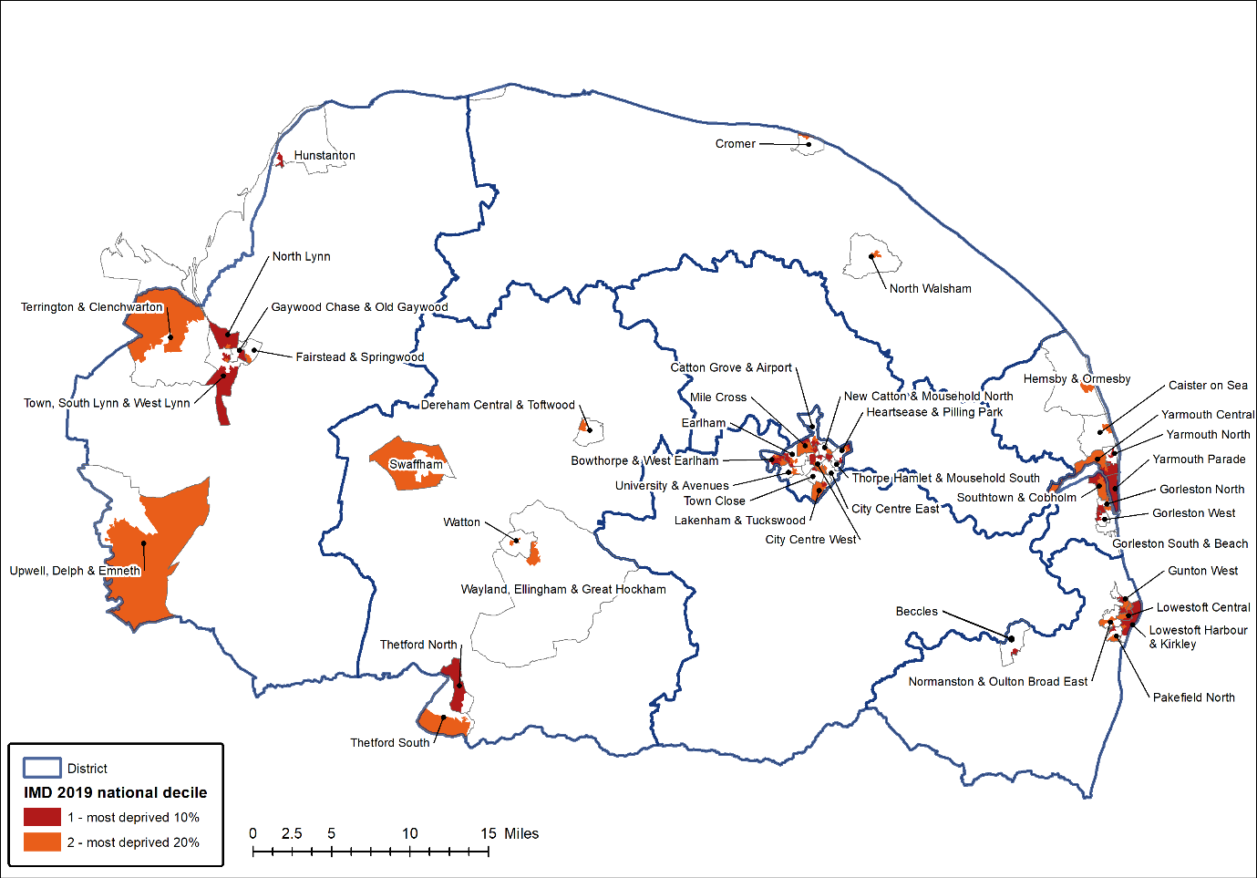
Figure 1 Map of Core 20 areas across Norfolk and Waveney IMD 2019
In 2019 more than 160,000 people in Norfolk and Waveney lived in areas categorised as the most deprived 20% in England. These are mainly located in the urban areas of Norwich, Great Yarmouth, Lowestoft, Thetford and King’s Lynn together with some identified pockets of deprivation in rural areas, coastal villages and market towns (Figure 1).
However, some of the smaller areas of rural deprivation, which make delivery of services more difficult and reduce accessibility for the population, remain hidden.
There are 42 communities across Norfolk and Waveney where some or all the population live in the 20% most deprived areas in England. However, none of these communities are in Broadland or South Norfolk. 40% of the populations of Great Yarmouth and Norwich live in the most deprived 20% of areas in England compared to 16% for Norfolk and Waveney as a whole (Table 1 and Table 2).
Although the majority of the female population aged 15 to 44 live in the middle deprivation deciles 4 to 6 across Norfolk and Waveney there about 32,300 females aged 15 to 44 who live in the most deprived communities (Figure 2).

Table 1 2020 ONS population estimates for the most deprived areas of Norfolk and Waveney by former district (ONS mid-year population estimates)
District | Most deprived decile 1  Core 20 | Most deprived decile 2  Core 20 | Other deciles | Core 20 Population | Total
Breckland | 2,500 | 12,300 | 126,500 | 14,700 | 141,255
Broadland | 0 | 0 | 131,900 | 0 | 131,931
Great Yarmouth | 26,900 | 12,800 | 59,500 | 39,700 | 99,198
KLWN | 12,100 | 11,200 | 127,900 | 23,300 | 151,245
North Norfolk | 0 | 2,800 | 102,400 | 2,800 | 105,167
Norwich | 27,400 | 28,100 | 86,700 | 55,500 | 142,177
South Norfolk | 0 | 0 | 143,100 | 0 | 143,066
Waveney | 16,000 | 11,800 | 90,700 | 27,900 | 118,622
Norfolk and Waveney | 84,900 | 78,900 | 868,800 | 163,800 | 1,032,661
England | 5,603,900 | 5,697,200 | 45,249,000 | 11,301,100 | 56,550,138

Table 2 % of population living in the most deprived areas of Norfolk and Waveney by former district (ONS mid-year population estimates)
District | Most deprived decile 1  Core 20 | Most deprived decile 2  Core 20 | Other deciles | Core 20 Population
Breckland | 1.7% | 8.7% | 89.6% | 10.4%
Broadland | 0.0% | 0.0% | 100.0% | 0.0%
Great Yarmouth | 27.1% | 12.9% | 60.0% | 40.0%
KLWN | 8.0% | 7.4% | 84.6% | 15.4%
North Norfolk | 0.0% | 2.6% | 97.4% | 2.6%
Norwich | 19.3% | 19.7% | 61.0% | 39.0%
South Norfolk | 0.0% | 0.0% | 100.0% | 0.0%
Waveney | 13.5% | 10.0% | 76.5% | 23.5%
Norfolk and Waveney | 8.2% | 7.6% | 84.1% | 15.9%
England | 9.9% | 10.1% | 80.0% | 20.0%

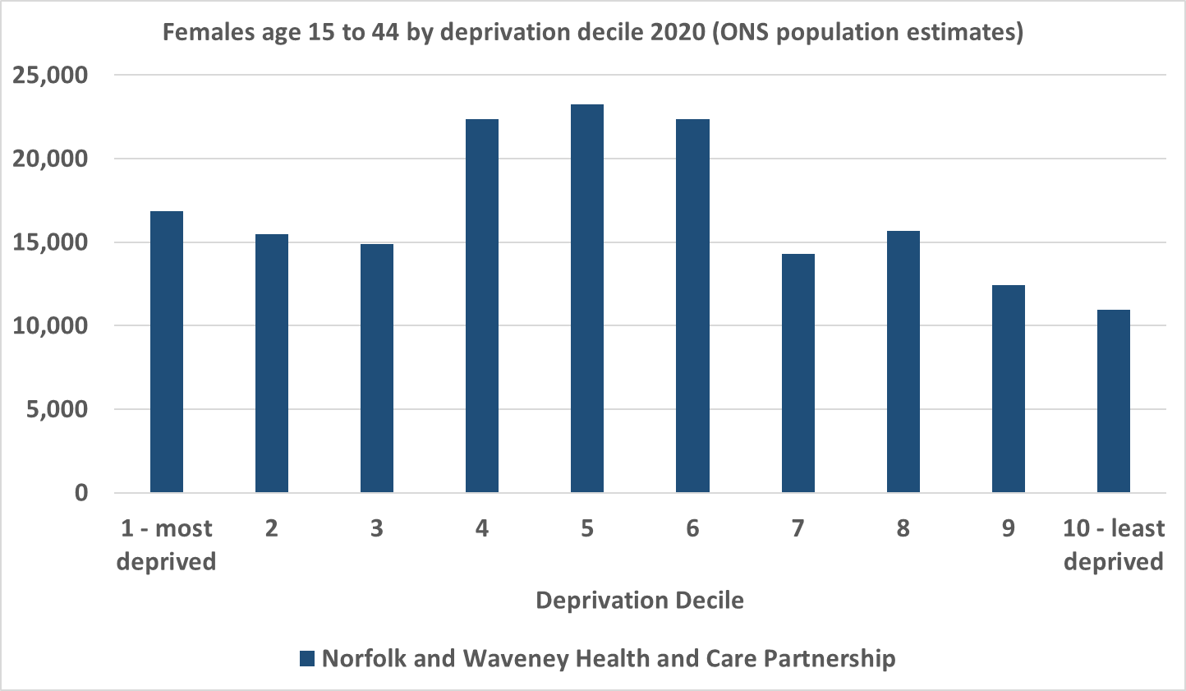
Figure 2 Numbers of females aged 15 to 44 by deprivation decile (ONS 2020 population estimates)
The Norfolk and Waveney female population aged 15 to 44 generally makes up a lower or similar proportion of the female population by deprivation decile compared to England (Figure 3). This reflects the generally older Norfolk and Waveney population. The higher proportion in the least deprived decile is due to the high numbers of student residents at University of East Anglia (which is in this decile).
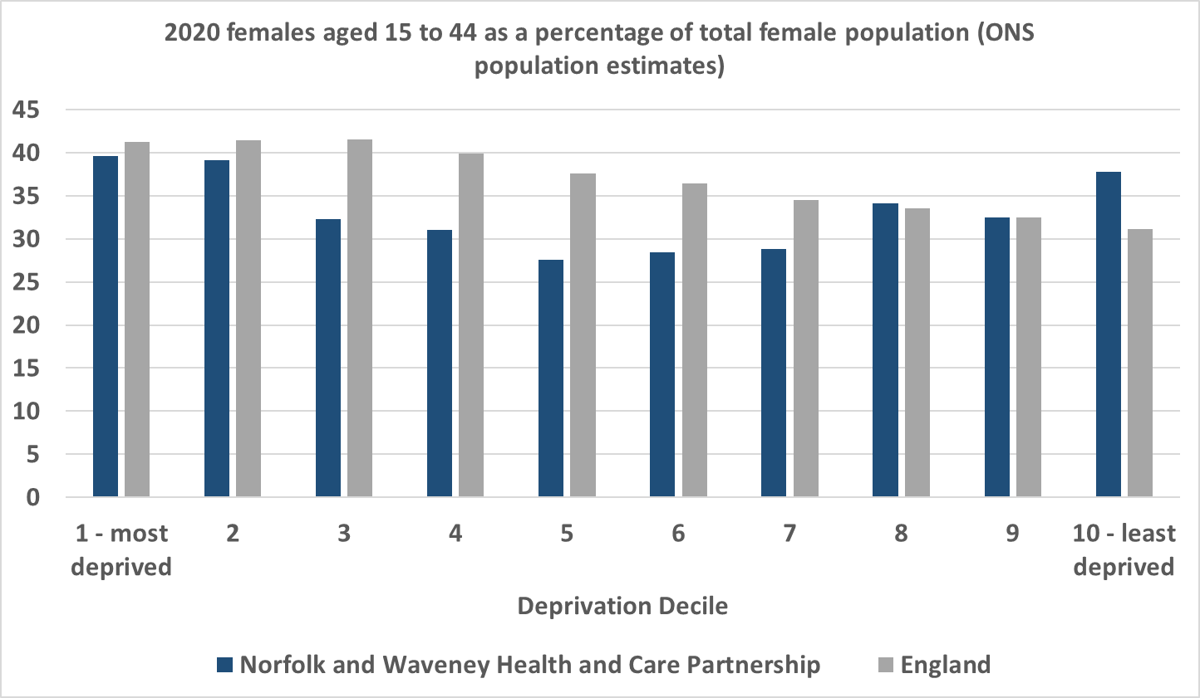
Figure 3 females aged 15 to 44 as a % of the total female population (ONS 2020 population estimates)
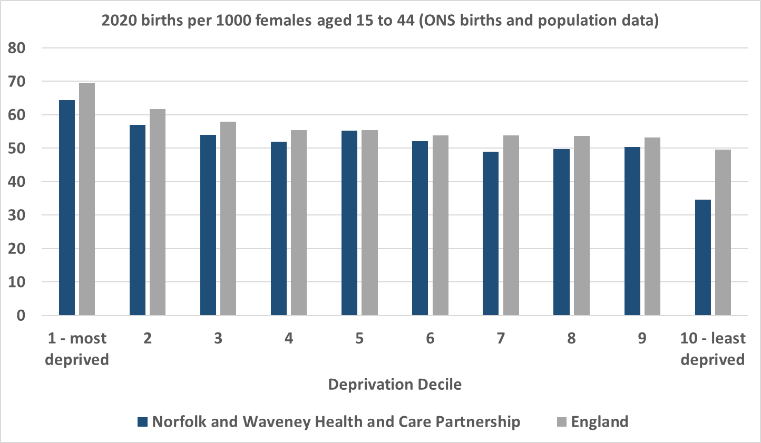
Figure 4 births per 1000 females aged 15 to 44 by deprivation decile (ONS 2020 birth data, ONS 2020 population estimates)
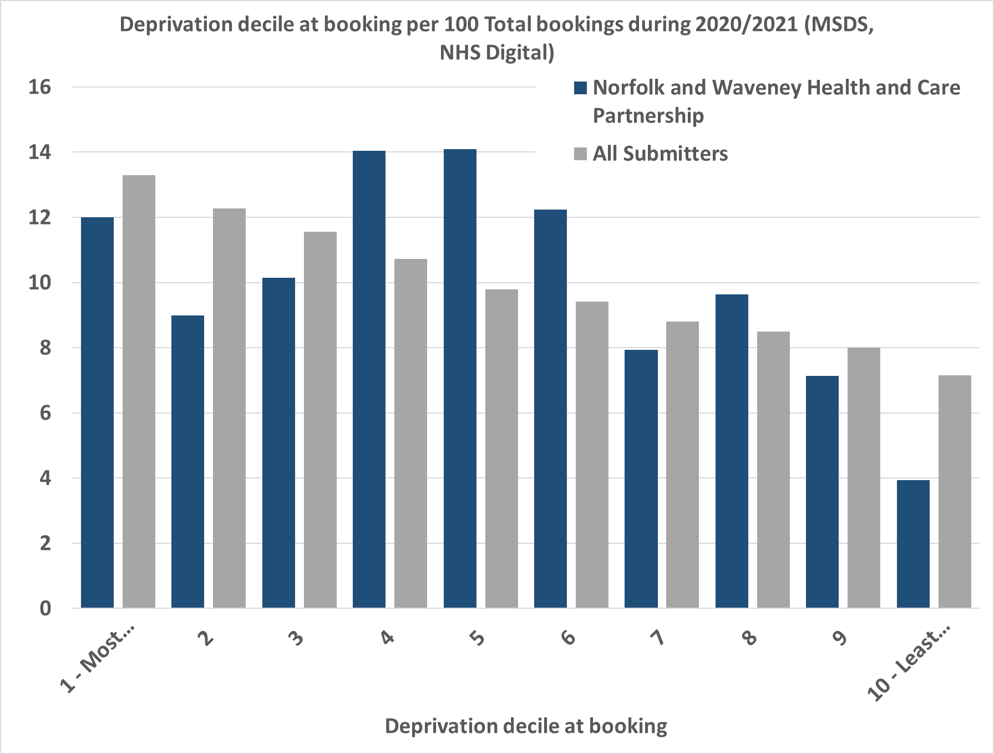
Figure 5 % of bookings by deprivation decile (MSDS, 2020/2021)
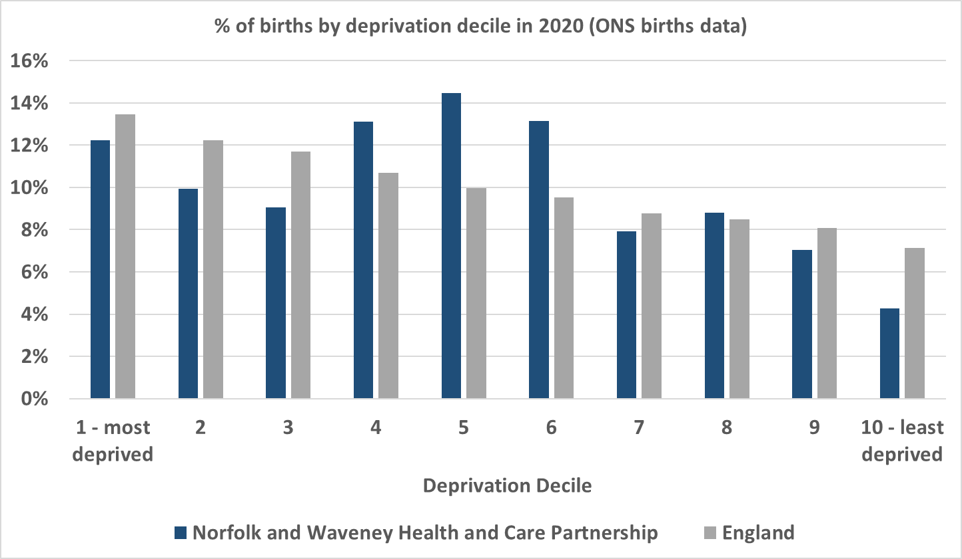
Figure 6 % of births by deprivation decile (ONS births data)
By Ethnic Group
Norfolk and Waveney generally has a less ethnically diverse population than England as a whole (Table 3) and this is reflected in the number of deliveries to mothers from BAME backgrounds. The districts of Norfolk and Waveney that most ethnically diverse are Norwich, Great Yarmouth and Breckland.
Table 3 Ethnic group by district (ONS 2019 estimates)
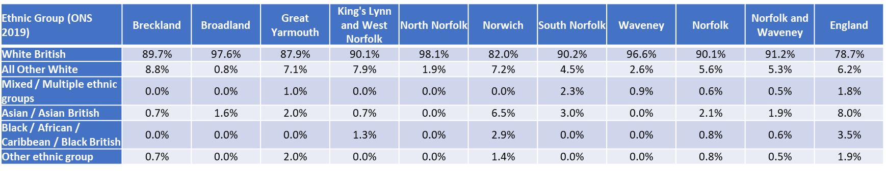

Norfolk and Waveney have one of the lowest percentage of deliveries to mothers from Black and Minority ethnic groups (Figure 7). However, there are a number of other ethnic groups and communities across Norfolk for whom the risk of poorer outcomes is higher e.g. mothers from outside the UK.

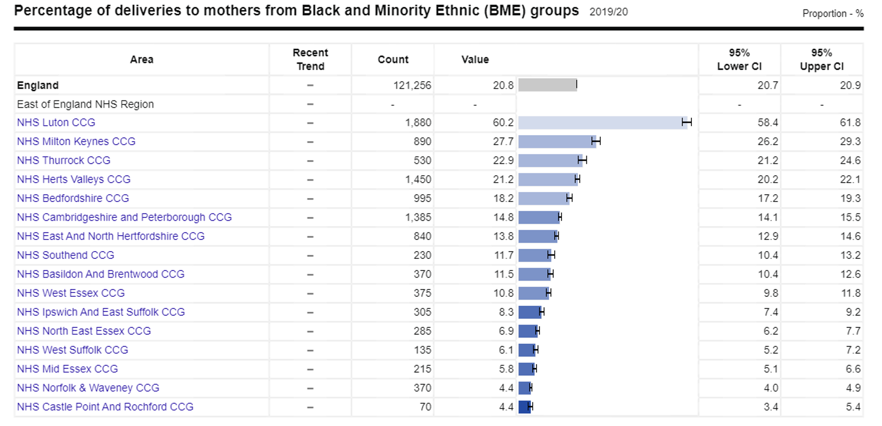
Figure 7 Public Health England. Public Health Profiles. [Date accessed 23/11/2021] https://fingertips.phe.org.uk © Crown copyright [2021]

Age at booking
The proportion of all bookings in younger age bands is generally higher in Norfolk and Waveney compared to England as a whole. This might imply higher need for these groups relative to England. Conversely, the proportion of bookings to older mothers is relatively lower and this might imply lower need for these groups.
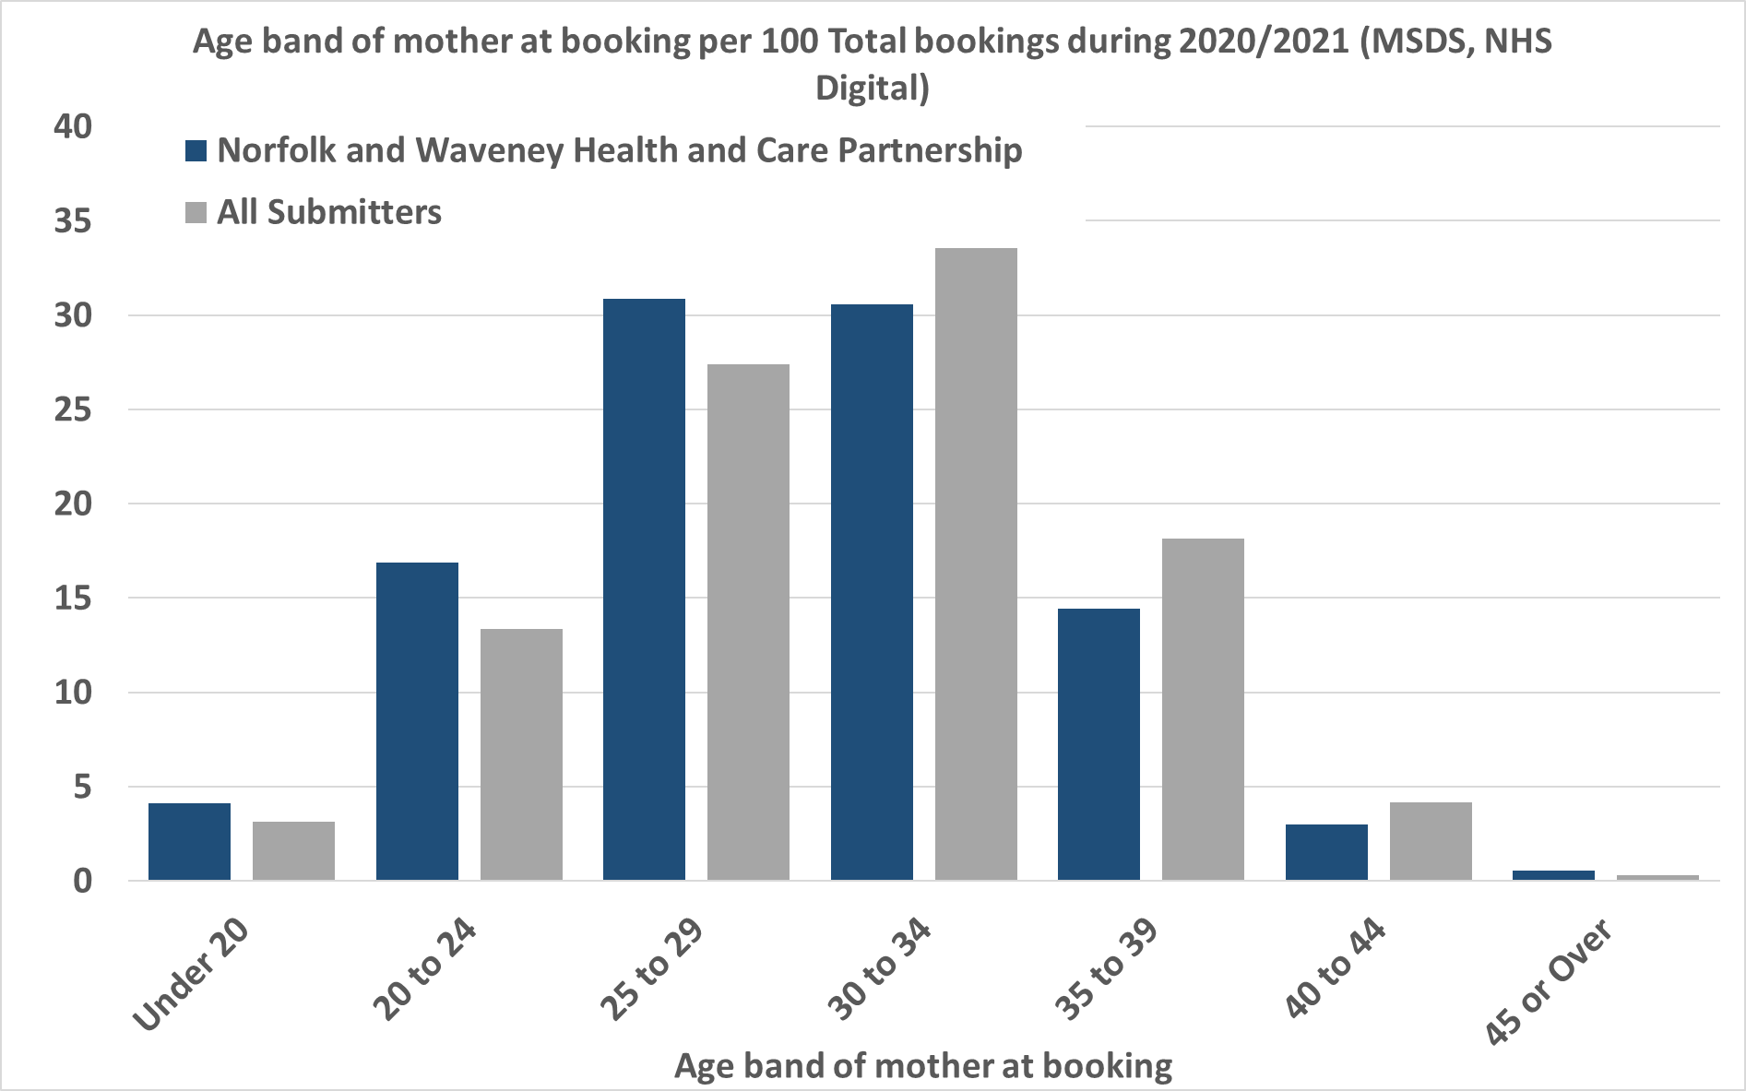
Figure 8 % of bookings by age band of mother 2020/2021 (MSDS, NHS Digital)

Complex social factors
Compared to England as a whole Norfolk and Waveney have fewer bookings with complex social factors. However, the proportion of bookings from Great Yarmouth and Norwich with complex social factors is higher than England and higher than Norfolk and Waveney (Figure 9). This possibly reflects the higher levels of deprivation in these districts
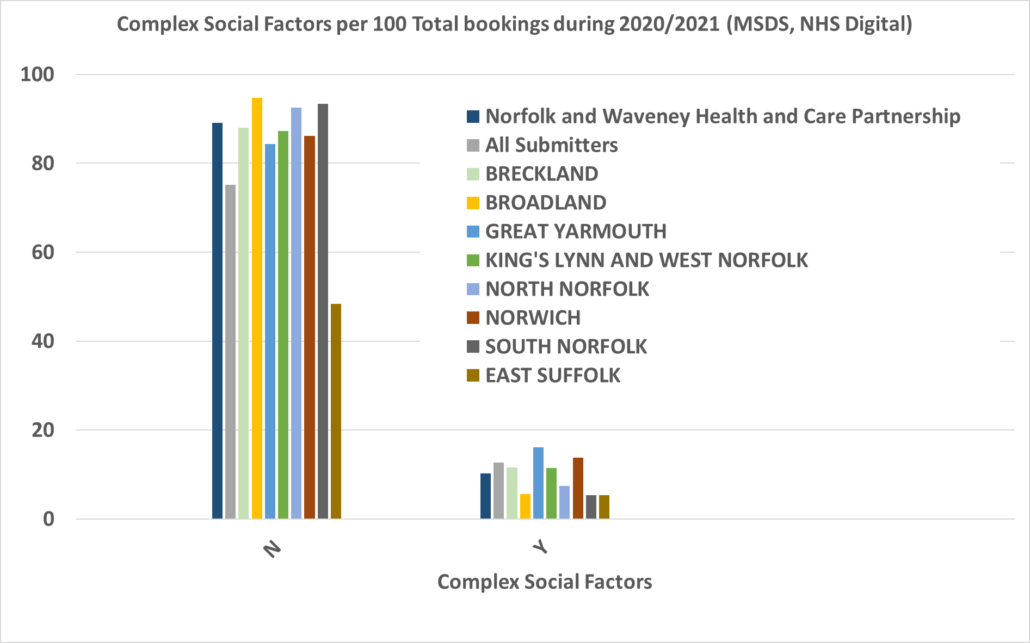
Figure 9 proportion of bookings with complex social factors (MSDS, NHS Digital)

Comparing risks and outcomes
Comparing risks and outcomes for the Norfolk and Waveney local maternity system (Figure 10) indicates that compared to England
- General fertility rate is lower
- Folic acid supplements, access to maternity care and very low birthweight of babies are all significantly better
- Multiple births, low birth weight, still birth rate and teenage mothers are similar to England as a whole
- However, obesity of mothers and smoking in early pregnancy are significantly higher than England

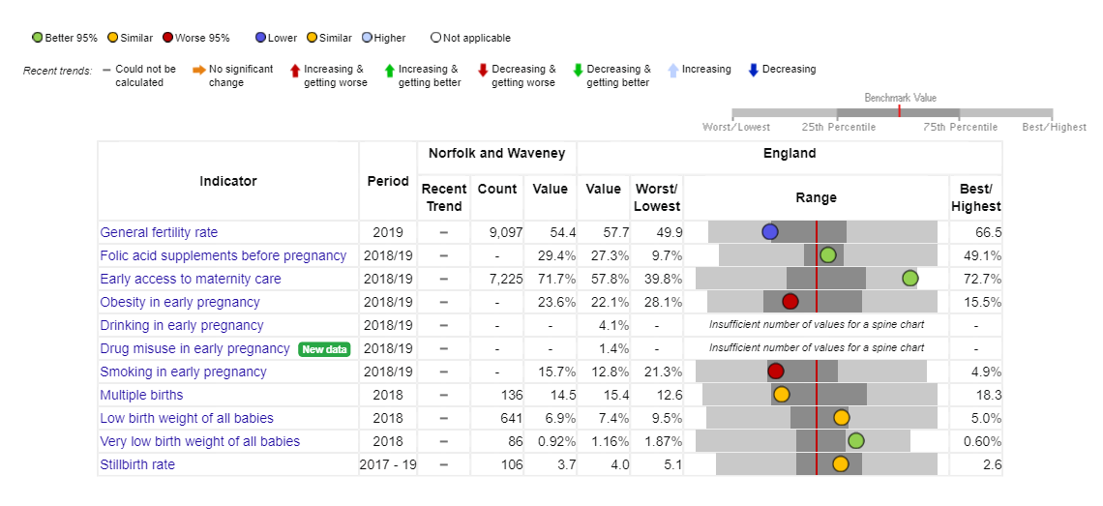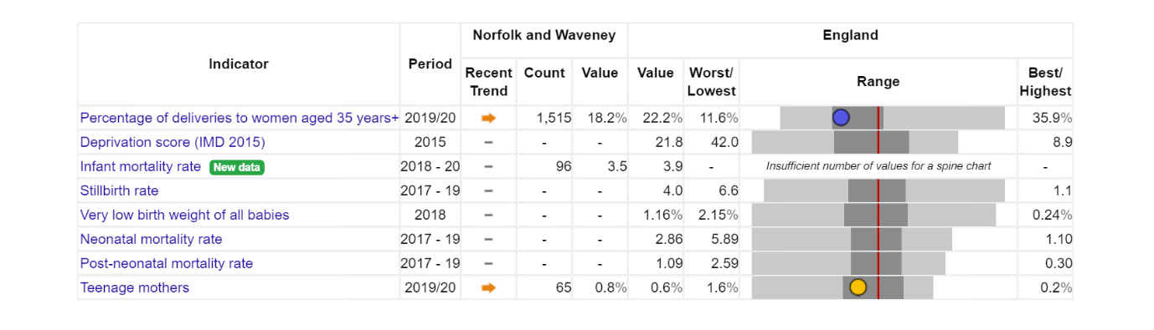
Figure 10 Outcome and risk summary for the Norfolk and Waveney Local Maternity System Public Health England. Public Health Profiles. [Date accessed 23/11/2021] https://fingertips.phe.org.uk © Crown copyright [2021]

In terms of lifestyle behaviours smoking in pregnancy across Norfolk has been consistently higher than the England average and has not decreased, unlike in England as a whole (Figure 11).

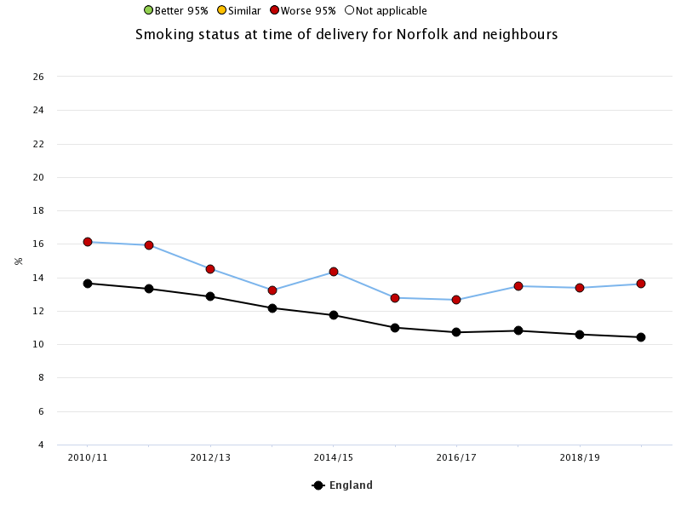
Figure 11 smoking status at time of delivery Public Health England. Public Health Profiles. [Date accessed 23/11/2021] https://fingertips.phe.org.uk © Crown copyright [2021]

Understanding variation in local need
To understand variation in need at local level we have used a weighted population approach. The target population of a community is weighted by the value of relevant indicators. The indicators are selected based on if they can be used to understand differing levels of need and if they are at a granular enough level to highlight variation across communities (Table 4).
Table 4 Indicators used to understand variation in need of different communities across Norfolk and Waveney
Indicator | Rationale | Note | Source
Female population 15 to 44 | Initial population of interest | This population gets weighted to understand need in community | ONS mid year LSOA population estimates
IMD 2019 score | More deprived areas have more need for support. Obesity and smoking are strongly associated with deprivation | Higher value = more need | MHCLG
General fertility rate (2015-2019) | Higher rate of births potentially indicates more need for services | Higher value = more need | Norfolk Insight (NOMIS)
Low Birth Weight per 1,000 live births (2015-2019) | Higher rate of low birth weight births potentially indicates more need for support maternity services | Birth weight < 2500g, Higher rate = more need | Civil registration dataset (Births)
Infant Mortality per 1,000 live births (2015-2019) | Higher rate of infant mortality might indicate more need for post birth services | Higher value = more need | Civil registration dataset (PCMD)
Percentage deliveries white other (2015-2019) | Higher proportion of births from non british white communities might require more resources | Higher value = more need | HES
Percentage deliveries BAME (2015-2019) | Higher proportion of births from BAME communities might require more resources | Higher value = more need | HES
Population density (could also use DfE accessibility indicators) | Lower density implies more difficult to access and deliver services | Currently lower density = more need | ONS census estimates
Percentage deliveries JPUH | Contextual to show where residents from Norfolk and Waveney communities are likely to give birth. This enables any required targeting from trust to community |  | HES
Percentage deliveries NNUH | As above |  | HES
Percentage deliveries QEH | As above |  | HES
Average deliveries per year (2015-2019) | Understand how many deliveries per year take place in a community | Used as denominator for other indicators | HES
Average deliveries per year to Norfolk and Waveney mothers in Norfolk and Waveney trusts (2015-2019) | Understand how many deliveries per year from a community take place in Norfolk and Waveney trusts | Used as a target population for weighting of resources by trust rather than community | HES

The market towns and communities across Norfolk and Waveney are shown in Figure 12 together with ONS resident population estimates. These communities represent almost 50% of the population and that leaves 50% in more rural areas where service access and delivery might require more resource.
Looking at the distribution of indicators across Norfolk and Waveney highlights those communities with higher level of need than others and the trust at which most of the deliveries from the community occur (Figure 13). This can be used to help understand the differing need by community and trust. In the table the higher the value the higher the need. The different indicators for a community can be combined to generate a weighted population for that community. If a weighted population is higher than the unweighted population then that community has a higher level of need for its population compared to a community that has a lower weighted population than its unweighted population. This method can be applied to deliveries as well as the total female population aged 15 to 44
For example, the Great Yarmouth community experiences the greatest deprivation, has the highest general fertility rate, one of the highest rates of low birthweight, and relatively high proportion of deliveries to mothers who are from BAME and white other groups. Most of these births take place at James Paget University Hospital (JPUH). The original unweighted female population aged 15 to 44 for Great Yarmouth is 5,404. After weighting by the indicators of need the weighted population is 6,834. This means that based on these indicators in Table 4 the community of Great Yarmouth has a 26% higher need compared to what we would expect for the average community across Norfolk and Waveney (Figure 13).
A similar level of need is seen in King’s Lynn community and most of the deliveries from this community occur at the Queen Elizabeth Hospital (QEH). The original unweighted female population aged 15 to 44 for Great Yarmouth is 8,035. After weighting by the indicators of need the weighted population is 9,597. This means that based on these indicators in Table 4 the community of King’s Lynn has a 19% higher need compared to what we would expect for the average community across Norfolk and Waveney. The reason the need is slightly lower is that deprivation is slightly lower, general fertility rate is slightly lower, that rate of low birthweight births is slightly lower. However, the proportion of births to mothers who are of white other groups is higher and the infant mortality rate is higher (Figure 13).
Resource allocation
This approach can be used to provide an initial estimate of the proportion of system resources that different communities might need and also the trusts might need to provide services to the mothers in those communities (Figure 14). One of the other benefits of this approach is to highlight those rural areas that have higher than expected need for resources compared to others. In the map Figure 14 these are the darker areas. For example, some of the rural areas of Breckland and King’s Lynn and West Norfolk.
The proportion of available system resource determined using this method can be aggregated by district and by trust (and by other geographies if required e.g. PCN). Based on the average % of deliveries from a locality at each trust we can calculate the weighted population for each trust.
However, some deliveries take place outside of Norfolk and Waveney (for example, for mothers in Thetford and parts of West Norfolk) and some deliveries for mothers resident outside Norfolk and Waveney take place at trusts in Norfolk and Waveney.
We can take the same approach using only those deliveries for Norfolk and Waveney mothers that take place in Norfolk and Waveney trusts as the target population but then excluding General Fertility rate from the weighting. The results for the trusts in the Norfolk and Waveney local maternity system are shown in Table 5.
Here if we had a notional £1,000 of resource to distribute based on the indicators from Table 4, the communities where mothers live who have babies delivered at each trust and the number of deliveries at each trust, then using the column Weighted % B (highlighted red) JPUH would need £211, NNUH would need £601 and QEH would need £188.
Table 5 example proportion of resources allocated to each trust in Norfolk and Waveney
Trust | Unweighted Population aged 15 to 44 | Weighted Population aged 15 to 44 | Unweighted deliveries per year (2015/19) in Norfolk and Waveney trusts (A) | Weighted deliveries per year (2015/19) in Norfolk and Waveney trusts (B) | Unweighted % A | Weighted % B
JPUH | 31,868 | 30,503 | 2,014 | 1,894 | 22.5% | 21.1%
NNUH | 102,463 | 100,294 | 5,400 | 5,394 | 60.2% | 60.1%
QEH | 24,646 | 27,148 | 1,556 | 1,683 | 17.3% | 18.8%
Other | 8,361 | 9,393
Total | 167,338 | 167,338 | 8,971 | 8,971

Likewise if we are delivering community interventions then the proportion of the available resource each community would need based on the indicators from Table 4, the communities where mothers live who have babies delivered at each trust and the number of deliveries at each trust is shown in column “Weighted – average N and W trust deliveries” in Figure 15. For example, Great Yarmouth would need 5.6% of the resource and King’s Lynn 7.2% of the resource.

Figure 12 location of communities and 2019 resident population estimates (continued on next page)
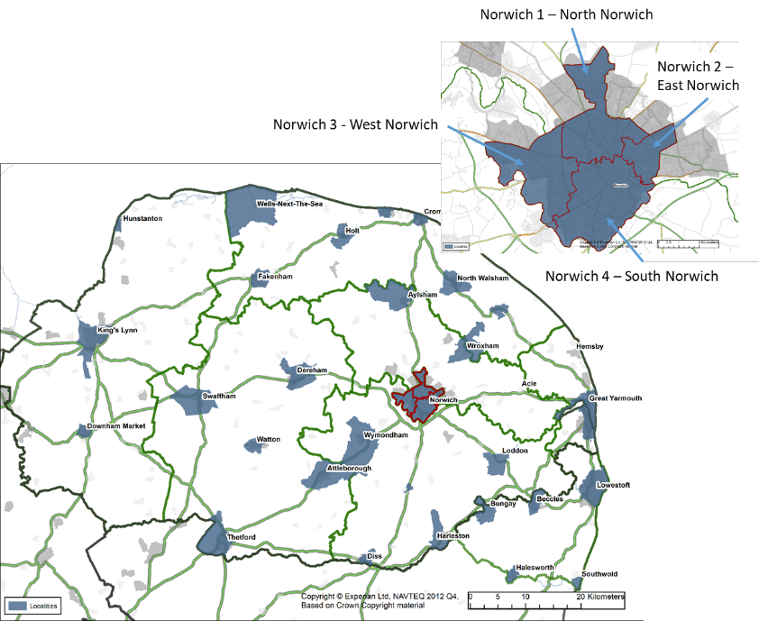
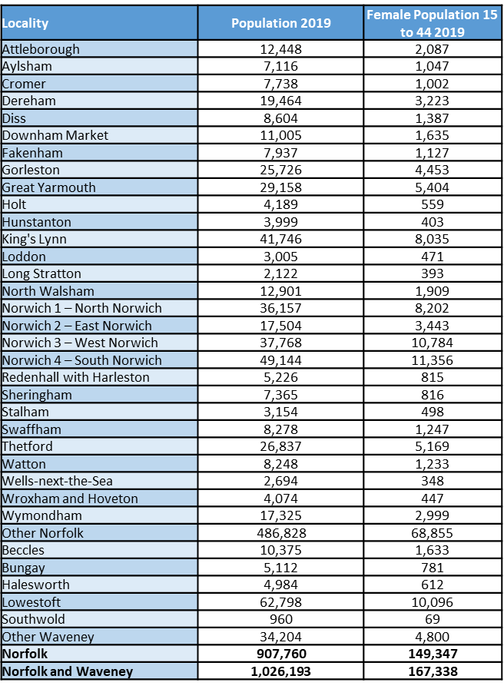

Figure 13 variation in indicators of need by community across Norfolk and Waveney. In all cases the higher the number the higher relative need (or use). Red indicates higher need (or use). For the weighted populations: if a weighted population is higher than the unweighted population then that community has a higher level of need for its population compared to a community that has a lower weighted population than its unweighted population. This method can be applied to deliveries as well as the total female population aged 15 to 44
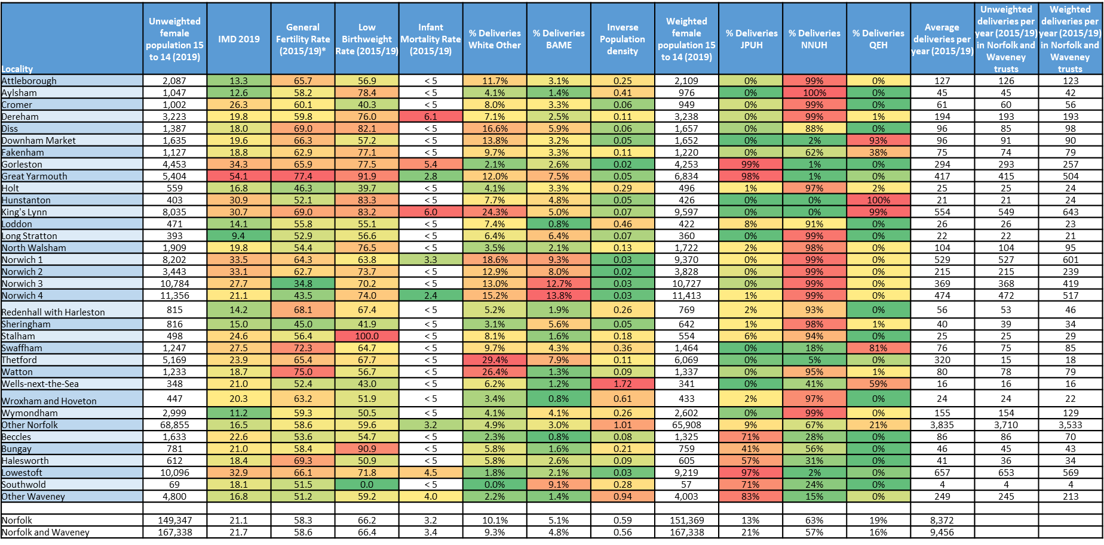

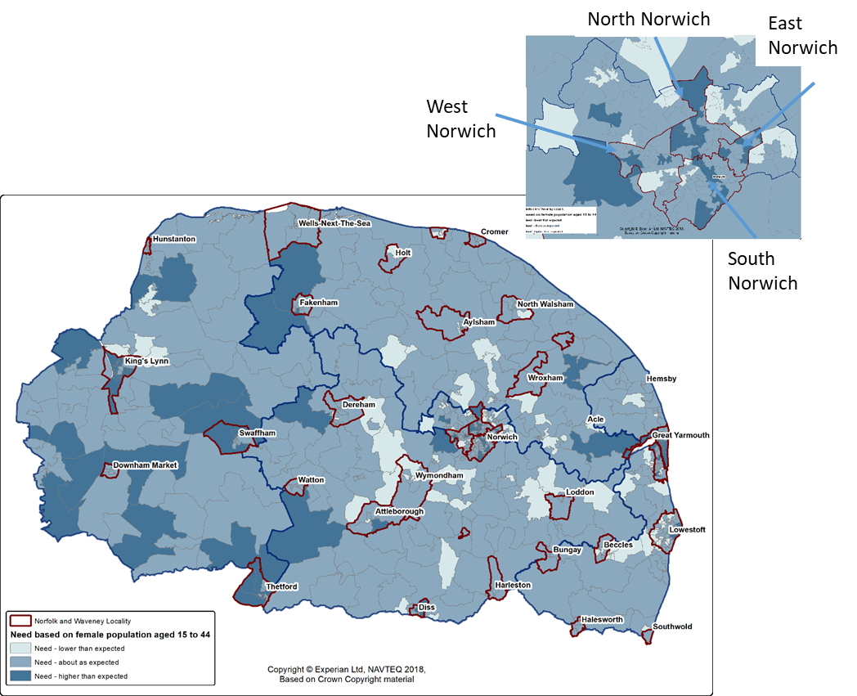
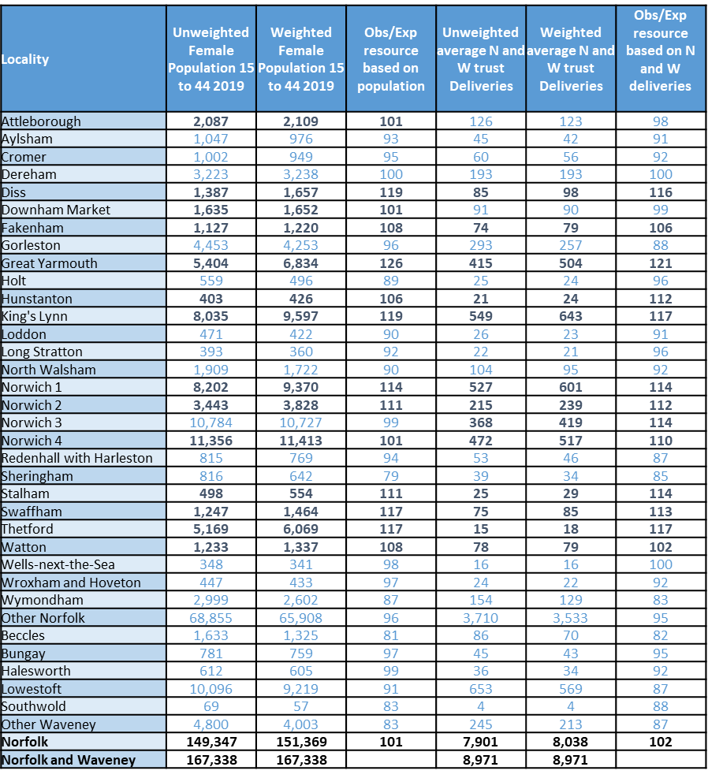

Figure 14 variation in level of need by community across Norfolk and Waveney. In the map (based on the female population aged 15 to 44), the dark areas have a higher than expected level of need and the light areas a lower than expected level of need. In the table the darker blue indicates a level of need higher than expected. For the weighted populations: if a weighted population is higher than the unweighted population then that community has a higher level of need for its population compared to a community that has a lower weighted population than its unweighted population. If the value in the Obs/Exp resource… columns is higher than 100 this is a higher than expected level of need. For example, Great Yarmouth has a Obs/Exp resource based on population score of 126 indicating a 26% higher than expected level of need. This method has been applied to deliveries as well as the total female population aged 15 to 44.

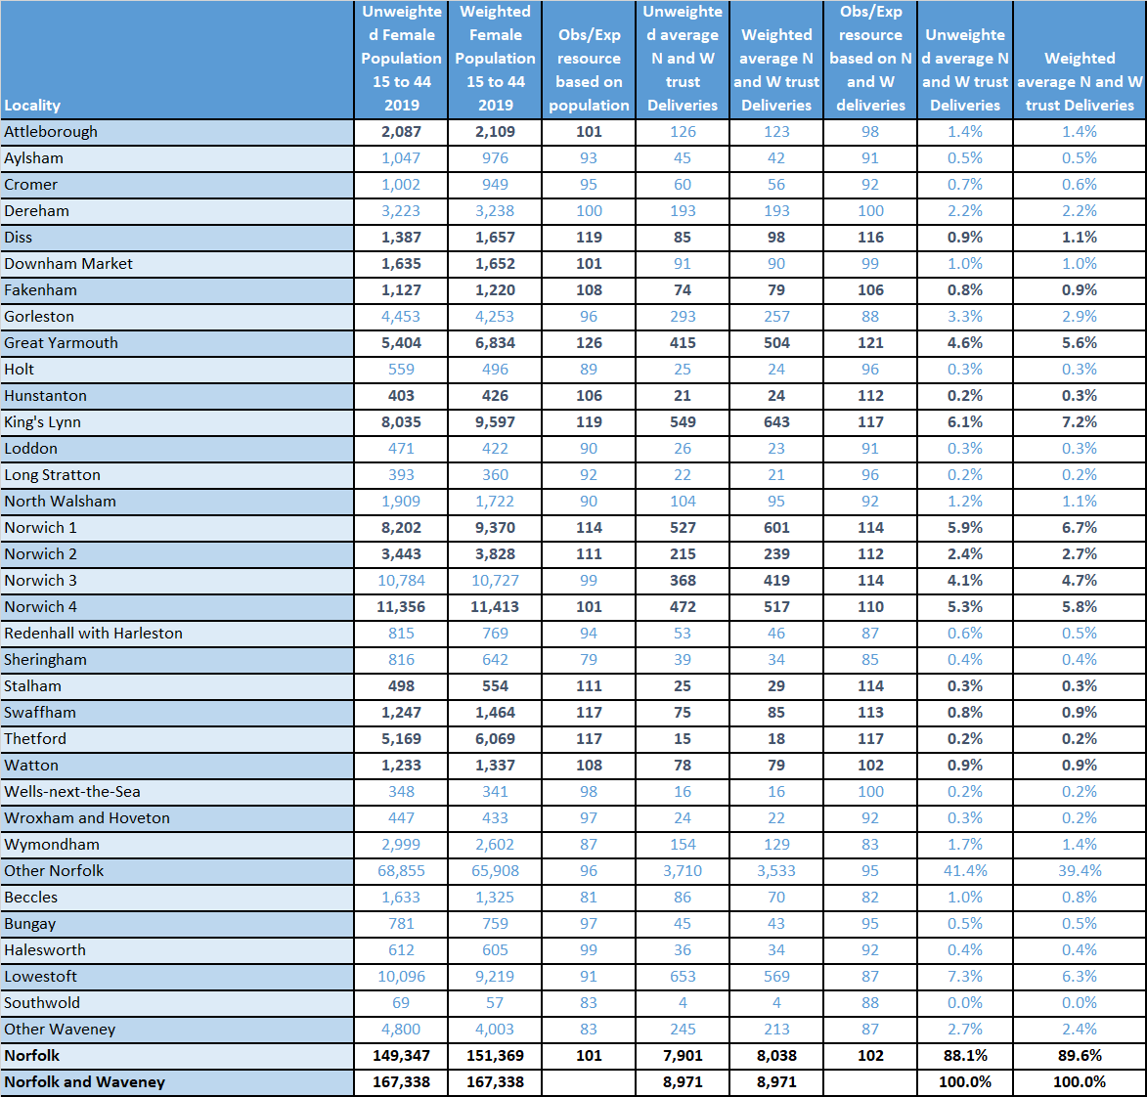

Figure 15 variation in level of need by community across Norfolk and Waveney. In the table the darker blue indicates a level of need higher than expected. For the weighted populations: if a weighted population is higher than the unweighted population then that community has a higher level of need for its population compared to a community that has a lower weighted population than its unweighted population. If the value in the Obs/Exp resource… columns is higher than 100 this is a higher than expected level of need. For example, Great Yarmouth has a Obs/Exp resource based on population score of 126 indicating a 26% higher than expected level of need. This method has been applied to deliveries as well and Great Yarmouth Obs/Exp resource based on deliveries of 121 – 21% higher than expected

CoC plans have been drawn up with these specific localities in mind and have considered the locality of maternity HUBS to try to deliver care into the heart of our most needy areas. Projects have been developed in accordance to IMD such as Deprivation Monies Project and working with grassroots organisations to meet the needs of the community and digital gifting with Norfolk Libraries. The MVP in addition to this are targeting our high risk groups of women such as teen parents and are actively engaging with FNP and outreach group to understand their needs.
We know from the data supplied to the RPQOG (Appendix 11) that James Paget is currently offering CoC to 54% of women and that 50% of the caseload in the reporting timescale were from a BAME/area of deprivation background. Hubs have been placed in areas with a high IDM score of 54 (Gt Yarmouth) 34.3 (Gorleston) and 32.9 (Lowestoft). We have further identified that Gorleston and Lowestoft do not have high BAME or White Other populations, but that Gt Yarmouth has a high BAME population (7.5%) and an even higher rate of White Other (12%). This alerts us to the fact that there is a high population of migrant families from Eastern Europe who reside in the Gt Yarmouth area, so resources for language line, community support and face to face translation is being sought to support women and midwives within their setting. This is where the Deprivation Money and working with the 3rd Sector will enhance CoC and support the most socially and financially deprived families. NNUH and QEH are not currently delivering COC, so this data is not able to be collated.
This data demonstrate that N&W have a vision of areas of deprivation and will launch new care pathways to these targeted groups once CoC comes on-line. The QEH has Hubs strategically placed to target the populations of most need in the catchment area.

Priority 1 4a Restore NHS Services inclusively
Personalised Care and Support plans are in place across all 3 Trusts, although only QEH currently has the digital ability and system to complete this electronically.
COVID-19 Four Actions for women from a Black, Asian or Ethnic Minority group.
Work is on-going across N&W with the four actions, see figure 16 for the latest updated survey showing progress.
The LMNS shared guideline was agreed and adopted by each of the three trusts who have developed their own SOP’s to undertake the pathways according to each individual trusts abilities.
The LMNS Multilingual Padlet has been re-launched with posters displaying the QR code to access the web page.
Norfolk and Waveney LMNS Multilingual maternity resources (padlet.com)
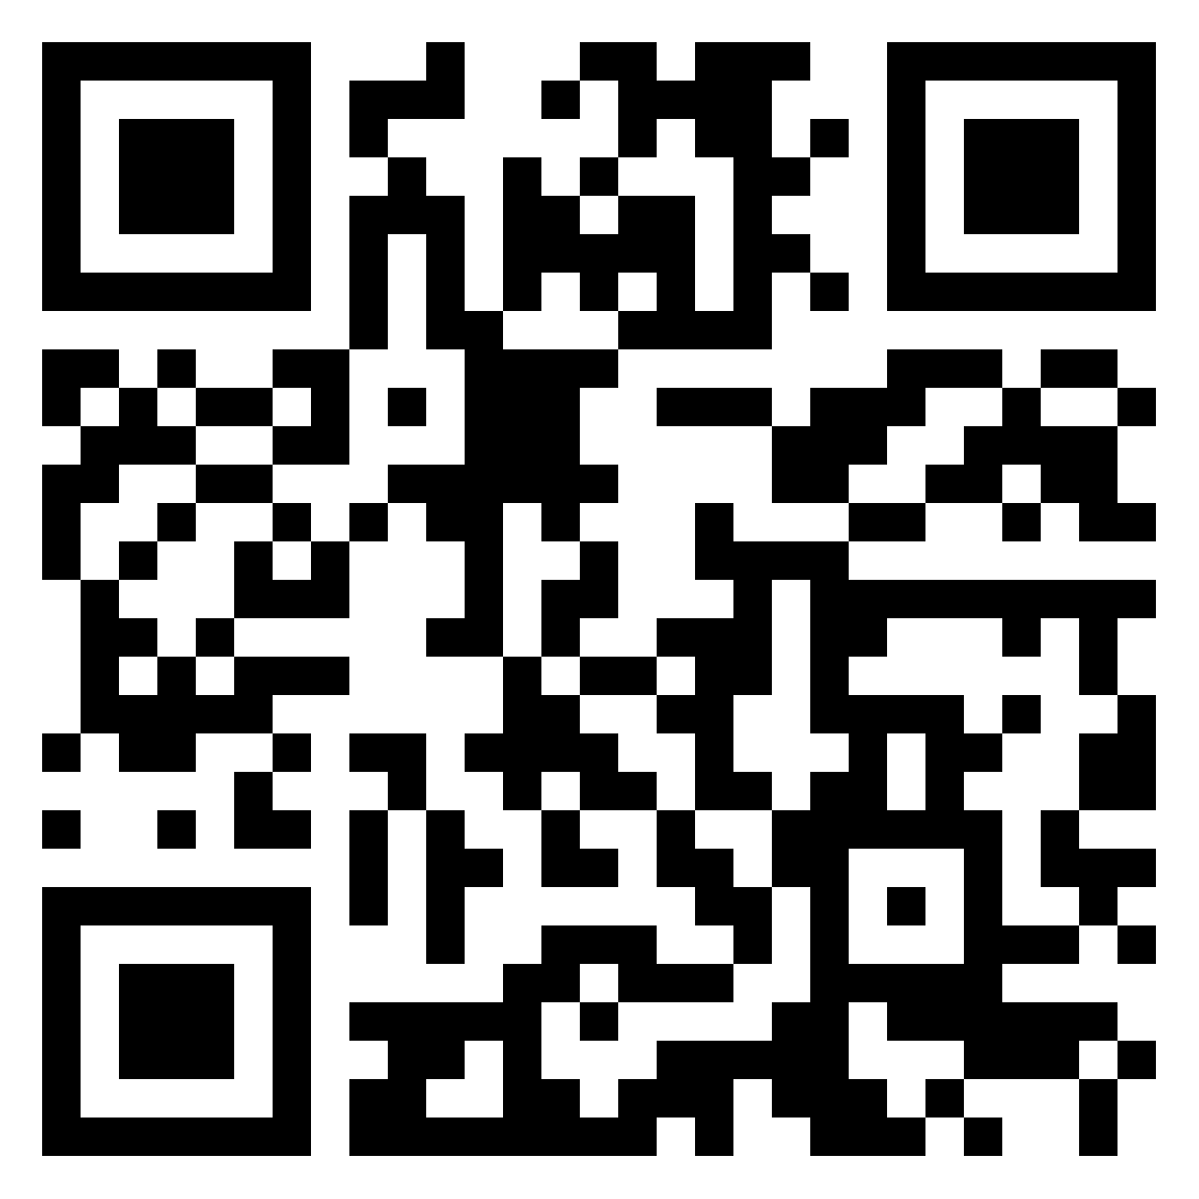
While Folic Acid is a routine question at booking, the LMNS has been examining with clinical staff the possibility of further support on supplementation.
Clinical teams have undertaken research on prescribing additional doses of Vitamin D to the high risk groups, following incidents where babies had been readmitted with Vit D deficiency. This paper is currently undergoing governance procedures and agreements across the System before further funding agreements can be source. A vitamin D SOP based on the recommendations has been drawn up and is awaiting approval from all sites. Appendix 7 Vit D papers.
Triage across all sites include ethnicity question and risk assessment for all admissions.

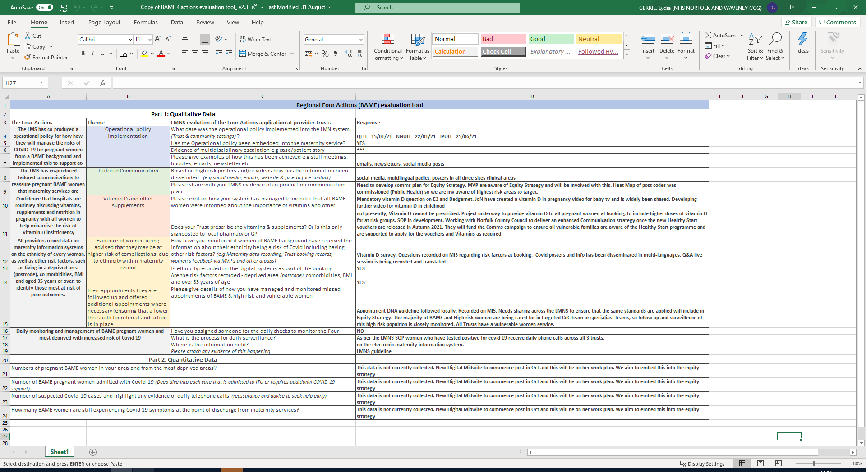
Figure 16 Regional Four Actions Evaluation Tool October 2021

WRES Data
NNUH
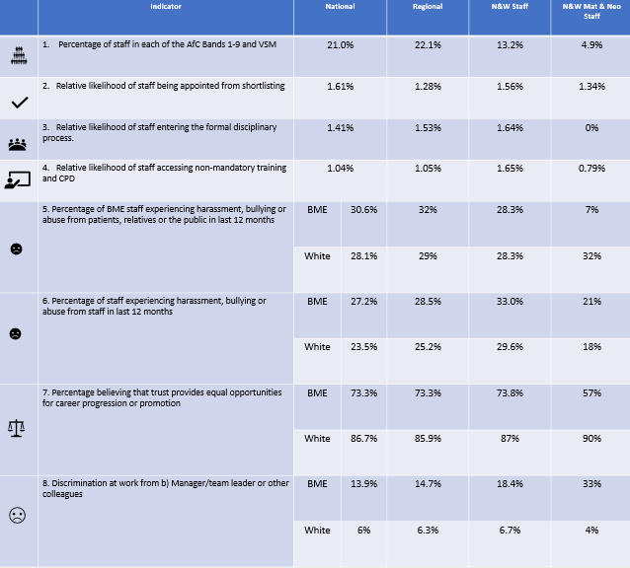

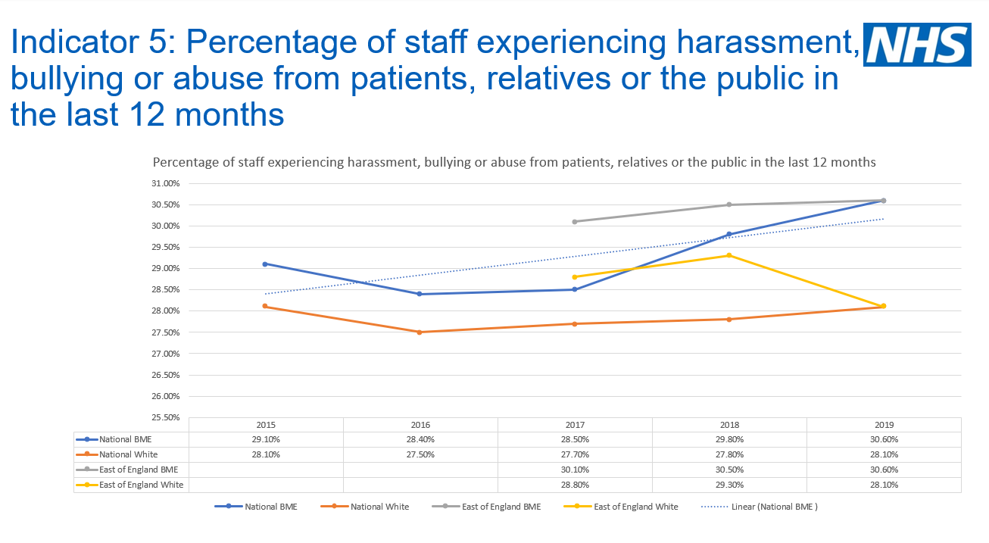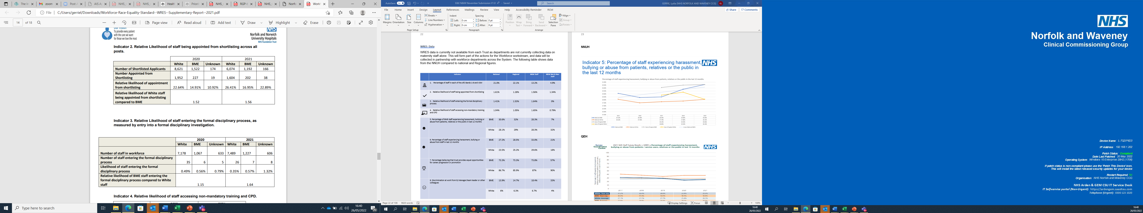

QEH
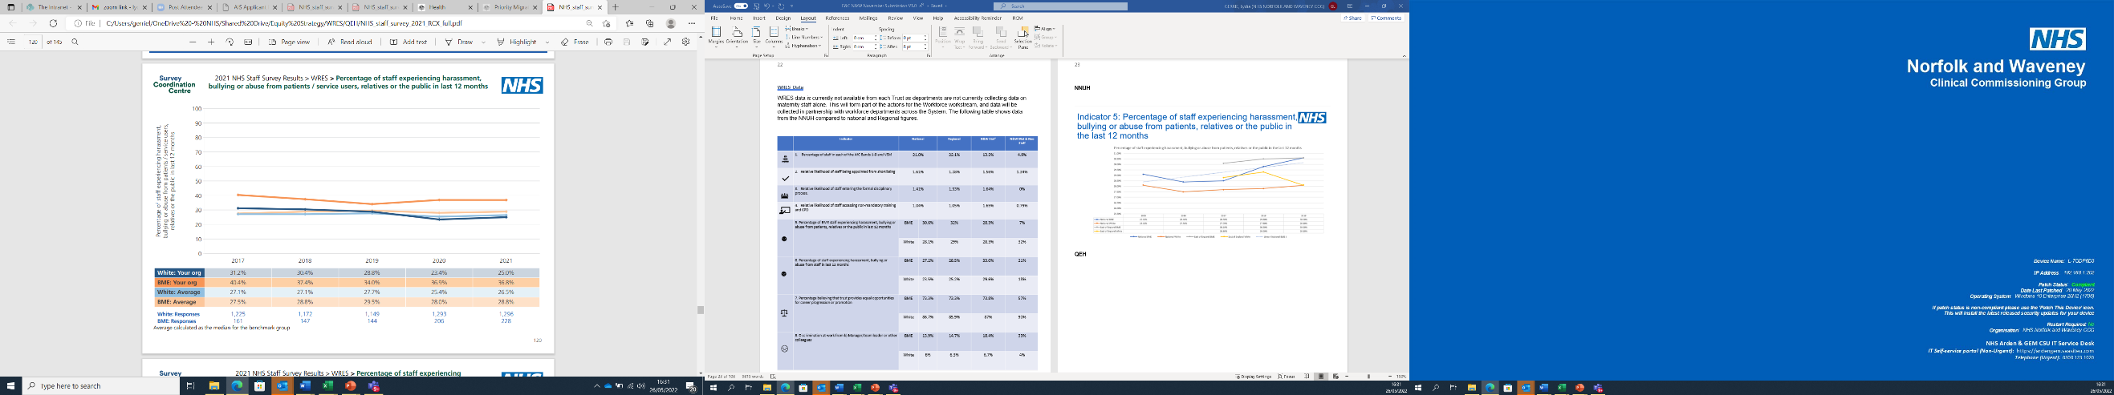

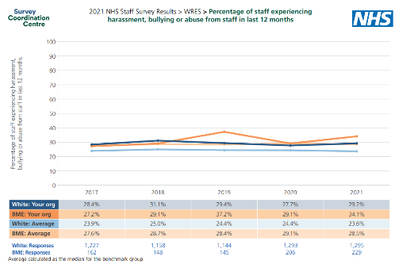

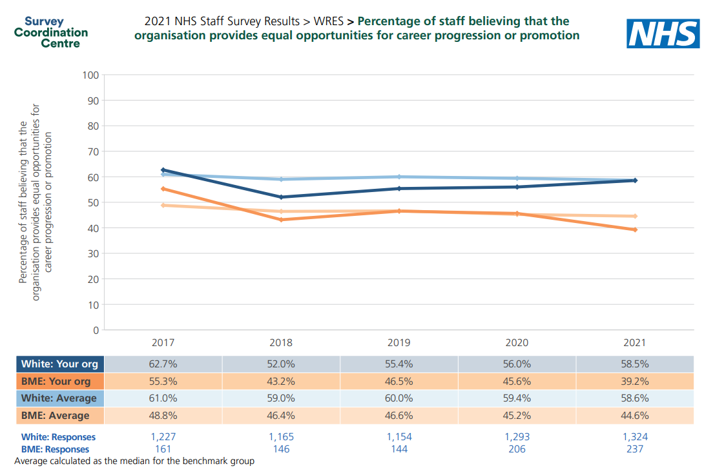
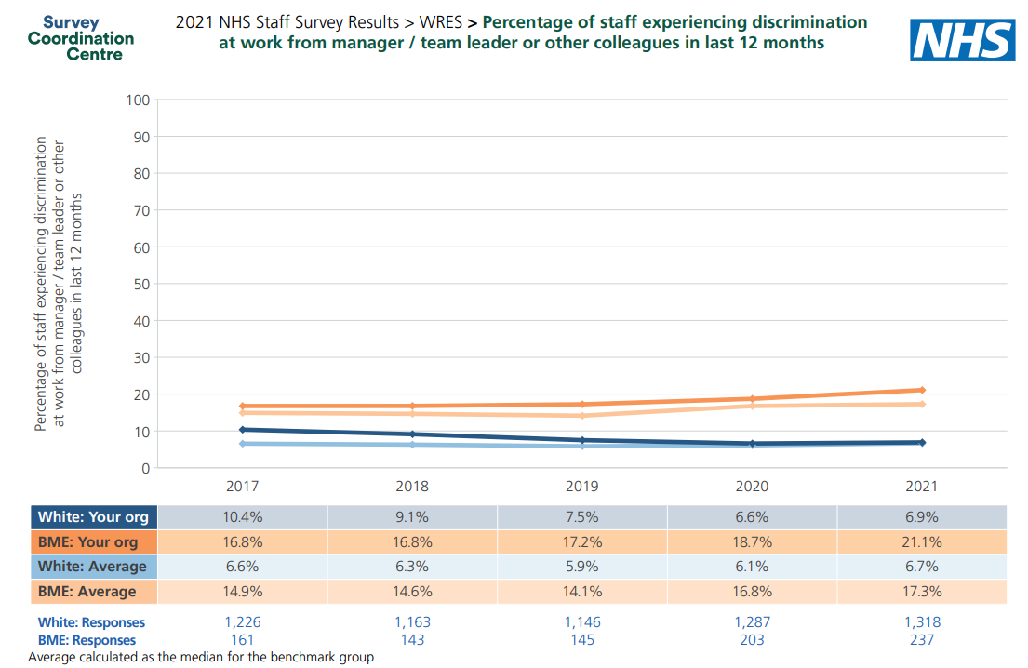

JPUH
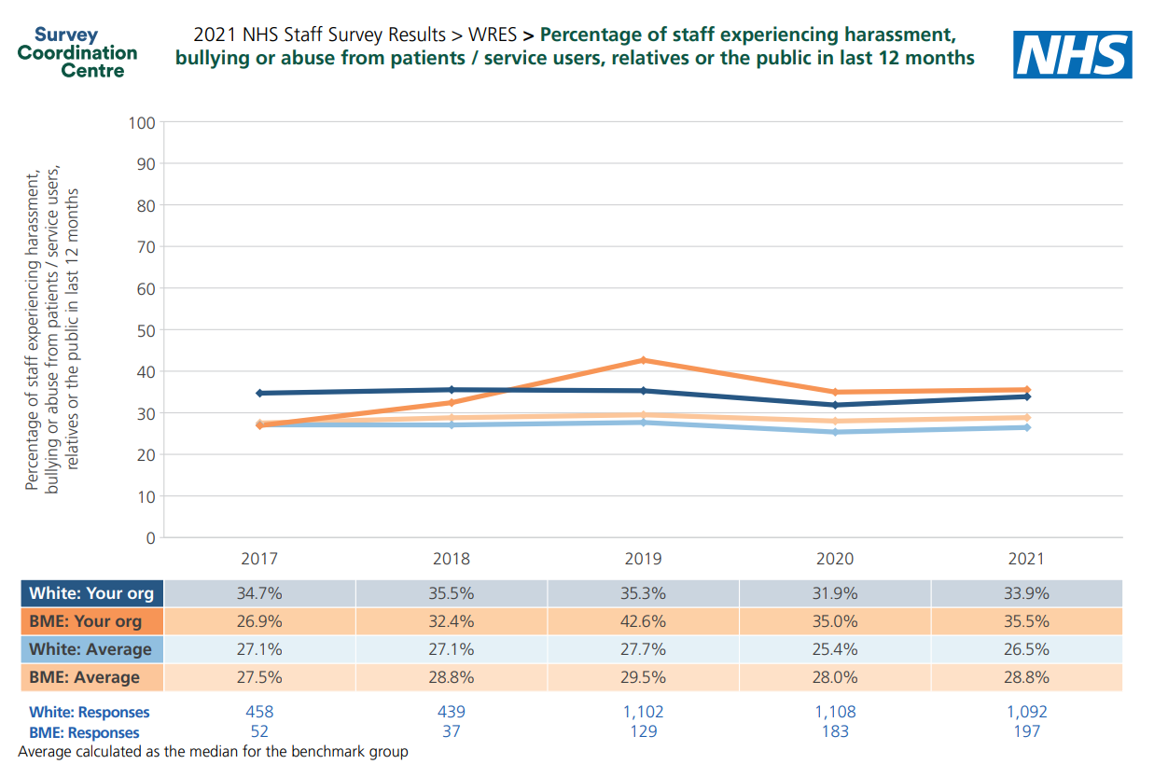
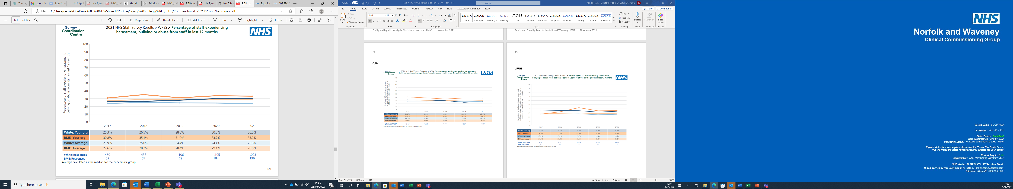
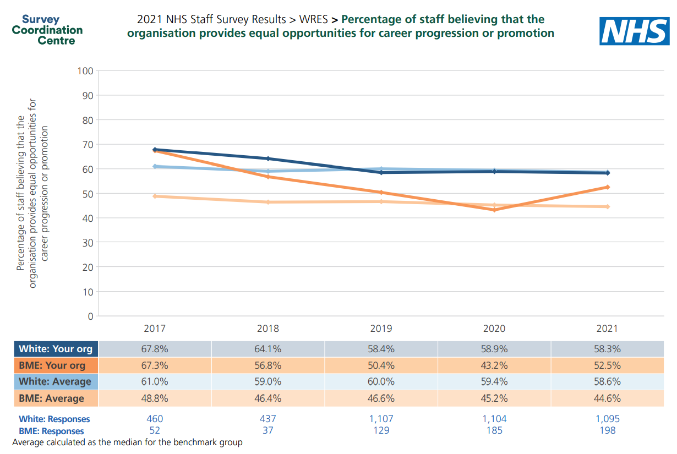
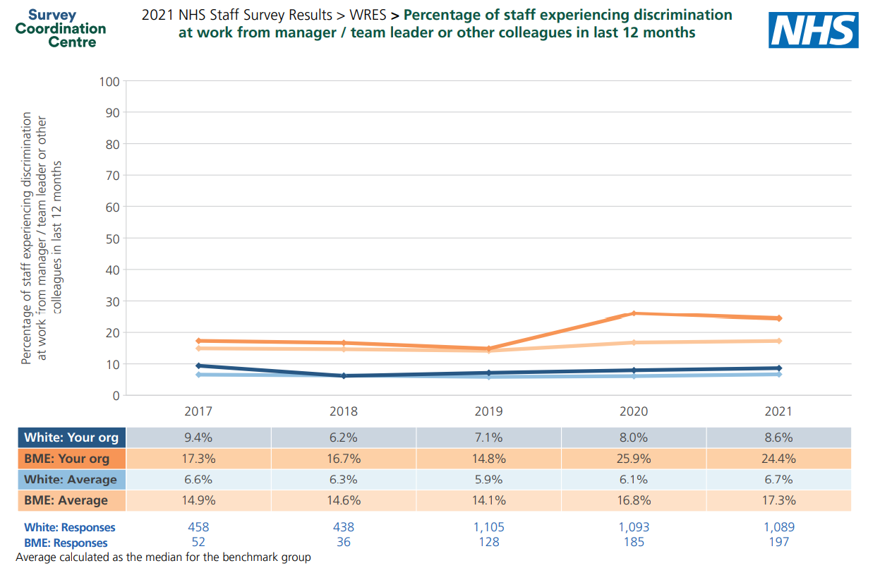

Midwifery Ethnicity Staff Survey

We undertook a staff survey in collaboration with our neighbouring Local Maternity and Neonatal Systems to explore the views around Ethnicity.

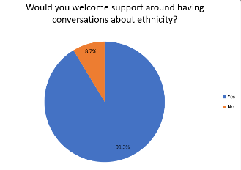
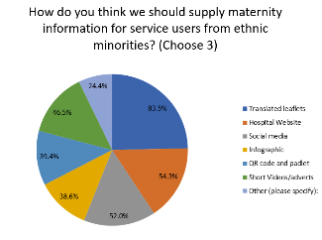
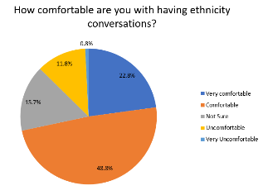
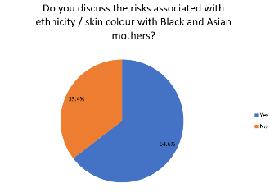
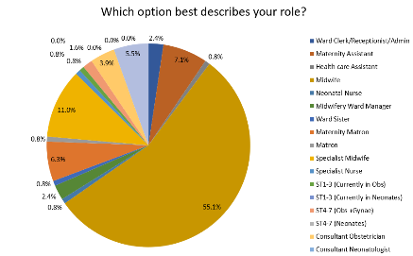
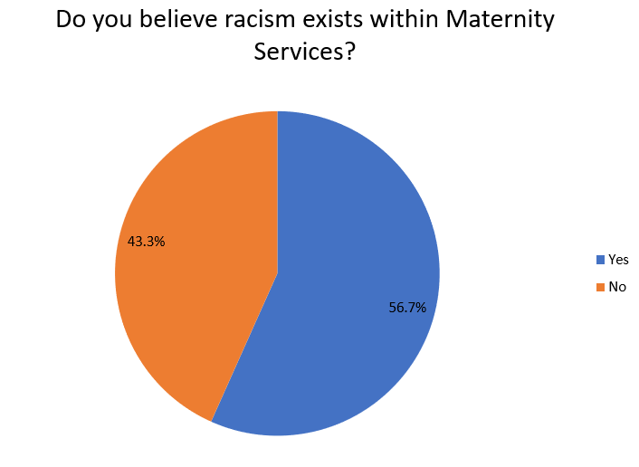

Mapping of community assets co-produced interventions.
We know that across Norfolk and Waveney during 2020/2021, community assets have been greatly reduced due to the Covid 19 pandemic. Indeed, our Public Health colleagues have not complied recent lists, due to the inaccuracy of the data at the current time. We have access to finger-tip data and resources from Norfolk County Council, but it is widely recognised that at this time, there are inaccuracies.
To overcome this, during the Pandemic, the LMNS and the Heathy Child Programme have worked in partnership to ensure that as many resources as possible have been uploaded onto the Just One Norfolk site, and all families are sign-posted to this service. Pathway To Parenting - Just One Norfolk This covers all aspects of pregnancy, health education, infant feeding, parent education classes and postnatal advice and support. It is also complimented with the Just One Number resources, where families can phone for advice and support 6 days a week, on all the above topics. Just One Number and Parentline (justonenorfolk.nhs.uk)
The Pathway to parenting (P2P) parent education offer has been on line, and through the pandemic has reached service users in the following ways
P2P content and numbers
Page Views – A browser on the page for up to 30 mins (IE- 31 mins would become a second page view)
Page interactions – Video clicks (play, pause, and stop), page clicks, and document downloads
Average time on page – Average time spent on each page.

 | June 21 – October 21
 | Session 1 | Session 2 | Session 3 | Session 4
Page views | 4249 | 1835 | 1622 | 822
Page interactions | 21592 | 9786 | 10213 | 4836
Average time on page (min) | 7.53 | 10.42 | 20.35 | 11.46

June 21 - Oct 21

11711 page views of all pregnancy content

Top visited pages;
Having a baby
Antenatal and postnatal appointments
Emotional development
Communication during pregnancy
4th trimester
Pelvic Health

We recognise that not all families will have access or the ability to participate in on-line classes. With this in mind, the HCP has offered bespoke sessions for families meeting the criteria. Any vulnerable families are referred by maternity services, triaged by the HCP and bespoke sessions offered in a variety of ways; one to one on the phone or video call, or even face to face if required, with a translator. This has ensured that no family has been left behind.
In addition, we work closely with the ECFS, who offer before to families as required. All services within the community are updated on the Norfolk Community Directory, which is currently undergoing an update and upgrade at time of writing. https://communitydirectory.norfolk.gov.uk/Home/UpgradeInProgress. We also have links with social prescriber’s through the Borough Council’s.
The LMNS funds an MVP to work with the Trusts MVP to enable us the hear the voice of service users. She is returning from her own maternity leave on 30th November. Her first role will be to use the Norfolk and Waveney Heat map, and to understand the new community assets available. She will be using the following criteria;
- High Low birthweight score
- High infant Mortality rate
- High % white other
- High % BAME
- IMD score

Contact will be made to communities using resources such as Community Action Norfolk (CAN) and Norfolk Community Foundation (NCF), who have links and contacts to most of the 3rd Sectors and religious communities across Norfolk and Waveney. This data and contact information will be shared with Trusts and Trusts MVP, so that new community mapping post Covid can take place, and new co-production plans can be made.
Community Action Norfolk is a leading charity working to build a stronger and fairer Norfolk. They work with over 500 organisations directly a year with links to over 5,000 organisations, volunteers and community champions.
Community Action Norfolk is the leading organisation for engagement with the voluntary, community and social enterprise (VCSE) sector in Norfolk. Working closely with VCSE organisations and other partners to build the positive relationships needed to collaboratively develop strategy, policy and services.
They provide practical support to VCSE organisations, and aim to be their first port of call for support to achieve their goals from helping to find funding and running an organisation, to engaging your community and strategic planning.
We live in a large rural county that for many is an excellent place to live and work but when things go wrong they hit the most vulnerable in our communities the hardest. Their goal is to work with partners to find solutions to the challenges we face and ensure fair outcomes for everyone regardless of where they live or who they are.
Covid vaccinations have been targeting the areas of highest needs, with co-located vaccine clinics and vaccinators embedded within Antenatal clinics, in partnership with vaccination service. Communications have been targeted, with a TV news article, radio, poster campaign in multi-languages, social media across the Trusts, LMNS and MVS sites.
Co-production informed the vaccination programme and over 500 service users responded to the MVP survey. This resulted in vaccines being offered with Antenatal clinics, and women’s voices were heard.
On-going work has been built on the Healthy Child Programme and Just One Norfolk (JON), where all leaflets and video and hosted. This award-winning service enables families to access information on Covid, and all other pregnancy related issues. The site has the ability to read aloud, for families who are unable to read, and is also able to translate in 80 languages.
A live Webinar was broadcast with 4 experts and hosted a number of questions posed by the public on the vaccine programme. This included the Lead midwife, a GP and Public Health. The webinar was hosted live, but recorded and translated, and this resource was also shared across all social media sites.
Covid Vaccination statistics are shown in Appendix 1
Priority 2-Mitigate against digital exclusion
Figure 17 outlines the position of the Norfolk and Waveney LMNS in relation to the Equity and Equality five priorities
The current requirement for PCSP is that they are offered at booking, although as a system, we recognise that there will be further touch-points required throughout pregnancy.
The current digital offer at Trusts is not yet set up to be able to offer a comprehensive digital PCSP package to all women, but work is underway to rectify this. The Queen Elisabeth Hospital has digital records, and is able to achieve this, while the NNUH and JPUH E3 system is not yet configured to achieve this.
All women have a PSCP offered at booking.
The LMNS has recognised that there is a risk of Digital exclusion for families with no access to hardware or data, and have been considering how to address this issue. In partnership with Public Health the CCG Digital funds, we have had a new Digital Gifting project approved at LMNS. See Appendix 2 .

 | Process Indicators | - LMNS Response | - Actions
2 | •The number of women with a PCSP which covers:  - antennal care by 17 weeks gestation  - intrapartum care by 35 weeks gestation  - postnatal care by 37 weeks gestation  • The numbers of women who had all three of the above in place by the gestational dates  With breakdowns by ethnicity (source: MSDS) | - The PCSP indicators -AN, IP & PN, and gestational window requisites have been removed by NHSE&I, as per email 23rd Nov 21. Maternity suppliers (Wellbeing - Euroking and Clevermed- Badgernet) are working to ensure that their maternity Information systems (MIS) now collate 3 digital touchpoints for PCSP reviews.  - Both suppliers have confirmed their solutions will be compliant with PCSP metrics for the MSDS January 22 data submission.  - The digital pathways to record the PCSP digital reviews will need to be guided, promoted, and audited to ensure clinicians compliance.  - Ethnicity is recorded by all 3 acute trusts as core data.  - Discrepancy has been noted between the data evidenced via the National Dashboard and the DQIM, both data extracted from the MSDS. This is being investigated with NHS DQ.  - However, QEH-KL have a registered issue whereby Ethnicity added to the MIS is being over-ridden with PAS data impacting compliance. This is being escalated locally and will require urgent review.  - Local reports will need to be built to ensure timely monitoring of PCSP X 3 reviews filtered by Ethnicity | - Digital Midwives to work with suppliers to ensure MIS collates 3 X digital reviews of PCSP.  - Review Jan scorecard for MSDS compliance  - Clinician guidance & promotion for digital PCSP reviews alongside audits to monitor compliance.  - Acute trust IS/BI teams to monitor:  - Ethnicity  - PCSP X 3 reviews  - PCSP X 3 reviews filtered by Ethnicity  - MSDS National Dashboard & DQIM data to be investigated with NHS DQ  - QEH -KL – escalate MIS Ethnicity override from PAS, with local Digital Health team
2 | • The number of women with a Personalised Care and Support Plan which covers:  - antennal care by 17 weeks gestation  - intrapartum care by 35 weeks gestation  - postnatal care by 37 weeks gestation  • The numbers of women who had all three of the above in place by the gestational dates  With breakdowns by index of multiple deprivation (source: MSDS) | - PCSP Indicators as above  - Multiple deprivation:  - MIS submits Postcodes as core  - MSDS filters by Multiple deprivation via submitted postcodes - evidenced on National Dashboard | - Acute trust IS/BI teams to monitor:  - Multiple Deprivation via Postcodes  - PCSP X 3 reviews filtered by Multiple Deprivation (via Postcode)
3 | Safety action 2, category 9: data submitted to Maternity Services Data Set (MSDS) contains valid postcode for mother at booking in 95% of women booked in the month. | - Post Codes are recorded as core data within all MIS at patient registration.  - MIS MSDS submissions includes postcodes as core  - National Dashboard – evidence compliances for all 3 acute trusts for deprivations derived from Postcodes– see table | - Digital Maternity teams to instigate/ maintain routine monitoring of MSDS submission files with correction of missing Postcodes  - Digital Maternity teams to monitor National Dashboard/DQMI for overview of compliance
3 | Safety action 2, category 10: data submitted to MSDS includes a valid ethnic category for at least 80% of the women booked in the month. Not stated, missing, and not known are not valid records. | - Ethnicity is recorded as core data within all MIS at patient registration.  - MIS MSDS submissions includes Ethnicity as core  - National Dashboard/DQIM – evidence compliances for all 3 acute trusts– see table  - QEH – KL AS above –MIS Ethnicity overridden by PAS, impacting compliance | - Digital Maternity teams to instigate/ maintain routine monitoring of MSDS submission files with correction of missing Ethnicity  - Digital Maternity teams to monitor National Dashboard/DQMI for overview of compliance  - QEH – to escalate Ethnicity over-ride – as above
4b | Booking at <70 days gestation | - MIS record date of booking and LMP / EDD which calculate the gestation at booking.  - Calculated Gestation is submitted to MSDS  - Please note:  - Gestation at booking is calculated by LMP at until a dating scan has been performed  - Gestation is then calculated by Scan EDD once available.  - National Dashboard/DQIM – evidence compliances for all 3 acute trusts– see table | - Digital Maternity teams to instigate/ maintain routine monitoring of MSDS submission files with correction of missing gestation  - Digital Maternity teams to monitor National Dashboard/DQMI for overview of compliance
4b | % of women attending the booking appointment who are from ethnic minority groups | - As above, MIS captures:  - Date of Booking  - Ethnicity | - Digital Maternity teams to instigate/ maintain routine monitoring of MSDS submission files for Ethnicity and Booking date errors  - Digital Maternity teams to monitor National Dashboard/DQMI for overview of compliance
 | Outcome Indicators | - LMNS Response | - Actions
1 | Women using folic acid | - MIS capture Folic acid use at booking as mandatory  - See data capture form MIS below  - The MSDS captures this data as part of the submission file | - Digital Maternity teams to instigate/ maintain routine monitoring of MSDS submission files  - Digital Maternity teams to monitor National Dashboard/DQMI for overview of compliance
4c | Breast milk at first feed | - MIS capture Method of first feed  - The MSDS submits first feed method as part of submission file  - Babies admitted directly to neonatal unit may have first recorded on Neonatal digital record and this often needs following up by Midwifery staff for MIS compliance  - Evidence can be found on the National Dashboard (MSDS data) | - Digital Maternity teams to instigate/ maintain routine monitoring of MSDS submission files for first feed omissions  - First feed omissions – Digital Midwives to monitor and review digital recording to improve compliance  - Digital Maternity teams to monitor National Dashboard/DQMI for overview of compliance
4c | Low birth weight (<2,500g for term births) | - Data collected via MIS as routine and submitted to local and national dashboards  - Data collected via MIS as routine and submitted to local and national dashboards  - Data collected via MIS as routine and submitted to local and national dashboards | - Digital Maternity teams to maintain local monitoring of data quality (accuracy and completion).  - Digital Midwives to work with IS / BI teams to:  - Ensure dashboards are clinically correct and accurate  - Automate data collection  - Streamline data and dashboard’s across LMNS
4c | Deliveries under 27 weeks
4c | Deliveries under 37 weeks

Figure 17 Digital and Data response to process indicators

Priority 3-Ensure datasets are completed
Serious Incidents are reviewed by the LMNS and taken to Programme Board. Ethnic origin has been recorded within these reports and issues around language and translation have been highlighted. However, there is recognition form Trusts that the recorded on Ethnic origins is not consistent across the reporting Datix/Safeguard systems, and we will now work to address this with the following plans;
- All reported SI into the CCG will be scrutinised for ethnic data. Where not completed, the Lead Midwife will request that this information is recorded.
- Serious Incident scrutiny will now occur in the planned Serious Incident scrutiny meeting to commence Feb 2022, and Ethnic origin will be discussed for every case.
- Ethnic origin will be recorded in every LMNS Board paper moving forwards.
- Audit to be competed to ensure this remains compliant.

Appendix 3 is an SI report to demonstrate recognition of ethnicity.
Priority 4 -Accelerate preventative programme and engage those at greatest risk of poor health outcomes.
4a and 4b -understand population and co-produced interventions, and action on maternal mortality, 3rd sector organisations – Maternity Voices Partnerships

As an LMNS, the Prevention work stream has been working tirelessly on this agenda over the past 12 months. In partnership with Norfolk County Council Public Health and the MVP, we have been making in-roads into understanding our population and creating innovations to meet their specific needs. We recognise that Poverty has the greatest impact on the health of our families, regardless of ethnic origin, and we are targeting CoC, and health input into the areas of greatest deprivation and needs. To this end, we have successfully appointed a Public health Midwife, and are in the process of recruiting a new team of a brand-new post, called Maternity Health Advisors. This is an innovation to support the health needs of the most vulnerable. Job Description Appendix 4
We have completed a local population heat map appendix 5 and community assets.
We have understood our population, and supported the Trusts in developing Hubs within the areas of highest deprivation. Both the JPUH and QEH have Hubs with the heart of their communities, which serve the most deprived areas, and the areas with greatest diversity. For example, Gt Yarmouth has this highest IMD score of 54.1. It is of note, that the % of BAME women in this cohort is 7.5%, whereas the % of ‘white other’ is 12.0%. This demonstrates that the population with the greatest need to the populations consisting of women from Eastern Europe, which is reported too by midwives requesting Language line for Lithuanian, Polish and Bulgarian. We know that there are high numbers of migrant workers in these areas, all of which require additional, bespoke and culturally sensitive support.
It is with this in mind, that the LMNS commissioned bespoke cultural competency training, delivered by Norfolk County Council This training was based on research undertaken with Eastern European families living in the area, and was aimed at professional working with these families. This training was aimed at Community Midwives, and was attended by 50 staff, with excellent feedback.
Conversely, the area with the greatest BAME population can be noted to be in Norwich 4, which is 13.8%. This area also has a lower IMD rate of 21.4. It is this understanding and analysis of our populations, which has allowed us to target bespoke services according to need.
Community assets are mapped with the midwives who work within HUBS. They have close working relationship with 3rd sector organisations, and have many projects planned with them. This will further be expanded with the Deprivation monies project to enhance CoC model, working with 3rd sector organisations.
The Early Childhood Family Service teams are included in the Prevention workstream, and partner with the LMNS to offer family centred care, as part of Action for Children. They work in Hubs (previously Sure Start Centres) in the heart of our communities, and work in partnership with midwifery and the Healthy Child Programme.
We have an engaged and fruitful relationship with the Healthy Child Programme who have services across Norfolk and signpost on JON. Midwifery Hubs (justonenorfolk.nhs.uk)
Norfolk Library Service are also partners at Prevention workstream, and work in partnership to offer bespoke education and training as required, and recently had a maternity focus on Smoking for October campaign and sign-posted families to the Maternity information on Just One Norfolk.
We have an employed Service User, who is returning from maternity leave 30th November, Her role will be to work with Norfolk Community Foundation, to make contact with all services across Norfolk who work with families. including religious organisations, and 3rd sector organisations. She will then work with the MVP to reach out to see what further support, guidance or sign-posting is required.
The Deprivation money (£70K) has been allocated to support Coc as directed, but within the hearts of the most vulnerable communities, in an innovative manner, working with 3rd Sector organisations.
See Appendix 6
All Trusts have referral pathways into Diabetes prevention programmes working with Trust Diabetes nursing teams. Formal quarterly meeting across the LMNS with the Specialist Diabetes Maternity teams have been arranged, to commence in 2022, to ensure a system-aide approach, in line with the work of the Infant feeding and Safeguarding teams.
All Trusts work with women with high risk social factors in accordance with NICE guideline, and specialist teams are available in 2 Trusts; The Eden team and Skylark teams. These teams offer enhance support to women requiring additional social support. See Appendix 10 Guideline for working with Migrant families and asylum seekers
Service User Groups
The Norfolk and Waveney MVP are based across the 3 Provider Trusts, and data has been collated regarding their representation of their communities. For Norfolk and Norwich data is as follows:
Percentage of reps and chairs who are BAME - 13%
Percentage of reps and chairs who are from or represent areas of deprivation (Norwich 1/2/3 Cromer) - 33%
Percentage of your MVP service user reps and Chairs are from minority ethnic groups, or from your areas of deprivation - 40%
Percentage of reps and chairs who are from or represent higher than avg need areas - (Diss, Stalham, Norwich 1,2,3,4) - 53%
For The MVP in the East
Percentage of reps and chairs who are BAME - 13%
Percentage of reps and chairs who are from or represent areas of deprivation >90%
Percentage of your MVP service user reps and Chairs are from minority ethnic groups, or from your areas of deprivation - >90%
For the MVP in the West
Percentage of reps and chairs who are BAME - 0%
Percentage of reps and chairs who are from or represent areas of deprivation 30%
Percentage of your MVP service user reps and Chairs are from minority ethnic groups, or from your areas of deprivation - 30%
Percentage of reps and chairs who are from or represent higher than average need areas – 0%
The QEH Maternity Voices Partnership (MVP) uses a range of channels to communicate and engage with service users both individually and through organisations / community groups supporting birthing people, partners and their families. The QEH MVP’s mailing list enables relevant maternity information and engagement opportunities to be shared with all MVP members from local and countywide groups/organisations (for example Lactation Motivation, Whisper from Wings, West Norfolk National Childbirth Trust (NCT), Coping & Living with Miscarriage (CALM), Access Migrant Support and more) to individual Service User Representatives, as well as statutory and maternity professionals (QEH, LMNS, Healthwatch Norfolk etc). All QEH MVP members are invited to attend virtual quarterly meetings and each year the MVP runs a programme of topic based ‘Listening & Discussion Events’ (currently online) which are open to any service users who have used QEH maternity services. The QEH MVP also has a number of working groups focused on particular topics such as the development of QEH’s new Butterfly Suite (Maternity Bereavement Suite). These multi-disciplinary working groups bring together service users, representatives from organisations/community groups supporting families and maternity staff to inform and shape particular maternity services. For example in the case of The Butterfly Suite and Garden, open monthly virtual meetings and a bespoke mailing list enables a wide range of service users, representatives and professionals to regularly inform and shape this important development.

The QEH MVP’s website is an important resource in communicating the purpose and role of the QEH MVP as well as providing an opportunity for those who have used QEH maternity services in the last two years to share their experiences anonymously via our surveys and get more involved in their MVP. Our QEH MVP Facebook page is also a way of engaging with individuals and organisations/groups on social media and is followed by 325 people.

The MVP based at JPUH uses facebook and a website to engage with service users. They also have used the Family nurse partnership and Eden teams to link in with the most vulnerable women. They have run 8 listening events on zoom on a variety of topics and 2 face to face events with the Family Nurse Partnership (FNP)team and young parent pathway practitioner for the most vulnerable group. The listening events were run with the FNP - this is in part because we cross 2 counties but again based on heat mapping this may be needed for the other MVP.

They are not running these as a sit down and listen event because both FNP teams were very clear this was not the way to interact with their families. Bookworms attended which is a local toddler group who run activities based on books and also are able to offer free funded places to families on benefits. They are running a 45 minute session for families with activities for us and staff to support.

The road map below shows how the MVP groups are firm enablers to all the work undertaken within the LMNS

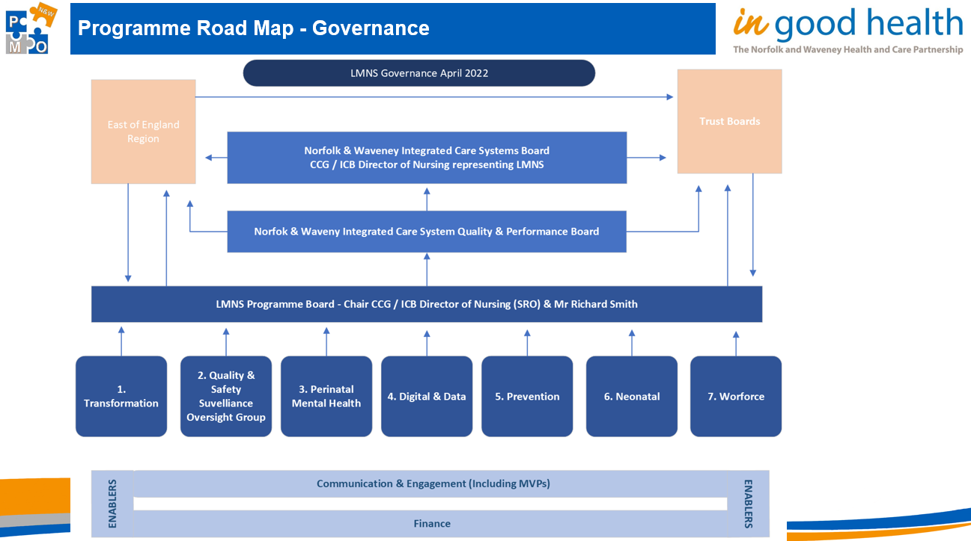

The timeline below shows MVP activity within each workstream.
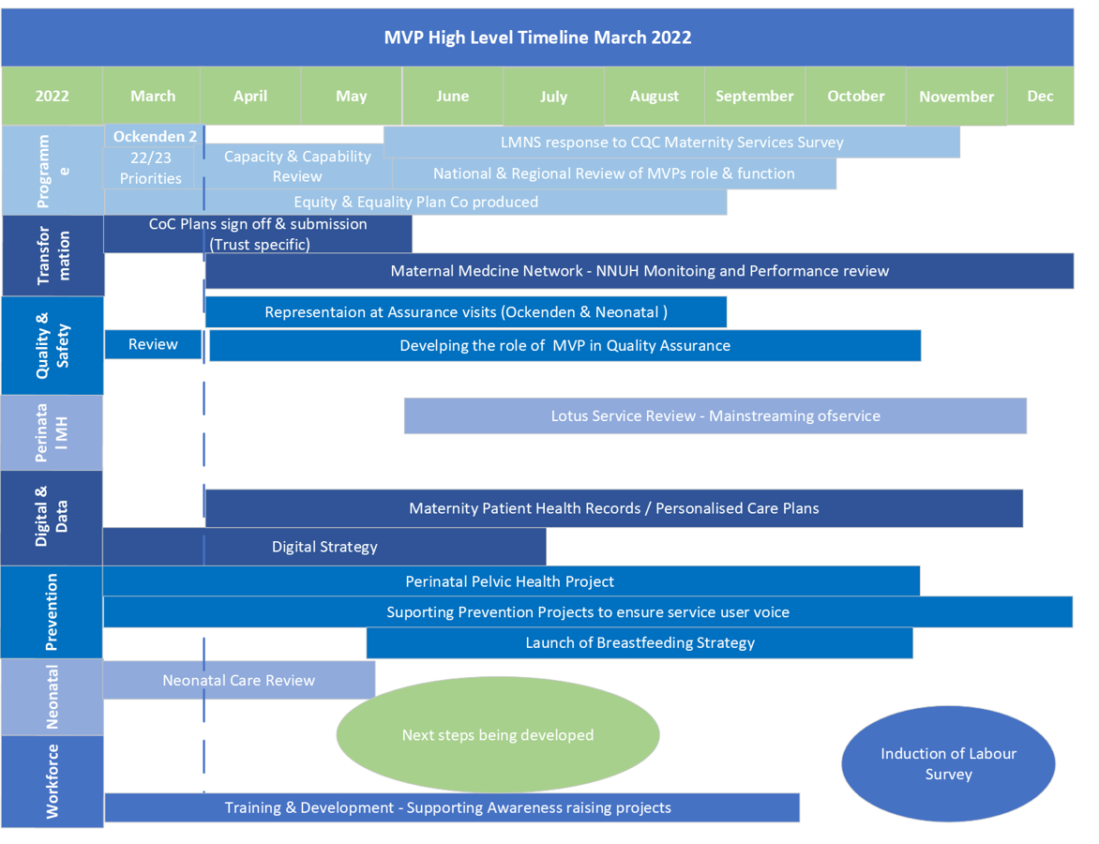

WRES indicators are discussed in section 4d – Support for Maternity and Neonatal Staff.
Social Media Engagement for the Norfolk and Waveney LMNS pages
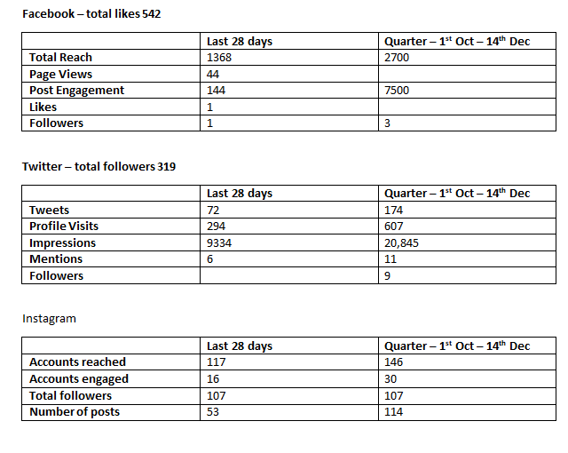
The LMNS has a page for Facebook, Instagram and Twitter. Each page’s stats are detailed above. Engagement varies between the pages with Twitter and Instagram having more activity than Facebook. Posts are published using a mixture of scheduling and spontaneous sharing. where the information is consistent such as the pelvic health videos, regular scheduling is carried out to ensure the videos reach the widest audience including newly pregnant women and people. Relevant posts are also shared from other pages and NHS trust pages as and when they arise.

Priority 4c- Action on Perinatal mortality and morbidity
CoC is being delivered at JPUH and by November will be at 85%. The HUBs are located in the heart of the most deprived areas, allowing maternity to offered CoC to the most vulnerable caseloads of women. Enhanced CoC money is being planned to be spent at JPUH, in partnership with 3rd Sector organisations and per Appendix 6

QEH have sourced Hubs and are currently offering traditional care out of these Hubs. CoC is in the final planning stages, and once launched, will be offering to most vulnerable in their catchment. Digital poverty will be addressed at QEH via the Digital gifting project as per appendix 2

The System-wide breast-feeding Strategy has been co-produced and written, but has not yet been finally ratified at LMNS Board. A draft version can be viewed in Appendix 8.
Two of the Trusts are L3 complaint with BFI, while the third Trust is currently not accredited, and is now beginning to work towards this again.

A safeguarding Strategy has been co-produced and written, but has not yet been finally ratified at LMNS Board. A draft version can be viewed in Appendix 9.
Priority 4d-Support for maternity and neonatal staff
Cultural competency training modules are not mandated and are therefore not currently included in any standard mandatory education, or included in the TNAs. However, the core competencies for this course are Culture, competence, values, beliefs, customs, , religion, religious, black, Asian, African, minority, ethnic, ethnicity, race, BAME, Romany, traveller, European, inclusion, diversity, equality, human rights, demographics, migration, international, refugee, refugees, global, globalisation, cultural blindness, acculturation, patient safety, disparity, disparities, interpreter, interpretation, language, dignity, pregnancy, co-sleeping, termination, ritual, rituals, breastfeeding, motherhood, community. On examination of other education that is delivered to staff, it is apparent that all of these subjects are included within other education sessions that are mandatory, such as Safeguarding Adults, Safeguarding Children (both L3), Prevent/Wrap, Equality and Diversity. Multi-cultural training and Cultural competency training is included across the LMNS within the Level 3 Safeguarding Children education as required by the Intercollegiate Document (2019) which states ‘Understand the impact of a family’s cultural and religious background when assessing risk to a child or young person’. This training is delivered in various formats across the System, but is quality monitored by the LSCP and the Section 11 Challenge meetings. All 3 Acute Trusts and the CCG are required to partake in Section 11 assessments. In additional the Safeguarding Adults Intercollegiate training requirements include Attitudes and values/ Supports a culture of inclusivity in diversity and equality for staff and patients/service users.
In addition, the LMNS has funded bespoke Cultural Competency workshops, aimed at Community Midwifes, MVP and other staff. These sessions were commissioned by the LMNS to fund NCC to deliver training based on research undertaken on the populations most at risk in N&W; Portuguese, Lithuanian and Polish. This flexibility and responsive education targeted the needs of the maternity staff and the population as it was in direct response to evidence and research on the local community. Over 50 staff attended this virtual training, in addition to their routine Mandatory education.
The LMNS Prevention workstream is currently focused on delivering a system-wide safeguarding strategy, in line with LSCP policies and guidelines. Cultural competency forms the backbone of this document.
In response to a Safeguarding Practice Review, the LSCP has cultural competency as a theme, and thus this is embedded within the LSCG meetings at local level,and translated into all MDT workstreams. Serious Incidents have been disseminated and issues relating to culture are examined without prejudice.
All Trusts also require staff to complete Equity and Diversity training as well as Prevent/wrap training at Level 3.
The three Trusts all report compliance levels for Safeguarding (including E&D/ Prevent/Wrap) of:
QEH 86& (midwives) and 94% (MSW)
JPUH 87%
NNUH 93.8%

WRES Indicators
We are working with workforce departments via the Workforce workstream, and are requesting the WRES data, However, this is not fully available to use to date due to having such a small number of Staff from BME backgrounds, the two smaller hospitals JPUH and QEH have been unable to divide up the WRES indicators to Maternity and Neonatal staff due to this then releasing identifiable staff responses. Work will form the Action plan to look at how to capture this information perhaps as a system rather than individual trusts moving forward. NNUH have however been able to drill down into the WRES data and this is shown in the table below. In addition, we have launched a staff survey in collaboration with Cambridgeshire LMNS to gauge the workforce understanding of equality in the workplace.

WRES Indicators Norfolk and Norwich University Hospital

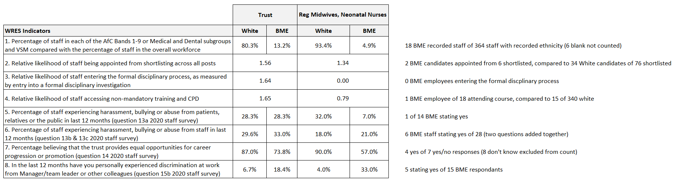

Priority 4E-Enablers.
As previously described in Appendix 2, 4 and 6, the LMNS will continue to work with Provider Trusts to work in partnership with Local Authorities, Public Health, social care and MVP to co-produce care that will support and enhance maternity care to achieve Proportionate Universalism.

Priority 5-Leadership
The LMNS has developed plans (attached) to manage the on-going equity and equality work through existing workstreams and we have decided not to have a separate Equity workstream to ensure that Equity and Equality forms a golden thread throughout all Norfolk and Waveney workplans and not rely on a stand-alone workstream this is shown in the LMNS organogram in Appendix 12.

. All elements are aligned to a workstream and E&E is now on each agenda moving forwards. The governance for this sits with LMNS Board and ICS Shadow Board.
As the ICS is in transition from the CCG the LMNS will ensure that we form part of the ICS equity strategies moving forward. The digital gifting work is in partnership with the CCG/ICS equity workplan and further developments along this pathway will continue to progress as the ICS develops.
In addition, the N&W LMNS has strong links with Lives for African Mothers and will be hosting both on-line education to maternity teams in Uganda, and has plans and funding with Imperial College London Woman’s Research Centre to travel to Uganda 2022-2025 for education and research opportunities.
Norfolk and Norwich University Hospital hosted an Each Baby Counts: Learn and Support local development lead funded by the RCOG and RCM. This member of staff was also one of our Better Birth Lead Midwives. The work undertaken within this locality has been used to inform the national toolkit which will be published in March 2022 by the RCOG.

Appendices
Appendix 1 Covid Vaccine Update

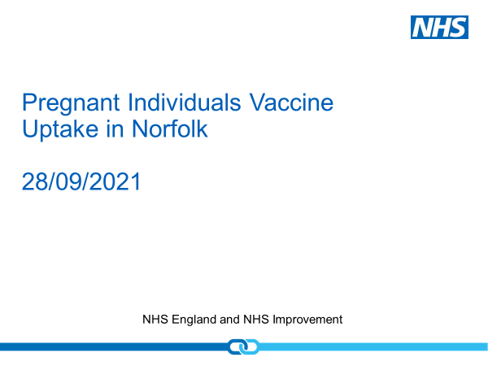

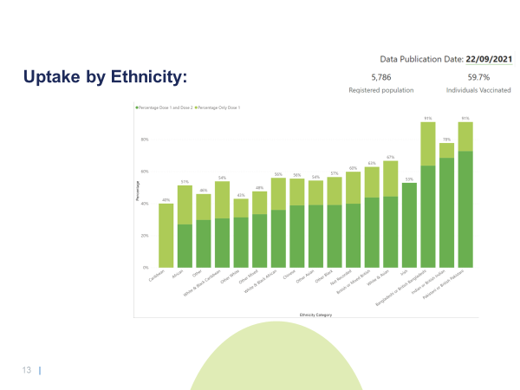

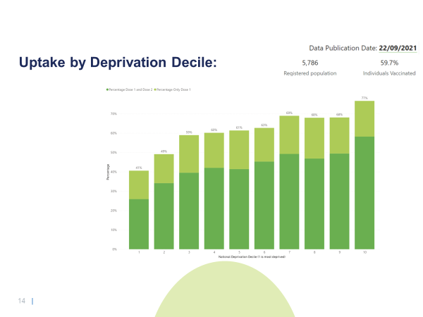
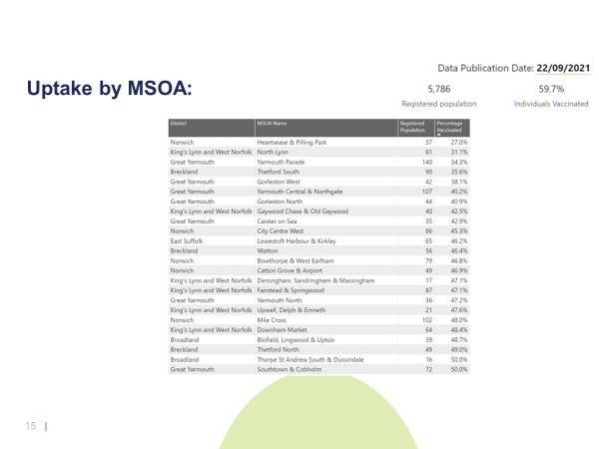

Appendix 2-Digital Gifting LMNBS Board Paper.

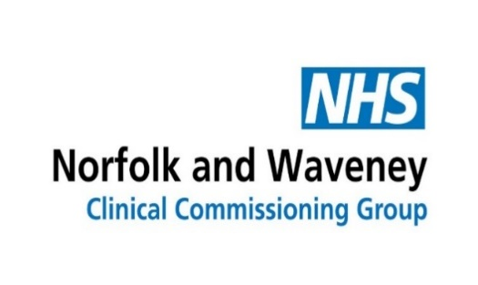
Agenda item: 7a

Subject: | Digital Equality
Presented by: | Nicola Lovett Lead Midwife  Kiya Rothman Public Health Midwife  Sarah Boyd Head of Digital Experience & Transformation
Prepared by: | Nicola Lovett Lead Midwife
Submitted to: | LMNS Programme Board.
Date: | 20th October 2021

Purpose of paper:

The purpose of this paper is to request approval for match funding for a Pilot from Digital Aspirant Fund working with Norfolk Libraries to tackle digital inequalities.

Executive Summary:

The Maternity Transformation programme is now reliant of good digital access for all parties including woman, whose health records are on-line, and are signposted to a number of on-line sites for health advice, information and education. However, work at Hubs in our areas of highest need suggests there is a lack of digital maturity, confidence and equity of access for some of our clients. Research from the Healthy Child Programme (HCP)suggests that up to 3% of our families are currently digitally excluded.

This proposal is to work with midwives to identify families at risk of digital exclusion, and referral to the Norfolk Library Service. The service will them ‘gift’ devices and data to the individual, with one to one tuition on the basics of use, which can include access to housing and benefits, Just One Norfolk, Health Education sites and e-paq.

The proposal is that we launch this in QEH, as they have high needs of deprivation and the electronic health records (e-HR) (Badgernet) are only available on-line, thus further increasing heath inequalities.

The Digital Aspirant Fund from Norfolk and Waveney Health and Care Partnership will match fund £15 000 to this project, if the LMNS can also release similar funds.

Recommendation to Quality and Performance Committee:

To approve the plan a pilot project at QEH to tackle digital inequality in partnership with Norfolk Libraries services, with the gifting project and education. This is to be jointly funded by the LMNS (£15 000) and the Digital Aspirant Fund (£15 000 in the first instance)
Key Risks
Clinical and Quality: | Clinical needs will be identified by LMNS team and Quality will be monitored by Norfolk Libraries.
Finance and Performance: | Release of £15 000 to Norfolk Libraries to deliver the service.
Impact Assessment (environmental and equalities): | Project will be monitored, evaluated and an impact assessment competed by Norfolk Libraries and Public Health Midwife
Reputation: | There is no reputational risk to this project.
Legal: | N/A
Information Governance: | N/A
Resource Required: | £15 000 for Equity Monies
Reference document(s): | Better Birth Maternity Transformation  NHS Long Term Plan  Ockenden Reports
NHS Constitution: | The guidance and report support the principles of the NHS Constitution. (values 1-7)
Conflicts of Interest: | No conflicts identified
Reference to relevant risk on the Governing Body Assurance Framework | None

GOVERNANCE

Process/Committee approval with date(s) (as appropriate)

REPORT FOR THE LMNS Board re Pilot for Digital Equality
Date
Title | Digital Equality Pilot Project
Author(s) | Nicola Lovett Lead Midwife LMNS/CCG  Kiya Rothman Public Health Midwife  Sarah Boyd Head of Digital Experience & Transformation
Purpose | The purpose of this paper is to request approval for match funding for a Pilot Digital Equity Project working with Norfolk Libraries to tackle digital inequalities.
Summary including  Key Performance Issues/Risks | Background  The Maternity Transformation programme is now reliant of good digital access for all parties including woman, whose health records are on-line, and are signposted to a number of on-line sites for health advice, information and education. However, work at Hubs in our areas of highest need suggests there is a lack of digital maturity, confidence and equity of access for some of our clients. Research from the Healthy Child Programme (HCP) suggests that up to 3% of our families are currently digitally excluded.  This proposal is to work with midwives to identify families at risk of digital exclusion, and referral to the Norfolk Library Service. The service will them ‘gift’ devices and data to the individual, with one to one tuition on the basics of use, which can include access to housing and benefits, Just One Norfolk, Health Education sites and e-paq.  The proposal is that we launch this in QEH, as they have high needs of deprivation and the electronic health records (e-HR) (Badgernet) are only available on-line, thus further increasing heath inequalities.  This project is part of a larger work stream within the CCG/ICS Health Inequalities work, and the ‘gifting ‘ project is already seen to be effective for Mental health and Cancer patients. It is anticipated that as the workstream evolves, that Maternity will seek to expand their project across the system to all women who are digitally excluded.  The Digital Aspirate Fund will match fund £15 000 to this project, if the LMNS can also release equal funds.
Monitoring / Escalation | On-going monitoring of the project will be undertaken by Norfolk Libraries with the Public Health Midwife with regular reporting to the maternity team and LMNS. On-going evaluation and impact assessments will be produced with an impact assessment at the completion of the project, to support future funding bids, where clinical and engagement outcomes are supported.
Action Required () | FOR DECISION  A decision is required to support or reject this proposal of a pilot project for digital exclusion to be launch at QEH.

Appendix 3-October SI report
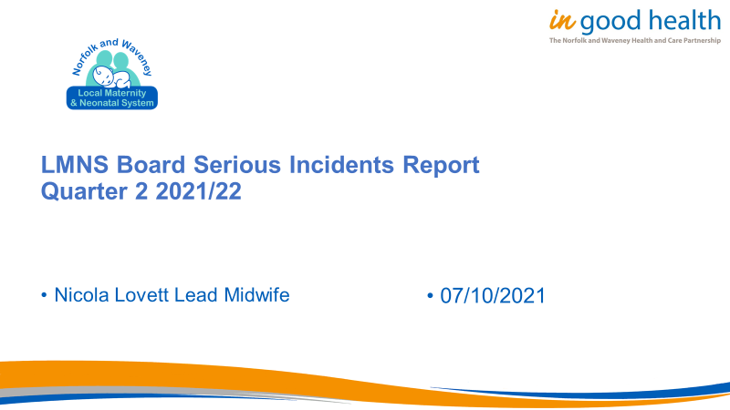

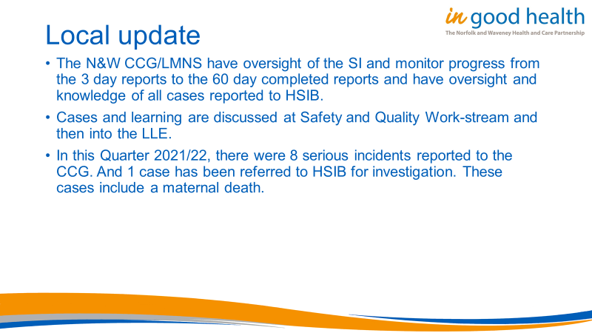

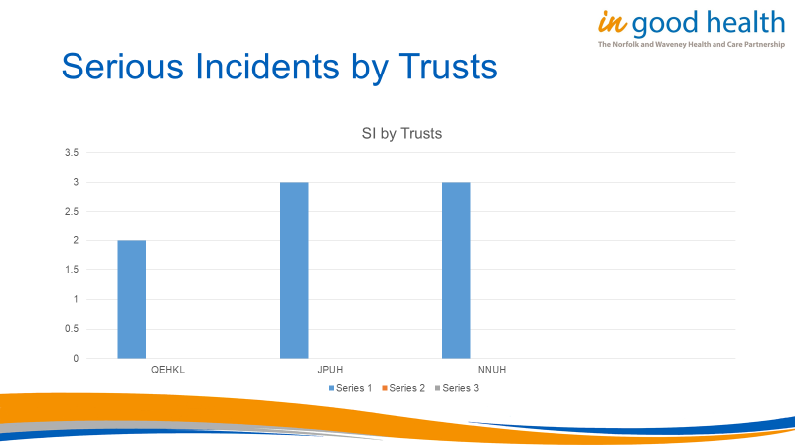
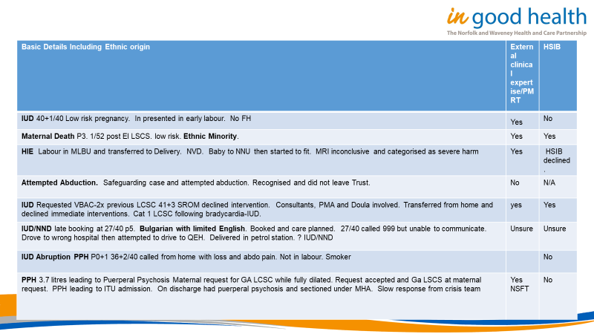

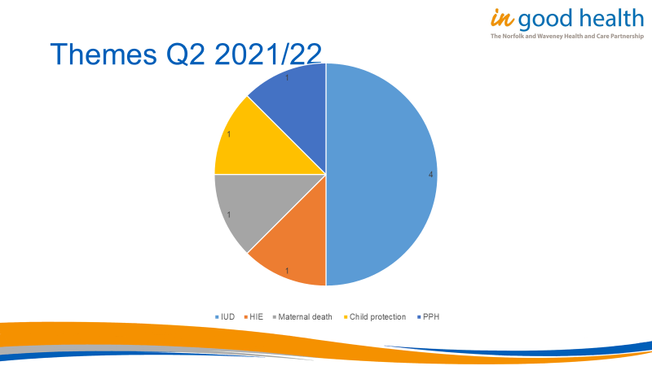

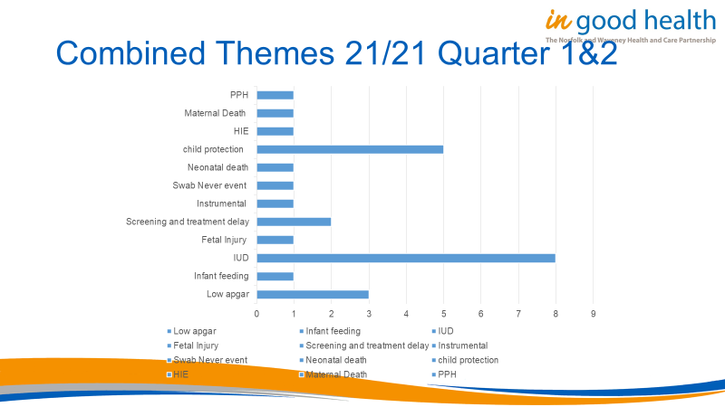

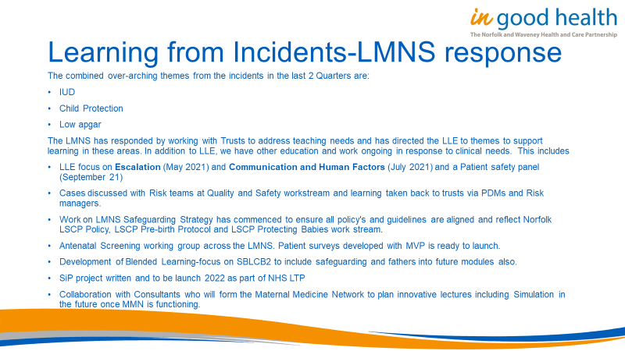

Appendix 4-Maternity health Advisers Job Description

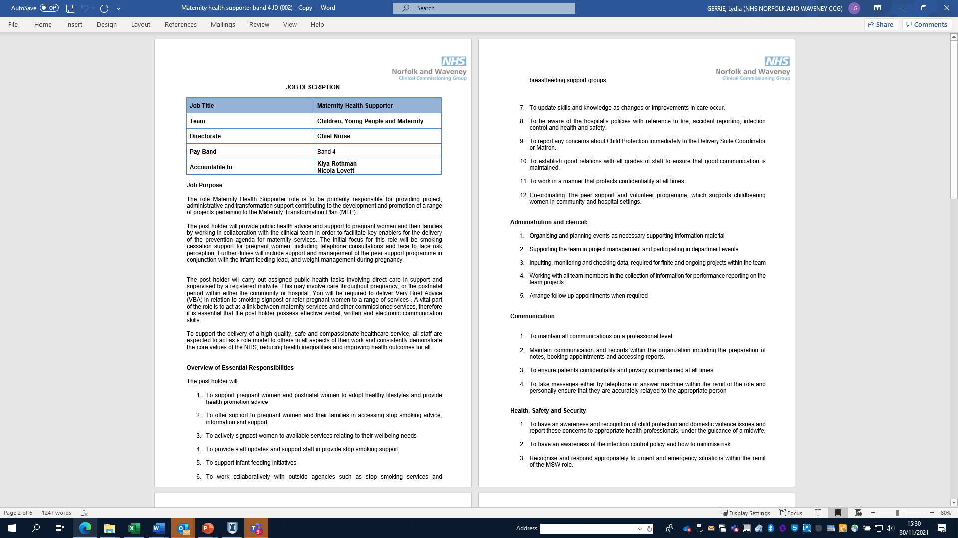

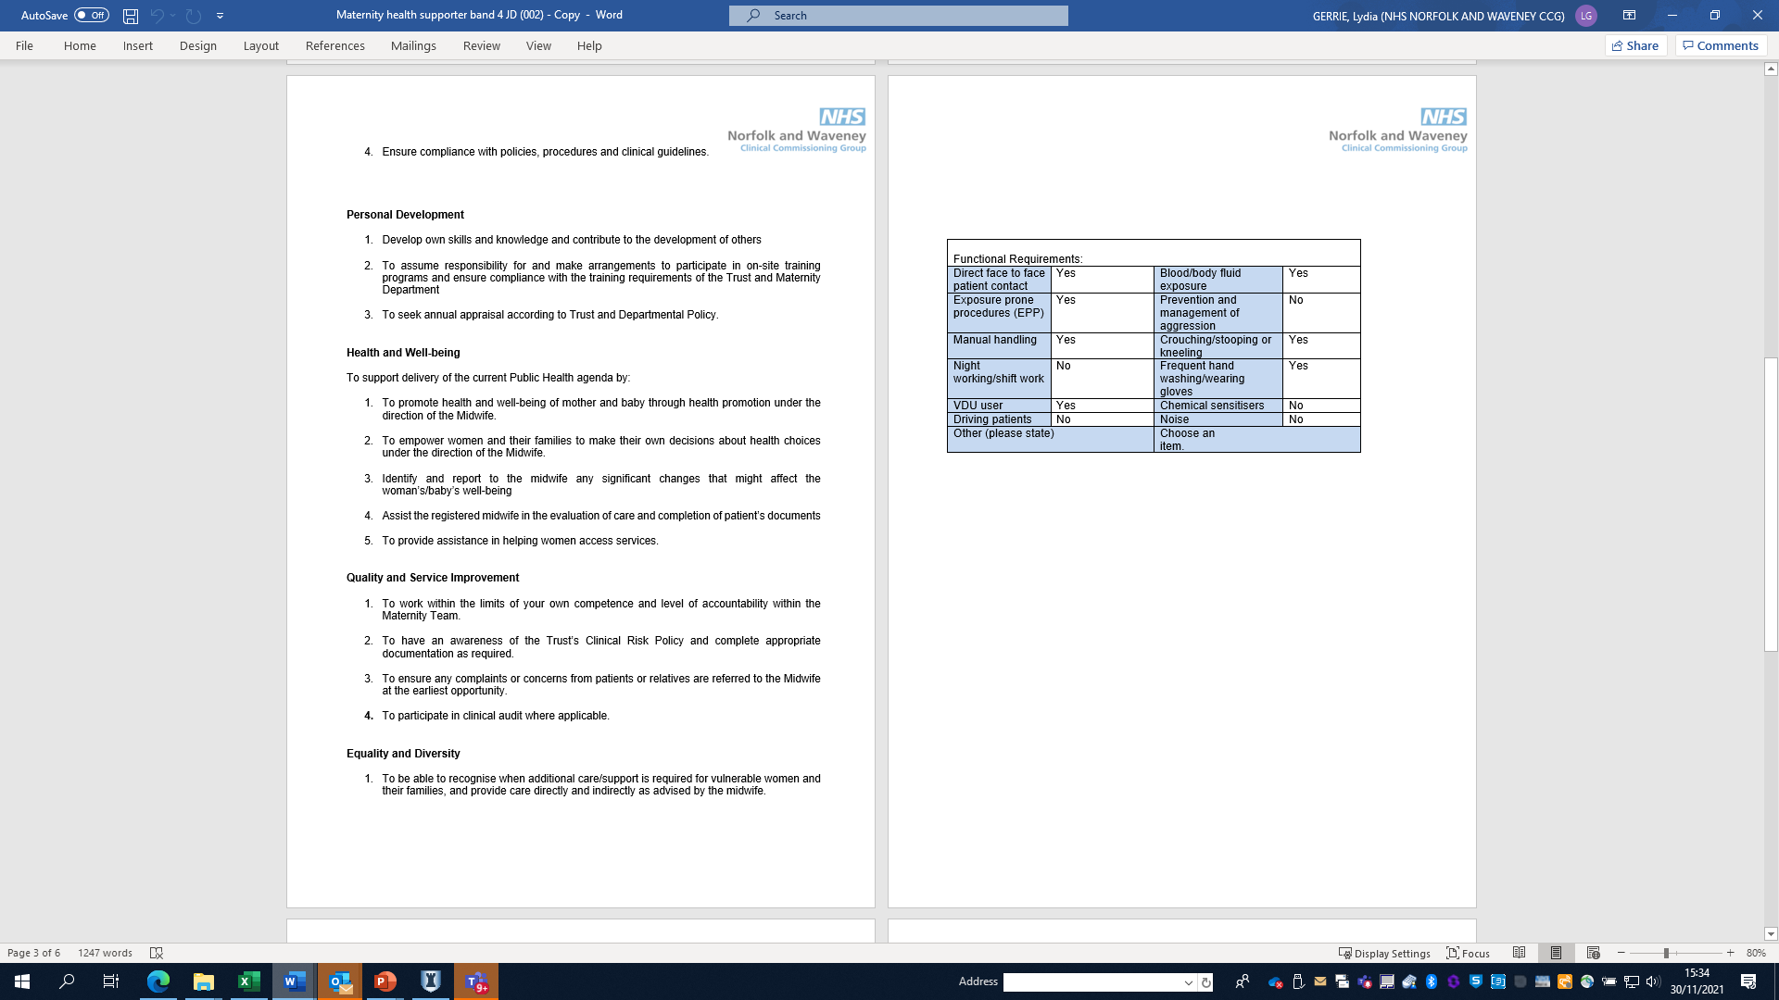

Appendix 5-Heat Map
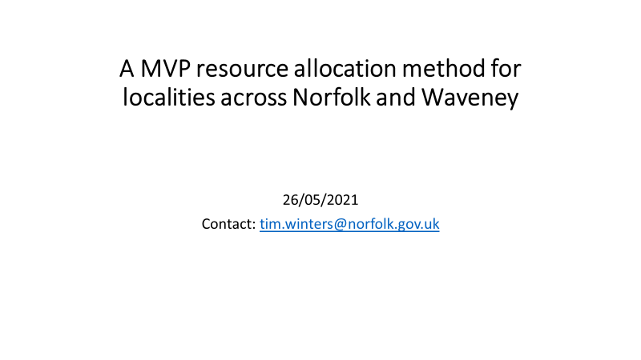

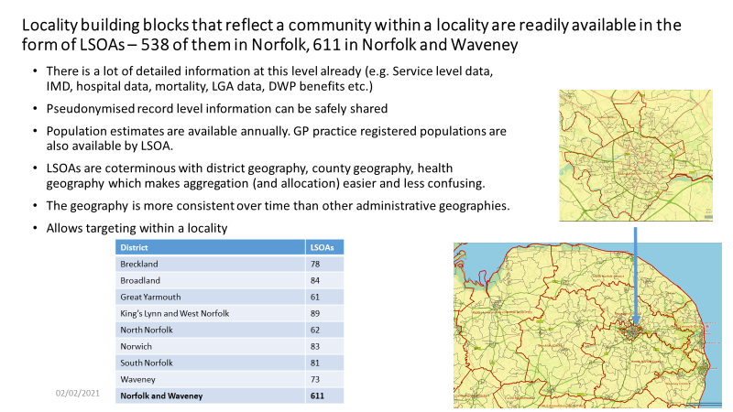
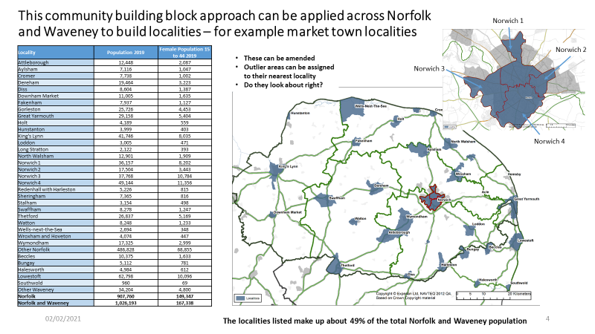

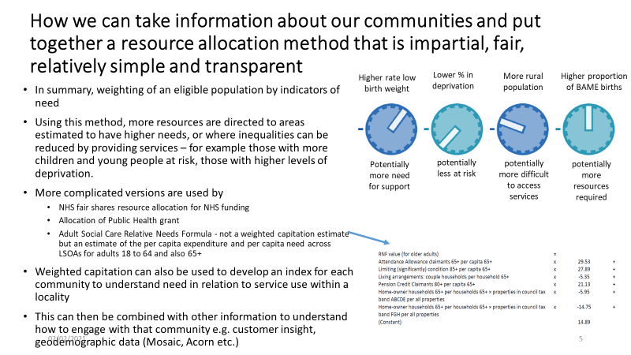

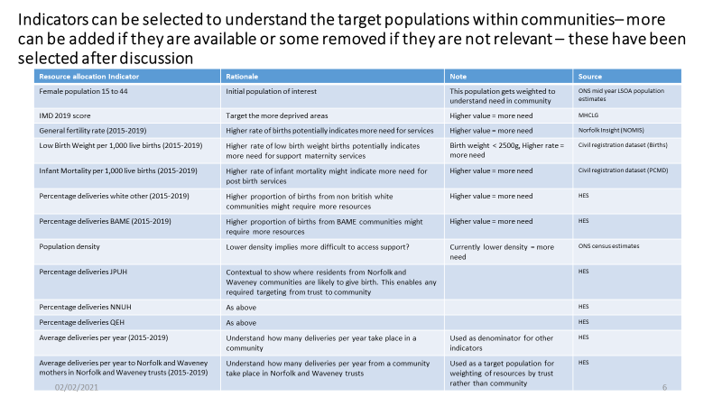

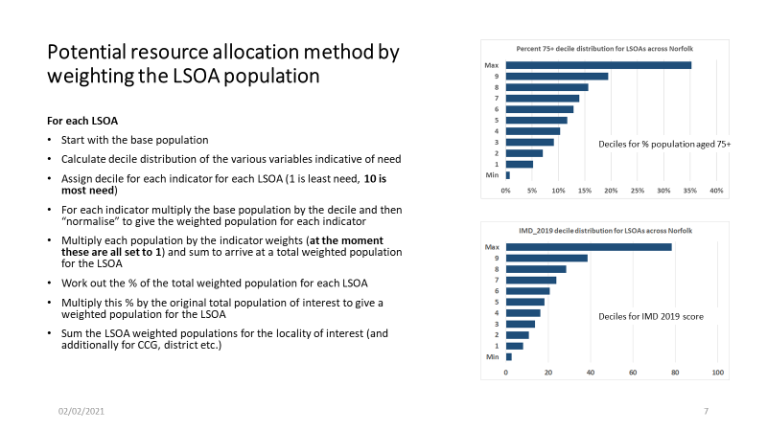

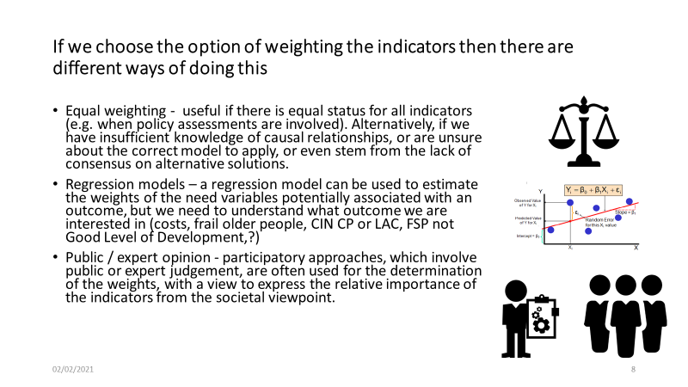

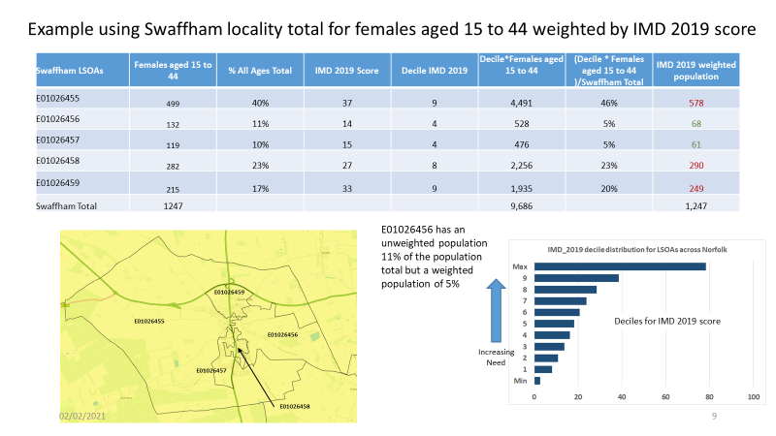

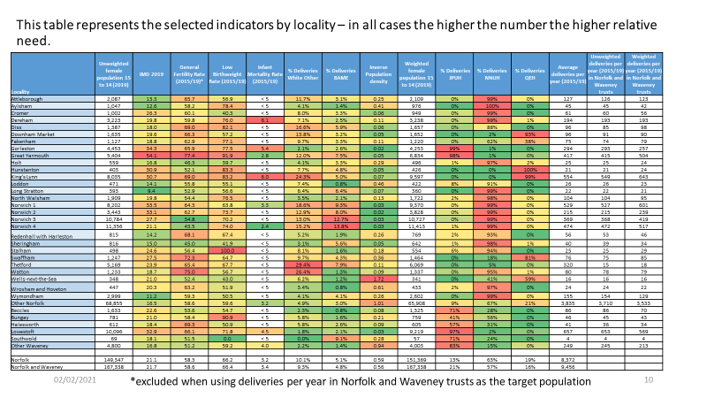

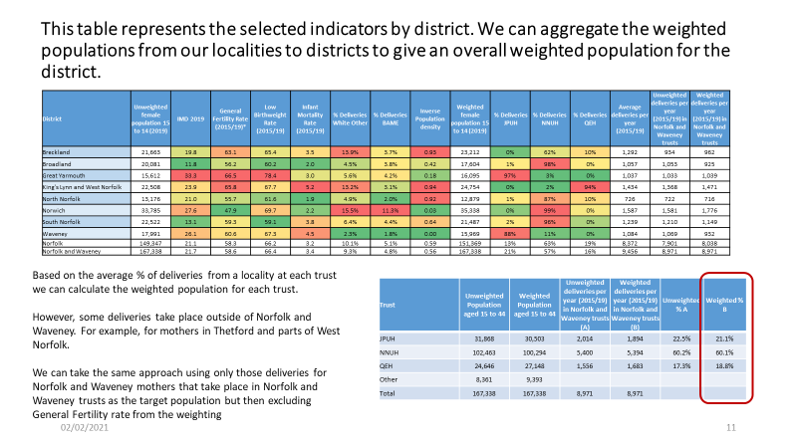

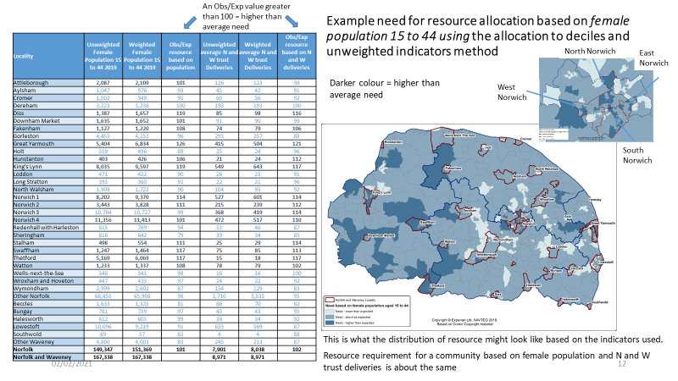

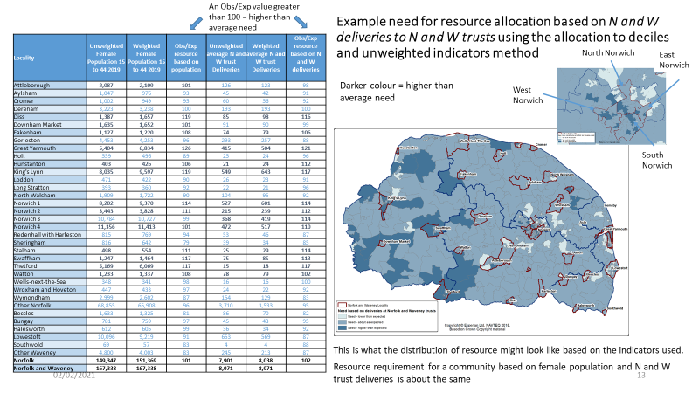

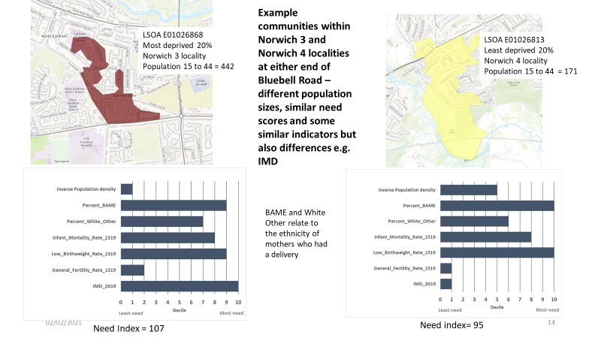

Appendix 6 Deprivation money paper
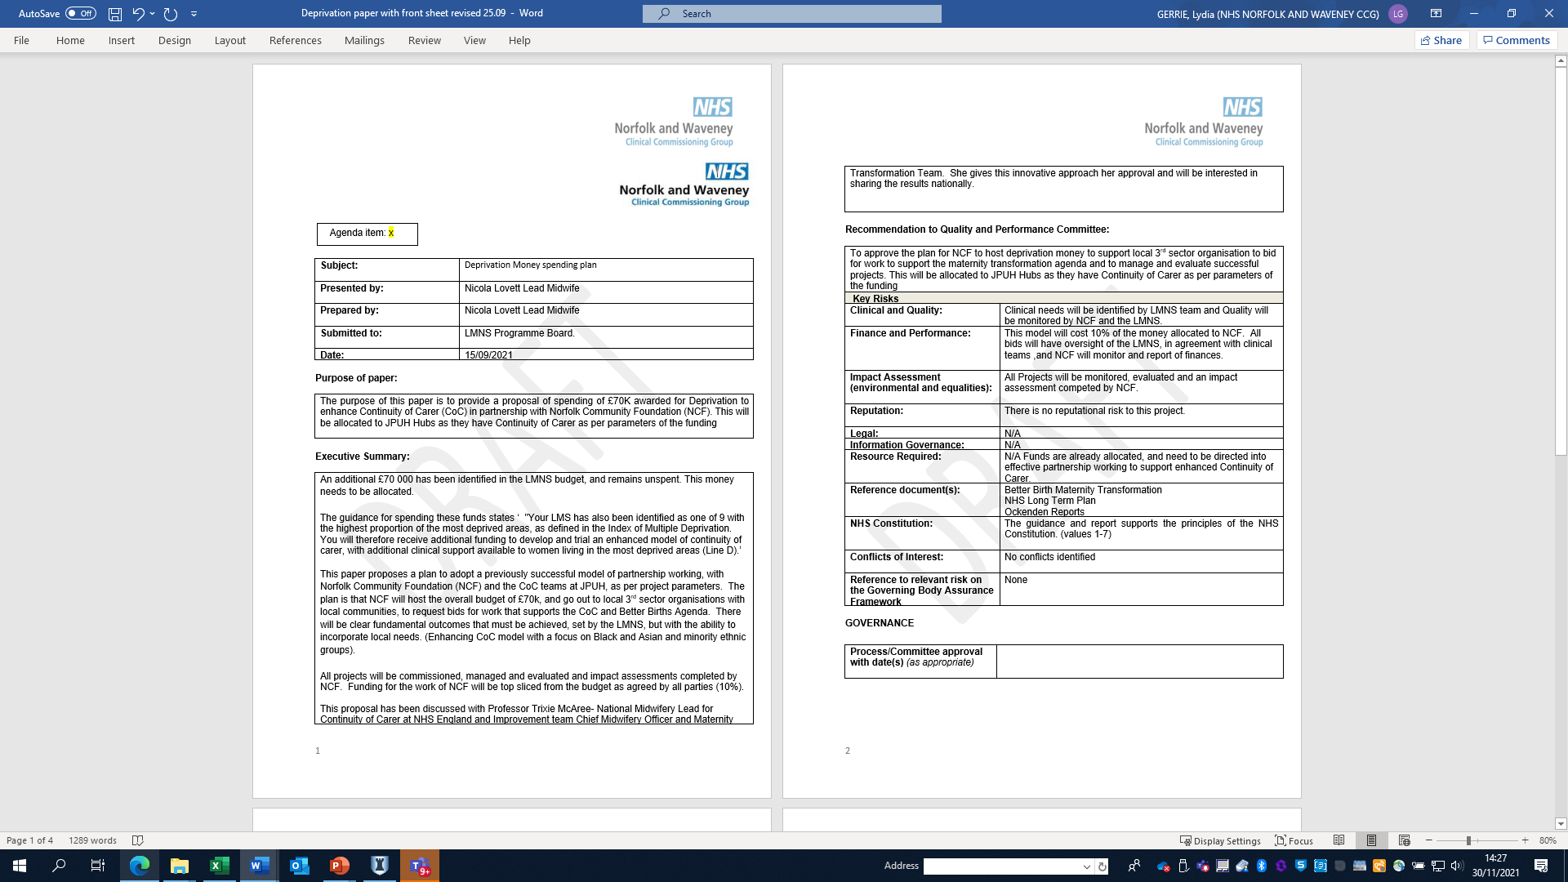

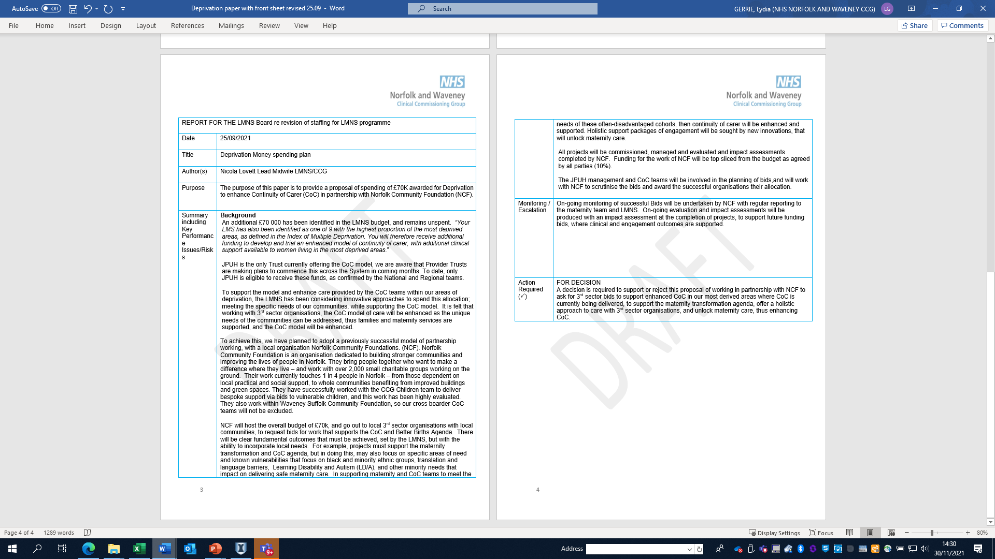
Appendix 7 Vitamin D SOP

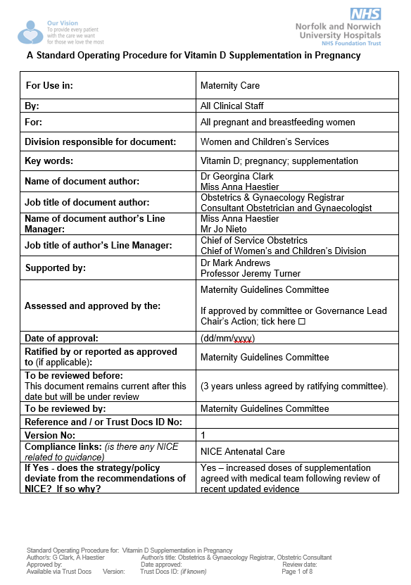

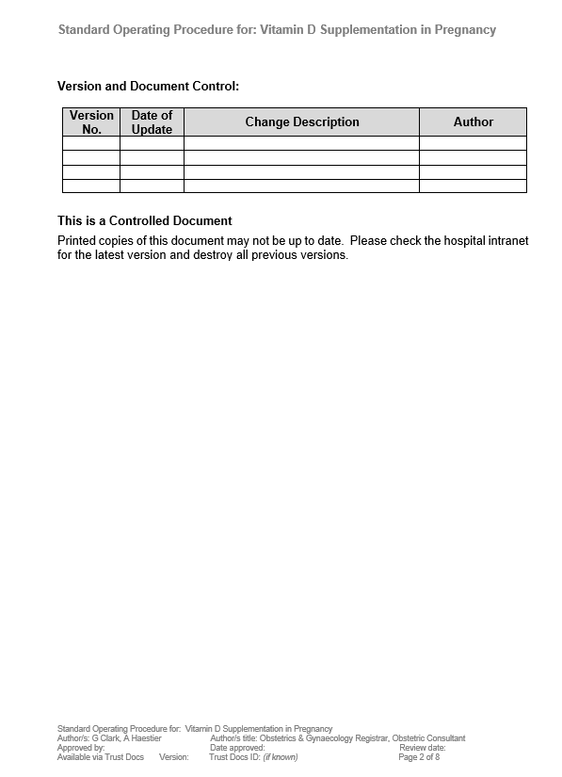
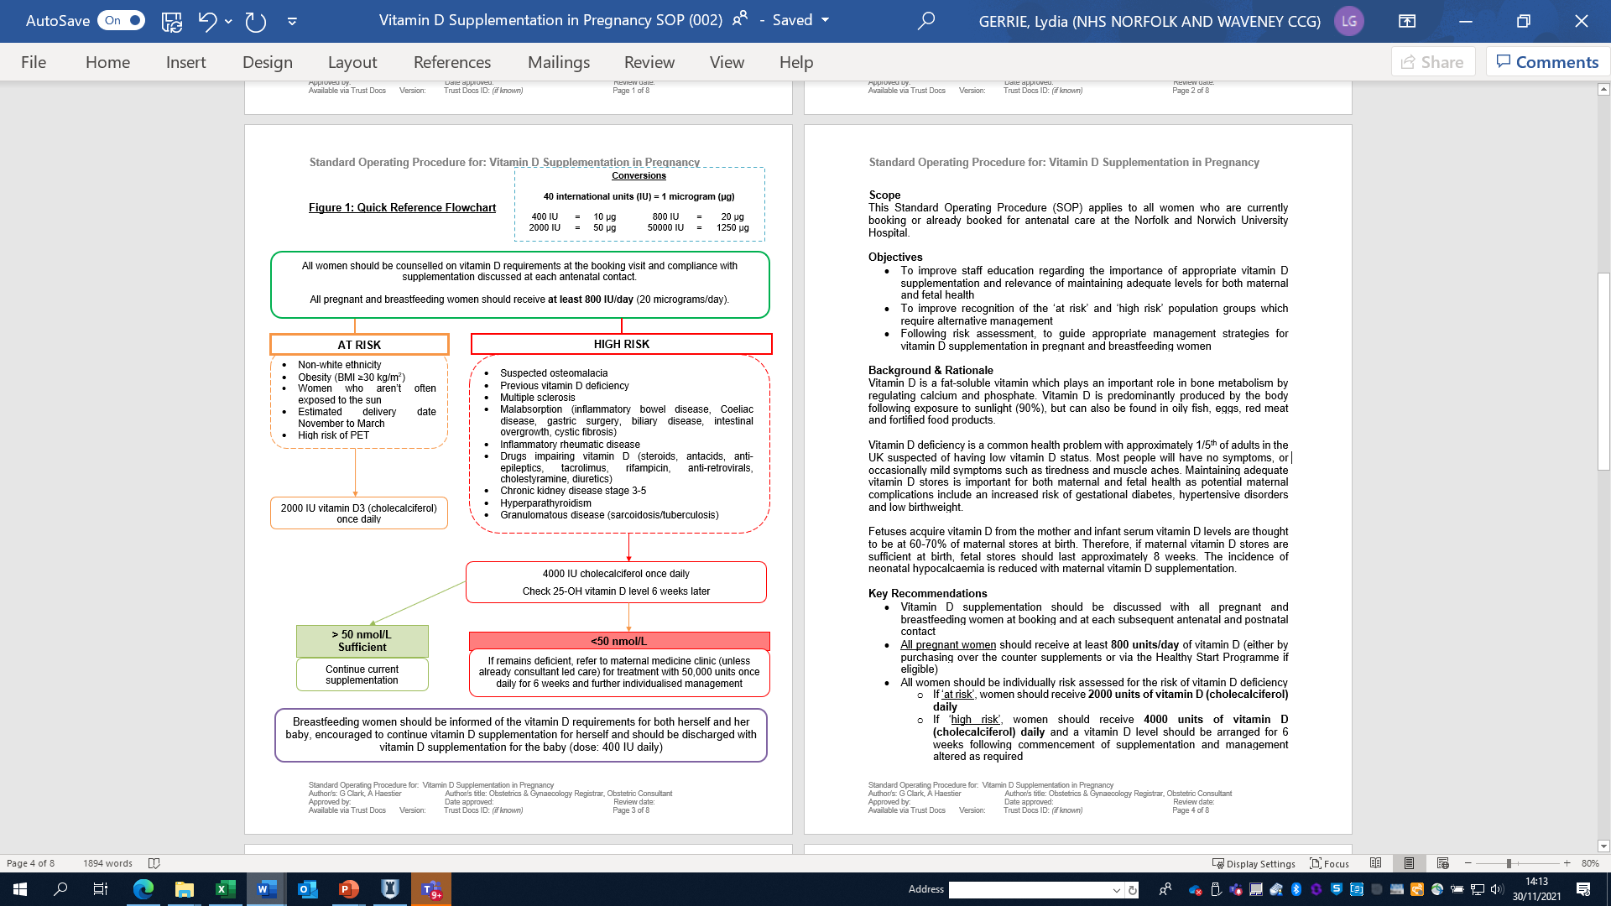
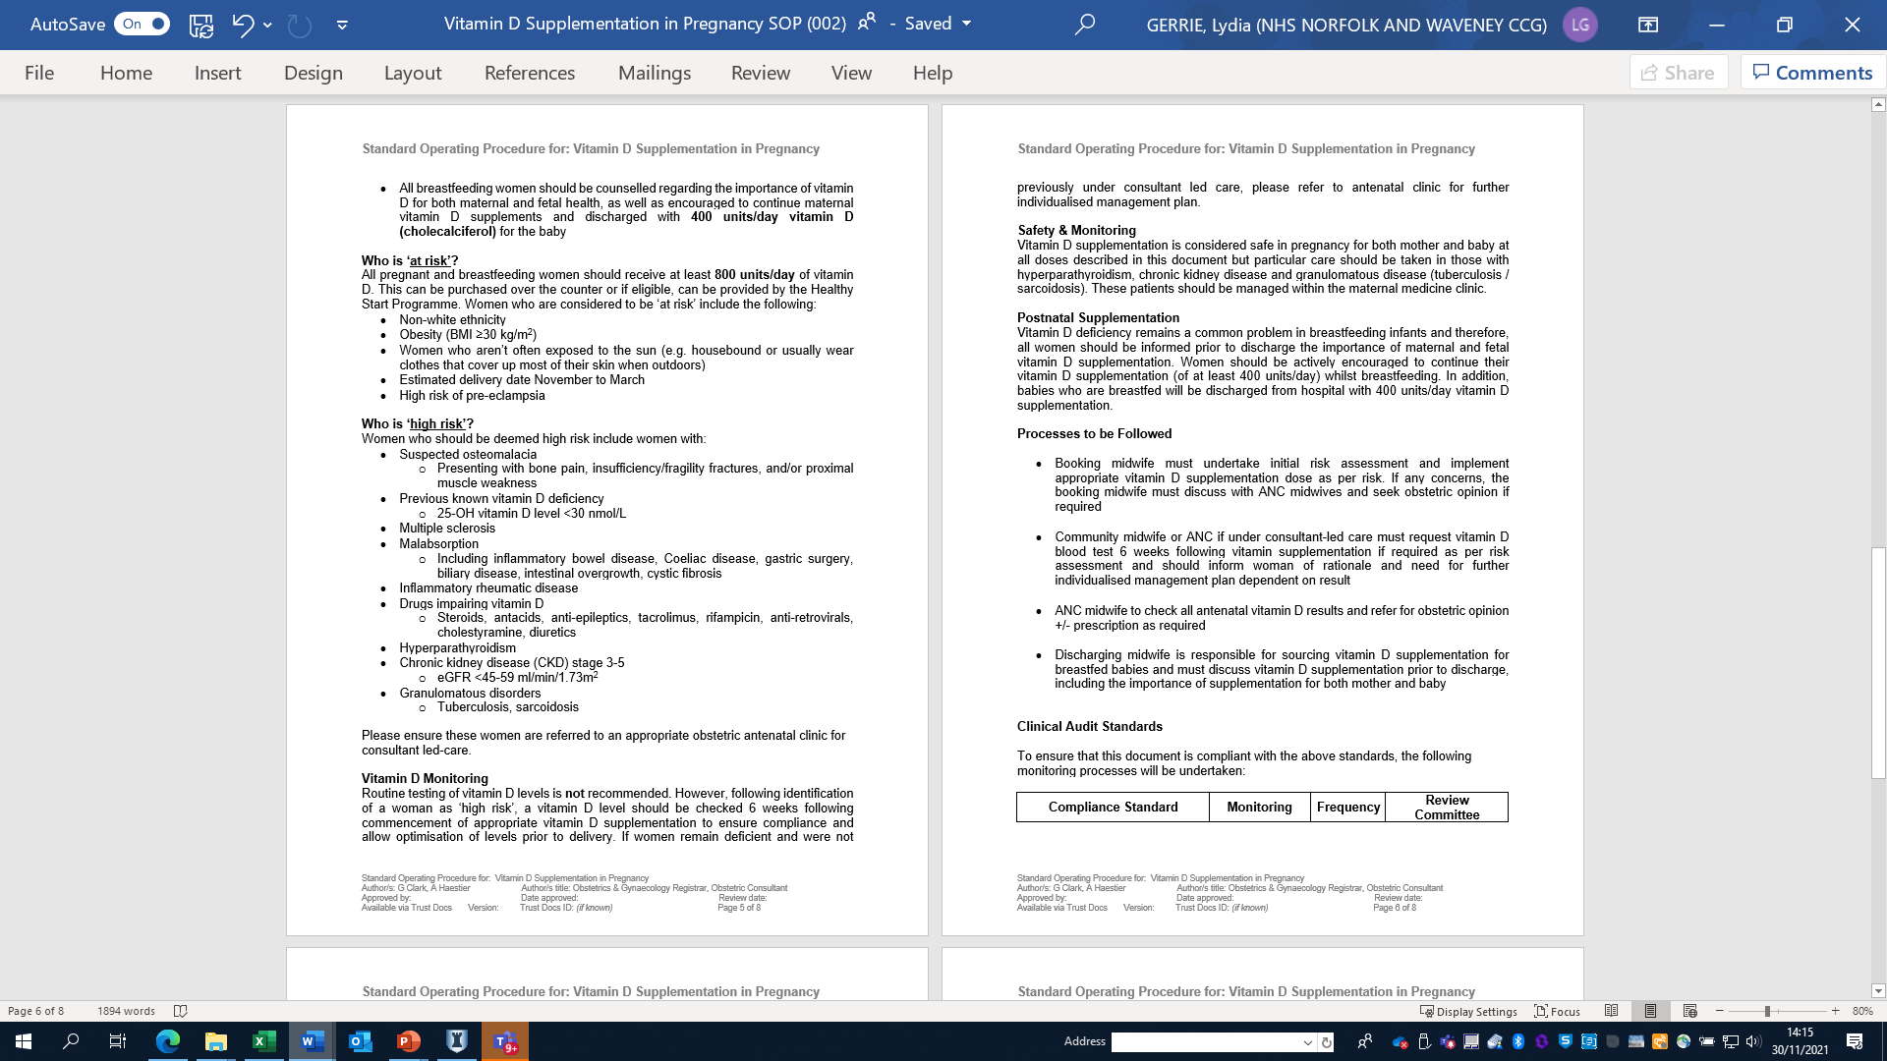
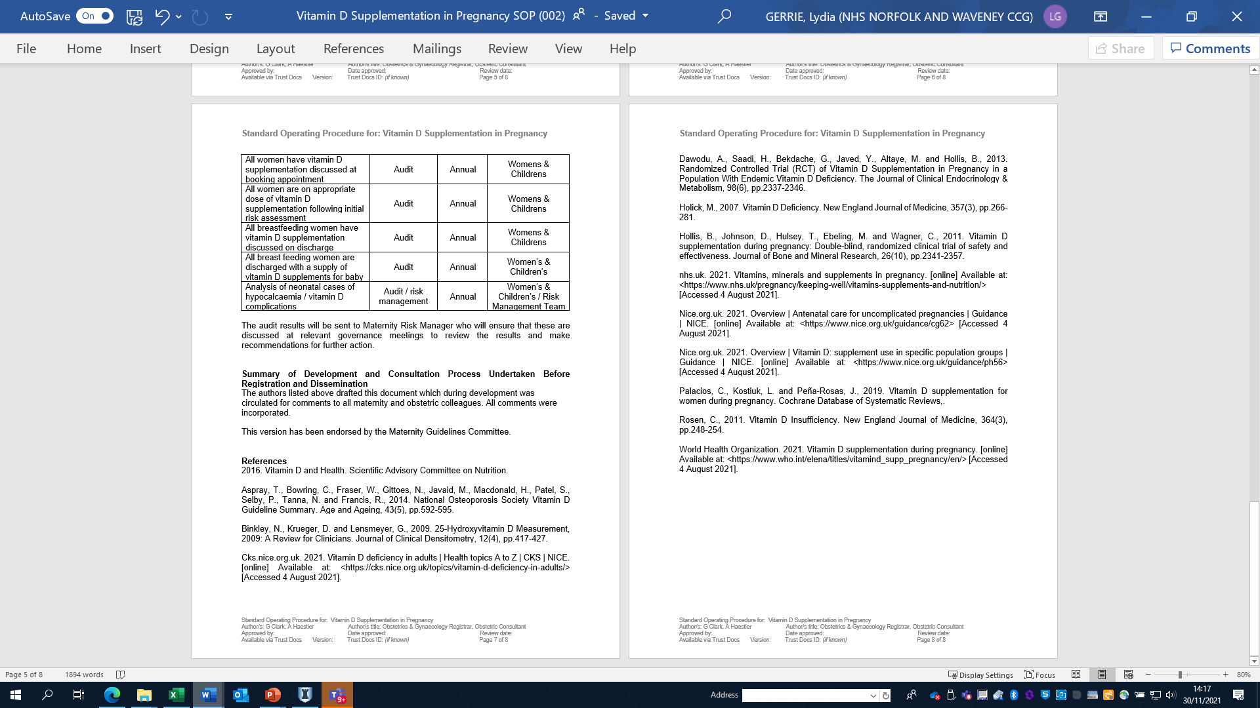

Appendix 8 Draft Breast Feeding strategy

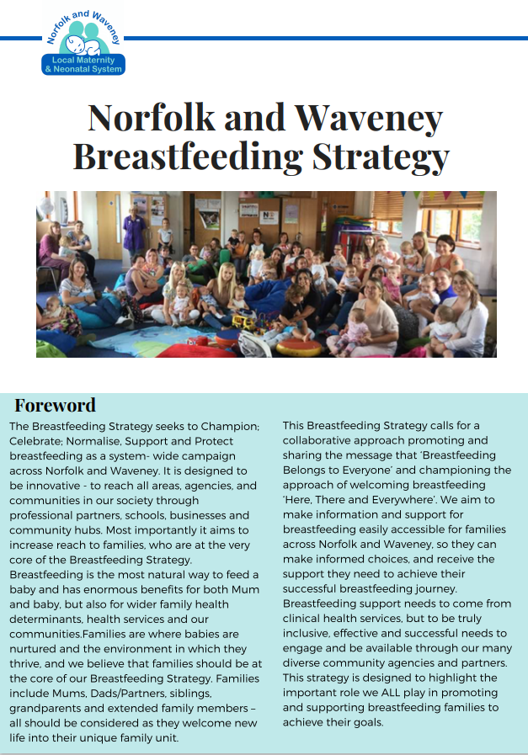

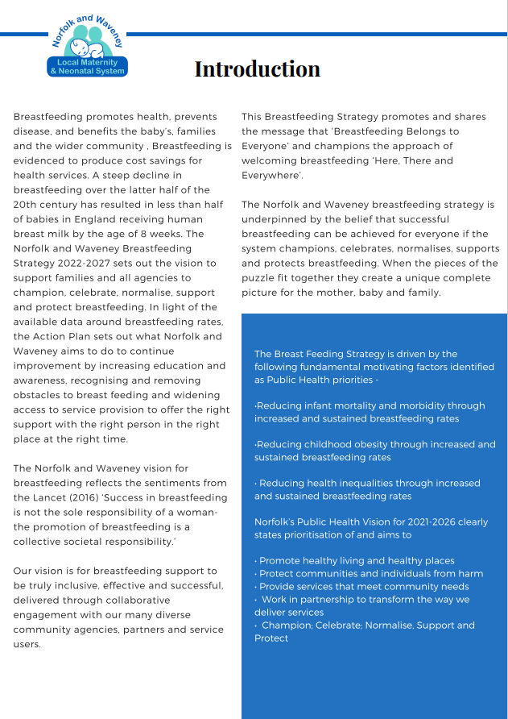

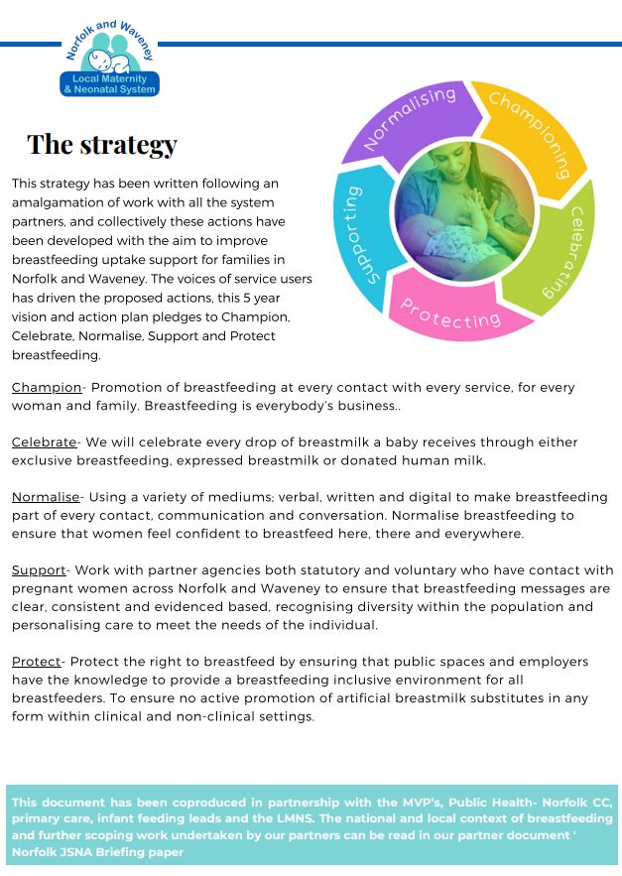

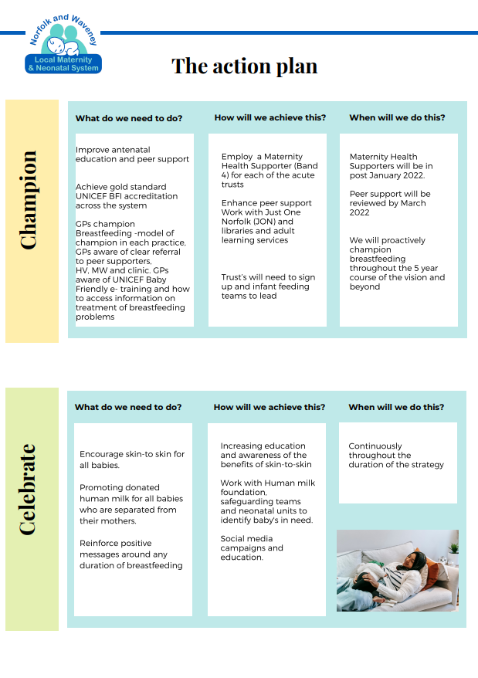

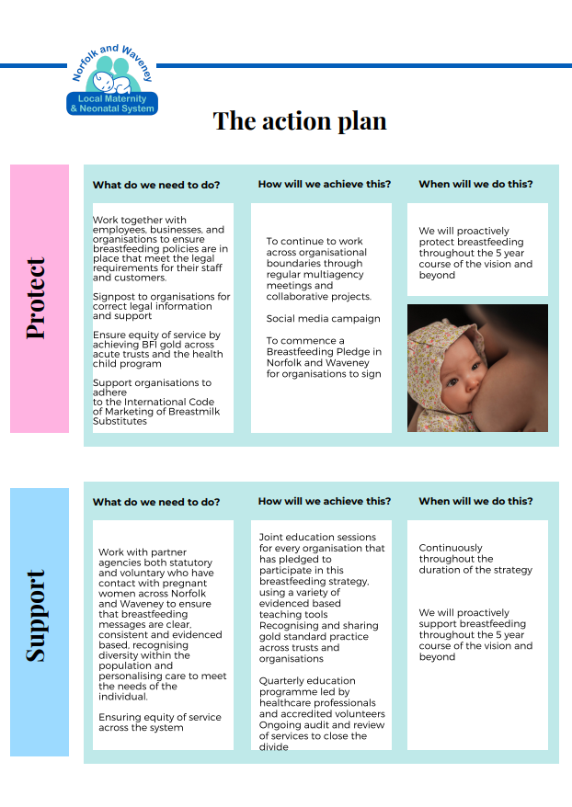

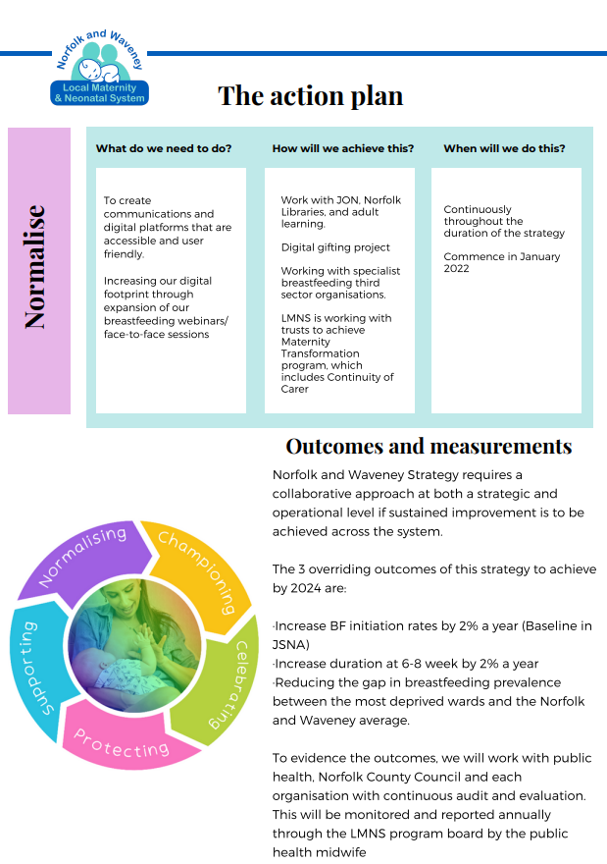
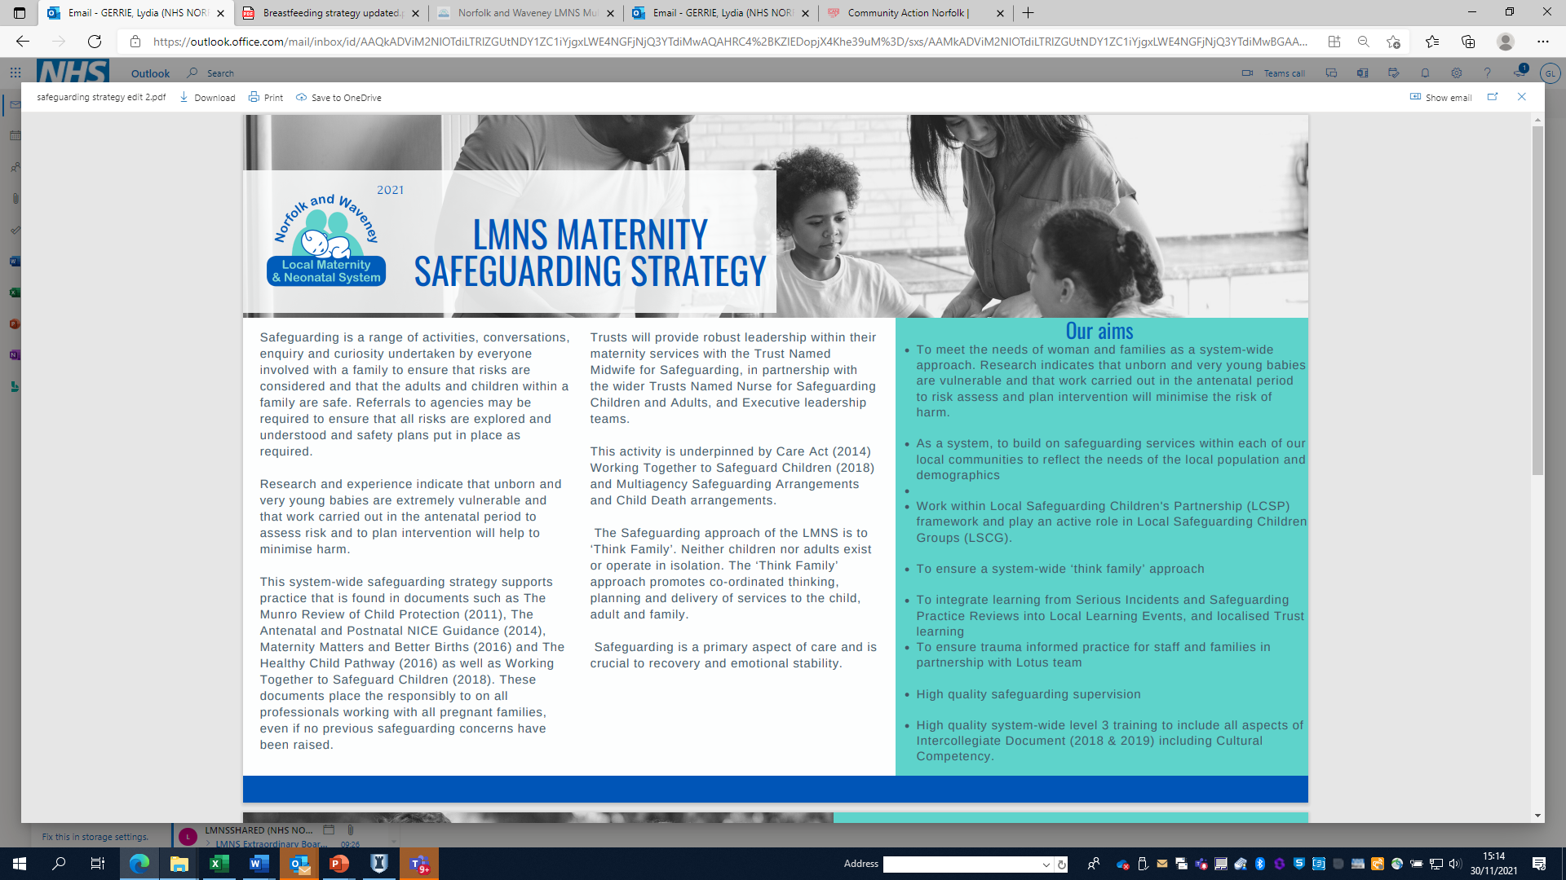
Appendix 9 Draft Safeguarding Strategy

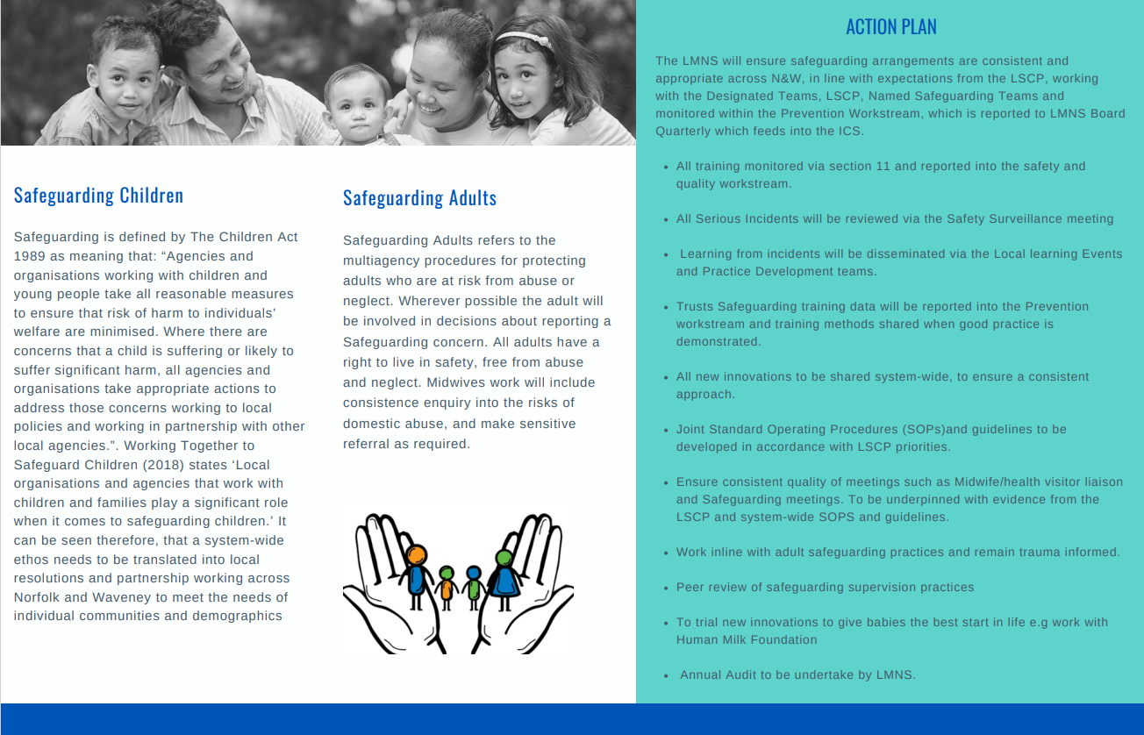
Appendix 10 Eden Team Migrant families and asylum seeker Guideline
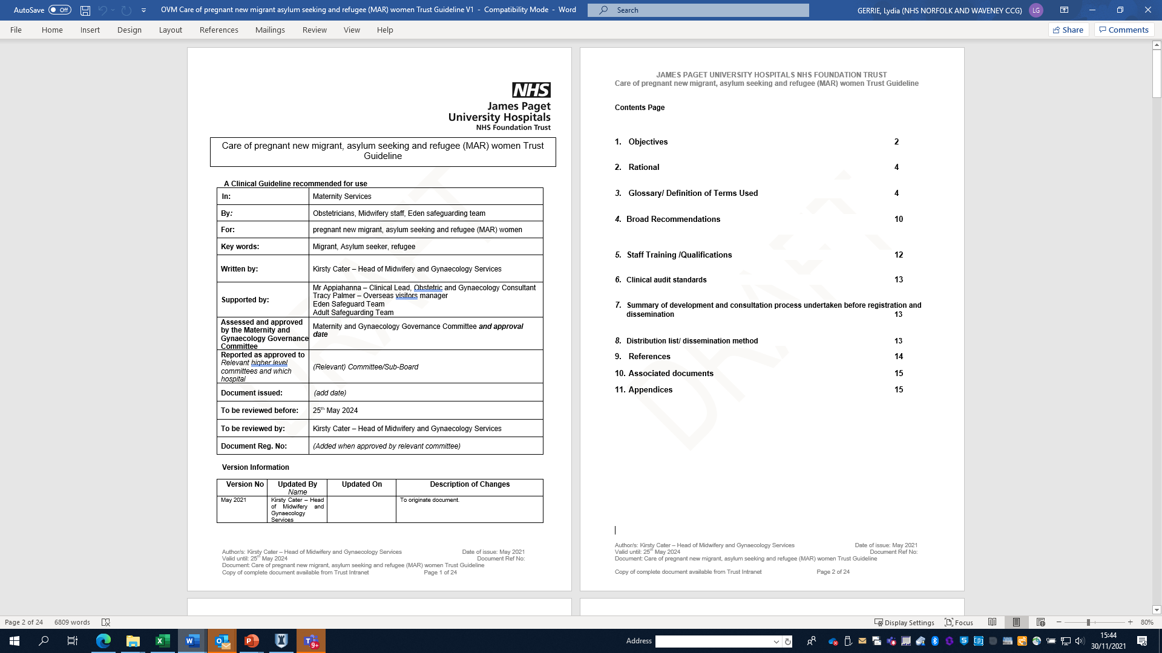

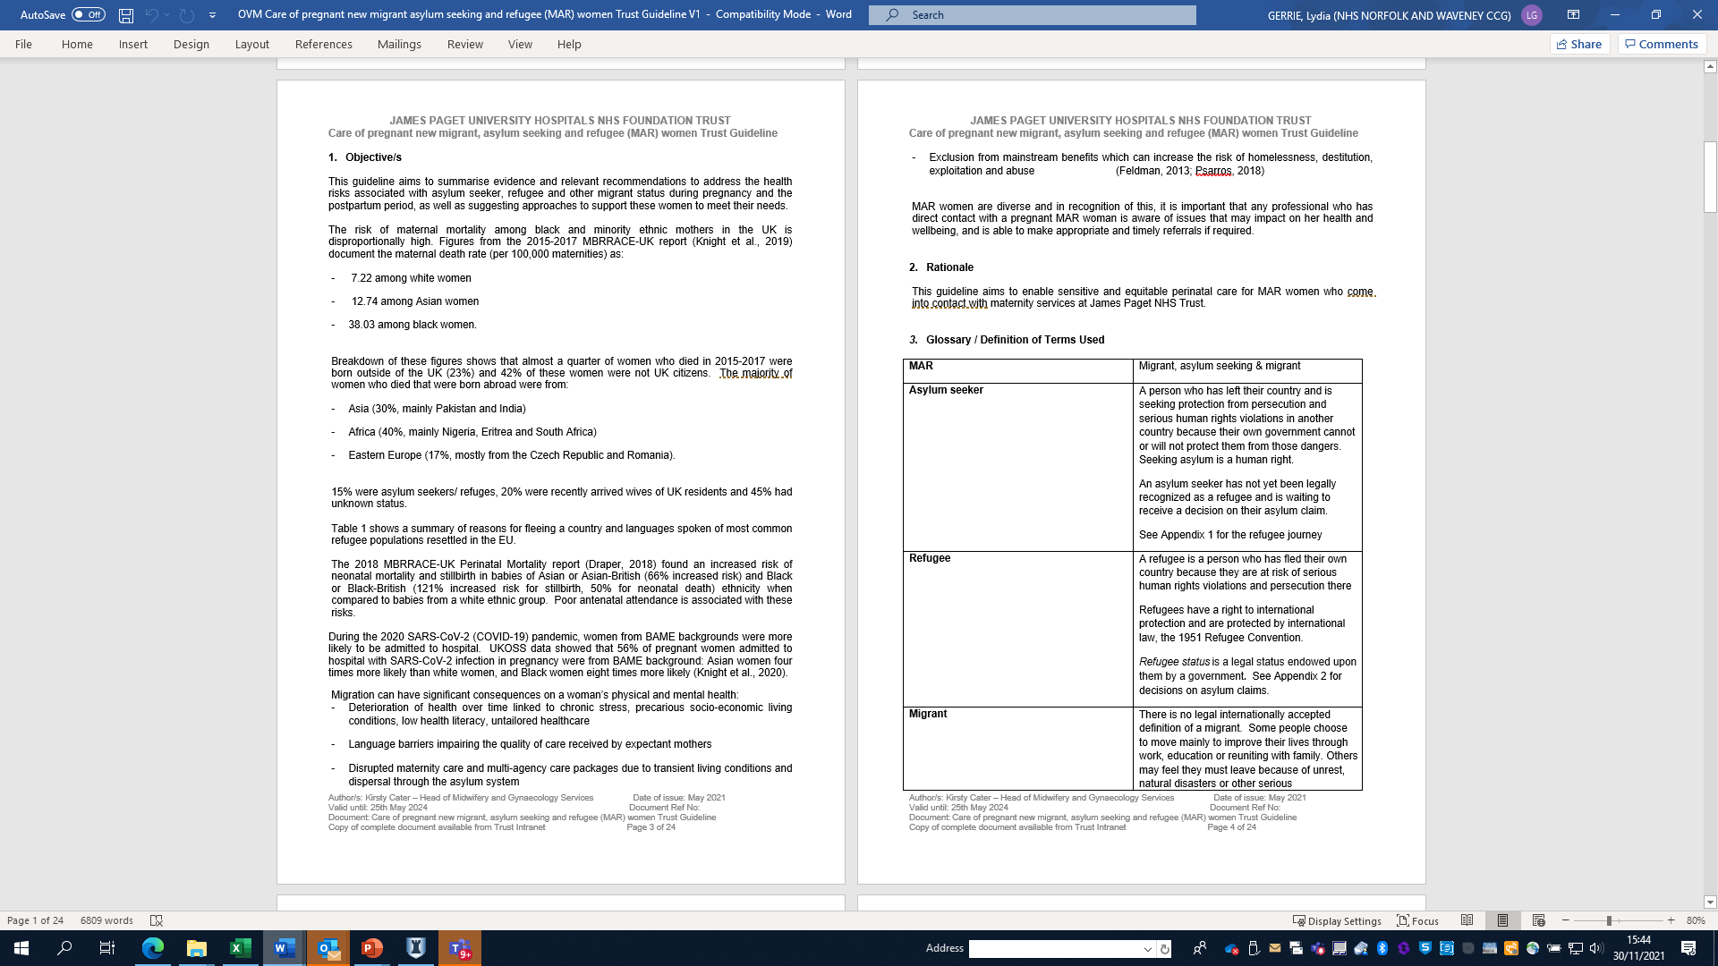

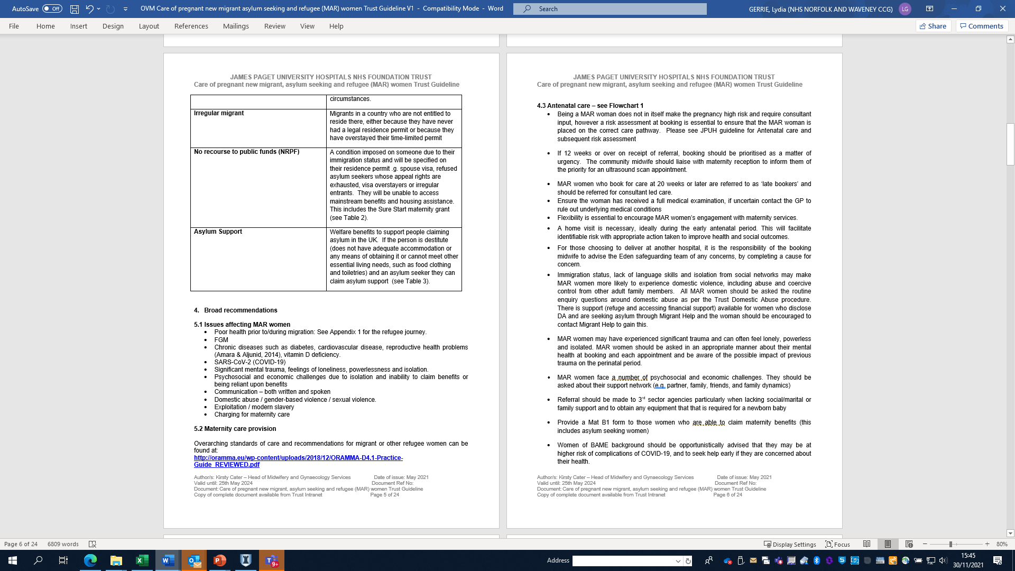

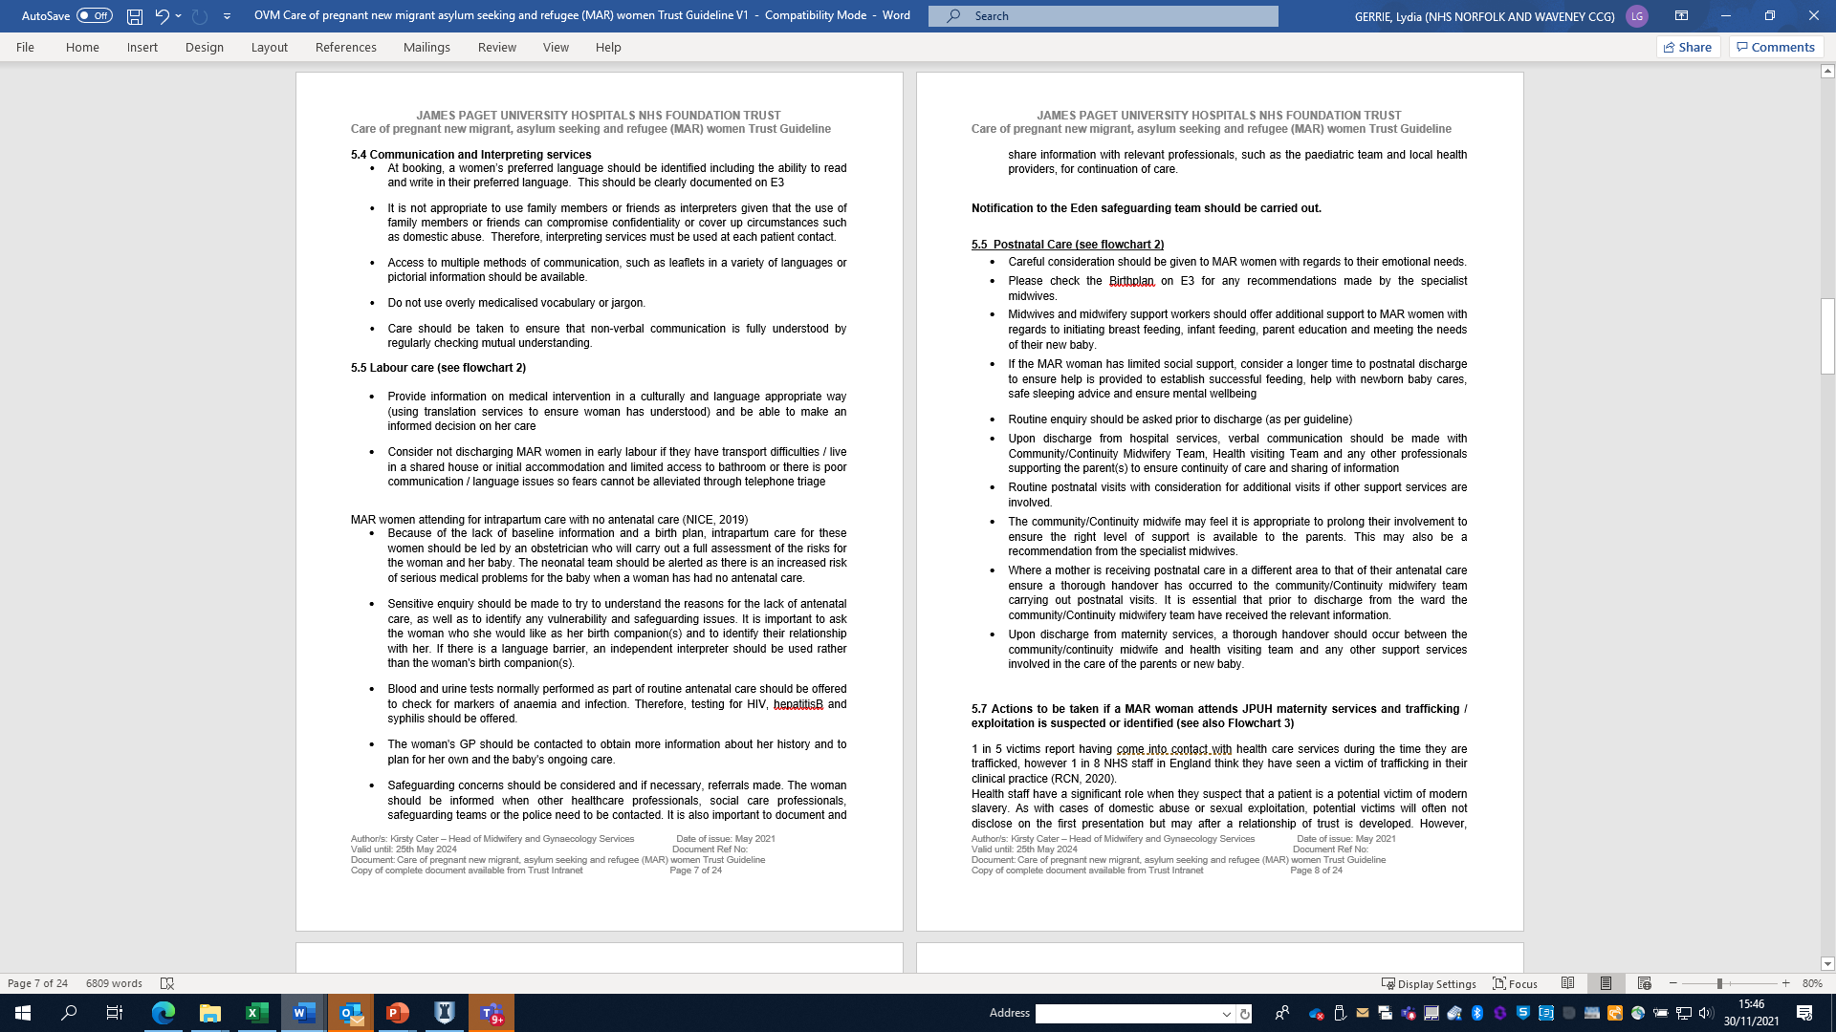

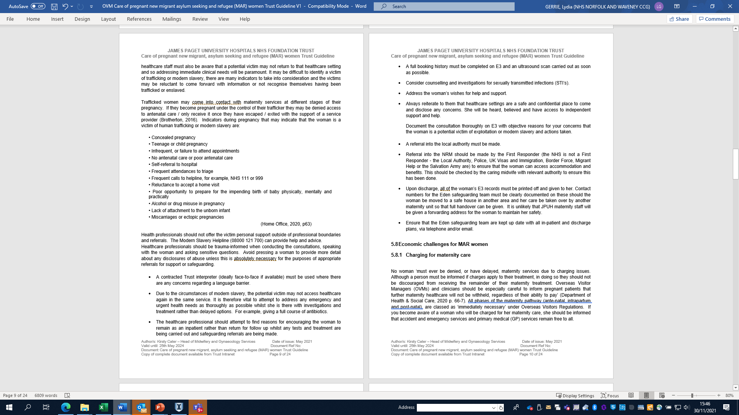

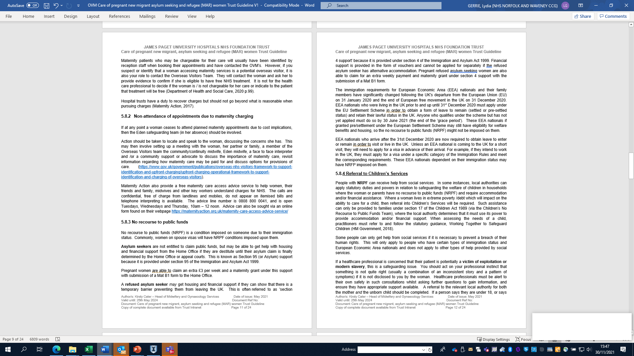

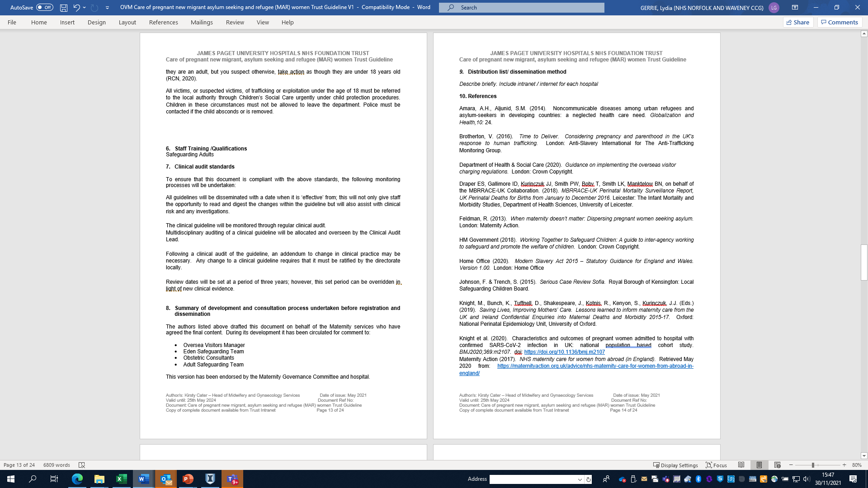

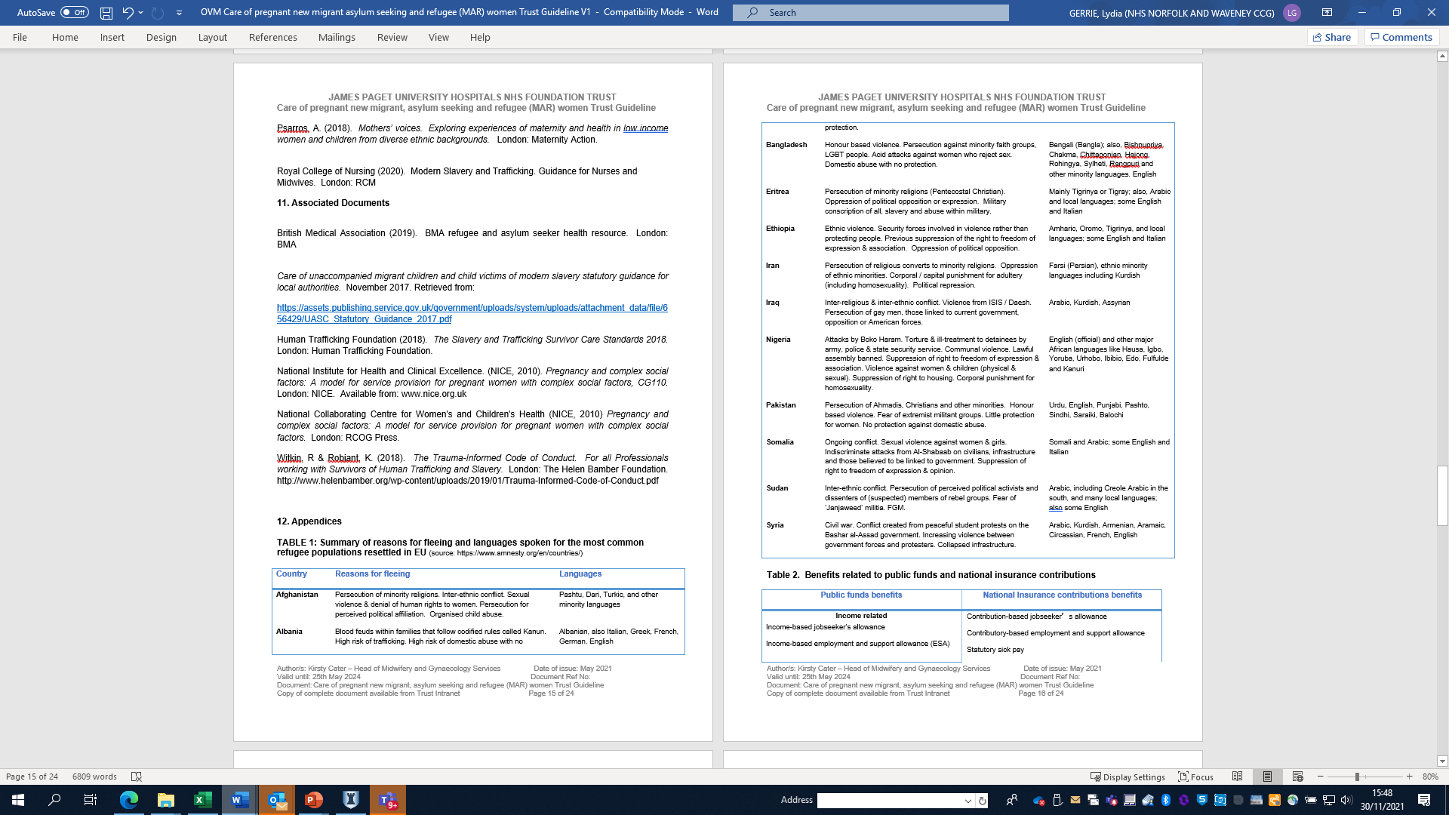

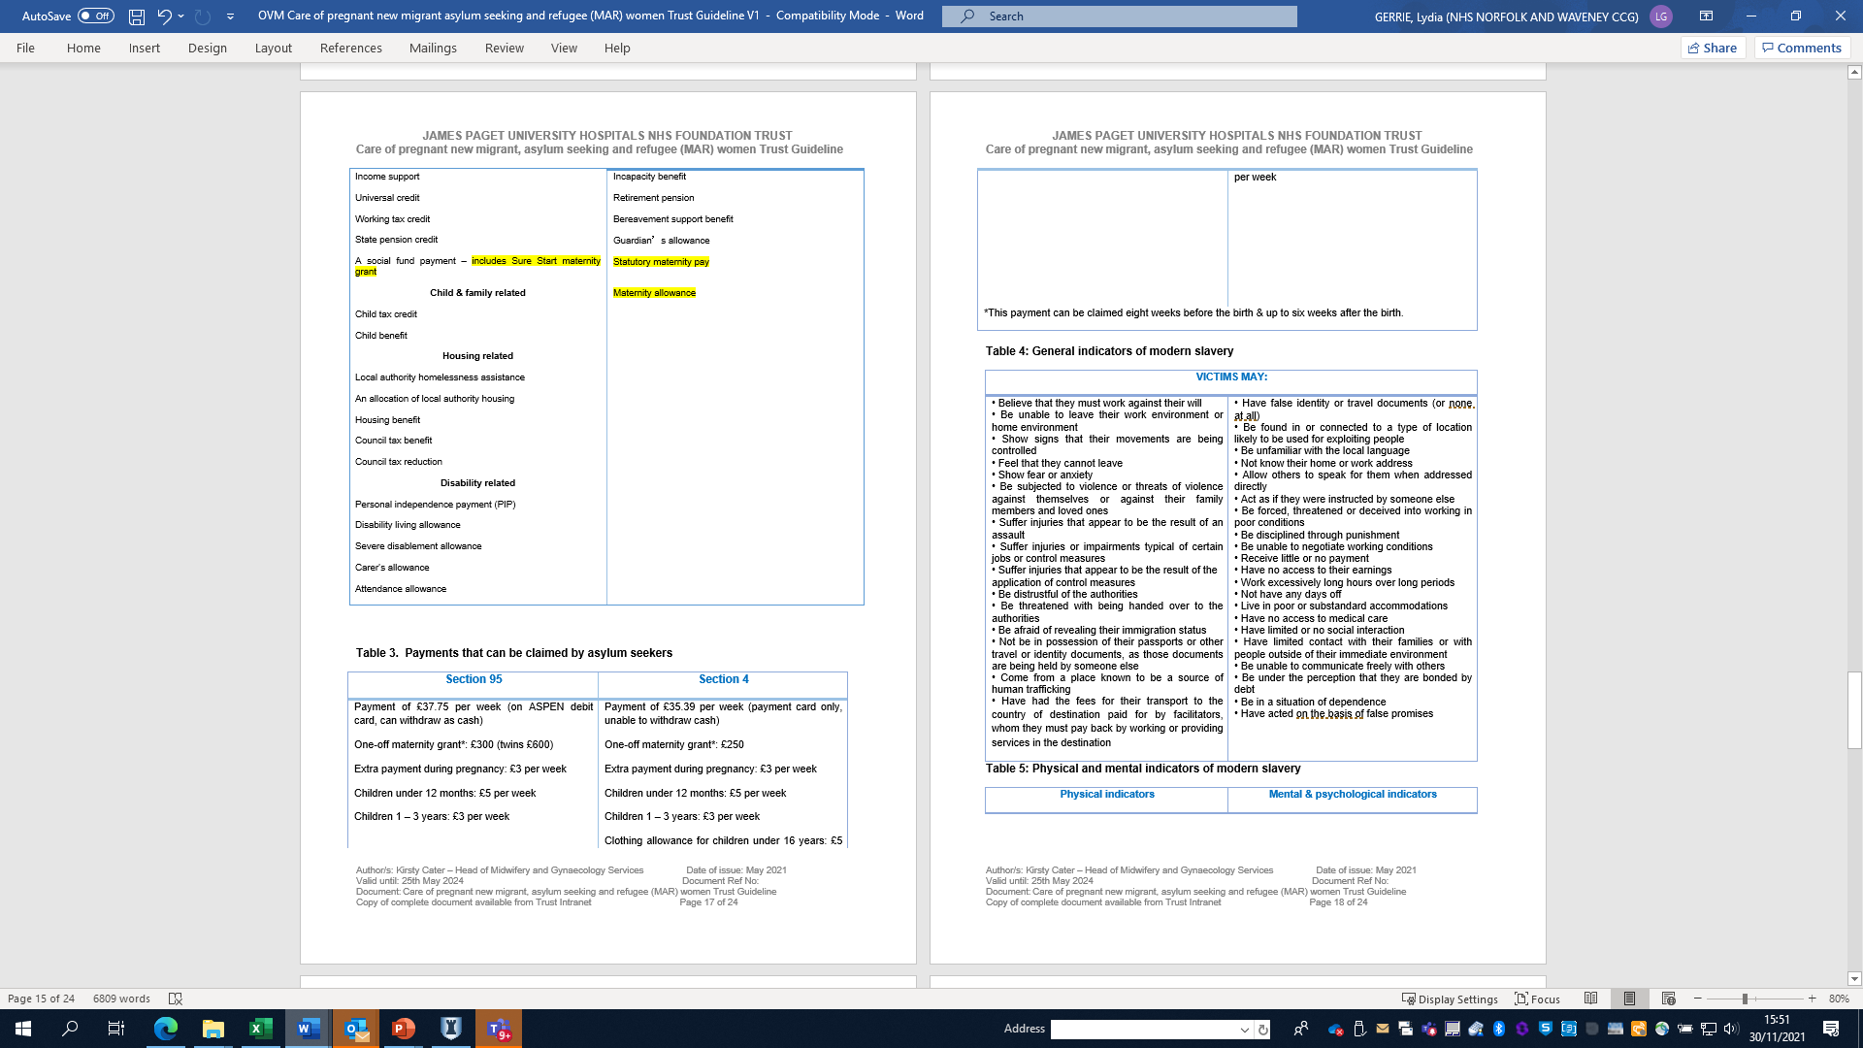
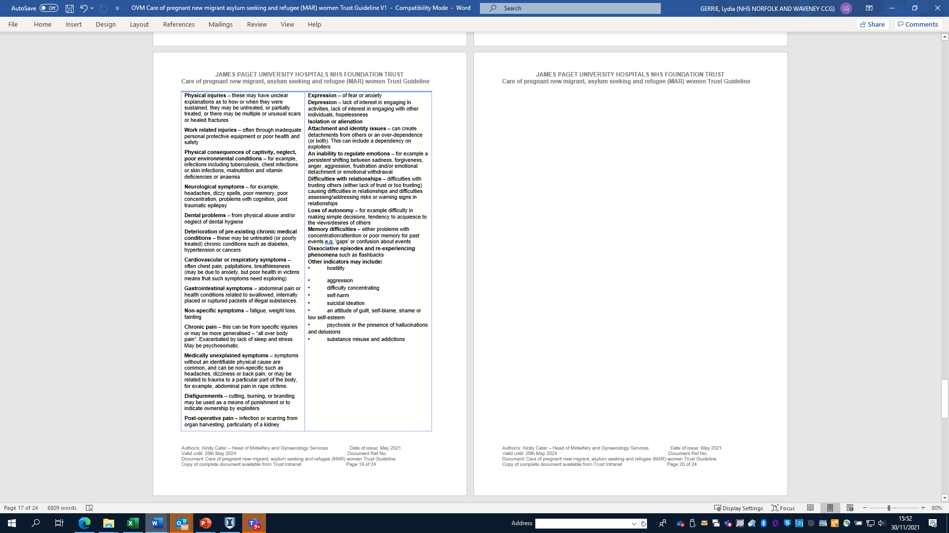
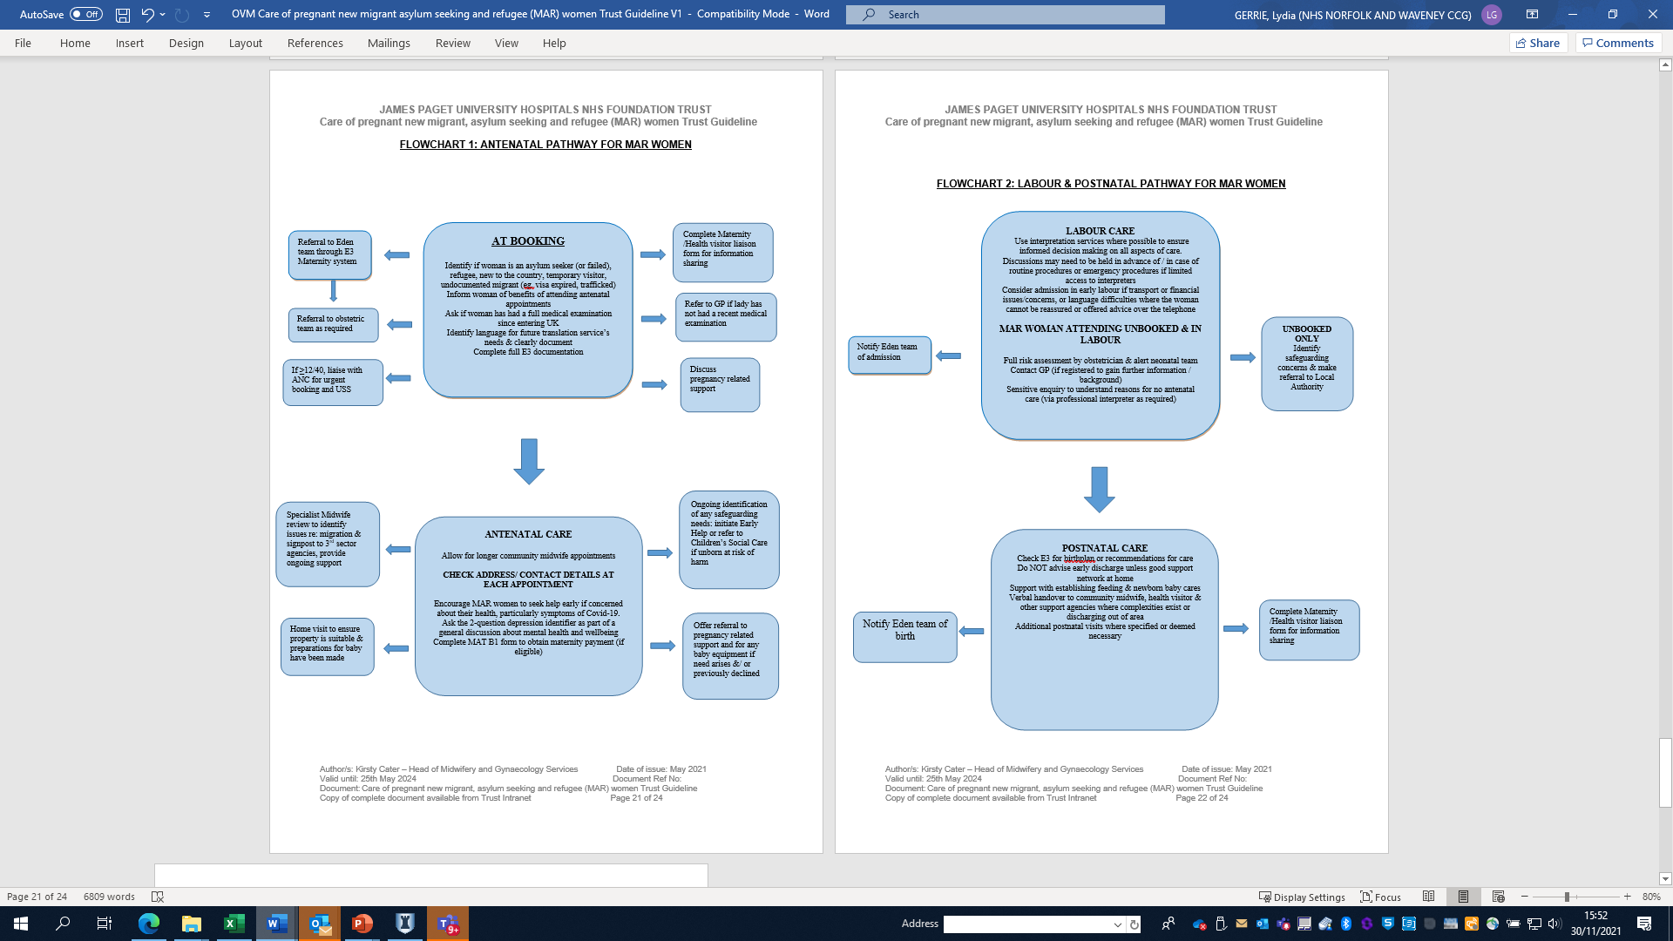

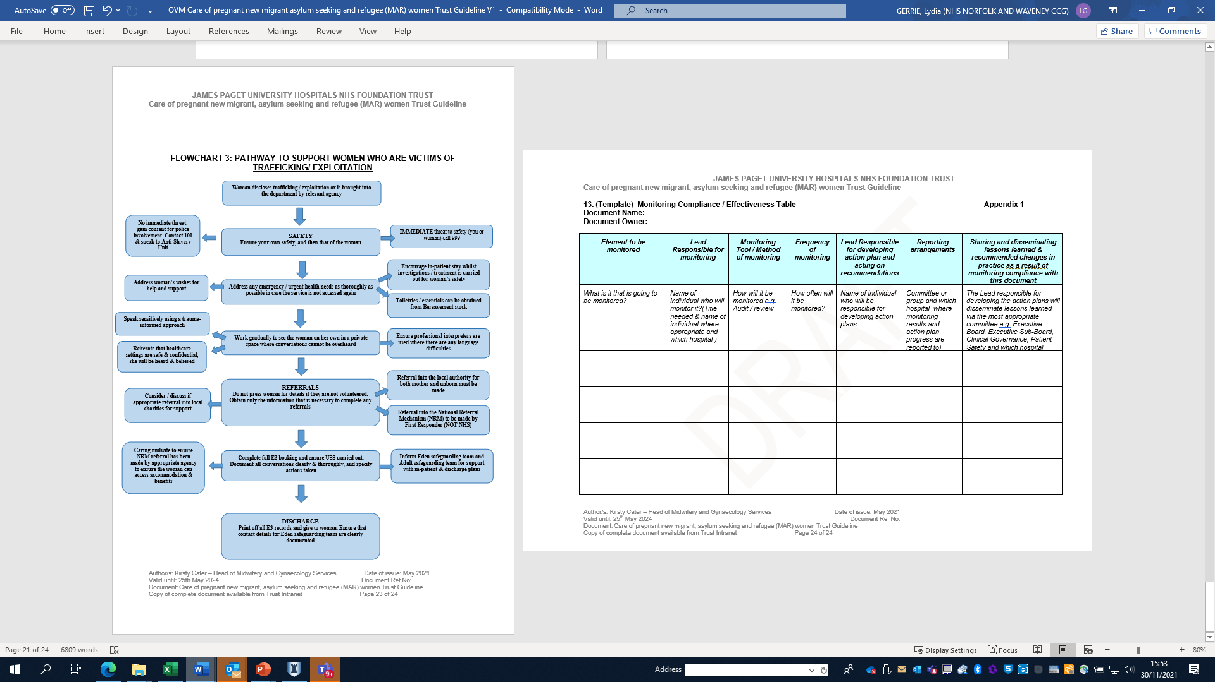

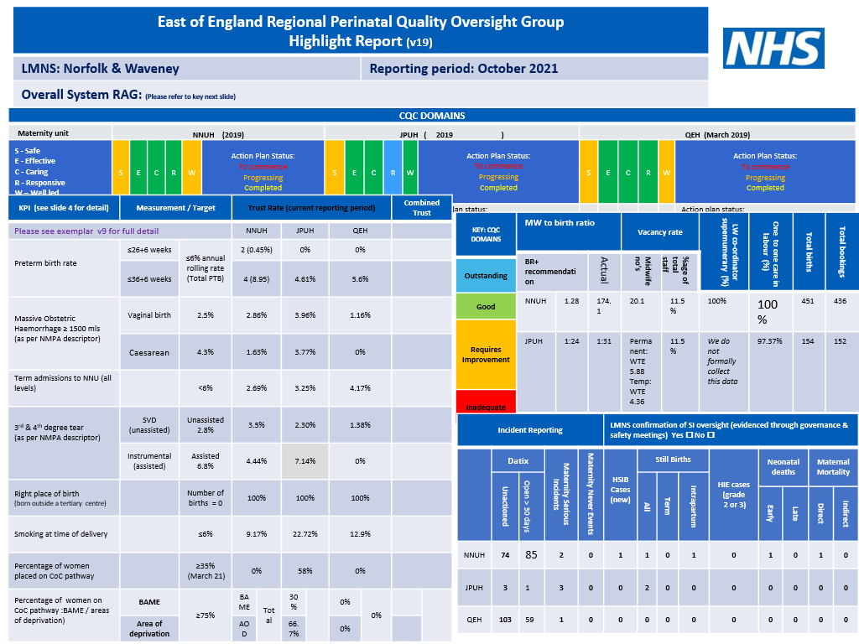
Appendix 11: RPQOG report

Appendix 12 LMNS Organogram
