Norfolk & Waveney LMNS Hub Strategy & Progress

Multidisciplinary community hubs that can accommodate low risk Midwife led community-based births are part of the programme plan deliverables for Local Maternity Systems (LMSs). Community Hubs are also planned for Primary Care and jointly these offer care closer to home for women across the N&W ICS System.

Since the start of the project in 2019, scoping of numerous sites has been completed for all x3 Trusts within the N&W LMNS (QEH, NNUH & JPH). Some have been successful; some have not been fit for purpose and some have been cost prohibitive either on refurb on recurrent costs.

As a brief overview, below is the current situation, not only for delivery of the traditional model of care but for the delivery of Continuity of Carer (CoC).

QEH have community hubs but have unsafe staffing levels to transition to the CoC model and therefore cannot move to the new model of care until staffing levels have improved. They are actively recruiting and are planning to roll out CoC in 2023.

JPH have established hubs and satellite clinics across much of their patch and currently delivering 85% Continuity of Carer. Scoping is in progress on a final facility to enable them to deliver 100% CoC by the end of 2022.

NNUH have one site that meets most of the hub requirements (opened June 2022) but, due to financial constraints and lack of community facilities (since coming out of GP practices during the pandemic), are currently unable to consistently deliver the NICE Antenatal Schedule of Appointments or CoC.

CoC is an NHSE deliverable as part of the Maternity Transformation Programme and NNUH lack of facilities is currently on the LMNS & NNUH risk registers. Community hubs are required in order to deliver Continuity of Carer.

Each Trust have made a different approach to facilitating community midwifery services. Below is a brief overview of current and expected provision.

Queen Elizabeth Hospital, King’s Lynn

QEH have successfully launched x3 standalone midwifery hubs based on footfall, areas of high deprivation and access. They also still operate out of a few GP practices as well as conducting normal home visits. The impact of the community hubs has been huge on the wellbeing of midwives and staff working from the buildings. As above, although the teams cannot deliver CoC at this time, they have space which is designed to deliver an effective, localised service to their pregnant women and their families using the traditional model of care.

The Wisbech Hub – Rowan

The QEH opened its first community hub in Wisbech in April 2019. The hub provides antenatal and post-natal care to around 800 women and their families with additional services including:

- ANC
- Pre booking clinic
- VBAC/T2T
- Smoking cessation midwife
- Anaesthetic clinic
- Feeding Class
- Whooping cough and flu vaccines
- Blood clinic
- Post-natal clinic Daily
- Perinatal mental health clinic
- Health visitor meetings
- Safeguarding meetings (core groups)
- Post-dates clinic

The St Augustine’s Hub – Maple

The QEH opened its second midwifery community hub in central King’s Lynn in April 2021 serving around 1000 women and families. The building sits within an area of high deprivation offering similar services to the Wisbech hub. The facility includes x5 clinic rooms, x1 quiet room, waiting area, reception, antenatal teaching space and office space.
Due to increased demand against capacity, we are currently scoping the expansion of this hub to facilitate an additional x3 clinic rooms downstairs by converting a large unused Art room. This will provide x5 clinic rooms on ground floor level. This will potentially allow for consultant led clinics to be conducted in the community using the upstairs rooms as well as space for other maternity linked healthcare providers, such as smoking cessation, perinatal mental health clinics, pelvic health, newborn hearing screeners, and health & nutrition promotion.

The Priory Centre Hub – Juniper

The QEH opened its third midwifery community hub in Downham Market in March 2022 serving around 450 women and families. The building includes x5 clinic rooms, waiting area, reception, antenatal teaching space and office space. Consultant led clinics are already running from the hub. It is joined to the local library and the two services have collaborated to provide more resource and access to various community services. The site is also being used to deliver perinatal mental health clinics, pelvic health and smoking cessation.

The three standalone hubs provide the space needed in most areas to cover antenatal/postnatal care. More rural locations are being served via a few GP practices or via home visits.

As part of the Wave4b PCT hubs project, QEH have submitted an SOA for space within the proposed hub. This project is still ongoing with regular steering group meetings. The current proposed site is Hardwick Road. Operational plans are scheduled for early to mid-2024. This will provide a further x3 clinic rooms and office space within a PCT building.

James Paget Hospital, Gorleston

JPH approached their hub provision by using a hub and spoke model in developing several main hubs alongside satellite hubs for their more remote women & families. JPH are currently delivering 85% Continuity of Carer. With scoping of one more facility, they hope to deliver 100% Continuity of Carer by the end of 2022.
They have hubs & satellite clinics in:

Lowestoft – Kirkley Midwifery Hub provides Continuity of Carer model of care for around 1000 women & families using x4 clinic rooms, waiting area/antenatal teaching space and small office space. Clinic room space is limited but is being used for satellite clinics for perinatal mental health, health promotion and pelvic health. One of the clinic rooms already has air conditioning installed, therefore there is potential to complete scanning from this site and this is being scoped.

Great Yarmouth – Nelson Midwifery Hub provides x3 clinic rooms for around x300 women, and a waiting area/antenatal teaching space within an existing GP practice. There is no capacity to facilitate other healthcare provision within the Nelson practice and no room to expand.

Halesworth – Single clinic room providing CoC to local women. Room rented from the Waveney Consortium and at a very small rent. There is also a large bookable meeting room for ‘meet the midwife’ and antenatal sessions.

Gorleston – Single clinic room within Seagulls children’s centre providing care to around 120 local women & families using CoC model of care. The room is being provided FoC in a reciprocal arrangement to improve Tier 2 referrals. This arrangement is working well. It also sits near a community shop and other children’s services.

Martham – Single clinic room within Martham & Trinity School children’s centre providing CoC to local women & families using CoC model of care. The room is provided at a very reasonable rent and helps to serve local women who could also have children at the school.

Beccles – Single clinic room within Beccles Medical Centre for one full day and two half days per week providing care to local women & families using CoC model of care. The room is provided at a very reasonable rent and helps to fill a gap in localised antenatal & postnatal care.

Future plans

Peggotty Road, Great Yarmouth – This building was brought to us from GYBC. It was previously a children’s centre and was in an ideal location. Unfortunately, it was cost prohibitive due to refurb and recurrent costs. It has now been discounted.

The Priory Centre, Great Yarmouth – This building is only just being scoped. However, it is in a prime location, potential for 3-4 clinic rooms, ample meeting/training room space and other bookable rooms for other healthcare provision. It has good transport links and free one hour parking nearby and two hours free parking at Sainsbury’s. Awaiting further lease details and costings to pursue further. If this proved suitable, there would be a cost saving via the Nelson facility as all care would move to the Priory Centre.

Shrublands - This building was part of the Wave4b PCT hub provision plans. JPH submitted an SOA back in early 2021. However, these are now being taken forward by other means via the N&W ICS who will be advertising for a third-party developer to deliver the scheme soon.

Norfolk & Norwich Hospital, Norwich

Establishing hubs has been challenging for NNUH due to funding for refurb, cost prohibitive rent for city central premises, locations to match footfall, areas of deprivation (see heat map below) and operational resources. A working group has now been established to address this with project management and business partner support. GP practices have been contacted as an ask for space to deliver the NICE Antenatal Schedule of Care, whilst the working group will look at long term provision of hubs to deliver Continuity of Carer. This is on the LMNS & NNUH Risk Registers.

GP collaboration- since coming out of GP practices there have been concerns raised from practices and midwives regarding unsafe care of pregnant women, i.e., concealed pregnancies, prescribing and anomalies. A task and finish group has been established to address this under the Data & Digital Workstream. Delyse Maidman (LMNS Lead Digital Midwife), supported by Karen Warrington (Project Manager) are leading on this. A solution has already been established to inform GPs they have a pregnant woman on the books. Access to EPRCore to give midwives read/write access to S1/EMIS is ongoing. If successful. This will give reciprocal vision of every woman’s antenatal pregnancy journey.

Bowthorpe – This is NNUH’s first midwifery hub and provides x7 clinic rooms for a large cohort of women and their families. This is an excellent facility for women, but NNUH still have a requirement for city deprived areas as well as outlying areas such as Fakenham, North Norfolk and South Norfolk.

A multitude of buildings have been scoped over the last 2.5 years. Many within the city boundaries carry prime city rents and therefore have proved cost prohibitive (See Appendix A attached). At least one more hub is required in the City Centre to provide full provision of midwifery services under the traditional model and CoC. The LMNS continue to seek support from the ICB and Primary Care Estates to offer up any suitable space.

Future Plans

The NNUH supported by the LMNS are developing a Business case to secure the required funding to support the future development of Hubs

Hoveton & Wroxham GP Surgery – NNUH currently have x1 clinic room and x1 office space within a designated maternity space within the practice. It has its own entrance. The lease is up for renewal in October 2023. Discussions have already commenced with the landlords, Primary Health Properties to look at the possibility of expanding provision. PHP also have other properties in East Anglia within their portfolio. Further scoping of other potential sites in Fakenham and Norwich are also being discussed. If expansion is not feasible, we have discussed a short-term rolling lease to facilitate antenatal provision of care.

North Norfolk – provision is required in North Norfolk. Discussions are under way with Holt Medical Practice to provide a single clinic room. Cromer Hospital does not have space but there is a possibility of a modular build for maternity using charitable funds. This is still under discussion and not yet agreed. Single clinic rooms were established within a podiatry practice within Sheringham, Aylsham, Fakenham and Norwich. Unfortunately, delays in securing these has meant the opportunity has been missed.

Fakenham – NNUH currently have space within the Fakenham Medical Practice, however this does not meet demand. After linking in with PHP, we are aware there could be potential additional space, and this is currently being scoped further.

South Norfolk – provision is required in South Norfolk. Satellite clinics are currently held in Long Stratton Medical Centre and Wymondham Medical Practice but there is no further space available. Wymondham is a huge area of development. PHP have a property in their portfolio in Wymondham and this is being scoped further.

Gurney Street, Norwich – short term lease has been agreed to facilitate face-to-face antenatal appointment provision.

Rackheath – This building is part of the Wave4b PCT hub provision plans. NNUH submitted an SOA back in early 2021. However, due to changes in NHS guidelines, this could no longer be funded by private investors and the N&W ICS have taken up this proposal to take forward a FBC. On meeting with the landlords NHS PS, they could not provide full financial background to the ongoing costs for the building and therefore, NNUH submitted a letter of withdrawal (Aug 22). The ICB are keen to re-
engage and meetings are currently ongoing to bring NNUH back into the proposal. This would be an NHS owned building providing bespoke facilities in a purpose-built, modern facility in an area of increasing demand for services.

Attleborough - This building was also part of the Wave4b PCT hub provision plans. NNUH submitted an SOA back in early 2021. However, these are now being taken forward by other means via the N&W ICS. They are currently waiting to hear back from the practice about the approach they wish to take with ICS support.

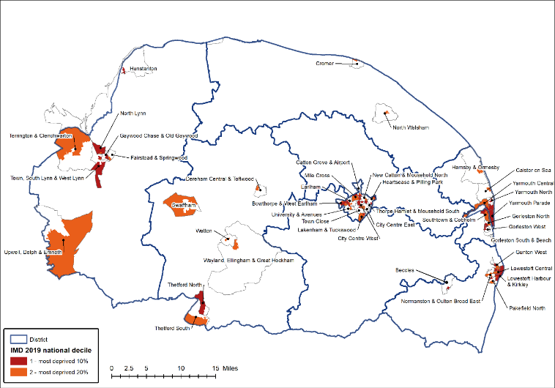
Norfolk & Waveney Heat Map showing areas of deprivation

