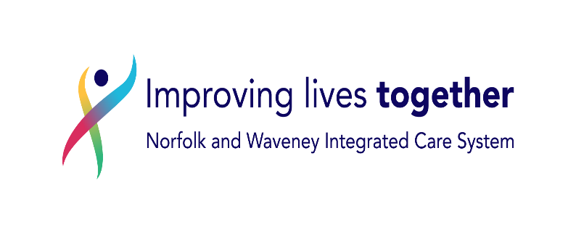

Dear <<fullname>> <<date2>>

RE: Support for those affected by dementia
We are writing on behalf of your GP practice, as your patient record shows you are living with a dementia diagnosis.

Your GP practice works as part of an Integrated Care System. That means the practice works with partners across health, social care, councils, and voluntary sector organisations to offer joined up, supportive care.

We aim to ensure that you and those who care about you receive the help, advice and information available to support physical and mental health and wellbeing.

We are writing to advise that a member of our Protect Now team will be contacting you in the coming weeks via telephone.

The team member will ask you if you would like your GP practice to offer you a follow up call.

The follow up call will be from the Social Prescriber working within your GP practice. They can talk to you or your carer about things like housing needs, social activities, financial benefits, equipment, local groups, activities, getting out and about and keeping active. The discussion will be individual to you and your carers needs.

If you prefer, you can access the questionnaire online at www.nhspatient.org. You can log in by adding your date of birth and your NHS number, which is listed below. The questionnaire can be completed in a few minutes and there are only three questions to be answered and only one if you would prefer not to be contacted.

Alternatively you can call us on 01603 257 258, leave us a message in our answerphone with your name, phone number and NHS number and we will call you back.

Your NHS number is: <<NHS number>>

If you or your carer decide a further discussion would be helpful and register that interest either with the call agent or by submitting your answers to the questionnaire in that link, a Social Prescriber will get back in touch within four weeks.

In the meantime, we have enclosed a “Worried About Memory” useful contact list which you or those who care for you may find helpful.

To check the authenticity of this letter, please search for Dementia letter on (Link where the letter is being saved on ICB website

Kind regards,

Dr James Gair on behalf of the North Norfolk Dementia Group

Support for those affected by dementia.
 | Why are you getting this letter?
 | 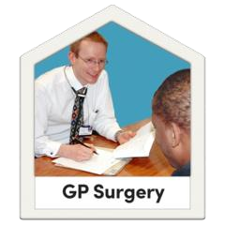   |  |  | Your GP (doctor) is working with partners across health, social care, councils and voluntary sector organisations to offer joined up, supportive care.  This is called an Integrated Care System (ICS).
 | www.nhs.uk/conditions/dementia/ |  |  | You are getting this letter because you have had a dementia diagnosis.
 |    |  |  | Protect NoW are a team of people in the local NHS who help doctors contact patients.  The local NHS Protect Now team will be contacting you in the coming weeks by telephone.
 |  |  |  | They will ask you if you would like a call from a social prescriber. This is someone who knows about information and advice.
What should you do after getting this letter?

  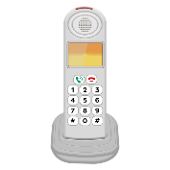   |  |  | Read the letter carefully.  You can wait for our team to call you.  Or you can go online and answer some questions.
 | 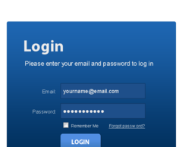 | If you want to go online please log on to this website: www.nhspatient.org
 |   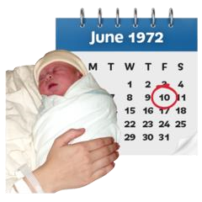 | You will need to put in:  - your NHS number  - your date of birth  You can find your NHS number in the letter we have sent you with this leaflet
 |  | Then click the button called ‘Go to My Homepage’
 |  | This will take you to an online form.  You can ask questions or get help.  You can ask to speak to someone.
 |  | It will only take you about 5 minutes to fill in the form
 |  | If you cannot fill in the form yourself, ask a family member or friend if they can help you
 | What do I do if I can’t fill in the form online?
 | 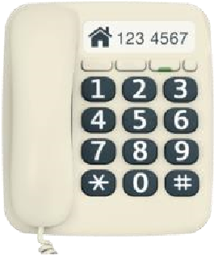 | Please phone: 01603 257 258  Leave a message on our answerphone telling us:  - your name  - your phone number  - your NHS number
 |  | A member of our NHS Protect NoW team will call you back and help you
 |    | Please only call the number above if you need help to fill in the form  We will not be able answer any other questions on this number
 |  | This letter was sent from Dr James Gair  I am a GP (doctor) in North Norfolk. I work with a group of health and care partners to support people who are living with dementia and their carers.

Worried about memory, attention, or concentration?
Here in North Norfolk, we understand how overwhelming it can be to notice changes with our own memory or difficulties with our thinking, or to see changes in those we care about.

In North Norfolk, there is a network of organisations here to listen, learn and provide support. Whether you just need someone to talk to about how you are feeling, or you want advice about anything from local groups through to the process of receiving a diagnosis of dementia and beyond; we are here to provide help and guidance.

Many of us experience memory difficulties of varying degrees and North Norfolk aspires to ensure that we provide inclusive, understanding, supportive neighbourhoods which help people to live longer, healthier, happier lives.

Clinical Services
If you are worried about dementia, diagnosis is via a Memory Assessment Process. Referral is via your doctor and they will talk you through the process.
Norfolk and Suffolk Foundation Trust provide this service. For more information contact: https://www.nsft.nhs.uk/service-details/service/north-norfolk-and-norwich-older-peoples-community-team-31/ or call 01603 421570 for more information.

Council Services
There can be a wait for a memory assessment, so looking after your health and wellbeing is important. The Social Prescriber at your GP practice is a great starting point for accessing advice and information, just ask your surgery for an appointment.

Your District Council can offer advice about things such as housing, finance, employment and benefits.
Norfolk County Council can advise on such things as social care assessments and equipment provision.
- North Norfolk District Council call 01263 513811 or visit https://www.north-norfolk.gov.uk/
- South Norfolk & Broadland District Council call 01603 431133 or visit https://www.southnorfolkandbroadland.gov.uk/help-hub
- Norfolk County Council call 0344 800 8020 or visit https://www.norfolk.gov.uk/care-support-and-health

Norfolk and Waveney Dementia Support Services
This service is provided as a partnership between Alzheimer’s Society, Dementia UK and Norfolk and Suffolk Foundation Trust. Dementia Advisors and Admiral Nurses work together to provide support from pre-diagnosis right through to end-of-life care planning.
- Call 01603 763556 or visit https://www.alzheimers.org.uk
Support Services in our Local Community
Overleaf are some of the local groups and resources available in our area. There are many more, but whoever you link with will be able to provide you more information about things such as activities, social groups, exercise, transport and carers support.
Take a listen – search for www.mixcloud.com/poppylandradio/community-connectors
Poppyland radio - Carers Support Show Poppyland Radio- Dementia Support Show

Social Groups and Activities | Contact/Details
CAMEO Dementia Café North Walsham  Furze Hill, 73 Happisburgh Road, North Walsham, NR28 9HD | 01692 502708  http://nwdementiasupportgroup.org.uk
Young Onset Dementia Group Southrepps  Southrepps Village Hall, Church Street, Southrepps, NR11 8NW | 01263 833397 https://sodotdotdot.org.uk
Holt and District Dementia Support  St. Andrews Meeting Room, Church St, Holt, NR25 6BB | 01263 713817 / 07760 462693 https://www.holtdementiasupport.org.uk
Sheringham Dementia Friendly Community | secretarysdfc@gmail.com
Singing Down Memory Lane Group  The Lighthouse, 62 Cromer Road, Sheringham, NR26 8RW | 01603 783556
Food for Thought Dementia Group  (Various venues) | 01692 403024 / 519277 https://foodforthoughtnorfolk.weebly.com
Sheringham CAMEO Group  St. Josephs RC Church Hall, Cromer Road, Sheringham, NR26 8RT | 01692 403024 / 519277 https://foodforthoughtnorfolk.weebly.com/sheringham-cameo-group.html
Salvation Army Sheringham  Cremer Street, Sheringham, NR26 8DZ | 01263 826059  sheringham@salvationarmy.org.uk
Forget Me Not Dementia Group Lessingham  Lessingham Chapel, Ingham Road, Lessingham, NR12 0TD | 01692 405591
Dementia Accessible Activities  St Andrews Methodist Church, Cromer Road, Sheringham | Tuesdays 10.00am – 13.00pm  Wednesdays 11.00am – 13.00pm
Forget Me Not Group Ludham  Church Room, Methodist Church, Ludham, NR29 5QT | 01603 678525
Forget Me Not Dementia Group Brundall  St. Laurence Centre, Brundall, NR13 5NA | 01603 715136 or 01603 715694
North Walsham Fish and Chip Group  The Sacred Heart RC Parish Hall, King’s Arms Street, North Walsham | 01692 403024 or 01692 519277  https://foodforthoughtnorfolk.weebly.com/north-walsham-fish--chips-group.html
Salvation Army Briston Friday Friends Group, Holt Road, Melton Constable, NR24 2HR | 01263 861645  briston@salvationarmy.org.uk
Local Transport Providers and Information
North Norfolk Community Transport | 01692 500840 https://www.nnct.org.uk/
Travel Norfolk Car Scheme | 0344 800 8020  https://www.norfolk.gov.uk/roads-and-transport/public-transport/travel-norfolk-car-scheme
Local organisations providing advice, information and practical support
Caring Together | 0345 241 0954 https://www.caringtogether.org/
Carers Voice | https://www.carersvoice.org
Age Concern North Norfolk  Cremer Street, Sheringham | 01263 821188  Day care centre plus bathing service, lunch club, laundry service and home meal deliveries
Local Exercise Schemes
Active Norfolk | https://www.activenorfolk.org/public
Everyone Active | https://www.everyoneactive.com

