Norfolk and Waveney Integrated Care Board (ICB)

Clinical and Care Professional Assembly

Terms of Reference

Revision History
Revision Date | Summary of changes | Author(s) | Version  Number
V1.0 18/10/22 | First Draft | Penny Emerson (PE)  Interim Programme Director CCPL | V1.0
21/10/22 | Incl. Dr Frankie Swords Amendments | PE | V2.0
24/10/21 | Amendments received from members of the CCTG | PE | V3.0
06/12/22 | Final Draft CCTG December - no changes | PE | V.4.0
06/06/23 | 6 month review, Dr Frankie Swords Amendments | FS | V.5.0

Approvals
Date | Body | Author(s) | Version  Number
06/12/22 | CCTG | PE | V4.0
16/12/22 | ICS EMT | PE | V4.0
15/06/23 | CCP Assembly
This document has been ratified by:

- INTRODUCTION

- Purpose of the Assembly

Our Clinical and Care Professional Assembly (CCPA) acts as the forum representing the voice of all clinical and care professionals across the Norfolk and Waveney Integrated Care System (ICS). It will act as a diverse critical friend for the Integrated Care Board (ICB) and Integrated Care Partnership (ICP) through which to sense-check ideas, plans and decisions made by the ICB which may affect the delivery, development and future clinical and care provision.

- FUNCTIONS
- Provides impartial clinical and care leadership and advice to the Norfolk and Waveney ICB and ICP. For example, in shaping ICS strategy and resourcing
- Draws on the skills of its members from diverse clinical and care backgrounds, independently of their professional background, banding or organisational base

- Identifies system clinical and care priorities to inform Provider Collaborative and Place CCP leadership groups, whose purpose and functions align with this group
- Promotes place-based clinical and care professional leadership, the use of evidence-based innovations in health and care and the use of health analytics to address local health and care needs

- Provides links to wider clinical and care structures; East of England and national clinical and professional bodies to consider local application of external work, drive innovation and apply research

- Supports the implementation of the system Clinical and Care Professional Leadership Framework, ensuring that the Clinical and Care Professional Council (CCPC) takes forward the work of the CCPA between Assembly meetings

- Ensures Clinical and Care Professionals are engaged, involved and invested in the vision purpose and work of the ICS

- Provides clinical and care leadership and views on system-wide service transformation proposals or significant changes to clinical models prior to their approval at ICB/ ICP Boards.

- Aligns to the work of the other system consultative forums; VCSE Assembly and Patient and Citizens Assembly and acts upon feedback from representatives which relate to the delivery of the aims of the ICS

- Ensures the system develops robust clinical proposals, being cognisant of safety and effectiveness and that the rationale underpinning financial assumptions are clinically sound

- Highlights risks regarding quality of care, feeding these into the appropriate risk and quality management systems

- DelegatED AUTHORITY

The CCPA acts as a consultative forum to the Integrated Care Board (ICB) and Integrated Care Partnership (ICP).

- Membership AND ATTENDANCE

The Assembly members taken from the following CCP Groups (though not necessarily one per group) following nominations from system partners
- Chair: ICB Executive Medical Director
- Deputy Chair: ICB Executive Director of Nursing
- ICB Deputy Medical Director
- Local Authority representative
- Mental Health representative
- Care sector representative
- Allied Health Professionals representative/s
- Public Health representative
- Healthcare Science representative
- Dentistry, Optometry and Community Pharmacy representative/s
- Medical - Primary Care representative
- Medical - Acute, Community and Ambulance Trusts
- Nursing – Primary Care / General Practice representative
- Nursing - Acute Community and Ambulance Trusts
- ICS Clinical lead for Health Inequalities

Nominated Deputies, identified by the Assembly member, to cover absence. Others may attend as observers, including Partner Organisation non-Executive Directors

Confirmed Members

Name | Role | Organisation
Dr Frankie Swords | ICB Executive Medical Director (Chair) | ICB
Tricia D’Orsi | ICB Executive Director of Nursing | ICB
Jenny Blades  Beverly Chambers | Head of Operations and Partnerships  Operations and partnership manager Waveney | SCC x 2
Helen Thacker  Faye Gower-Smith  Simon Baugh | Head of Service - Safeguarding  OT Professional Lead  Interim operations director North | NCC x3
Tracey Fleming | ICB AHP Lead  & Clinical Support Services Director NNUH | ICB
Stuart Lines | Director of Public Health | NCC
Jay Lingwood | HealthCare Science Lead | JPUH
David Standerwick | Senior Clinical Pharmacist | GY Northern Villages PCN
Dr Hilary Bryne | GP | Attleborough Surgery and ICB partner member
Dr Bernard Brett | Deputy Medical Director and chair of EoE Clinical Senate | NNUH and EoE Clinical Senate
Dr Venu Harilal | Medical Director | NCHC
Callum Metcalfe-O'Shea | ANP (Primary Care) & Diabetes Practice Nurse Forum | Thorpewood Medical Group
Kate Spence | Professional Clinical Lead | ECCH
Tracey Williams | Practise Nurse and Clinical lead for Health Inequalities | ICB
Dr Heidi Grant | Junior Doctor Forum Chair | QEHKL
Dr Zeyn Green Thompson | Consultant Psychiatrist | NSFT
Angela Steggles | Care Home CEO | Thornage Hall Independent living
Dr Andy Griffiths | Deputy Medical Director | ICB

- MEETING QUORACY

Whilst the CCPA is an enabling group, there may be occasion where a decision is required to provide a recommendation to the Integrated Care Board.

A quorum for decision making must include the Chair or Deputy Chair,
and at least one representative from each of the following organisations/sectors:

- Primary Care
- Secondary Care
- Local Authority / other community care provider

And at least one representative from the following clinical and care professions:

- Doctor
- Nurse
- AHP or healthcare scientist
- Social Care

- THE CCP COUNCIL

This group is the operational delivery group supporting the CCP Assembly and wider CCP leadership. It will focus on implementing the CCP Framework and Manifesto commitments. Its membership and terms of reference will be developed once the deputy Medical Director has started in post (due August 2023) and will be shared with the CCPA in due course. Once established, the CCP Council will provide a quarterly update report to the CCPA.

- BEHAVIOURS AND CONDUCT

Ways of Working

- Works in an open and transparent way, ensuring the advice it gives is evidence-based and in the best interests of the Norfolk and Waveney population
- Captures system-wide views, knowledge, skills and experience
- Finds ‘system thinkers’; innovators, experts and respected leaders within the ranks of CCPs
- Supports wider CCPs to communicate their contribution, so their voice is heard and integrated into the leadership structure
- Recognises primacy of Place and the principle of subsidiarity: ensuring CCPs working alongside communities at Place are heard
- Identifies the next generation of CCP system leaders
- Supports collaborative approaches to co-production of new leadership initiatives and opportunities, building on current work already in progress

Equality and diversity

Members must demonstrably consider the equality and diversity implications of decisions they make.

- DECLARATIONS OF INTEREST

All members, ex-officio members and those in attendance must declare any actual or potential conflicts of interest which will be recorded in the minutes. Anyone with a relevant or material interest in a matter under consideration will be excluded from the discussion at the discretion of the Committee Chair.
If the Chair has a conflict of interest then the co-chair or, if necessary, another member of the Committee will be responsible for deciding the appropriate course of action.

- SECRETARIAT AND ADMINISTRATION
The Assembly shall be supported with a secretariat function which will include:

- Collation of papers
- Recording of minutes
- Recording of decisions, actions and issues to be carried forward
- Recording conflicts of interest
- Minutes, action log and agendas to be circulated 5 working days prior to each meeting

- MEETING COVERNANCE

The meetings of the CCPA are to be held monthly. Terms of reference will be reviewed by the CCPA on a regular basis in the first year and no later than June 2023 , following which, review will take place annually

This is a consultative forum and as such is not formally required to provide assurance to the ICB.

However, a six monthly progress report of this meeting and progress against delivery of the CCP manifesto will be provided to the People Board, with an annual report on Clinical and Care Professional leadership also provided to the Remuneration, People and Culture Committee of the Integrated Care Board.

Appendix 1
ICB Decision Making Framework

The current ICB Decision Making framework is set out below. However, this is subject to change during the ICB restructure, and as Provider Collaboratives and Places develop and are incorporated into the overarching decision making structure.
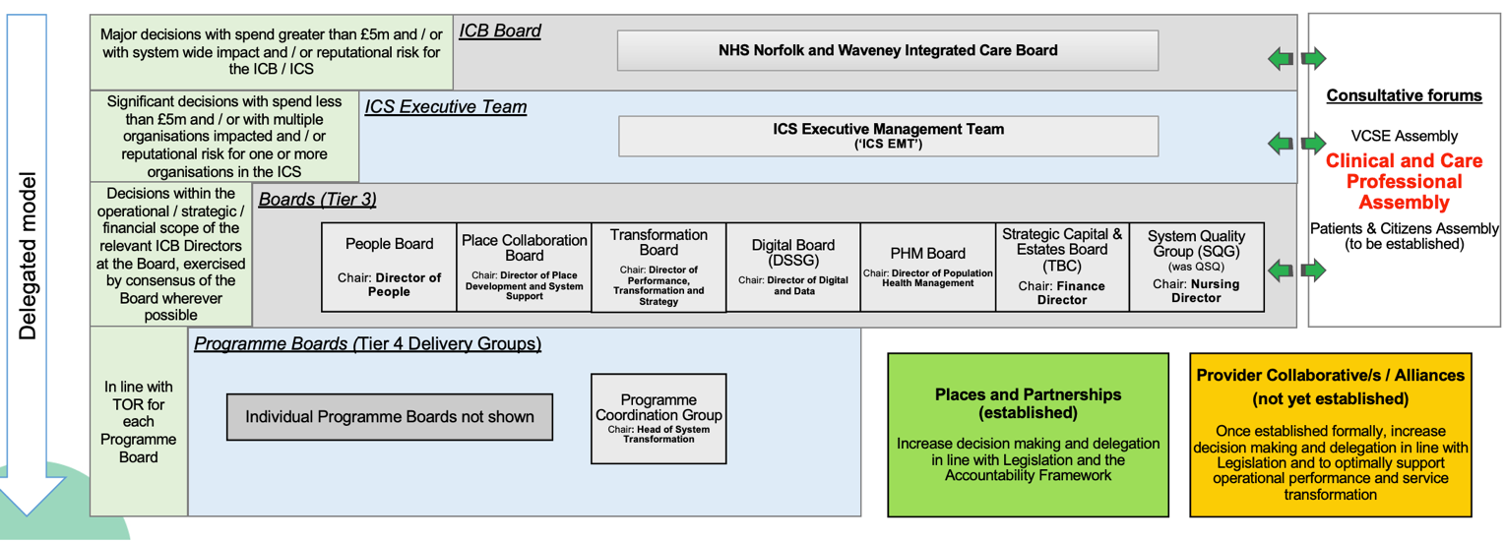

Appendix 2
Standard Meeting Agenda
CCP assembly meeting agendas will follow the following standard template:
11.00 Welcome and Introductions
11:05 Notes and open actions carried over from last CCPA
11:10 Declarations of interest
Clinical and Care Strategic items
11:15 Main agenda item: to review system-wide service transformation proposal / any potentially significant changes to clinical models / progress against CCP manifesto in line with forward planner
12:00 CCP Showcase
Each month a different assembly member will be invited to share examples of where the CCP voice has influenced decision making, and has led to meaningful change
12:20 What went well, even better if…
Reflections and feedback on the meeting
12:25 AOB
12:30 Close

Date of approval: 16/12/22
Date of review: April 2023

