<<Date4>>

Dear <<Title>> <<First name>> <<Surname>>

GP practices and the local NHS in Norfolk and Waveney are currently reviewing how we best support people at risk of type 2 diabetes and hypertension for which you have been identified and we are there for getting in touch to bring to your attention the Active NoW programme that could bring you benefits in your health and lifestyle.

The Active NoW programme is designed to help you with accessing opportunities to be active, and build movement and activity into your routine, which can help you reduce your diabetes risk or hypertension risk.

Please note your records DO NOT indicate you have Diabetes.

Taking action as early as you can is really important in protecting your health and quality of life for the future. You may have already been thinking about improving your health - now is the right time to start making healthier choices and changes, and we want to support you.

We would like to offer you the opportunity to access the Active NoW service, where you will be able to pick up an initial conversation with Active NoW’s trained call handlers about opportunities to be active that meet your individual circumstance.

If you would like to be referred to ‘Active NoW’, please complete the online questionnaire – details of how to do this are below. ‘Active NoW’ is a fantastic way to make the lifestyle changes now that could prevent diabetes and other long-term conditions, helping you to stay healthier for longer. Your GP is aware that this letter has been sent to you and we really hope you will take advantage of this opportunity to reduce your future diabetes risk.

If you would like to check the authenticity of this letter, then please do visit the Norfolk and Waveney Integrated Care System website at Active NoW - Norfolk & Waveney Integrated Care System (ICS) (improvinglivesnw.org.uk)

Completing the online questionnaire - your NHS number is: <<NHS number>>

- Go to www.nhspatient.org and enter your NHS number (above) with your date of birth and click the button that says ‘Go to My Homepage’ to access your secure NHS Portal. The questionnaire will take less than 5 minutes to complete. If you cannot do this yourself, please ask a family member or friend to help. If you are unable to access or complete the questionnaire, a member of our Virtual Support Team will follow up the letter with a phone call to assist you in completing the questionnaire and to offer any further support. If you do not wish to participate, please let the call handler know and this will be recorded so you are not contacted again.

- If you would prefer to leave a voice message, please call us on 01603 257 256 and leave your name and telephone number and a member of the team will then call you back to assist. The purpose of this phone line is to assist those who need help in completing the questionnaire, it is not a general enquiries number.

- If you are unsure whether the Active NoW service is suitable for you, please contact your local doctor / GP to discuss this with them.

Once you have completed the questionnaire you will receive a call from an Active NoW Adviser. They will leave a voice message and contact details if you do not answer.

Kind Regards

Clare

Dr Clare Hambling
GP Clinical Lead for Diabetes
Norfolk and Waveney

On behalf of the following GP practices: Hellesdon Medical Practice, Lawson Road Surgery, Prospect Medical Practice

NHS Active NoW Programme


What is the Active NoW Programme?

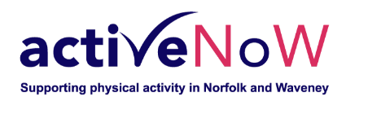 | ‘Active NoW’ is the name of an NHS prevention programme to help with access to opportunities to be active.
 | It will help you to do things that will reduce the risk of you getting Type-2 diabetes
 | The ‘Active NoW’ programme has activity advisors  They will help you to find the right type of activity for you.
 | Your GP (doctor) has told us that you DO NOT have diabetes  BUT your doctor thinks you have a bigger risk of getting Type-2 diabetes or decline of your health.
  X | People who have Diabetes or Hypertension are more likely to be very ill if they get Coronavirus (Covid-19)
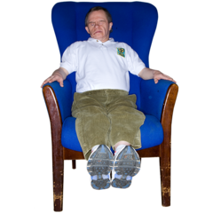    X | It is likely that you can stop yourself getting Type-2 diabetes if you make some changes to things like:  - what you eat  - how much exercise you have
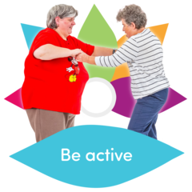   | The ‘Active NoW’ programme can help you to make changes to how active you are so you don’t get Type-2 diabetes
 | We would like you to answer some questions on a form called:  Active NoW questionnaire
This is how you fill in the form

 | Please log on to this website:  www.nhspatient.org
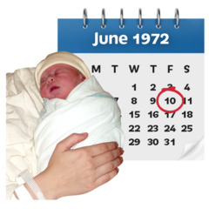   | To open the form you will need to put in:  - your NHS number  - your date of birth  You can find your NHS number in the letter we have sent you with this leaflet
 | After you have put in your NHS number and your date of birth, click the button that says ‘Go to My Homepage’  This will open the form in a safe NHS page
 | It will only take you about 5 minutes to  fill in the form
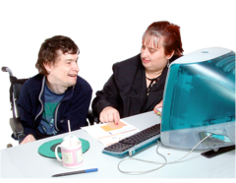 | If you cannot fill in the form yourself, ask a family member or friend if they can help you

Here’s what you should do if you can’t
fill in the form online

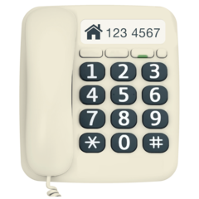     | Please phone: 01603 257256  Leave a message on our answerphone telling us:  - your name  - your phone number  - your NHS number
 | A member of our NHS team will call you back and help you
What happens after you have filled in the form and answered the questions?

 | After you have answered all the questions, we will be able to help you to get support with how active you are.

