Social Media Messaging from Monday 6 November 2023 – Sunday 12 November

Post/Time | Post Copy | Artwork
1  Date/Time | FACEBOOK:  We’re supporting #PoppyDay. The Census 2021 shows there are over 40k people in Norfolk (just over 30k in Suffolk) who had previously served in the UK Armed Forces. Identifying veteran and serving patients as soon as possible is vital for getting them and their families the support needed to ensure best outcomes. NHS Norfolk and Waveney ICB is proudly supporting those who serve by signing the Armed Forces Covenant.  https://improvinglivesnw.org.uk/our-work/working-better-together/supporting-armed-forces-and-veteran-healthcare/  TWITTER:  We’re supporting #PoppyDay. Identifying patients who are part of the armed forces community as soon as possible is vital for getting them and their families the support they need. NHS Norfolk and Waveney ICB is proudly supporting those who serve by signing the Armed Forces Covenant. Take a look & please #share. #PoppyDay @DRM_Support  https://improvinglivesnw.org.uk/our-work/working-better-together/supporting-armed-forces-and-veteran-healthcare/ | 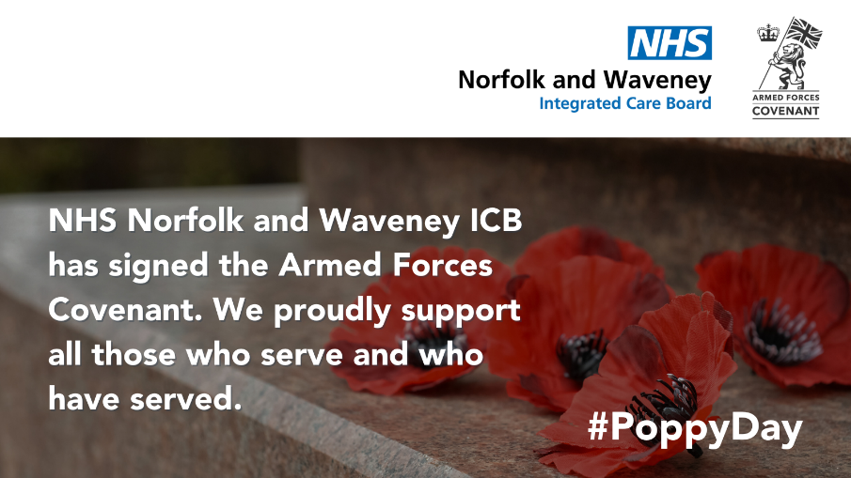  Link image to: improvinglivesnw.org.uk/~documents/route%3A/download/888/
2  Date/Time | FACEBOOK:  We’re supporting #PoppyDay. The Census 2021 shows there are over 40k people in Norfolk (just over 30k in Suffolk) who had previously served in the UK Armed Forces. NHS Norfolk and Waveney ICB is proudly supporting those who serve by signing the Armed Forces Covenant and promoting employment schemes aimed at the Armed Forces Community.  https://improvinglivesnw.org.uk/our-work/working-better-together/supporting-armed-forces-and-veteran-healthcare/  TWITTER:  We’re supporting #PoppyDay. NHS Norfolk and Waveney ICB is proudly supporting those who serve by signing the Armed Forces Covenant and promoting employment schemes aimed at the Armed Forces Community. Take a look & please #share. #PoppyDay @DRM_Support  https://improvinglivesnw.org.uk/our-work/working-better-together/supporting-armed-forces-and-veteran-healthcare/ | 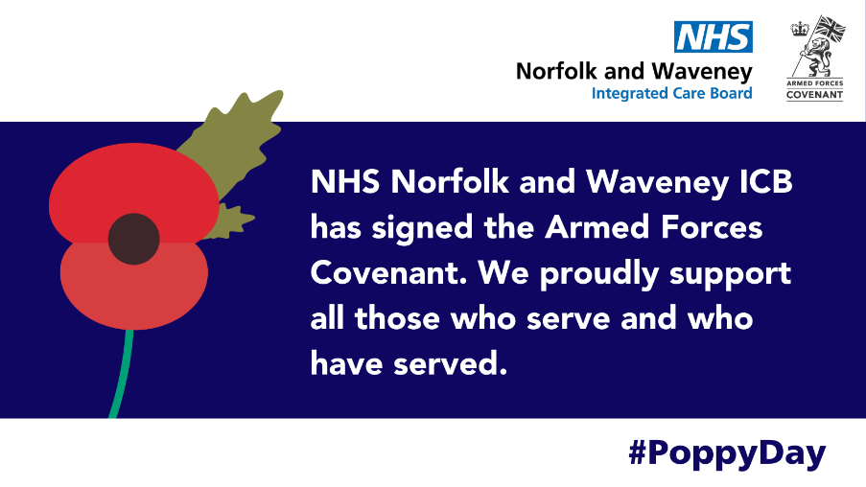  Link image to: improvinglivesnw.org.uk/~documents/route%3A/download/888/

