Community Voices Women’s Health Project

Introduction
In response to NHS England’s Women’s Health Strategy (2022), Norfolk and Waveney Integrated Care Board identified key priorities around training and education related to Long-Acting Reversible Contraception (LARC) and menopause awareness, with a particular emphasis on reaching women from under-served communities.
Building on the success of the Community Voices bowel cancer project, additional funding was secured through the Innovation for Healthcare Inequalities Programme (InHIP) to develop the Community Voices Women’s Health project.
Based on the trusted communicator model the aim of this project was to proactively engage women aged 40–60 from under-served communities, listen to their experiences of care and to increase awareness and improve access to support around:
- Breast, bowel, and cervical cancer screening
- Menstrual health and menopause
- Sexual health services
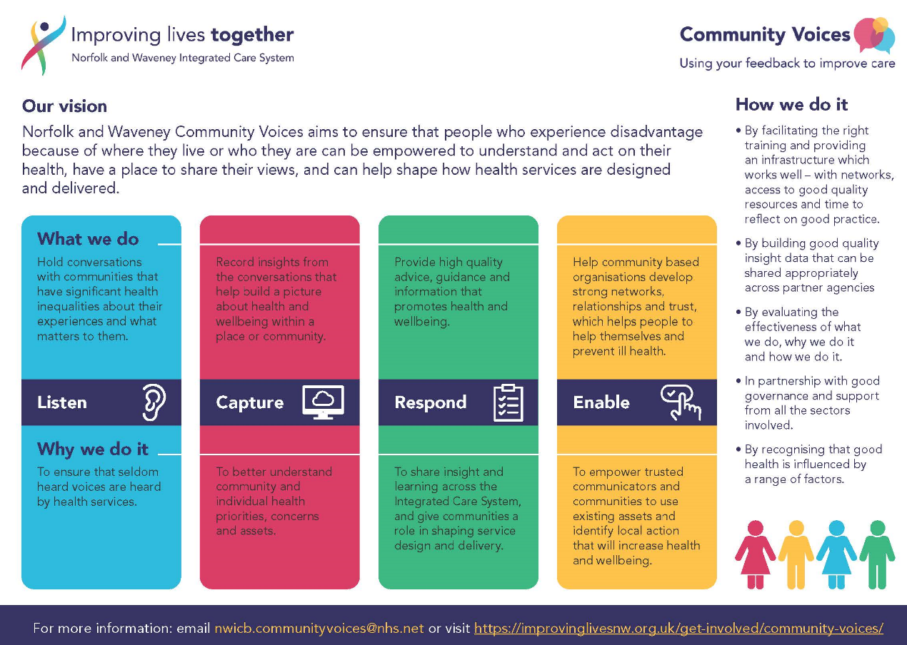

Key findings
Overview and general health:
Four topics were covered in the conversations (breast, bowel and cervical cancer, menstrual health, menopause, and sexual health) but menopause was the most frequently discussed topic - signs, symptoms and the impact on women’s lives were described.
Issues described as having most significant effect on day-to-day health and wellbeing are:
- impact of the menopause
- impact of prevention on general health and wellbeing
- impact of other health conditions and illnesses
- impact of poor mental health
- financial and economic factors
Five cross-cutting themes emerged from the conversations:
- attitudinal barriers (shame, embarrassment, fear) particularly for women who are vulnerable or who have experienced sexual violence
- negative experiences with health professionals, leading to potential disengagement with services
- women not feeling listened to or lacking a ‘voice’ in their medical care
- cultural aspects of women’s health care
- impact of an individual’s protected characteristics on their health care
Factors which enable women to secure appropriate health care are:
- personal motivation and ability to engage
- outreach and community-based services and support
- appropriate and accessible information (leaflets, online help)
- access to appropriate services
- being supported by family and friends and support from medical practitioners
Factors which prevent women accessing appropriate health care are:
- feelings of embarrassment, shame or concern about discussing 'personal' matters or being worried about ‘bad news’ such as cancer diagnosis
- lack of information, too much, or competing information
- issues with getting support in preferred language or issues with interpreters
- negative interaction with a medical professional
- physical or mental disability, neurodiversity, mental health issues, age or lack of support from family or friends
- lack of ‘voice’, feeling ‘unheard’ or dismissed

Women’s experiences could be improved through:
- accessible information in preferred format or help with IT
- professional, appropriate and empathetic support from medical practitioners
- improved opportunities for the patient voice to be heard; feeling listened to by health professionals
- better availability of medical services such as tests and routine checks
- support including help with accessing, navigating or arranging health care by people such as trusted communicators, intermediaries, or peer support workers
- community based or outreach medical services and services in variety of places
- better availability of interpreters or leaflets in first or preferred language
Outcomes of the conversations include:
- the person or group’s understanding of women's health issues was improved (through conversation, receiving leaflets or being signposted to further support)
- women were supported to access treatment or seek further medical advice about women’s health issues
- preventative interventions (check-ups and screening) were promoted
- the menopause was discussed in a supportive environment which made it easy for people to share their experiences, support one another and encourage further engagement and action

Recommendations
Based on the insights and learning gathered from the project, the following recommendations are proposed to improve engagement, understanding and access for women:
- Enhance visibility of inclusive support options for women
- Strengthen cultural competency across the workforce
- Prioritise targeted, empowering health messaging
- Commission co-produced, culturally responsive resources and services

Ripple Effect Mapping
Norfolk and Waveney Integrated Care Board Evidence and Evaluation Hub facilitated an adapted ripple effects mapping exercise with the trusted communicators for the women's health conversations.
Ripple Effects Mapping (REM) is a participatory method for evaluating both the intended and unintended outcomes of an intervention. It typically produces a visual map of these outcomes and the connections (ripples) between them, which can then be reviewed and updated over time.
Two Ripple Effects Mapping sessions were conducted to capture the impacts of the women’s health conversations; additional input was gathered from group members who could not attend the initial session. All participants were provided with preparatory material and prompts to guide pre-session thinking. During the REM sessions, participants developed initial impact maps using MIRO (Appendix 1 and 2).
Key intended and unintended impacts of women’s health conversations captured during the sessions were:
1. Empowerment and Confidence of women (intended) – stronger sense of voice and agency
2. Improved Health Literacy and Service Navigation (intended) – application of new knowledge gained to improve own health and others
3. Strengthened Community Connections and Peer Support (unintended) – community based conversations extending beyond health topics
4. Organisational Impact (unintended)- changes in organisational policy
5. Staff Development (intended) – improved health literacy in VCSE workforce
6. Identification of System Barriers and Opportunities (intended) – value of informal support networks where formal pathways or support were unclear or insufficient.

Background
This report provides analysis and a summary of conversations captured as part of the Community Voices Women’s Health Project during January-May 2025. Grants were made through Norfolk Community Foundation and Suffolk Community Foundation to nine organisations to carry out conversations with women in under-served communities.
Conversations (anonymised) between Trusted Communicators and participants were recorded on the Community Voices Insight Bank.
A total of 766 women took part in the conversations. 362 conversations were recorded.
- 293 of these were individual one to one conversations.
- 69 were group conversations.
Analysis was undertaken by the Norfolk Office of Data and Analytics (NODA) in the Insight and Analytics Team at Norfolk County Council. The conversations covered multiple topic areas: cancer (breast, bowel, cervical), menstrual health, menopause, sexual health, and general health and wellbeing. Any quotes included in this report are given verbatim from the Insight Bank.

Process
NODA was commissioned to analyse eight qualitative questions covering the themes of cancer (Breast, Bowel, Cervical) signs and symptoms, menstrual health, menopause and sexual health. Questions also explored factors which enable women to seek support, and the barriers they experience. Conversations included a general question about issues which affect women’s health and wellbeing.
8A sample of comments was read, and a coding framework developed, tested, and refined. Each comment was coded, and codes were quality assured for consistency and accuracy. Analysis of quantitative elements of the project was out of scope although the qualitative elements of Q3 and Q33 are included in this report.
The phrase ‘Trusted Communicator’ is used throughout as a way of describing people who lead the Community Voices conversations and is not intended to reflect a specific role.

Discussion
Five cross-cutting themes emerged from responses across all questions. These themes highlight why women’s health relating to cancer, menstrual health, the menopause, and sexual health are distinct from other medical issues. The five cross-cutting themes are:
- Attitudinal barriers (shame, embarrassment, fear) particularly for women who are vulnerable or who have experienced sexual violence
- Negative experiences with health professionals, leading to potential disengagement with services
- Women not feeling listened to or lacking a ‘voice’ in their medical care
- Cultural aspects of women’s health care
- The impact of an individual’s protected characteristic on their health care

1. Attitudinal barriers

Shame and embarrassment about discussing breasts, bowel, sex, or reproductive systems and fear of ‘invasive’ preventative services particularly cervical screening, were frequently mentioned in the conversations.

"I find the whole bowl [bowel] subject very difficult to speak about, I am not sure why but I cant seem to describe the symptoms without feeling dirty".
These feelings could be magnified in the presence of a male practitioner: “Barrier number one is being embarrassed to talk to a professional about women's health topics. These subjects are still quite delicate and stigmatized. She would not want to talk about them with a stranger IE a doctor. Worst case scenario would be a male doctor too.”
Even when the value of preventative services is acknowledged, uptake can be limited by anxiety: “It [cervical screening] was something that was invasive that she did not want to do and was easier to ignore”.

Victims of sexual violence face additional barriers: “She was raped as a teenager and does not like having her breasts touched” and “her past experience of smear tests and her sexual assault both prevented her from attending her smear tests.”

2. Negative experiences with health professionals
The impact of lack of professional care and empathy on individuals was raised many times throughout the conversations. The impact of negative interactions included reluctance to attend future appointments, anger, loss of confidence and anxiety.
“Discussion on body image and breast cancer, the impact of how a woman feels after a mastectomy. An attendee knows of a situation where a patient once asked ' does this mean men wont fancy me?' and the health professional replied 'yes probably' this could have lead to that person not wanting to have the operation that would have ultimately save their lives. This shows a need for more compassion within women's health and consideration to the language and responses used to patients.”
“This lady said she went for a smear test at the doctors practice and the nurse completing the smear mad it a terrible experience. The lady said that the nurse was "putting their whole hand in there, taking it in and out, and couldn't complete the smear test". The said the nurse tried for over 45 minutes and then told her there was so much discharge that she either had an STI or cancer! This lady was so upset! She went home and had an argument with her husband as both accused each other of having an affair. Then they got upset that she had cancer. All testing was carried out and everything was negative. The lady said she was fuming with the nurse and has since moved practises. She also had the smear test done at the hospital, and it was completed quickly and easily within 10 minutes and no issues. She now always requests that her smear tests be carried out at the hospital.”
“She reported that she has a coil fitted but when she went for her smear test they couldn't find it. The nurse spent a while looking for it which she said was very embarrassing, the nurse was moving her light around and muttering under her breath, making her feel awkward and like it was her fault she couldn't find it. She then left her on the bed, exposed, and said she was going to find someone else. She came back in with another lady who didn't introduce herself but went straight down to look between her legs. She said she had no idea who this person was but she couldn't find anything either. They asked her if she checks her string is there and when she last checked, she felt this was said in a way that was blaming her, but she said she just didn't think to check them. They were also asking while one had a speculum in her vagina and was looking inside, so she didn't really feel very comfortable being asked at that point. They told her to get dressed and that they would refer her to the hospital. She is reluctant to go to the hospital as no-one has explained what will happen next. She doesn't know now if she is protected when she has sex as if they couldn't find the coil she wonders if it is still working, but she was too embarrassed to ask as there were two of them in the room who had just been looking at her intimately. She had prepared herself for the smear test knowing how important it is to go, but had not prepared for this and now feels on reflection it could have been handled a lot better.”

3. Women not feeling listened to, heard, or understood by medical professionals was also raised.
“One of the biggest barriers to her health was the lack of communication (understanding) and trust with her doctor, which has left her feeling dismissed and isolated in managing her treatment. She expressed, “It’s like they don’t listen. I try to explain what’s happening, but they just brush it off. I don’t feel like they care enough to get to the bottom of it.” This lack of trust has led her to avoid seeking help even when she’s clearly struggling with side effects”.
“In addition, there was significant concern around feeling "gaslit" by GPs, for eg., we heard in the group that it took one woman 18 months, one woman 2 years, and one woman 15 years to "fight" for HRT and convince GPs of their "worthiness" to take it.”
“We held a women's focus group about menstrual health and the menopause. General feedback was that the majority of women felt dismissed by healthcare professionals about their menstrual health. While they could recognise heavy periods, 3 women reported that these were dismissed by their GPs as normal. In addition, one woman reported that other symptoms such as anxiety and heightened anger around her period were dismissed as heavy periods. Women felt that they were pushed toward hormonal contraception options and desired more holistic conversations around how symptoms could be managed through diet.”

4. Cultural aspects of women’s health care
The importance of offering culturally sensitive and appropriate women’s health services which recognises different perspectives and ensures equitable access to care was discussed.
“The individual highlighted that in their culture women that discuss sex, including contraception were considered 'loose' and promiscuous and therefore women were discouraged from discussing matters around sex. She highlighted that sex was something that men spoke about, and it was considered improper for women to discuss sex. The individual herself did not necessarily subscribe to these beliefs but highlighted that this was her environment.”
“Another attendee said 'no one speaks about this [menopause], its a taboo subject socially even amongst women.”
Given that she relied on medication from Poland and initially had a different understanding of HRT than what she later heard from her UK GP, access to bilingual or culturally tailored resources could have supported her in navigating differing medical opinions with more clarity and confidence.”
“The person came from a culture where menopause was not discussed publicly. The person has never learnt about menopause in a professional or personal environment. Women's health topics such as menopause and menstrual health are not discussed and their is shame around the topics. Therefore, these mental and personal barriers must be overcome even before other barriers to access care.”
“The conversation was about cancer Breast, Bowel and Cervical. When we talked about signs and symptoms and screenings the Client said “Although I have good understanding and go to all of my cancer screenings not everyone does” and “I find that there is a lack of understanding (of signs and symptoms) and knowing where to go in ethnic minoroites”.

5. Impact of protected characteristics in accessing support for Women’s Health
The conversations revealed how age, disability, gender or ongoing health issues affect how women’s health services are experienced.

5.1 Age
'Some women our age (mid 50s), still feel like we are making a fuss when we are struggling with health problems that women have'.
“The barriers for this woman were her autism and her age. She was told repeatedly that "it's just the menopause." It wasn't ; was stage 4 cancer.”
“The person wanted to have a bowel screening but was told by her GP they don't do this. She went online and found out from NHS site she could request over the phone wish she did and a test was posted out to her. 'People need to know that if they are over the age limit they can contact NHS direct and ask for a test'.”
“Age was something that came up a lot. "I think younger people are much more clued up on sexual health, taking tests prior to having a new partner etc, it’s a shame older people aren't" "I do think that this imbalance needs to be addressed.”

5.2 Gender
“Women’s health is just not treated the same way as Men’s health in this country, if men went through what we go through things would be very different.”
“The woman has experienced attitudes which are dismissive of women's health issues, having heard comments like 'are you doing this because you are a woman' and she questioned 'why does everyone say 'oh it's just your age' to women' if they have a health complaint”.

5.3 Disability and health conditions
Disclosure of whether the respondent has physical or mental conditions that reduce their ability to carry out day to day activities was optional. Therefore, this information may not have been captured for all respondents. For those that did disclose this, responses are summarised in Table 1 below.
Table 1: Summary of respondents with physical or mental conditions which reduce their ability to carry out day-to-day activities
Option | Number of respondents
Yes | 52
No | 146
Prefer not to say | 13

Physical and neurological health issues
“This lady because of her autism finds it difficult to make the initial appointment as she finds making phone calls very difficult and then attending the appointment will make her very anxious. Also because of a physical disability she has to rely on someone giving her a lift as her autism makes her too anxious to use taxi services”
“the client has epilepsy and isn't sure of what she can take with her current epilepsy medication and sometimes getting to GP would be difficult as she doesn't drive . I have offered to help with supporting this if she needed support to go to GP”

Neurodiversity
“They were able to access Cognitive Behavioural Therapy but this was not tailored to neurodiverse people so was not helpful, this type of therapy was not available in Norfolk and Waveney. The woman was able to access an Autism and ADHD assessment through the NHS which went through a third party and this was very organised, a diagnosis of both was subsequently made 'I thought the clinicians were brilliant they went above and beyond' . Taking a holistic approach would be more beneficial - being neurodiverse and in menopause can increase mental health problems and become overwhelming. More understanding would be good regarding older women and late Autism/ADHD diagnosis, mental health and menopause and other treatments and support to suit this.”
“The biggest impact on this woman's health is probably her autism and the lack of knowledge and therefore lack of appropriate care that she received. She and her husband compiled 2 boards which they placed above and behind her bed giving health staff detailed information about how best to care for her in terms of her autism but most of the time this was ignored. One nurse even said disparagingly" apparently she's autistic, that's why she's behaving like that!" Not very caring, not very kind. This woman said that without her husband advocating for her she would probably never have coped with her hospital stay at all. She also queried why disability passports were for in patients only and not out patient appointment She also said that the support of the disability support nurse was invaluable to her but had no idea of her existence. Knowledge of this person earlier would have helped make her hospital experience more positive.”
Other ways in which neurodiversity was reported to have impacted some women’s experience of care were:
- Lack of knowledge about the offer of a Disability Support Nurse who could support them through their medical appointments and navigating the healthcare system
- Stress and anxiety for autistic people attending an appointment is potentially greater than for neurotypical people
- Support for autistic individual during the appointment dismissed despite filling out pre-appointment forms to notify professionals

Mental health issues
“During Drop-in session, this lady was relaying that her Drs do not take her seriously. That everything is dismissed because of her previous "poor mental" health and what she is experiencing is all "in her head".”
“Long term trauma and domestic abuse that has impacted on her life choices, including a period of time addicted to drugs. She feels that the addiction is always present when seeing anyone to do with her health and that she is judged. She would rather avoid going to any appointments than feel the way some health professionals have made her feel.”
“Previous substance misuse issues that she does not want to go back to and worried if results were bad she would lapse as a coping strategy. Hasn't always had positive experiences with health appointments, feels judged by her past and that they see an ex addict before the current problem so she would rather not go than be judged and feel bad when she comes out.”

Ethnicity
Disclosure of ethnicity was optional, therefore data relating to respondents’ ethnicity may not have been captured for all respondents. For those that did disclose their ethnicity, these are summarised in Table 2 below.
Table 2: Summary of respondents’ ethnicity
Ethnic Group | Number of Respondents
English, Welsh, Scottish, Northern Irish or British | 133
Irish | 2
Any other White background | 52
White and Black Caribbean | 1
White and Asian | 2
Any other Mixed/multiple ethnic background | 2
Any other Asian background | 2
African | 3
Caribbean | 3
Any other Black/African/Caribbean background | 1
Any other ethnic group | 1

The most commonly reported ethnic groups were ‘English, Welsh, Scottish, Northern Irish or British’ and ‘any other White background’. The high representation of respondents from any other white background may reflect Community Voices’ engagement with the Hanseatic Union which supports communities in King’s Lynn and West Norfolk often including those whose first language is not English.
Being from an ethnic minority background may have impacted some women’s experiences of care:
“They felt that other ethnic minorities make struggle because of their beliefs and language barriers and may be put [off] by dismissive GPs”

Finally, one Trusted Communicator noted the impact of living in a deprived area on perceptions of health services.
“Women in the group identified feeling "gaslit" by GPs and this seemed to reflect a wider sense of mistrust in healthcare as an organisation. Our hub sits within one of the most deprived areas of the city, and there was a sense that healthcare, including the NHS, can be seen as representative of the government in general and therefore, seen as an institution that is untrustworthy.”

Analysis of questions
This report is structured into three sections which mirror the themes of the discussions:
Part 1: Overview of conversations and people’s general health (Q2 and Q32)
Part 2: Enablers and barriers (Q4, Q5 and Q6)
Part 3: Outcomes of conversations (Q3, Q33 and Q34)

Part 1: Overview of conversations and people’s general health (Q2 and Q32)

Q2. Please provide a summary of your conversation. Prompts: Was the conversation about cancer (Breast, Bowel, Cervical) signs and symptoms, menstrual health or menopause, sexual health? Include person’s awareness of signs and symptoms about the health topics. Did you talk the person through what to look out for, how to access support?

There were 301 responses to this question.

1.1 Menopause
The topic mentioned most frequently was the menopause. Symptoms were described as physical signs (“sweats and flushes”) and emotional changes (“mood swings and depression”).
- Understanding about the signs and symptoms of the menopause varied from “we discussed many of the menopause symptoms - she knew them and she said she has most of them” to limited or no awareness “she felt that education about Menopause should start earlier so women are forewarned about the signs and symptoms. she had not started the menopause yet but still felt very much in the dark about it”.

- Source of information about the menopause included medical professionals, friends and media: “She said it was talking to friends and watching the Davina McCall tv programme which really educated her in the symptoms and treatments” / “The lady was aware of the signs and symptoms of the menopause (including perimenopause stage). She was aware of them all because she talked a lot about it with her mum”.

- Some conversations recorded the physical impact of the menopause: ” Talked about menopause symptoms - experienced excessive sweating and struggling to work at care home as needed to help people move physically and was embarrassed”.

- The emotional impact of the menopause was also described: “This lady is going through Menopause. She is struggling with Insomnia, low mood and finding their mood swings really to be quite debilitating, affecting her daily routines and putting pressure on her friendships”.

Conversations about the menopause included discussion about hormone replacement therapy (HRT). As with discussion around the menopause, people’s knowledge of the signs and symptoms and their attitude towards HRT varied.
- “Is not phased by hrt as understands the benefits of taking it.”
- “She said she didn't want to go on HRT as she has heard bad things about it.”
Positive and negative examples of people’s experience of using HRT were cited.
- “The woman was already on hormone replacement therapy (HRT), but she was struggling with the side effects, including irritability, fatigue, and mood swings.”
- “Currently experiencing menopause and is taking HRT which they say has drastically improved their health and wellbeing.”

1.2 Cancer
Sources of information about the signs and symptoms of cancer included:
- Public health programmes - “The poo on a stick test”.
- Private health care providers – “General health check with private health care provider and given information about signs and symptoms.”
- Family and friends - "My mother had breast cancer so she taught me the importance of getting things checked out”.
- Media – “She said the media coverage is very good so it has educated her in signs and symptoms.”
One conversation noted that information may not be equally available to all women: “The conversation was about cancer Breast, Bowel and Cervical. When we talked about signs and symptoms and screenings the Client said “Although I have good understanding and go to all of my cancer screenings not everyone does” and “I find that there is a lack of understanding (of signs and symptoms) and knowing where to go in ethnic minoroites”.

Breast Cancer
Breast cancer was the most frequently discussed type of cancer with cervical and bowel cancer being mentioned fewer times.
- Where the signs and symptoms of breast cancer were noted people usually referred to the emergence of unusual lumps or breast pain: “[she is] regularly palpating the breast and aware that any unusual pains needs to be checked with doctor”.

- People were generally more likely to be aware of the signs and symptoms of breast cancer than other cancers: “we discussed the all the cancers breast, bowl ,cervical the ladies said they knew more about breast and bowel symptoms but not cervical we went on the website and had a look at all the symptom's but they were all up to date on there cervical screening”.

- In one case, greater knowledge about breast cancer in comparison to other cancers was directly attributed to public health messaging: “I would say that I am a lot more aware of the symptoms of Breast cancer as it is so well publicized, I am not as informed about the signs for the other two”. Other women described following medical advice: “checks boobs regularly as is advised”.

- Examples of the importance of awareness of signs and symptoms were recorded: “This was a conversation about cancer screening and how important it is, however, this lady had cancer which wasn't picked up on the routine mammogram. She had gone for a mammogram and it came back clear. She had a spot on her breast at the time that was concerning her. After a few weeks of having the mammogram she decided to go back to the Doctors and they sent her to the breast clinic straight away where in fact she did have cancer and she had to have a mastectomy. Luckily she knew the signs and persevered with getting a second opinion”.

Cervical cancer
Although fewer conversations were recorded about cervical cancer compared to breast cancer, and signs and symptoms were noted less frequently, a clear theme about take up and experiences of cervical screening emerged.

Take up of cervical screening services could be limited by:
- Terminology – “The person recognised the term smear test but not cervical cancer screening.” / “The conversation was about cervical cancer screening. The individual was unaware of the term cervix as English is not their first language, therefore they did not recognise the term cervical screening. We showed the individual a diagram of a uterus and identified the cervix, they were able to recognise the diagram. Once the procedure was explained, the person stated that they had had a cervical screening before.”

- Awareness of cervical screening – “Some students were unaware of cervical screening in their home country, as it is only available privately and not regularly offered”. / “The individual was apprehensive about their appointment as they had never been to a cervical screening appointment, though they were older than the threshold, due to the fact they had recently moved to the country.”

- Fear – “This person spoke mostly about having a cervical smear tests coming back needing to be retested and how much this scared them.”

- Availability of female health professionals – “The conversation was about cervical cancer screening and wanting to ensure the doctor that was conducting the appointment was a woman. The person would not be comfortable with the appointment being conducted by a male medical professional.”

- Needing support – “Explained Chaperone can present at smear test if you fell uncomfortable. Group didn't know that chaperone can accompany for the smear test.”

Embarrassment at the intimate nature of cervical screening was frequently mentioned: it was often linked to previous poor experiences and feelings of vulnerability.

“She didn't attend it [cervical screening] because the last one she had the nurse commented she wasn't very relaxed and it was difficult to get to the right place as she was so uptight and needs to relax, this panicked her more making her even more stressed and therefore even harder to get done. It hurt her in the end and she left useless and said she would never do that again. I asked if she told the nurse this when having the implant but she said she hadn't told anyone as she was so embarrassed. I explained that our local GP surgeries offer double appointments for smear tests and are very kind, we would get one of the smear test champions to talk to her first and she agreed. We talked through signs of cervical cancer and gave a leaflet.”

Bowel Cancer
Bowel cancer was discussed in fewer conversations than breast and cervical cancers. References to signs and symptoms were infrequent.
Recurring themes about bowel cancer in conversations included family histories and take up of the NHS faecal immunochemical test (FIT).
- Family histories - “Our conversation was around bowel cancer, screening and lady's family history. She said that her father died having a bowel cancer, it was very traumatic for her and she is quite anxious within that subject. She was very concerned about her being diagnosed too.” / “Father diagnosed with bowel cancer last year so she and her siblings all got tested. Had nothing previously from nhs about getting tested in early 50s.”

- FIT kit - “Client is up to date with bowel screening as she has the kit every few years though the post.” / “Used the kit sent through the post and was diagnosed from that.” / “She said she has received the FIT kit but hasn't got round to completing it but is up to date on the other testing.”

Other types of cancer
Other cancers discussed in the conversations included:
Rectal cancer – “Client talked about rectal cancer. Had surgery 8 years ago and struggling because has to use stoma bags. Needs a lots of support from GP, but no problems as interpreter is always provided and she attending very often.”
Skin cancer – “Person has ongoing health input due to high risk of skin cancer and has regular apintments to check out freckles and moles. Her mother has the same condition and has had to have skin cancers treated.”

1.3 Menstrual and sexual health
Conversations about menstrual health covered physical issues (heavy or abnormal bleeding, tiredness, mood changes) but more reference was made to difficulties in getting appropriate support.
- “Hasn't felt listened to and felt that women are just meant to 'put up' [with] period problems.”
- “General feedback was that the majority of women felt dismissed by healthcare professionals about their menstrual health. While they could recognise heavy periods, 3 women reported that these were dismissed by their GPs as normal.”
Cultural attitudes towards menstrual health were also noted;
- “All 15 women agreed that menstrual health and the menopause are still taboo to talk about.”
- “She felt that employers and Men should be educated more about menstrual health as currently alot of them just say things as a joke around it.”

Specific services were singled out for praise: “Has mirena coil fitted. Has had sti testing kit through iCash and is really pleased with this service as can be done from home. Marked improvement from how it was years ago”.
Conversations about sexual health mostly focused on different types of contraception and their pros and cons: “The person knew of some contraception methods, such as condoms and the pill, but did not know them all, nor did they know the distinction between LARC and other forms of contraception.”
Practicing safe sex and the risks of sexually transmitted diseases were also discussed: “The conversation was about sexual health, specifically STIs and contraception in midlife. The person was not very aware of the risks of STIs at their age and had never really thought about getting tested or using protection in new relationships. She assumed that STIs were only a concern for younger people and was surprised to hear that infection rates are increasing among those over 40.”

1.4 Prevention
Preventative interventions such as screening and routine checks ups were frequently mentioned in the conversations.

- “We talked through why smear tests are offered and why preventative health appointments are so important.”
- “Checks boobs regularly as is advised. Has always had smear tests. Not yet
been called for breast screening nor received bowel cancer test.”
- “We talked about checking for breast lumps, which she does in the shower, and for blood in her poo, which she said she does when she wipes.”

Q32. What was raised in your conversation which you consider to have an impact on the person’s health and wellbeing in its widest sense?
There were 300 responses to this question. The main issues raised were:
- impact of the menopause
- impact of prevention on general health and wellbeing
- impact of other health conditions and illnesses
- impact of poor mental health
- financial and economic factors
- impact of positive health care experiences
- barriers and enablers to accessing support

Effects of the menopause were discussed more frequently in this question than the effects of cancer, menstrual, or sexual health, and in particular the wider impact of the menopause on women’s wellbeing. People described how going through the menopause had – in addition to physical effects – a much wider impact on their lives:
- “In the area of ​​menstrual health and menopause, the conversation revealed that many women experience ailments that are trivialized by both the healthcare system and society … a lack of empathy and appropriate support can lead to a deterioration in the quality of life.”

- “The patient described the menopausal period as “the most difficult time of my life”, highlighting the profound effect it had on her mental health and sense of identity. She experienced social withdrawal, emotional instability, and psychological distress, which were compounded by physical symptoms such as hot flushes and weight gain. These experiences had lasting effects on her confidence, relationships, and engagement with the world.”

- “Her menopause is not just about hot flushes and mood swings. This is a feeling of genuine loss.”
For some women, the impact is experienced particularly acutely: “being neurodiverse and in menopause can increase mental health problems and become overwhelming”.

The impact of prevention on general health and wellbeing was also noted:
- Healthy lifestyle - “She leads a very health-conscious lifestyle—with no smoking, no alcohol use, a good diet, and regular physical activity—all of which significantly contribute to her long-term physical and mental wellbeing.”

- Taking up screening offers – “Recently received letter for bowel screening and agreed to have it and has sent sample in last few days. … She feels the nhs have really been on it with regards to this and very important”.

- Consistency of preventative health messaging was questioned by one participant: “The person has noticed that there is awareness raising/health campaigns in other areas but not in Waveney, for example in spotting symptoms of Ovarian cancer - when to to contact your GP. They feel that prevention measures like this may not be considered enough”.

The impact of other health conditions and illnesses on general wellbeing was discussed in many conversations and covered people’s experience of managing acute and chronic diseases: “She said that she has had difficulties with pneumonia a couple of years ago and the biggest difficulty has been falls and mobility problems”.

Examples of the impact of poor mental health were also discussed: “She reported periods of low mood and thoughts of not wanting to live. A follow-up has been arranged to check referral and to ask about waiting list. Client previously completed cognitive behavioural therapy (CBT), which she found helpful. She is now on the waiting list for another round of therapy”.

Broader financial and economic factors were referenced in the conversations: “Lots of things are impacting on her. Her physical health, mental health, money and debt and housing. There is no financial support available for people with cancer. Bills and rent are not considered in the persons journey through their treatment and this can sometimes out way concerns with treatment”.

Some examples of the impact of positive health care experiences on wider health and wellbeing were also recorded: “Another attendee commented that they had a great experience, an early hysterectomy meant that they could move on with their life”.

People’s experiences of barriers to health care were frequently raised in the conversation as having an impact on wider health and wellbeing (barriers are described in greater detail in Section Two). The main barriers and their impact on people’s wider health and wellbeing were:
- attitudinal barriers – feelings of embarrassment, concern about discussing 'personal' matters, not wanting to know bad news, fear or worry and lack of trust in services.
- negative experiences with health professionals – lack of professional care and empathy.
- capacity for self-care – lack of capacity for self-care linked to a physical or mental disability, neurodiversity, mental health issues, age, or lack of support such as family and friends.
- lack of information – not knowing where to get information or who to talk to.
- not feeling listened to, heard, or understood.
- inability to access services or access them at convenient times.

Conversations also described solutions to barriers and the factors which enable people to find and access health services (addressed in greater detail in Section Two). People described changes which would have a positive impact on their general health and wellbeing as:
- improved support from medical professionals (such as sufficient time with GP, access to other health professionals or specialists)
- accessible information in preferred format or help with IT
- more/better medical services, tests and routine checks

Part 2: Enablers and barriers (Q4, Q5 and Q6)

Q4. What did you find to be the enablers for the person/s in accessing support for the women's health topic (cancers, menstrual health, menopause or LARC) that was discussed?

There were 270 responses to this question. The main enablers were described as:
- personal motivation and ability
- outreach and community-based services and support
- appropriate and accessible information (leaflets, online help)
- access to appropriate services
- being supported by family and friends
- support from medical practitioners

People described the factors which enabled them to access support as:
- Personal motivation and ability – having the motivation, time, or money to seek care:
“Her strong intrinsic motivation to maintain good health is a major enabler”.
“Enablers were her very own motivation and not giving up to the point that she went privately. She was quite capable of talking to people, aware of her symptoms and being conscious about her body/health.”
“Extremely capable of accessing health services and is active and motivated in doing so.”
“The person was enthusiastic about women's health topics and menopause and motivated to learn.”

- Outreach and community-based services and support such as Trusted Communicators, mobile breast screening unit, facilitated peer-to-peer groups and safe spaces:

“Her key message to others in the room was: ‘Don't wait — if something feels wrong, act quickly. Time is important.’ This encouraged others present to reflect on their own health and highlighted the power of peer experience in improving community health awareness”.

“Enablers -access to support groups /services that are easy to use.”

“She found talking to other women very helpful, especially when talking about peeing herself and dribbling! She is not alone!”

- Appropriate/accessible information (leaflets, online help): people’s perception of the best place to get health information varied. One respondent noted that spotting an advert in her GP’s surgery prompted her to seek advice from the practice nutritionist about weight loss, but for other people, social media was their preferred choice:

“We talked about why she felt TikTok was the place to get information and why she liked that best. It was relatable, conversational, could find lots and lots of information quickly relating to all aspects of the menopause. It has peoples personal experiences of symptoms and solutions, both good and bad. NHS website just has a list of symptoms you may have but doesn't tell you how those symptoms may affect you or the impact that will have on your life or your relastionships”.

“TV advertisements, letters from GP surgery and the bowel screening coming directly to the door.”

“She talked about having access to information via books, passed down intergenerationally through her grandmother and mother. Having access to this information helped her to recognise the signs and symptoms of menstrual health, sexual health and menopause issues.”

- Access to appropriate medical services and tests including those which act as a ‘gateway’ to more specialised services:

“We talked about the woman's experience of finding a breast lump and seeing her GP, the referral went through quickly and within 2 months she had had an operation. The whole process was 'terribly efficient, you couldn't fault it'. Treatment was provided at the James Paget Hospital and Norfolk and Norwich both very good - 'very reassuring, no complaints at all -(the staff) were very dedicated'. The check ups were really prompt and there was a dedicated nurse available 24/7 afterwards and after 12 months another mammogram 'You felt there was back up all the time'”.

“The enablers for her attendance at cervical screening appointments were the pre-scheduled appointments and reminders”

- Being supported by family and friends: informal friends and family networks were described as important sources of support:

“Good family and friends network around her with lots of females to support and discuss many issues. Her mother in particular has been very helpful and supported her with accessing GP and when she had a miscarriage.”

- Support from medical practitioners - caring and accessible medical practitioners were noted as enabling factors:

“She knew that she could contact her nurse and surgery for advice, she has a good relationship with these services.”

- Other enabling factors included being able to time off work, availability of interpreters and, in one case, “support from host on arrival to the UK”.

Q5. What did you find to be the barriers for the person/s in accessing support for the women's health topic that was discussed?
There were 281 responses to this question. The main barriers were described as:
- feelings of embarrassment, shame or concern about discussing 'personal' matters or being worried about ‘bad news’ or a health check
- not being sure where to get information from or who to talk to, not enough information, too much information, or conflicting information
- not being able to get support or services in preferred language or issues with interpreters
- negative interaction with a medical professional or lack of support and knowledge from health professionals
- physical or mental disability, neurodiversity, mental health issues, age or lack of support from family or friends
- lack of ‘voice’
- actual or perceived lack or shortage of healthcare services
- inability to access support in preferred format or digital barriers
- insufficient time to engage
- health service offer the at wrong time of the day/week for the person
- prohibitive cost of care/treatments or accessing care or treatments
- lack of integration or communication between services

People described the barriers which prevented them accessing support as:
- Feelings of embarrassment, shame or concern about discussing 'personal' matters, symptoms, or undergoing health checks, or being fearful or worried about ‘bad news’ or a health check. People attributed these feelings to previous trauma, negative experiences of medical interventions, or cultural barriers. In some cases, the embarrassment expressed was attributed to being a particular age or life-stage.
“The person described feeling embarrassed about her menopause symptoms.”
“Barrier included the triggers in talking about this subject, shame in discussing issues with breasts due to differing cultural beliefs.”
“They do not conduct breast examinations on themselves largely out of fear for what they might find.”
“Another major barrier was embarrassment and stigma. She felt that talking about sexual health at her age was awkward and uncomfortable, both with doctors and with friends. She worried that bringing it up with a GP would make her seem “irresponsible” or that she would be judged for dating and having sex in midlife.”
“They talked about the barriers that affected the younger generations. They spoke about their daughters generation who shied away from screening because it was embarrassing, uncomfortable and inconvenient. They said the discomfort was momentary and "Its a bit like having your boob shut in a fridge door".”

- Not being sure where to get information from or who to talk to, not enough information, too much information, or conflicting information.
“Felt somewhat overwhelmed at how much information was out there.”
“Lack of knowledge of where to go for support or support available to her.”
“There is so much information available she doesn't know where to start looking. Everyone has a different opinion about HRT and whether she should remove her ovaries and be postmenopausal.”

- Not being able to get support or services in preferred language or issues with interpreters.
“Most significant is language barrier - client needs to access interpreter in GP and hospital and it's not always available.”
“First barrier is definitely that English is not her first language. If she contacts her surgery she does that online so she can translate all online.”
“Disappointment and discomfort due to the presence of a male interpreter despite requesting a female.”
“Language barrier - English is not the person's first language and they are not fluent. The terms 'cervical' 'cervix' and 'screening' are not terms they come across often, and therefore they did not understand what was being asked of them. If English is not their first language, the cervical screening appointment letters can be ignored, removing the opportunity to access the appointment.”
“In terms of capability, the language barrier was a huge issue. She felt unable to fully explain her symptoms and concerns to her doctor because of her limited English skills. This made it difficult for her to speak for herself effectively and to feel understood. Without the right words, she felt she couldn’t articulate the specific side effects she was experiencing with HRT, which led to her feeling dismissed and frustrated.”

- Negative interaction with a medical professional or lack of support and knowledge from health professionals.
“Knowledge of the subject by the GP and the nurse at the surgery seemed less than what she already knew, and she found this concerning.”
“He (the GP) said that HRT was not good for me and could cause cancer, he was very angry when I said that he knew about these things.”
“She is put off ever going back through gynaecology, the way the Dr was unprepared with no computer or pen and the way he spoke to her and also the very long wait for the appointment.”
“"Gaslit by GPs".”

- Physical or mental disability, neurodiversity, mental health issues, age or lack of support from family or friends.
“Having memory problems, easily confused if given too much information. Hearing and sight deteriorating.”
“The need to attend a hospital appointment which would cause an enormous amount of anxiety related to various sensory overloads. The lights, other people, noise etc.”
“The main barrier is that she has autism which makes her anxious about making the appointment, attending the appointment and physical disabilities make it difficult for her to get there.”
“Memory issues, which may impact health management and appointment attendance.”
“Her mums attitude, that there was nothing wrong. Had never attended or made a drs appointment by herself before. This made it difficult for her to access support.”

- Lack of ‘voice’: not feeling listened to, heard or understood.
“She is fed up of not being heard, not being listened and ignored.”
“Person felt sometimes not taken seriously due to being overweight.”
“”Women are dismissed by the medical profession".”
“They stated "I dont really feel that supported by my own GP surgery and I dont feel that they listen to me".”

- Actual or perceived lack or shortage of healthcare services such as appointments, screening or tests.
“Her motivation is reduced by the perception that access to gynaecologists in the UK is limited and only through GPs.”
“Access to preventive screenings and medical consultations can be limited by long waiting times for specialists and an insufficient number of facilities offering screening services. In certain areas, particularly rural regions, the number of healthcare providers is limited, making it more difficult to access tests and consultations.”
“The client has said (there are not enough doctors in the village as and the village has doubled in housing).”

- Inability to access support in preferred format or digital barriers.
“As she did not use the internet or social media and these seem to be the only way of accessing more information, she felt very isolated.”
“Some women may also lack the necessary skills to navigate the healthcare system, such as booking appointments or identifying trustworthy sources of health information.”
“The change to digital for many services or access to appointments etc has been a barrier for this person, they do not use a computer and do not wish to, use only a landline. This has meant they have felt digitally excluded.”

- Insufficient time to engage because of caring/family/work responsibilities.
“Person said that the opportunity was sometimes difficult for them as they struggled to get time off work to see their GP.”
“Time as she has a young family and works.”

- Health services at the wrong time of the day/week for the person.
“Shift work schedule limiting appointment availability.”
“Difficulty to scheduling appointment with GP due to agency work and inflexible scheduling.”

- Prohibitive cost of care/treatments or accessing care or treatments.

“The pharmacy told me then that I had to pay for two separate prescriptions for my HRT every month that’s a lot of money!”

Issues around the financial implications of ill-health and potential longer-term consequences for health were also raised in a summary of the conversation (Q2): “She has had a lumpectomy which is healing well and thinks that she will be able to return to work sooner than she thought as she needs the money. I expressed my concern that she may be doing too much too soon and that she still needs to have her radiotherapy before she can make any decisions around returning to work. She is getting into more debt and her expenses to travel for appointments are mounting. She said she is thinking of not having radiotherapy as she cannot afford the fares. I said that there is financial support for this and that she should be able to claim her fares back. We looked for this information and was able to see how she gets these paid for and has agreed to continue her treatment. She had applied for pip and had an appointment around her debt who are going to support her”.

- Lack of integration or communication between services

“While the patient was able to access support, reliance on private care abroad could be a subtle barrier to fully integrating with local healthcare. This might mean missed opportunities for holistic care coordination or delayed responses if symptoms arise between visits abroad. Additionally, the fact that her cervical screening from Poland was not automatically recognised in the UK system could limit seamless data sharing and tracking over time.”

“Results taking too long to be returned from the hospital. Lack of communication between doctors.”

Q6. What came up in your conversation that reflects what would have made the person's experience different to the one they had? Prompts: Solutions, any community assets.
There were 258 responses to this question. Solutions or ways of improving women’s experiences were described as:
- accessible information in preferred format or help with IT
- professional, appropriate and empathetic support from medical practitioners
- improved opportunities for the patient voice to be heard (individually and collectively); feeling listened to by health professionals
better availability of medical services such as tests and routine checks
- support including help with accessing, navigating or arranging health care by people such as trusted communicators, intermediaries, or peer support workers
- community based or outreach medical services and services in variety of places
- better availability of interpreters or leaflets in first or preferred language
- changes in individual attitudes towards health care
- faster services with fewer delays
- better integration and communication between different health services

- Easily accessible information in preferred format or help with IT to access information
“Given that she relied on medication from Poland and initially had a different understanding of HRT than what she later heard from her UK GP, access to bilingual or culturally tailored resources could have supported her in navigating differing medical opinions with more clarity and confidence.”
“Client mentioned that she doesn't like online resources. printed resources have been provided about the menopause."
“She also felt that better access to clear, judgment-free information could have helped. She never saw posters or leaflets about STI risks for women her age in clinics, and she didn’t recall ever seeing midlife sexual health discussed in the media. If there had been more public awareness campaigns, she might have realized earlier that she was still at risk and that contraception could still be necessary.”
“If there were more signposting on NHS website.”
“Suggested surgeries could send out informative texts especially as people over 50 more likely to respond to a text with information than seek it on the internet.”
“Her experience has shown her that ageism is the biggest barrier for older women and that nhs service providers still do not give enough allowance for those isolated and not technologically able. Although this is improving as people become more technically literate, it could make a massive difference to those who are not, even life changing.”
“If they had not worked in medicine then they were far less likely to have been aware of the options open to them for screening and fast access etc. They felt that there did need to be more eye catching information about.”

- Professional, appropriate and empathetic support from medical practitioners
“GPs having deeper understanding of female-specific conditions.”
“More patience and experience from the nurse practitioner who carried out this particular smear test which caused a huge amount of distress. Some etiquette as she told this lady she had either an STI or cancer when she didn't.”
“Collective feedback that the attendees to the webinar would have benefitted from more specialized health care professionals in GP settings. Language used by male professionals was said to be minimizing of women's health and the impact it has on them.”

“She felt that a women's only clinic would be great as the male Drs "dont get it".”
“The nurses at the smear test appointment taking the time to reassure her. Not asking probing questions while also having a speculum inside her vagina and prodding her. The second nurse who walked in while she was undressed introducing herself before looking at her private area. Taking the time after the procedure to explain next steps and ask her if she had any questions.”
“They felt that if health professionals particularly male GP’s were more educated in the menopause and not dismissing women’s health issues their experience would have been much better and they would have felt less disregarded.”

- Improved opportunities for the patient voice to be heard; feeling listened to
“When she told one particular nurse that she didn't like being touched and that this was probably because of her autism, the nurse patted her leg in a totally inappropriate and patronising why and totally ignored her request not to be touched!”
“More active listening by some services/practitioners to achieve person centred outcomes.”
“A more sympathetic GP who was prepared to listen to what she had to say instead of "fobbing her off". Someone with her to advocate for her so she didn't feel so vulnerable and undervalued.”
“Health professionals listening more to patients personal experience and needs, everyone is different. 'More listening and understanding is needed'.”

- More medical services, tests and routine checks
“Being able to book ahead for non-urgent GP appointments, although this is offered online there are never any appointments available.”
“home testing for cervical cancer.”
“If it were easier to get a GP appointment, does not use computer so could be digitally excluded. More understanding from some reception staff.”
“Her experience might have been different if … hormone testing was a standard part of menopause diagnostics, which would help women better monitor their health”

- Support including helping with accessing health care systems or arranging care by people such as trusted communicators, intermediaries, or peer support groups

“Support - offering a peer support worker and wrap around support from our centre, understanding, listening, time for her to talk through her feelings out loud. Trust.”

“A patient navigator or advocate role could support individuals during the waiting period, checking progress of referrals and offering reassurance. Emotional support services, even informal peer-based or community-led, could help women like her cope with the uncertainty of waiting.”

“assistance with booking appointments, reassurance that support is available if client doesn't feel comfortable attending alone.”

“Having Health/community Champions who truly understood and were able to offer genuine support and advice to women.”

- Community based or outreach medical services, services in variety of places and accessible

“When we talked about community assets they really felt that somewhere that women could self refer to such as a menopause clinic was much needed as well as places for women to meet and talk. They said "A cup of tea and a biscuit and everything is fine".”

“More community events just for women like the IWD events which are full of all things for Ladies health and wellbeing or even more engagement from Drs with their patients. ie, a womens health day at the surgery out of hours just for women to ask the questions they might not otherwise get the opportunity to ask.”

“Appointments to go to have the smear test at evenings and weekends. More places to go to have the smear test, like they have breast screening in supermarket car parks etc why can't they do the same for smear tests and make it easier for people who work to get checked either during their lunch breaks of before of after work.”

- Solutions involving language such as better availability of interpreters or leaflets in first or preferred language

“More translated materials available to the individual so that they are able to improve their understanding of English terms around sexual health, and therefore able to advocate for themselves and ask for the support they need. There is no current opportunity where the individual, out of education, would be taught these terms in English.”

“Another solution would be if she knew that there are language support services available within the healthcare system. If she had been informed that she could request an interpreter for her appointments, she might have felt more confident in speaking openly about her symptoms. This would have removed the language barrier and likely resulted in a more productive visit. Lastly, If she was informed that language helpline is widely available then she would definitely access it. Her English is not bad but talking about detailed health issues it is another level. She is not feel confident to speak herself.”

“Ongoing support from Hanseatic Union with language barrier.”

“Support from a Polish-speaking community worker or interpreter at GP practices could significantly reduce the language barrier. Providing translated NHS materials and help with online or in-person GP registration increases access.”

- Changes in individual attitudes towards health care
“The person accepted that their misgivings were probably a generational thing and that their daughter would have no such difficulties.”
“The woman expressed that although she is aware of the importance of screening and women’s health checks, her emotional state and lack of motivation have consistently prevented her from taking action. She said she knows she should go, but “just can’t get myself to do it”.”
“If she wasn't so worried about taking up a Dr apt when she knows they are in short supply and there are others who she feels are more deserving.”

- Faster services with fewer delays
“Faster access to diagnostic services following a breast lump report, especially in cases with a strong family history, would reduce stress and support early intervention”.
“She felt that her experience could have been improved by faster access to gynaecological specialists.”

- Better integration and communication between different health services
“Too many different opinions from different professional. Dr changing her medication and the nurse advising Hysterectomy. Look at the person as a whole, yes this is a menopause problem but she has other medical issues that need to be considered also.”
“Someone taking accountability for the issue rather than each person involved in her medical treatment saying it's not their area and passing the buck. She understands everyone has their specialism and area but she is a whole person and sometimes it would be nice to been seen as that.”
“One of the key points that could have improved the patient’s experience is better recognition or integration of overseas health records, particularly private cervical screening results. If there were a system that allowed NHS services to acknowledge verified international screening, it might have reduced the need for explanation or revalidation and improved the patient's trust and continuity of care”.

Other factors which could have made the person’s experience different included:
- a more welcoming and better designed GP surgery
- being made aware of the option of having a female practitioner and double appointment for cervical screening
- knowing it is possible to be accompanied at an appointment.
- having the concerns that come with being a carer recognised.
- more information about financial support for cancer treatment.

Part 3: Outcomes of conversations (Q3, Q33 and Q34)

Q3. As a result of the conversation did you support the person with any of the following? (You can tick more than one)

This question consisted of both quantitative and qualitative elements. Trusted Communicators were asked to tick types of support given as a result of their conversations from a list (quantitative) but were also given the opportunity to provide comment (qualitative).
There were 224 responses to the qualitative element of this question.
The main outcome reported was that the conversation helped to improve women’s understanding of menopause symptoms. A summary of outcomes is provided in Figure 1 below.
Figure 1: Summary of support given to the person as a result of the conversation
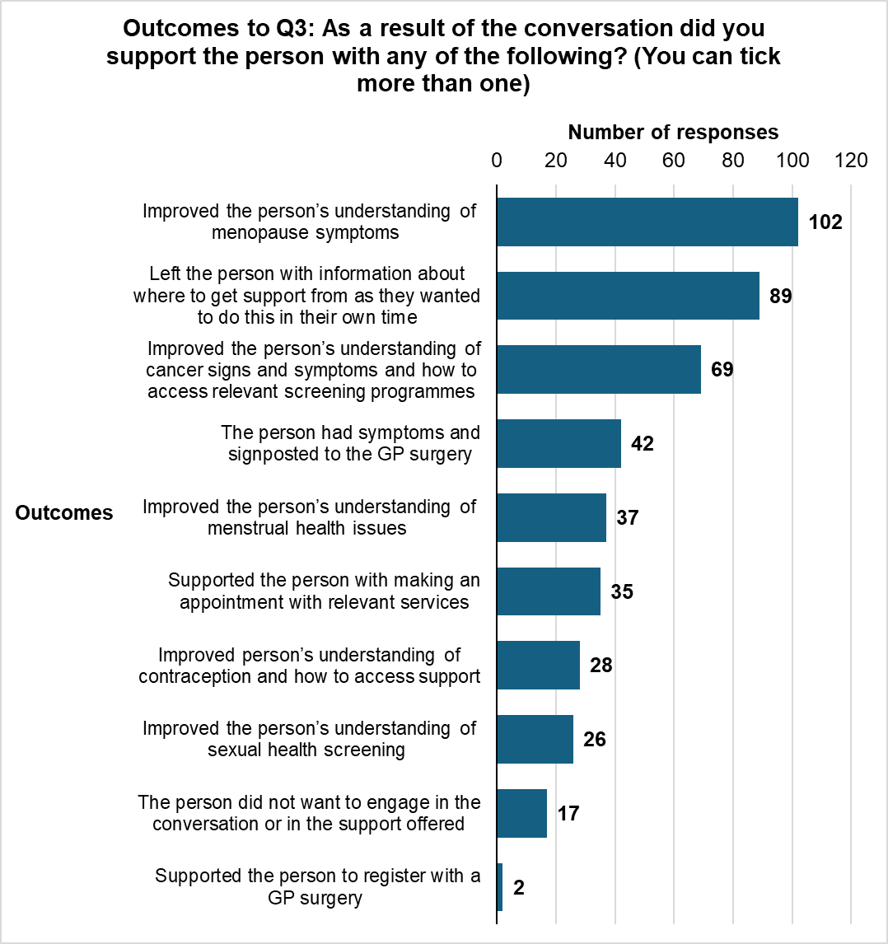

A supplementary open question gave Trusted Communicators the opportunity to explain in further detail the outcome of their conversations. The main outcomes of the conversations were:
- the person or group’s understanding of women's health issues was improved (through conversation, leaflets, signposting)
- people were supported to access treatment or seek further medical advice or care about women’s health issues
- preventative interventions (check-ups and screening) were promoted
- the menopause was discussed in a supportive environment

- The person or group’s understanding of women's health issues was improved (through conversation, leaflets, signposting)
“Supplied the group with leaflets and information to support the management of Menopause sighs , and symptoms, and gave date for next Menopause support group session.”
“The conversation helped the woman better understand the potential signs of perimenopause, such as mood swings, hot flushes, and temperature fluctuations. We also discussed the importance of sexual health screening and contraception, which she had never previously considered.”
“Discussed the importance of breast screening, client wasn't aware about all symptoms, provided a leaflet and helped to arrange the appointment.””
“We had invited a Menopause nurse to speak to out group so this person was able to ask specific questions and receive expert advice there and then.”
“The person was given information about how to access sexual health screening support local to them. We talked about using contraceptives in later life and later life pregnancies, improving the persons knowledge of this.”

- People were supported to access treatment or seek further medical advice/care about women’s health issues
“Support was offered to book and to attend the appointment to help the client feel more confident. Despite requesting a female interpreter during the booking, a male interpreter was provided instead. The male interpreter provided essential information before the procedure but was asked to leave for the examination. Addressed the interpreter issue with the medical center.”
“We are going to book the lady on a one to one support with a menopause support worker.”
“Provided step-by-step guidance on navigating healthcare systems and booking procedures.”

- Preventative interventions (check-ups and screening) were promoted:

“Supported to make an appointment for cervical screening with their GP.”
“The lady has said she is behind on the breast screening we discussed her contacting the breast screening to get a new appointment.”

“X did not need much information as she was already aware of what is available for her at the age she is but she was interested to hear about bowel cancer screening.”

- The menopause was discussed in a supportive environment:
“This lady gained so much from hearing other ladies experiences of the Menopause.”
“We had a lengthy chat about just how many signs and symptoms there are of menopause and gave each other information which was great.”

Q33. What action was taken at the time/as a result of your conversation?

This question consisted of both quantitative and qualitative elements. Trusted Communicators were asked to tick relevant outcomes of their conversations from a list (quantitative) but were also given the opportunity to describe their actions (qualitative).
There were 43 responses to the open-text qualitative part of this question.
The most frequently mentioned outcome was supporting the person to access treatment or seek further medical advice about women’s health issues. A summary of these outcomes is provided in Figure 2 below.
Figure 2: Summary of reported actions taken at the time/as a result of the conversation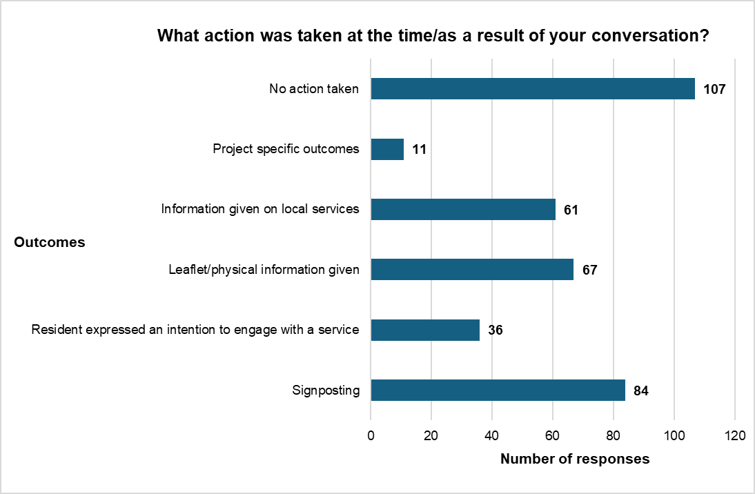

Q34. If relevant, please give information about the actions taken, such as which organisations you signposted to.
There were 127 responses to this question.
Trusted Communicators signposted people to their GP in many cases but also used their local and professional knowledge to direct people to charities, useful websites, and specialist medical teams. Women were signposted to:
- iCASH (noted ten times), Suffolk Sexual Health service, early pregnancy assessment unit
- Monthly menopause café, The Menopause Charity, Menopause Matters, menopause webinars being held by Daisy Programme during this project.
- Big C centre, James Paget Cancer support group, Keeping Abreast
- Norfolk and Waveney Mind, BEAT eating disorder support, mental health support services
- “Help to access Bupa which is an employ benefit,” Access to work
- Events at the local hospital and surgery, NHS website
Report title: Community Voices Women’s Health Report
Report Date: 19 June 2025
Report authors: Ellie Phillips, Sophie Bitten and Lizzie Benefer, NODA, Insight and Analytics, Norfolk County Council
Co-authors: Amrita Kulkarni, Community Voices Norfolk and Waveney Integrated Care Board

Appendix 1:

Ripple Effect Mapping analysis: intended and unintended impacts of Community Voices Women’s Health conversations on staff (trusted communicators), participating organisations and women in under-served communities

Appendix 2

Ripple Effect Mapping analysis: Facilitators and Barriers to women’s health conversations as discussed by trusted communicators during the sessions

