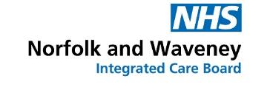

Our plans for NHS dental services in
Norfolk and Waveney

Tell us what you think.



What is this survey about?

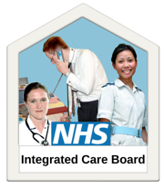 | We are NHS Norfolk and Waveney Integrated Care Board.  An integrated care board or ICB for short is the NHS organisation that plans what health services are needed in Norfolk and Waveney and buys them.
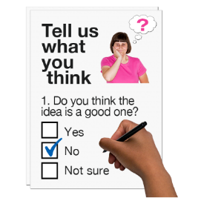  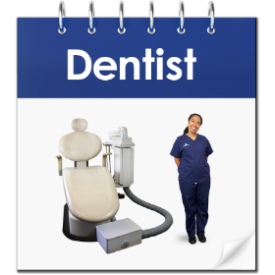 | We are making plans for how we will buy NHS dental services for the next few years.  This easy-read survey is asking for your views on our plans for NHS dental services.
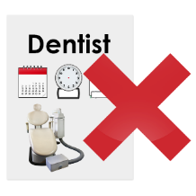  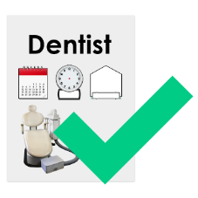 | We know that right now it can be hard to get an NHS dentist appointment. Some people haven’t been able to see a dentist for many years.  We want everyone to be able to see an NHS dentist when they need one.
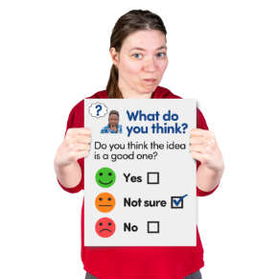   | We have a plan for how we will buy dental services for the next two years.  There are lots of things we need to work on to make it easier for people to see a dentist, but we can’t do everything at once.  Some areas are more important than others, so they will be priorities. We want to know what you think about these priorities.

Our plans for dental services

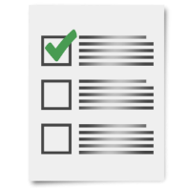 | There are four areas that we plan to focus on over the next two years:
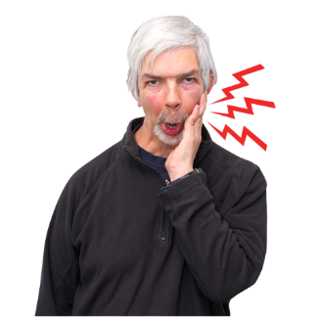 | Urgent Care:  We want to pay dental practices to provide more urgent treatment appointments on the NHS.  This would mean that if you were in pain and a healthcare professional says you need urgent help, you could get an NHS dental appointment within 48 hours.
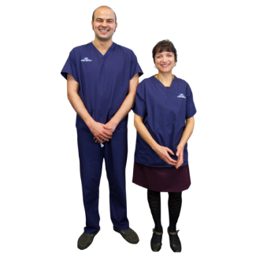 | More dental professionals:  We need to get more dentists and dental professionals to work in Norfolk and Waveney.  Without more dentists and dental professionals, we can’t help everyone see a dentist that needs one.
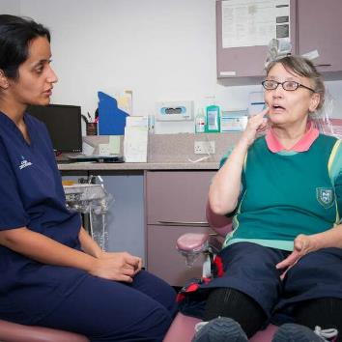 | Get a dentist appointment:  We want everyone to be able to see an NHS dentist when they need one.  But until there are more dentists in our area, that can’t happen.  Over the next two years, we want to make sure that children and young people can see a dentist, as well as people who have the greatest health needs.
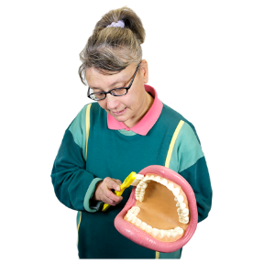  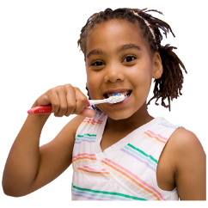 | Help people manage the health of their teeth and mouth:  If your teeth and mouth are unhealthy, it can have a big impact on other areas of your life.  We want to make sure that people have the right advice, education, and tools to look after their teeth and mouths at home.  This also includes supporting parents to help look after their children’s teeth and mouths.

Our survey - what do we want to know?

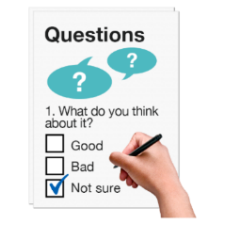 | These are the questions we would like to ask.
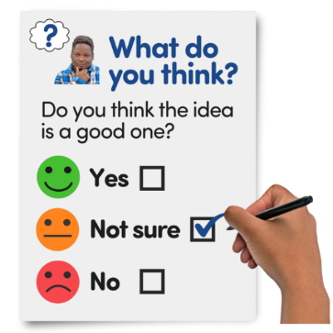 | 1. How much do you agree that the four priorities described above are the right priorities?  ☐ Strongly Agree  ☐ Agree  ☐ Disagree  ☐ Strongly Disagree  ☐ I Don’t Know
 | 2. Do you have anything you would like to say about our plans?  Please tell us below:
  I think… | We are also making plans for dental services over the next 5 years.  3. What matters most to you when it comes to your dental health?
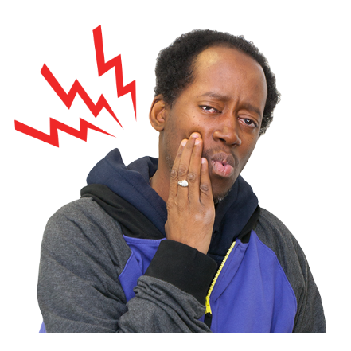 | 4. Last year we set up an Urgent Treatment Service so that people could get urgent help when they are in pain.  Have you used this Urgent Treatment Service?  ☐ Yes  ☐ No  ☐ I am not sure  The rest of the survey asks more questions about the Urgent Treatment Service.  If you said No, or I am not sure to the last question, you can go to Page 8.  If you have used it, how did you get an appointment?  ☐ Through NHS 111  ☐ By calling a local dental practice  ☐ I don’t remember  If you have used it, how would you describe your experience?  ☐ Very Good  ☐ Good  ☐ Just OK  ☐ Not Very Good  ☐ Terrible  ☐ Something else  Use the space below if there is anything else you want to say about the Urgent Treatment Service:

Our survey – tell us about you

You do not have to answer these questions, but if you do it helps us make sure we are hearing from a lot of different people.

What is your age? Tick one box:

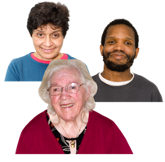 | ☐ Under 18  ☐ 18 - 24  ☐ 25 - 34  ☐ 35 - 44  ☐ 45 – 54  ☐ 55 - 64  ☐ 65 - 75  ☐ 75+
How do you describe yourself?
 | ☐ Male
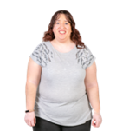 | ☐ Female
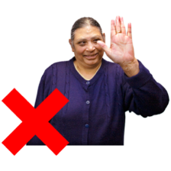 | ☐ Prefer not to say
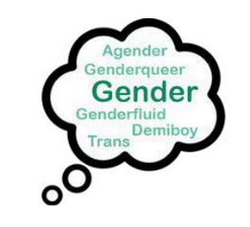 | ☐ I use a different word to describe myself:  __________________________________
Where do you live?
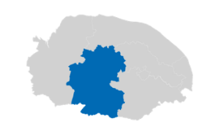 | ☐ Breckland
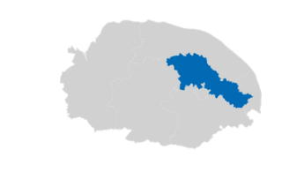 | ☐ Broadland
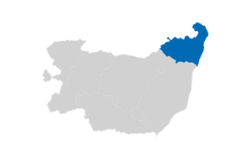 | ☐ East Suffolk (Waveney area)
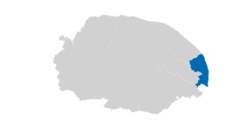 | ☐ Great Yarmouth
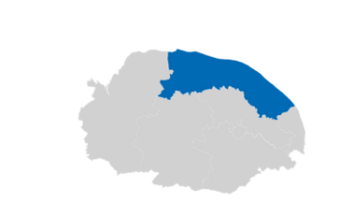 | ☐ North Norfolk
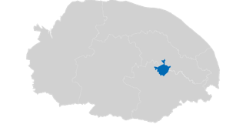 | ☐ Norwich
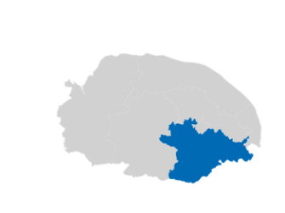 | ☐ South Norfolk
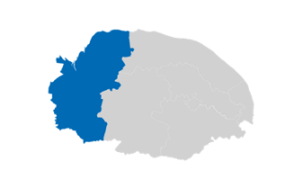 | ☐ West Norfolk
 | ☐ I live somewhere else. I live in:  __________________________________
What is your ethnic group?

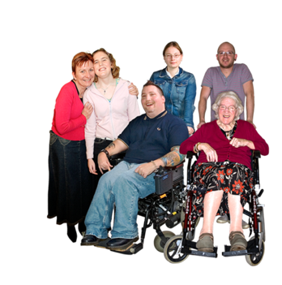 | ☐ Prefer not to say
  White
  ☐ English/Welsh/Scottish/Northern Irish or British
  ☐ Irish
  ☐ Gypsy or Irish Traveller
  ☐ Roma
  ☐ Any other White background
  _________________________
  Mixed
  ☐ White & Black Caribbean
  ☐ White & Black African
  ☐ White & Asian
  ☐ Any other mixed or multiple ethnic background
  ___________________________
  Asian or Asian British
  ☐ Indian
  ☐ Pakistani
  ☐ Bangladeshi
  ☐ Chinese
  ☐ Any other Asian background
  _________________________
  Black or Black British
  ☐ Caribbean
  ☐ African
  ☐ Any other Black background _________________________
  Arab
  ☐ Arab
  ☐ I am from a different ethnic background that is not on this list:
  ____________________________


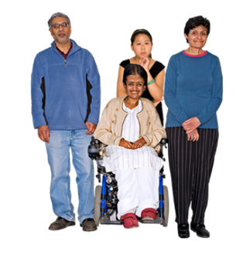
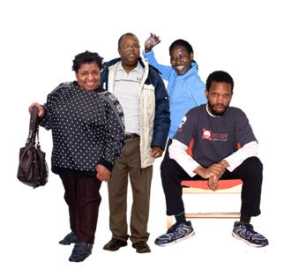
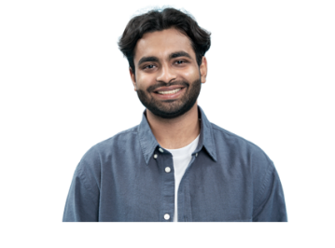

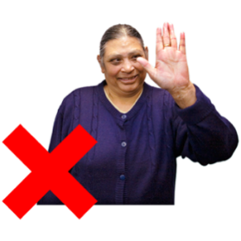
Can we contact you again?

 | Would you like us to contact you for other surveys? This could be for surveys about dental services, or other health services.  If yes, what is your email address?  We will not give your email address to anyone else.

How can I take part in the survey?

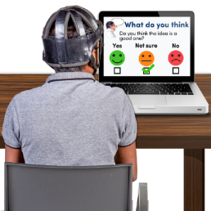 | Online by clicking this link:  https://www.smartsurvey.co.uk/s/dental-priorities-survey/
 | You can fill in this survey and email it to us at nwicb.haveyoursay@nhs.net
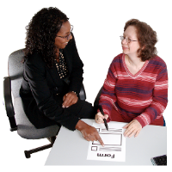   | If you want a paper copy of this survey to fill in, you can telephone or email us and we will send you one.    Call this number:  01603 595857    Email us:  nwicb.contactus@nhs.net
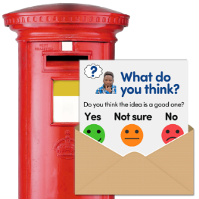 | By post. You can send it for free to:  Freepost RTCL-XSTT-JZSK  County Hall  Martineau Lane  Norwich  NR1 2DH
 | Our survey closes on Wednesday 21 February 2024.
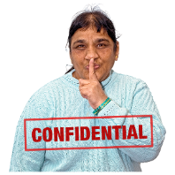 | Our survey is anonymous. This means you should not use any information or tell us anything that might identify you personally.
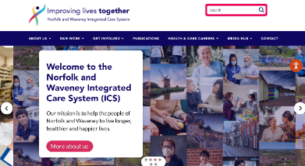 | We have made a special webpage about this survey. You can see it on our website by clicking here:  https://improvinglivesnw.org.uk/dental-engagement/  There is more easy read information on the NHS Norfolk and Waveney ICB website: https://improvinglivesnw.org.uk/about-us/easy-read/

