This is the area you need to keep clear for docmail to add the name and address into.

The size of the area is 7cm wide and 4cm deep.

Dear <<fullname>> <<date2>>

RE: “Keeping Well at Home”
Living in a cold home can increase the risk of health problems. With the current cost of living pressures, many households are struggling to pay for essential heating to stay warm. Your local NHS service is collaborating with Borough Council of King’s Lynn and West Norfolk to ensure residents receive all the financial support they may be eligible for, helping them stay warm and healthy at home this winter.
Staying warm in winter is vital for your health, helping to prevent colds, flu, and severe illnesses like heart attacks and pneumonia. Maintain a comfortable temperature of at least 18°C in regularly used rooms, especially if you have existing health conditions.
The Borough Council of King’s Lynn and West Norfolk can help your home qualify for energy efficiency improvements through the ECO Flex program. Funding is provided by energy companies, and approved installers carry out the work. The Housing Standards team is available to discuss your eligibility and support options.
This funding could significantly impact your home, your energy bills, and your health. The Council and NHS are working together to ensure these offers are genuine, and we hope you will be interested in learning more.
Who can be referred to this service?
Referrals to the program are only for individuals who meet all the following criteria:
You must either live with or be diagnosed with one or more of the following conditions:
- Cardiovascular disease
- Chronically Respiratory Disease
- An Immunosuppressed system
- Limited mobility

We recognize that everyone's circumstances are unique, and you may have questions or concerns. To assist you, we have created a simple questionnaire that allows you to raise any queries and provides practical help and support, including the option to speak to someone.

You can access the questionnaire online at www.nhspatient.org You can log in by entering your date of birth and your NHS number, which is provided below. The questionnaire can be completed in just a few minutes.

Your NHS number is: <<NHS number>>

We want to highlight some financial support options that could assist you. One of our experienced NHS team members will contact you in the next few weeks to explain the offers available to you, so please be on the lookout for our call from the number 01603 257 000.

If you have trouble accessing or completing the questionnaire, a member of our Virtual Support Team will follow up with a phone call to assist you in finishing it and to offer any additional support you may need. If you prefer not to participate, please inform the call handler, and we will record this to ensure you are not contacted again.

Alternatively, if you would like to discuss this further, you can contact the Borough Council of King’s Lynn and West Norfolk Housing Standards team at Housing.Standards@West-Norfolk.gov.uk or 01553 616 227.

Kind regards,

Emily Clark
Dr Emily Clark BSc.(Hons), MBBS MRCGP DCH DFSRH
Norfolk and Waveney ICB Population Health Management Clinical Advisor

And

Jacob Medlock
Housing Standards Officer (Energy Efficiency)
Borough of King’s Lynn and West Norfolk

Keeping Well at Home

 | Why are you getting this letter?
 | 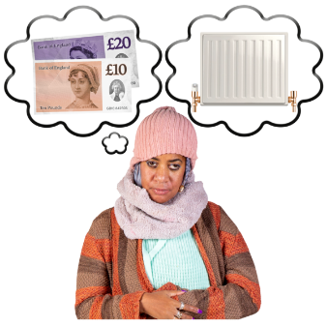 | Borough Council of King’s Lynn and West Norfolk and NHS are supporting people to keep warm this year. You might be able to access some support.
 | 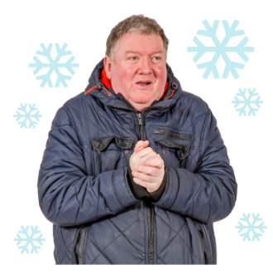 | It is normal to feel worried or stressed especially during this time.
 | 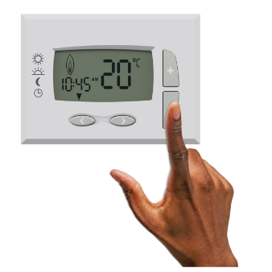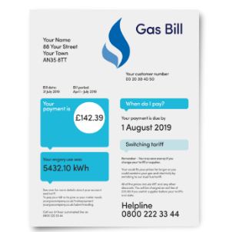 | Your local NHS and Borough Council of King’s Lynn and West Norfolk will try to support you by advising you about possible money help for your energy, or other costs of living.
What you should do after getting the letter
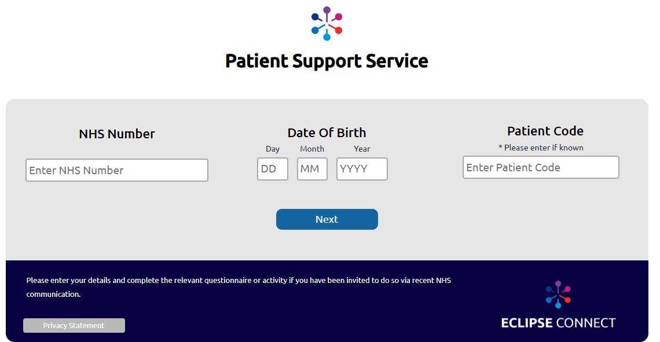 |  |  | Please log on to this website:  www.nhspatient.org
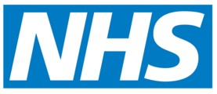  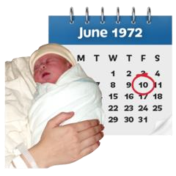 |  |  | To open the form you will need to put in:  - your NHS number  - your date of birth  You can find your NHS number in the letter we have sent you with this leaflet
 |  |  | After you have put in your NHS number and your date of birth, click the button that says ‘Go to My Homepage’  - This will take you to an online form.  - It will only take you about 5 minutes to fill in the form
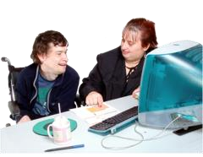 |  |  | If you cannot fill in the form yourself, ask a family member or friend if they can help you

Here’s what you should do if you can’t fill in the form online
 | Wait for a call from a member of our NHS team.
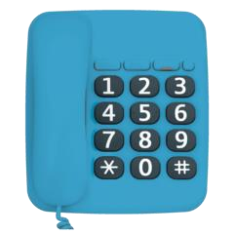 | You can also contact the Borough Council of King’s Lynn and West Norfolk on 01553 616227 for direct contact and additional clarity on the support available.

