Social Media Messaging from Friday 3 March 2023

Post/Time | Post Copy | Artwork
1  Date/Time | FACEBOOK:  📢Can you help us design a recruitment process that is open and accessible for everyone?  🤝We are recruiting people with lived experience of local health and care services to join our Patients and Communities Committee. We want help designing the information pack.  🗣️More information and how to feedback are available on our webpage  https://improvinglivesnw.org.uk/can-you-help-us-recruit-lived-experience-representatives-for-our-patients-and-communities-committee/  TWITTER:  📢Can you help us design a recruitment process that is open and accessible for everyone?  🤝We want help designing recruitment information for lived experience representatives on our patients and communities committee  🗣️Read more and feedback here  https://improvinglivesnw.org.uk/can-you-help-us-recruit-lived-experience-representatives-for-our-patients-and-communities-committee/ | 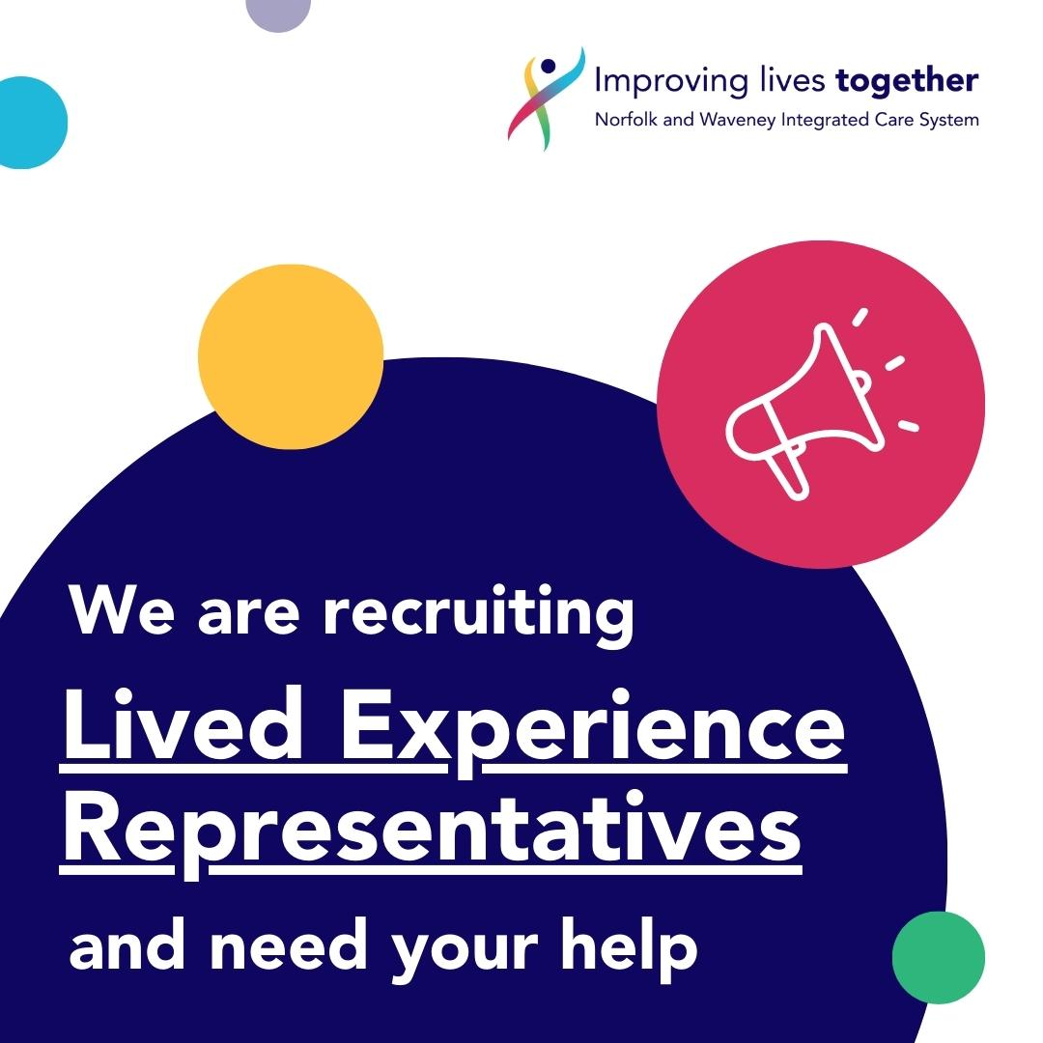
2  Date/Time | FACEBOOK:  📢Can you help us design a recruitment process that is open and accessible for everyone?  🤝We are recruiting people with lived experience of local health and care services to join our Patients and Communities Committee. We want help designing the information pack.  🗣️More information and how to feedback are available on our webpage  https://improvinglivesnw.org.uk/can-you-help-us-recruit-lived-experience-representatives-for-our-patients-and-communities-committee/  TWITTER:  📢Can you help us design a recruitment process that is open and accessible for everyone?  🤝We want help designing recruitment information for lived experience representatives on our patients and communities committee  🗣️Read more and feedback here  https://improvinglivesnw.org.uk/can-you-help-us-recruit-lived-experience-representatives-for-our-patients-and-communities-committee/ | 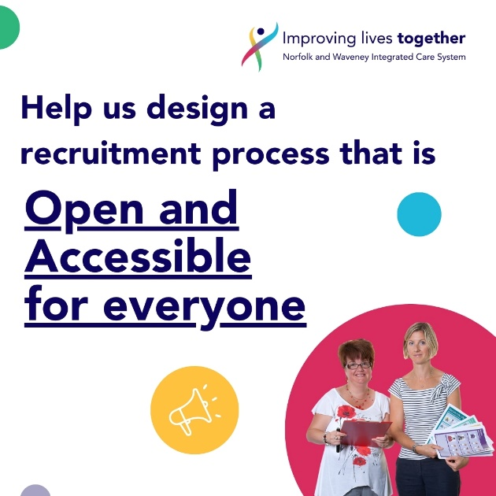
3  Date/Time | FACEBOOK:  📢Norfolk and Waveney ICB are recruiting lived experience representatives for their Patients and Communities Committee  🤝Can you help us design the information so that it appeals to lots of different people? We want people at the heart of what we do.  👀Let us know your ideas and experiences. You can find out more and feedback here  https://improvinglivesnw.org.uk/can-you-help-us-recruit-lived-experience-representatives-for-our-patients-and-communities-committee/  TWITTER:  📢Norfolk and Waveney ICB are recruiting lived experience representatives for their Patients and Communities Committee  🤝Can you help us design the information so that it appeals to lots of different people? We want people at the heart of what we do.  👀Let us know your ideas and experiences. You can find out more and feedback here  https://improvinglivesnw.org.uk/can-you-help-us-recruit-lived-experience-representatives-for-our-patients-and-communities-committee/ | 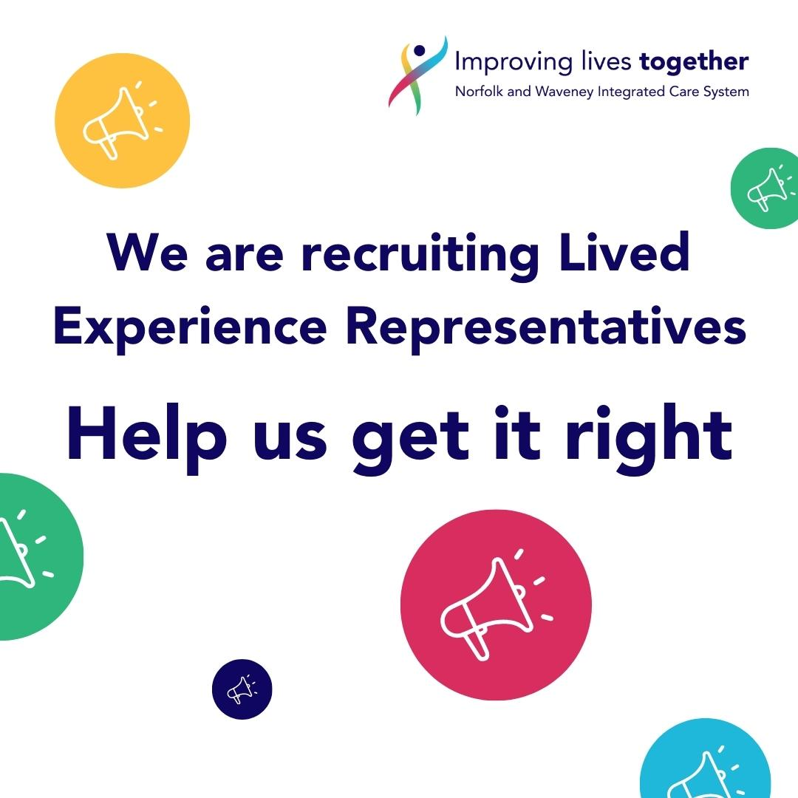
4  Date/Time | FACEBOOK:  📢Norfolk and Waveney ICB are recruiting lived experience representatives for their Patients and Communities Committee  🤝Can you help us design the information so that it appeals to lots of different people? We want people at the heart of what we do.  👀Let us know your ideas and experiences. You can find out more and feedback here  https://improvinglivesnw.org.uk/can-you-help-us-recruit-lived-experience-representatives-for-our-patients-and-communities-committee/  TWITTER:  📢Norfolk and Waveney ICB are recruiting lived experience representatives for their Patients and Communities Committee  🤝Can you help us design the information so that it appeals to lots of different people? We want people at the heart of what we do.  👀Let us know your ideas and experiences. You can find out more and feedback here  https://improvinglivesnw.org.uk/can-you-help-us-recruit-lived-experience-representatives-for-our-patients-and-communities-committee/ | 