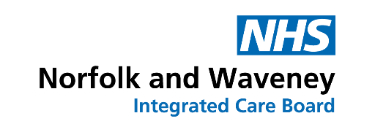
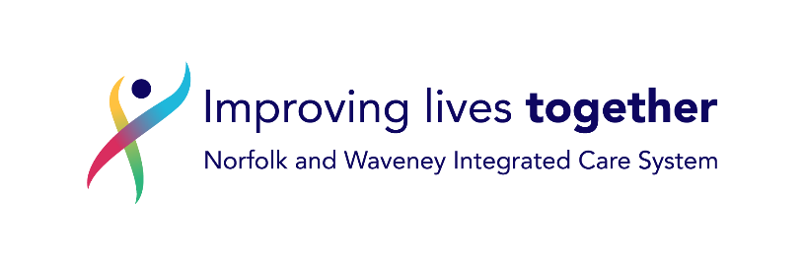

2023/24 Continuing Healthcare Uplift Tariff – Frequently Asked Questions Document

Q1: For care home costs why have tiers 2, 3 and 4 only been awarded an uplift of 2.5%. when tier 1 has had an 8.21% uplift?
Answer: As a commissioner we are working within a financial envelope that is affordable to Norfolk and Waveney Integrated Care Board (ICB). Therefore, the decision regarding the uplift rates is the final decision of the ICB.

Q2: Why do some packages have no automatic tariff uplift?
Answer: In recognition of the significant investment the ICB has made to ensure the sustainability of CHC prices going forward, the ICB is expecting bespoke packages or requests from providers for Tier prices above the identified clinical needs of individuals, to be by exception and such requests will require ICB executive sign off.
Where it has been evidenced at review; care need driven packages (bespoke C) will be considered for up to a 2.5% uplift. All remaining packages will be considered as being price driven and no uplift will be applied.

Q3: If I wish to escalate the issue of a tariff uplift what process should be followed?
Answer:
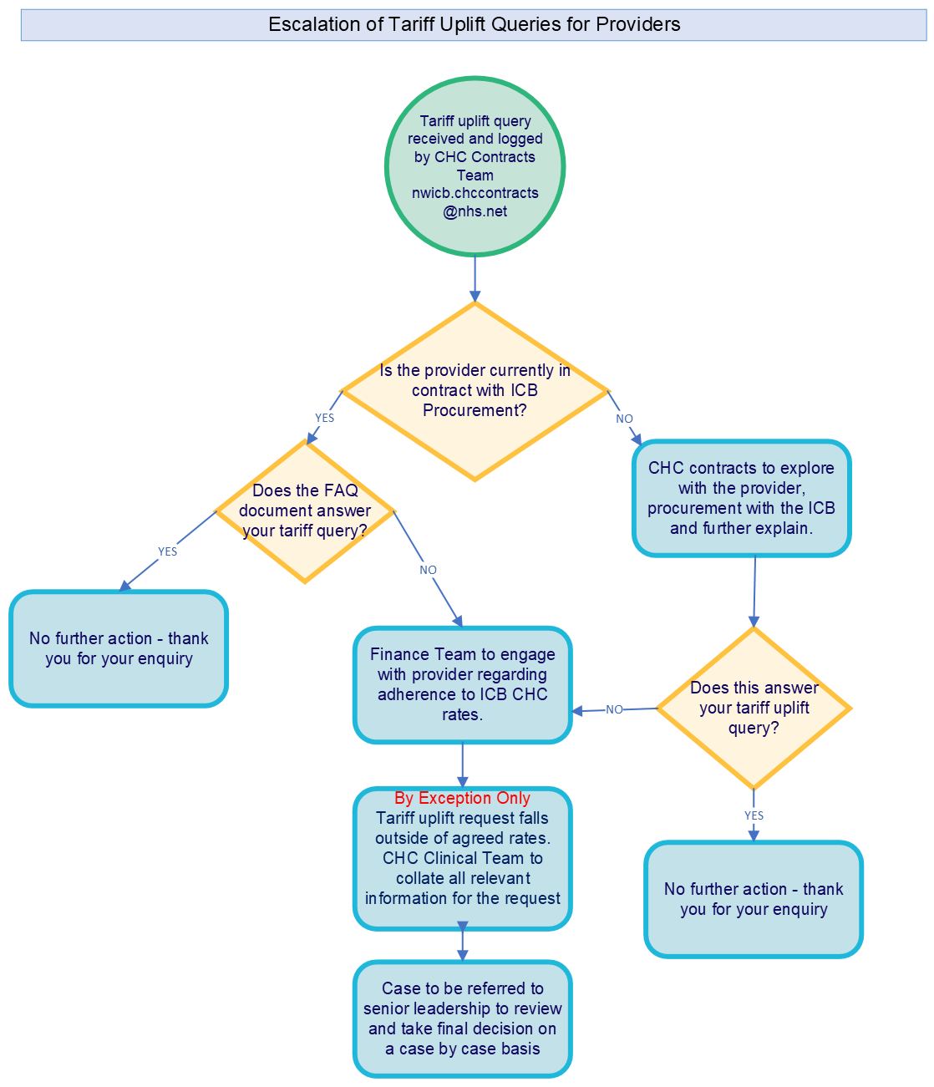

Q4: What is the date from which the uplifts will be applied?
Answer: Start date is Monday 10 April 2023. This date aligns with the increase date for our Local Authority partners (Norfolk County Council and Suffolk County Council).

Q5: When will I see the new prices applied to the Care and Service Agreements (CASA)?
Answer: CASAs for the new package prices will be available as of 1 July 2023. For the time period from 10 April 2023 to 30 June 2023 there will be a ‘bridging package’ to enable backdating of the uplift.

For any queries that are not covered in the above document please use the following contact details to raise your question / query:

Questions relating specifically to contractual issues please email: nwicb.chccontracts@nhs.net

Questions relating specifically to individual packages please email
nwicb.chcinvoicevalidation@nhs.net

