RE: Smokefree Pregnancy Support
Your maternity service is working alongside the local stop smoking service (Smokefree Norfolk) to support you to have a Smokefree Pregnancy. Stopping smoking during pregnancy can be a challenge, but with the right support you are much more likely to succeed.
What are the benefits of having a Smokefree pregnancy?
- Less likely to suffer from morning sickness
- Less likely to suffer a miscarriage, stillbirth, or premature birth
- Your baby is more likely to be born a healthy weight
- More likely to recover from birth quickly and have a shorter stay in hospital
What support can Smokefree Norfolk offer?
- A friendly conversation with a specialist advisor via telephone
- A safe space to discuss your smoking
- Medications to support your quit attempt, which can be used during pregnancy
- A free 12-week vape scheme to help you switch from smoking tobacco
We understand that everyone’s journey to stop smoking is different, and that you may have questions or feel worried. To help you with this, we have set up a simple questionnaire that allows you time to think about your smoking and if you would like support to quit.
If you would like to check the authenticity of this letter, then please do visit the Norfolk and Waveney Integrated Care System website at (need to include the ICB link on both letters)
So that you can learn more about the support available to you, please visit our website https://www.smokefreenorfolk.nhs.uk/.
If you would prefer to speak with someone, please call us on 01603 257 258 and leave your name and telephone number and a member of the team will then call you back to assist. The purpose of this phone line is to assist those who need help in completing a referral, it is not a general enquiries number.

If you do not wish to participate, please let the call handler know and this will be recorded so you are not contacted again.

This number can also be used to leave a message if you have specific communication needs: we want the information to be accessible to everyone. We have also enclosed an ‘easy read’ version of this letter. Please do get in touch if you are unsure about anything.
Kind regards,
James Wade
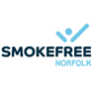
Operations Manager Smokefree Norfolk

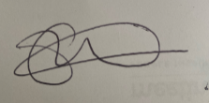
Emma Wiskin
Public Health Midwife,
Norfolk and Waveney Local Maternity and Neonatal system

Smokefree Pregnancy Letter
Why are you receiving this letter?

 | Your Midwife is working is working with the local stop smoking service.
 | To help you to quit smoking because smoking during pregnancy is very harmful
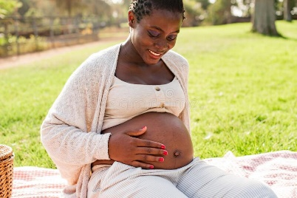 | Smokefree Norfolk can help you
   | Smokefree Norfolk can help you in lots of different ways, like talking to people and taking medication to help you quit smoking
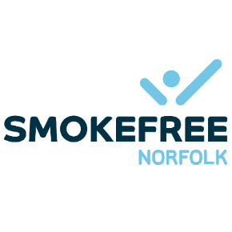 | You can learn more about our service on the website:  https://www.smokefreenorfolk.nhs.uk/

Here’s what you should do if you can’t go online
  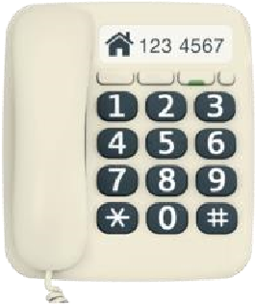    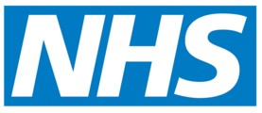 | Please phone: 01603 257 258  Leave a message on our answerphone telling us:  - your name  - your phone number  - your NHS number
 | A member of our NHS team will call you back and help you
 | Please only call the number above if you need help to complete your referral  We will not be able answer any other questions on this number

