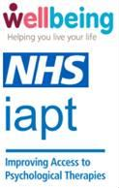

RE: Wellbeing support
Your GP surgery is working alongside the NHS Wellbeing Service to support your mental wellbeing, and we’d like to tell you a bit more about how we can help. It’s completely normal to feel anxious, stressed or low, especially in these times, and there are many ways that we can support you through this to help you feel more like yourself again.

The NHS Wellbeing Service offers a wide range of webinars and talking therapies, including counselling and cognitive behavioural therapy. This can be tailored according to your age and your needs and provided virtually or face to face. Alongside this Wellbeing also offer social support within your community including peer support with trained volunteers, employment advice and social events which can help with loneliness and isolation.

So that you can learn more about the support available to you, please visit our website www.wellbeingnands.co.uk/norfolk/ or call 0300 123 1503

We understand that everyone’s circumstances are unique and that you may have questions or feel worried. To help you with this, we have set up a simple questionnaire that allows you to raise any queries you may have and offers practical help and support, including the option to speak to someone.

You can access the questionnaire online at www.nhspatient.org You can log in by adding your date of birth and your NHS number, which is listed below. The questionnaire can be completed in a few minutes.

Your NHS number is: <<NHS number>>

If you are unable to access or complete the questionnaire, a member of our Virtual Support Team will follow up the letter with a phone call to assist you in completing the questionnaire and to offer any further support. If you do not wish to participate, please let the call handler know and this will be recorded so you are not contacted again.

If you would prefer to leave a voice message, please call us on 01603 257010 and leave your name and telephone number and we will get back to you as soon as possible.
This number can also be used to leave a message if you have specific communication needs: we want the information to be accessible to everyone. We have also enclosed an ‘easy read’ version of this letter. Please do get in touch if you are unsure about anything.
To check the authenticity of this letter, please search for IAPT letter on Norfolk and Waveney Integrated Care System (ICS) (improvinglivesnw.org.uk)

Kind regards,
Nesta Reeve - Consultant Clinical Psychologist/ Clinical Lead for Norfolk and Suffolk Wellbeing Services

Dr Ardyn Ross - Mental Health Clinical Lead, Norfolk and Waveney Integrated Care Board
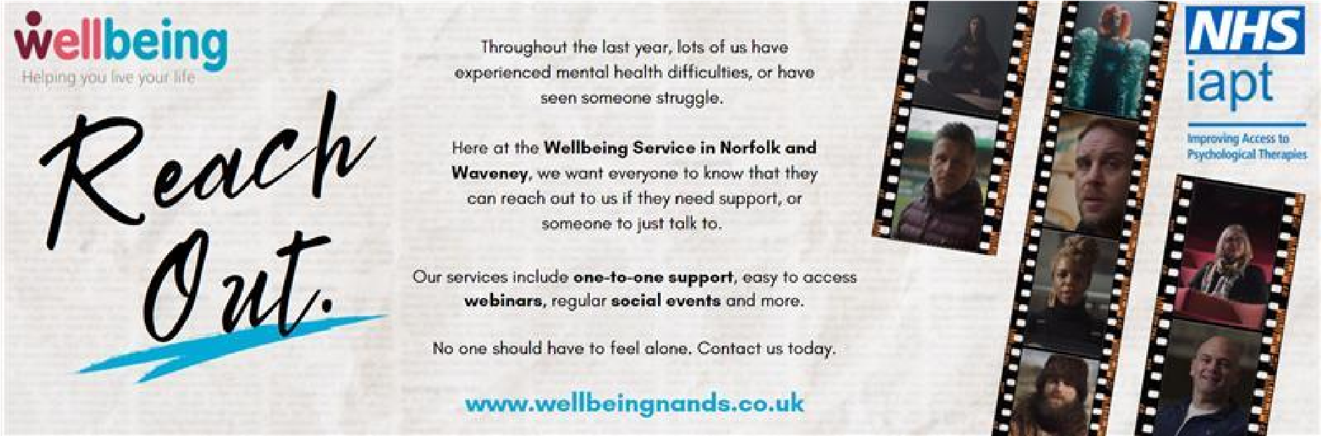

Wellbeing Service Letter
Why are you receiving this letter?
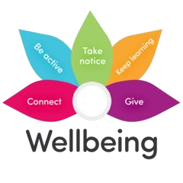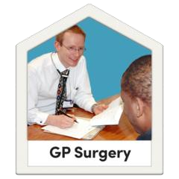 | Your GP (doctor) is working with the local NHS Wellbeing Service to support your mental wellbeing
 | It is normal to feel worried, stressed or low especially during Coronavirus  (COVID)
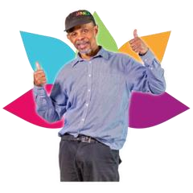 | The NHS Wellbeing Service can help you feel more like yourself again
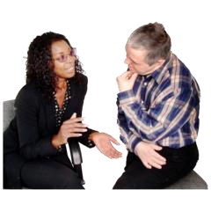  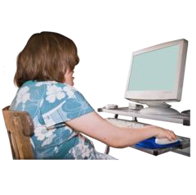 | The NHS Wellbeing Service can help you in lots of different ways, like learning new things online or talking to people
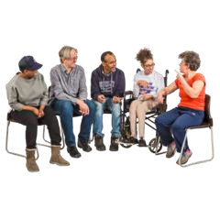   | We also offer social events and employment advice.
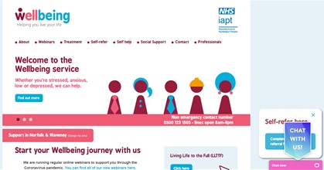 | You can learn more about our service on the website:  www.wellbeingnands.co.uk/norfolk/

Do you want to ask questions?
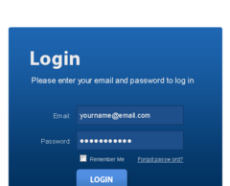 | Please log on to this website:  www.nhspatient.org
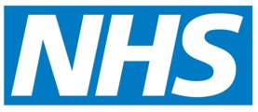  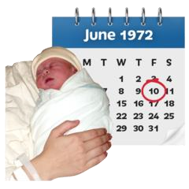 | To open the form you will need to put in:  - your NHS number  - your date of birth  You can find your NHS number in the letter we have sent you with this leaflet
 | After you have put in your NHS number and your date of birth, click the button that says ‘Go to My Homepage’
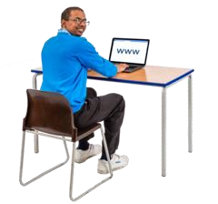 | This will take you to an online form.  You can ask questions or get help.  You can ask to speak to someone.
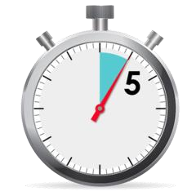 | It will only take you about 5 minutes to fill in the form
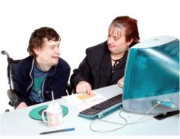 | If you cannot fill in the form yourself, ask a family member or friend if they can help you

Here’s what you should do if you can’t fill in the form online
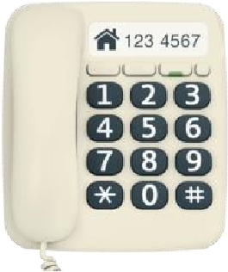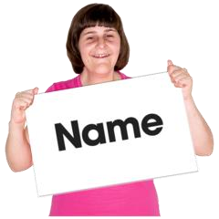 | Please phone: 01603 257010  Leave a message on our answerphone telling us:  - your name  - your phone number  - your NHS number
 | A member of our NHS team will call you back and help you
 | Please only call the number above if you need help to fill in the form  We will not be able answer any other questions on this number
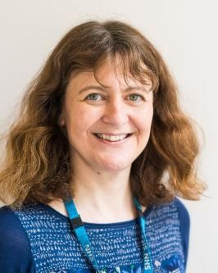 | This letter was sent from Nesta Reeve  and Dr Ardyn Ross  We work for the NHS in Norfolk and Waveney helping people with their mental health

