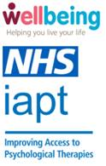

RE: Wellbeing support
Your GP surgery is working alongside the NHS Wellbeing Service to support people aged 65 and above with their emotional wellbeing. It’s completely normal to feel anxious, stressed, or low, especially if you’re worrying about the rising cost of living or have recently retired, lost a loved one or had a fall; and sometimes you can feel low or stressed without any obvious trigger, but we can support you to feel more like yourself again.

The Wellbeing Service offers a range of talking therapies, workshops and groups that are proven to reduce feelings of worry and low-mood, especially for those aged 65 and above. To find out more about how we can support you, please read the leaflet enclosed.

We’d also like to invite you to a short workshop called ‘Wellbeing over 65: Living well in later life’, aimed at supporting people in this age group who feel low or worried. It includes information on how to notice when you’re feeling this way, and some useful tools to help you feel better.

To book onto this workshop or refer yourself into the service to explore all the options we have available, please go to www.nhspatient.org, where you’ll be asked to complete a few questions and find our online referral form. You can log in by adding your date of birth and your NHS number, which is listed below.

Your NHS number is: <<NHS number>>

If you do not have access to a computer, or need support in completing the questionnaire, our support team is on hand to help. Please leave a voice message, with your name and telephone number on 01603 257 010 and we will then get back to you as soon as possible.

This number can also be used to leave a message if you have specific communication needs: we want the information to be accessible to everyone. We have also enclosed an ‘easy read’ version of this letter. Please do get in touch if you are unsure about anything.
To check the authenticity of this letter, please search for IAPT letter on Norfolk and Waveney Integrated Care System (ICS) (improvinglivesnw.org.uk)

Kind regards,
Nesta Reeve - Consultant Clinical Psychologist/ Clinical Lead for Norfolk and Suffolk Wellbeing Services

Dr Ardyn Ross - Mental Health Clinical Lead, NHS Norfolk and Waveney Integrated Care Board

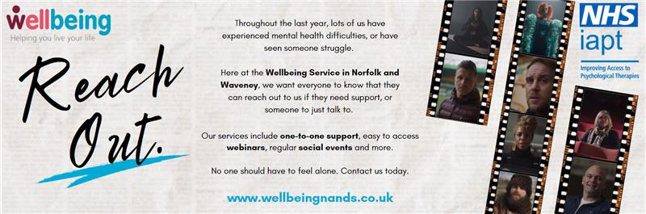

Wellbeing Service Letter
Why are you receiving this letter?
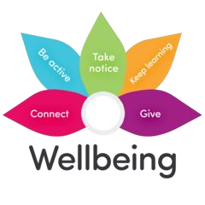  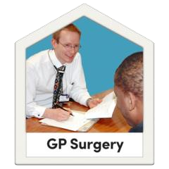 | Your GP (doctor) is working with the local NHS Wellbeing Service to support your mental wellbeing
 | It is normal to feel worried, stressed, or low especially during Coronavirus  (COVID)
 | The NHS Wellbeing Service can help you feel more like yourself again
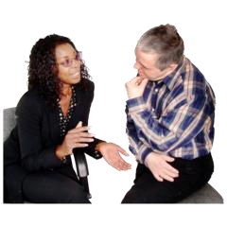  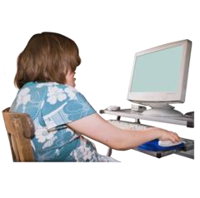 | The NHS Wellbeing Service can help you in lots of different ways, like learning new things online or talking to people
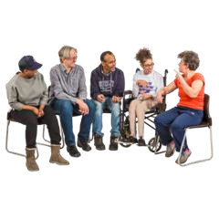 | We also offer social events and employment advice.
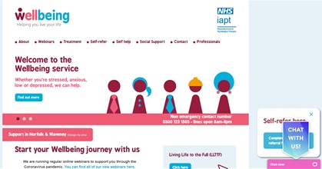 | You can learn more about our service on the website:  www.wellbeingnands.co.uk/norfolk/

Do you want to ask questions?
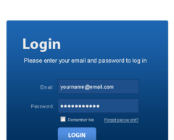 | Please log on to this website:  www.nhspatient.org
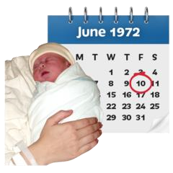  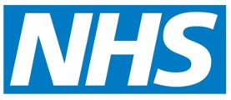 | To open the form you will need to put in:  - your NHS number  - your date of birth  You can find your NHS number in the letter we have sent you with this leaflet
 | After you have put in your NHS number and your date of birth, click the button that says ‘Go to My Homepage’
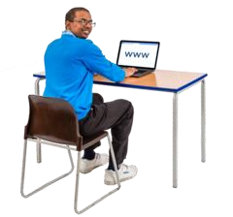   | This will take you to an online form.  You can ask questions or get help.  You can ask to speak to someone.
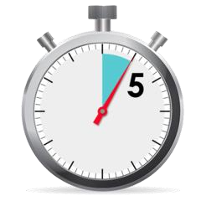 | It will only take you about 5 minutes to fill in the form
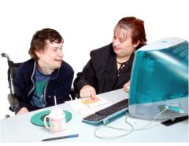 | If you cannot fill in the form yourself, ask a family member or friend if they can help you

Here’s what you should do if you can’t fill in the form online
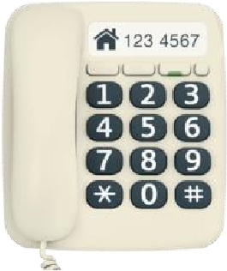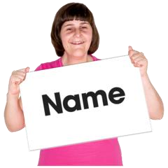 | Please phone: 01603 257010  Leave a message on our answerphone telling us:  - your name  - your phone number  - your NHS number
 | A member of our NHS team will call you back and help you
 | Please only call the number above if you need help to fill in the form  We will not be able answer any other questions on this number
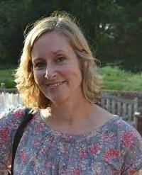  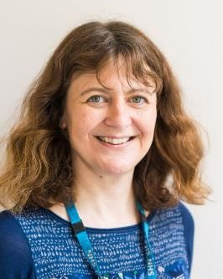 | This letter was sent from Nesta Reeve  and Dr Ardyn Ross  We work for the NHS in Norfolk and Waveney helping people with their mental health

