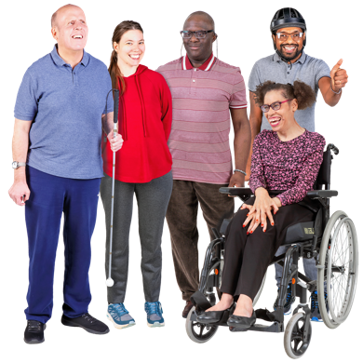 | Survey about Talking Therapy

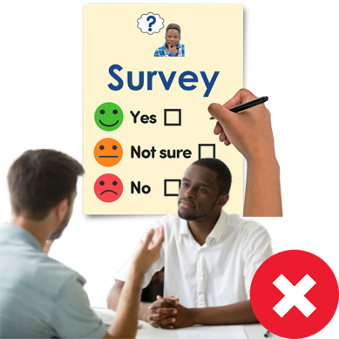 | This survey is for people that have not used NHS Talking Therapy service.

 | What are talking therapies?

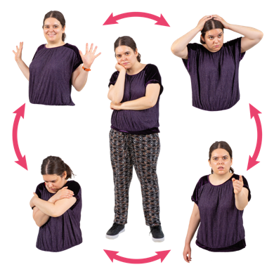 | Talking therapies are for people who have mental and emotional problems like:

Stress |  | 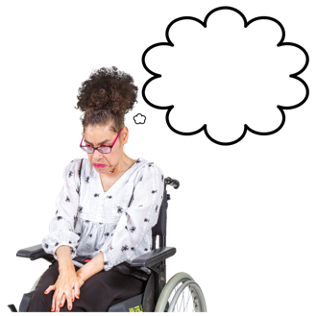 Anxiety |  | Depression

 | Talking therapies involve you being helped by a therapist.

 | A therapist is a health professional who is trained to help people understand and cope with mental and emotional problems.

 | Talking therapies are things such as:

- Cognitive behavioural therapy can help you manage your problems by changing the way you think and behave over time.

 | - Counselling is where a therapist listens to you and helps you find ways to deal with emotional issues

 | - Mindfulness-based therapy helps us to become more aware of our thoughts and feelings. This helps us to see our thoughts more clearly.

 | Norfolk and Waveney Talking Therapy Service

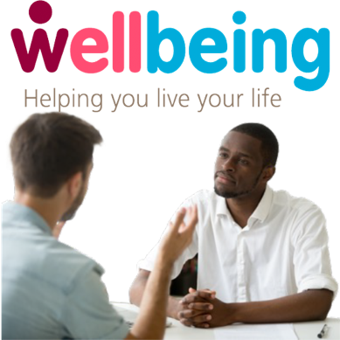 | Our talking therapy service is called Wellbeing in Norfolk and Waveney.

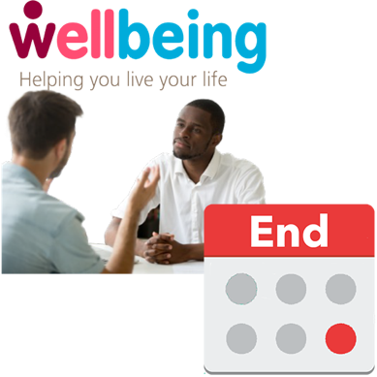 | The agreed amount of time for Wellbeing service doing talking therapies is ending.

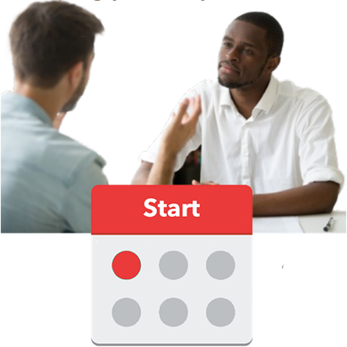 | There will then be another agreed amount of time for an organisation to do a talking therapy service.

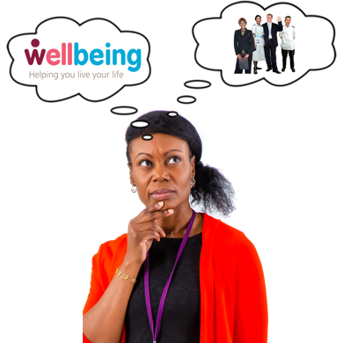 | We need to decide whether we want to continue working with Wellbeing or work with someone else.

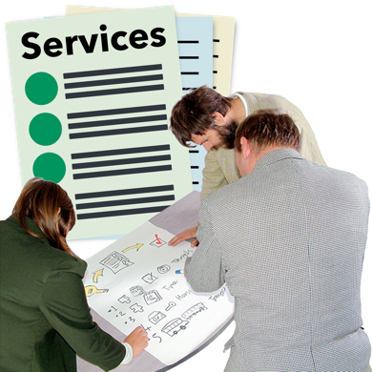 | We will be asking organisations that do talking therapy to tell us how they would run this service

 | We want your help to plan and develop how this talking therapy service is delivered.

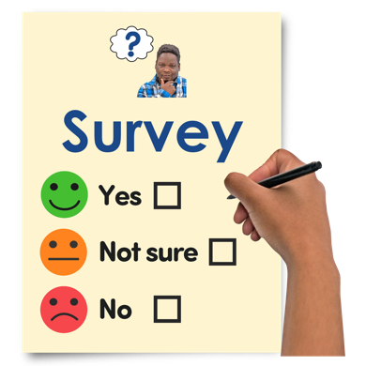 | Why are we doing this survey?

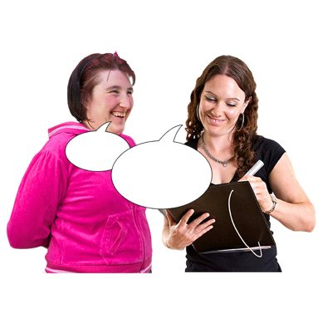 | We will be asking you questions in this survey about:

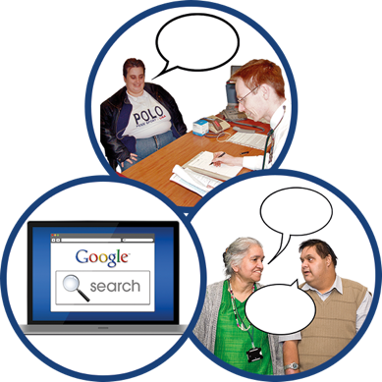 | - Where would you go to find out about talking therapies

 | - What will help you to access talking therapies if you need it

 | - How would you want a talking therapy service to contact you

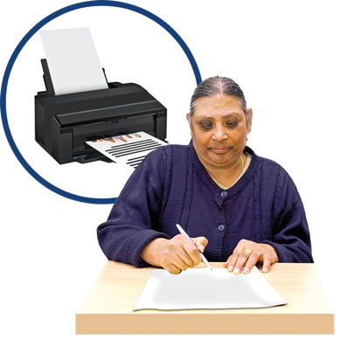 | You can print out the survey and fill it in.

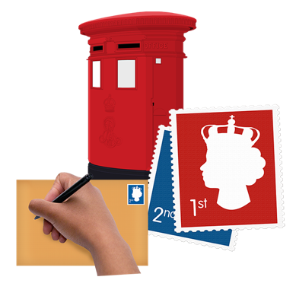 | You can then post back to:  FAO Talking Therapies feedback survey, NHS Norfolk and Waveney ICB, County Hall, Martineau Lane, Norwich, NR1 2DH

 | You can fill out the survey on your computer.

 | You can click on the boxes that are  correct for you.

 | You can type your answers in the  grey boxes after clicking on them.

 | You then save the survey on your computer and send it to:  nwicb.talkabouttalkingtherapies@nhs.net

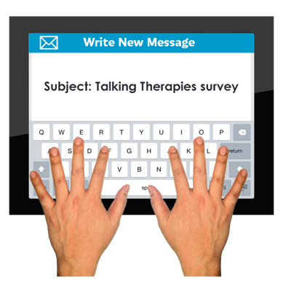 | Give your email the subject title “Talking Therapies survey”

Survey Questions

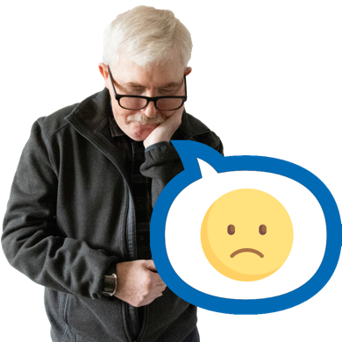 | Question 1.  If you were finding it hard to cope with your thoughts and feelings, who would you speak to about it?  (Tick any boxes that apply to you)

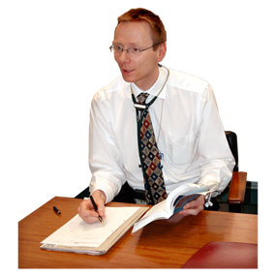 |  | Speak to my doctor (GP)

 |  | Search the internet to find out what support is available

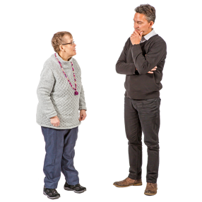 |  | Speak to your employer

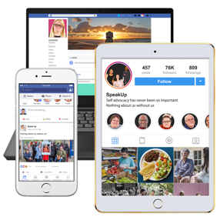 |  | Search on social media

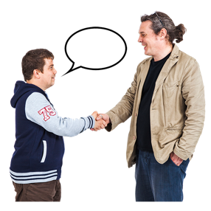 |  | Speak to a friend or other trusted person

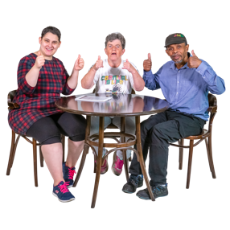 |  | Speak to someone in my community such as a faith/religious group, clubs, or sports groups

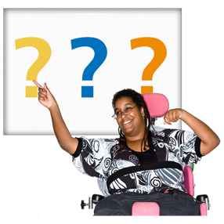 |  | Other – please write details

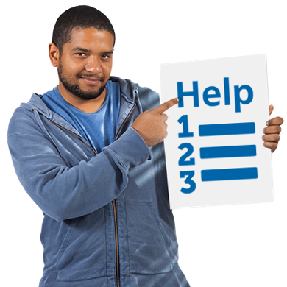 | Question 2.  If you were finding it hard to cope with your thoughts and feelings, where would you go for help?  (Tick any boxes that apply to you)

Speak to my doctor (GP)

Search the internet to find out what support is available

Speak to your employer

Search on social media

Speak to a friend or other trusted person

Speak to someone in my community such as a faith/religious group, clubs, or sports groups

Other – please write details

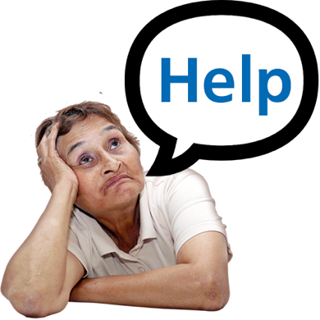 | Question 3.  If you wanted support from an NHS talking therapy service, how would you want to ask for that help? (Tick one box that applies to you)

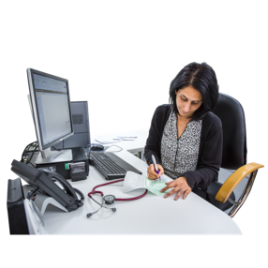 |  | Get your Doctor (GP) or other professional at your doctor’s surgery to refer you

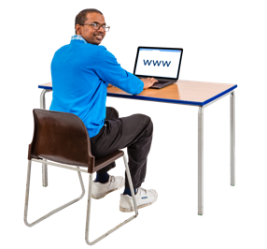 |  | Refer yourself online or get someone supporting you to refer you online

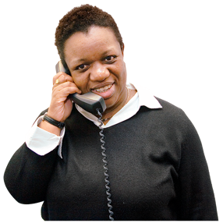 |  | Refer yourself by telephone or get someone supporting you to refer you by telephone

Another way – please write details

 | Question 4.  Have you accessed any support instead of going to NHS Talking Therapies?  (Tick any boxes that apply to you)

 |  | No, I accessed any support instead of going to NHS Talking Therapies

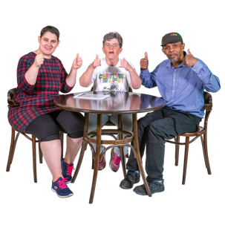 |  | Community groups in my local area, such as; faith groups, parent support groups, men’s sheds or lunch groups

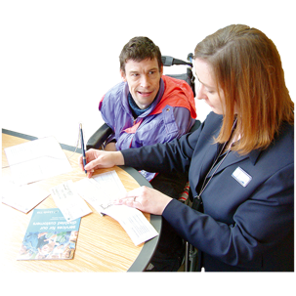 |  | Support with other things that were worrying me, such as money and housing

Doctor (GP) or other professional at your doctor’s surgery (e.g., social prescribers)

 |  | Community Mental Health Teams (CMHTs), Crisis Resolution and Home Treatment Teams (CRHTs)

 |  | Private counselling – counselling you pay for that is not done by NHS

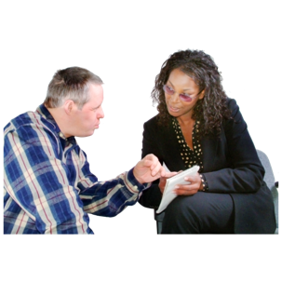 |  | Social care

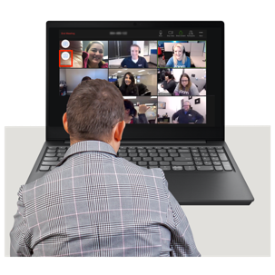 |  | Online support such as virtual workshops, events and forums to help support your mental wellbeing

Other – please write details

 | Question 5.  What would make it easy for you to access support from a talking therapy service?  (Tick all boxes that apply to you)

 |  | Support offered face-to-face

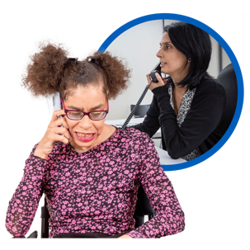 |  | Support offered by phone

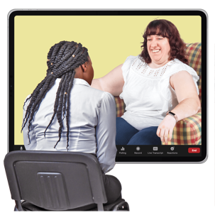 |  | Support offered by video call

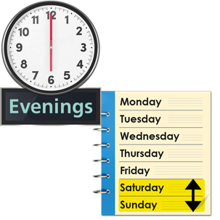 |  | Support is available in the evenings or at weekends if you are not available during the day.

 |  | Live online workshops - An online session that includes a professional talking to you individually or as part of a group

Pre-recorded online workshops - A video of online session where a professional talks and offers help and support

 |  | Being seen quickly

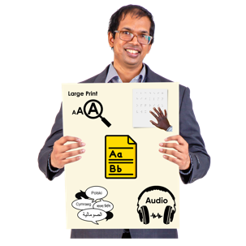 |  | Information available in different formats and/or languages – e.g. Easy Read, Braille, Audio or languages other than English

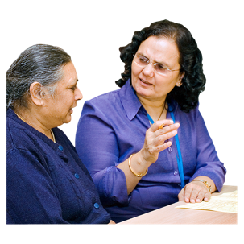 |  | Therapists available who speak other languages

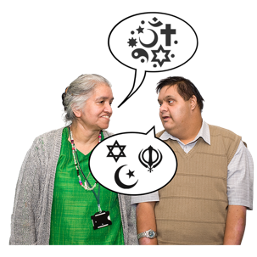 |  | Being aware of my religious and cultural beliefs

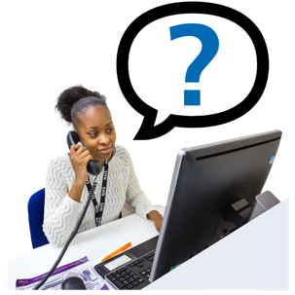 |  | Staff finding out why someone doesn’t go to their appointment

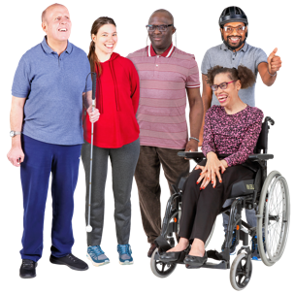 |  | A therapist who is similar to me in terms of age, gender, or ethnic background

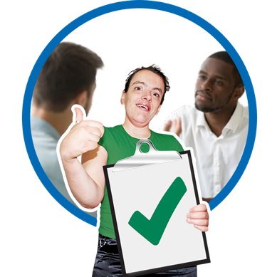 | Question 6.  When arranging a face to face appointment which of the options below are most important to you?  (Tick all boxes that apply to you)

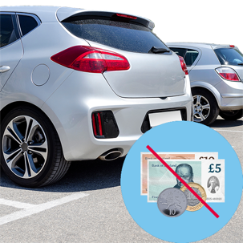 |  | Free car parking

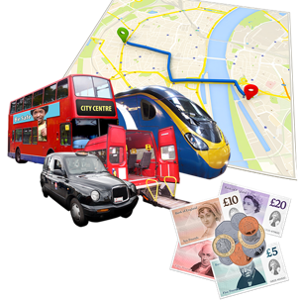 |  | Help paying transport costs to get you to your appointment

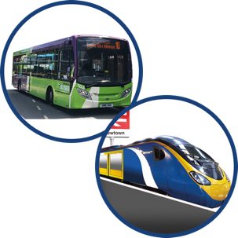 |  | Public transport available to get you to your appointment

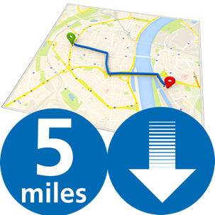 |  | A location less than 5 miles from home

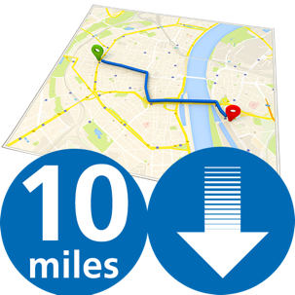 |  | A location less than 10 miles from home

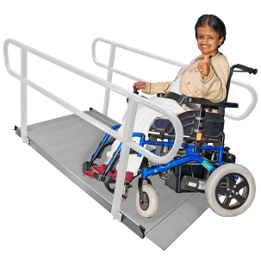 |  | Settings that meet my physical needs e.g., ramps and lifts for wheelchair access

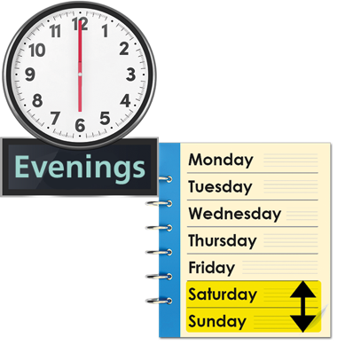 | Question 7.  If it would be easier for you to access support out of hours which of the two options would be most suitable for you? (Tick one box that applies to you)

 |  | Evenings – after 5:00pm

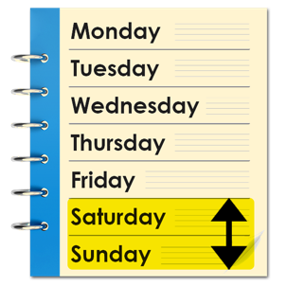 |  | Weekends – Saturday or Sunday

 | Survey Questions About You

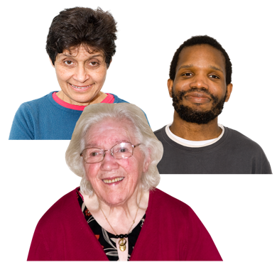 | Question 8.  What is your age?  (Tick one box that applies to you)

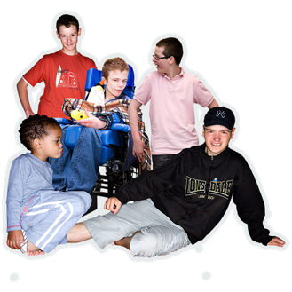  Under 18 |  | 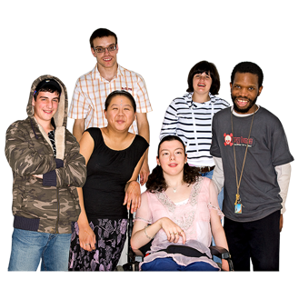  18 – 24 |  | 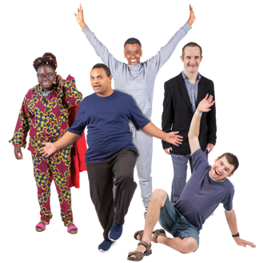  25 – 34

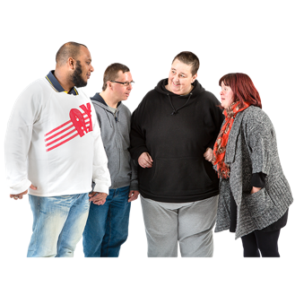  35 - 44 |  | 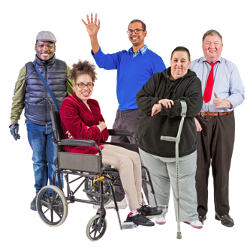  45 - 54 |  | 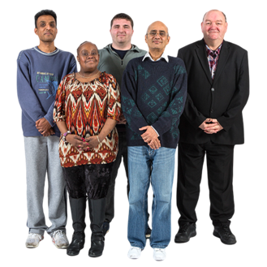  55 - 64

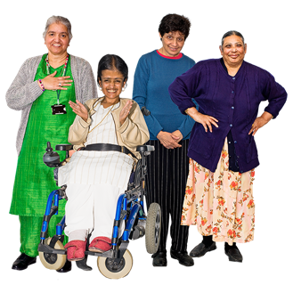  65 - 74 |  | 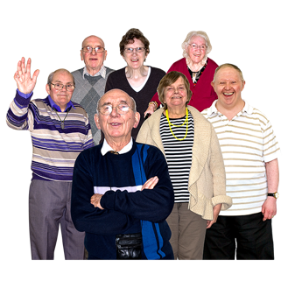  75 and over |  | 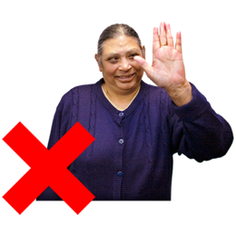  Prefer not to say

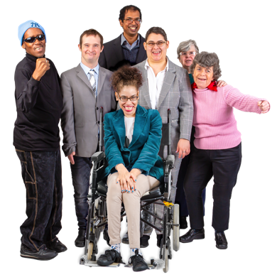 | Question 9.  Which of the following would you use to describe yourself?  (Tick one box that applies to you)

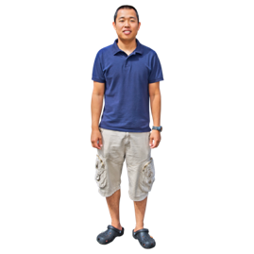  Male |  |   Female

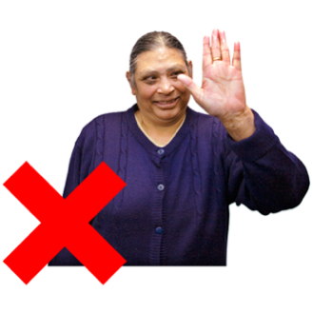
Prefer not to say

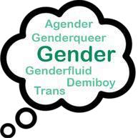 |  | I use a different word to describe myself.  I am  ……………………………………………….

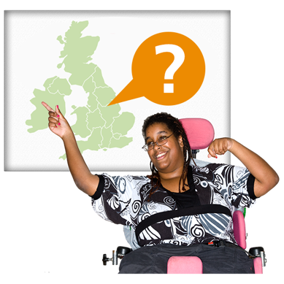 | Question 10.  Where do you live?  (Tick one box that applies to you)

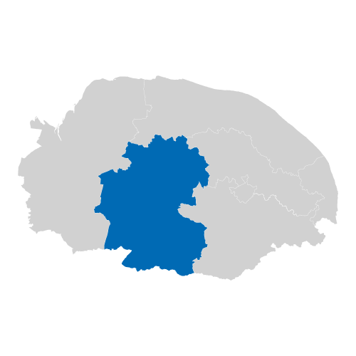  Breckland |  | 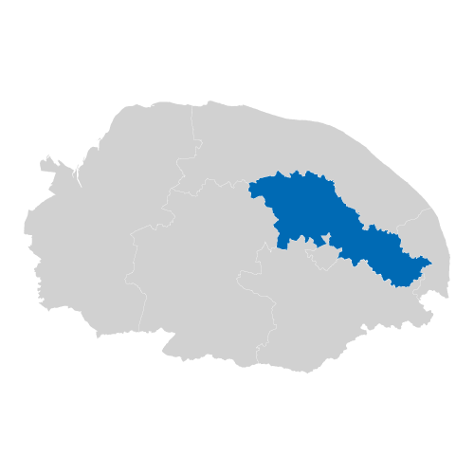  Broadland

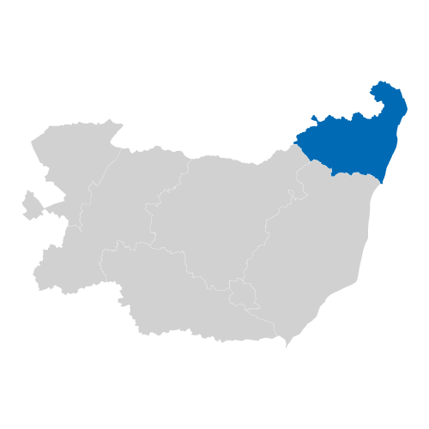  Waveney |  | 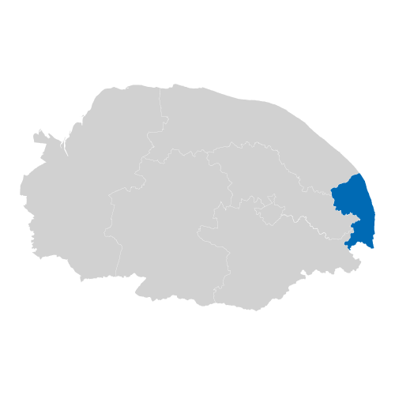  Great Yarmouth

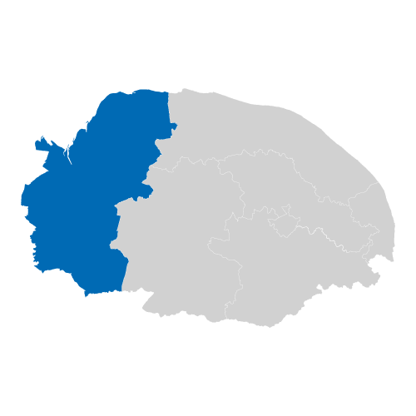  West Norfolk |  | 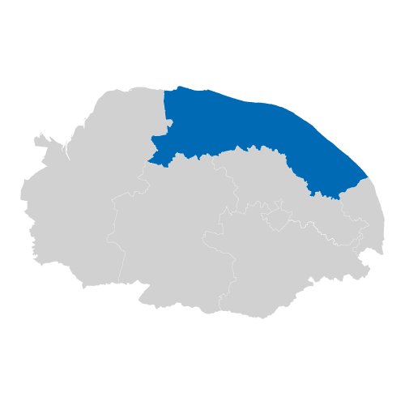  North Norfolk

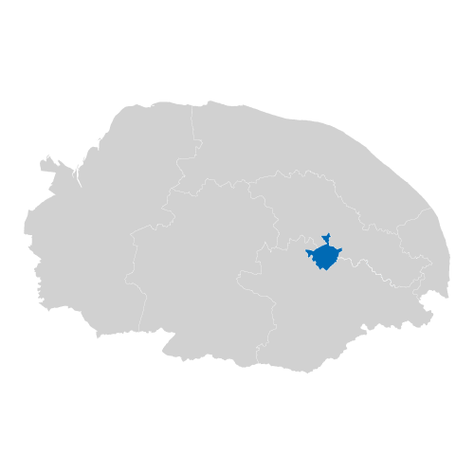  Norwich |  | 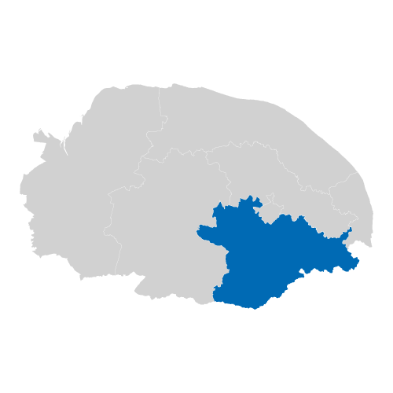  South Norfolk

Prefer not to say

 |  | I live somewhere else.  I live in  ……………………………………………….

 | Question 11.  What is your ethnic group?  (Tick one box that applies to you)

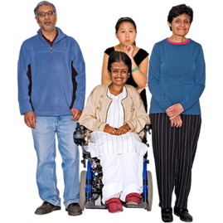 | Asian / Asian British
 | Bangladeshi | Chinese
 | Indian | Pakistani

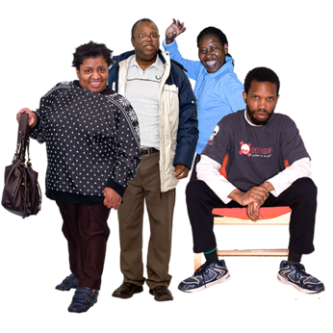 | Black / African / Caribbean / Black British
 | African | Caribbean

 | Mixed / Multiple ethnic
 | Asian and White | Black Caribbean and White
 | Black African and White

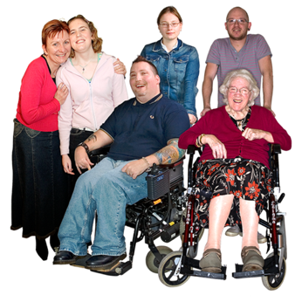 | White
 | British | Irish
 | Gypsy or Irish Traveller | Roma

 | Other Ethnic Background
 | Arab

Prefer not to say

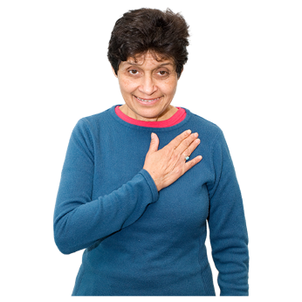 |  | I am from a different ethnic background that is not on the list.  I am  ……………………………………….

