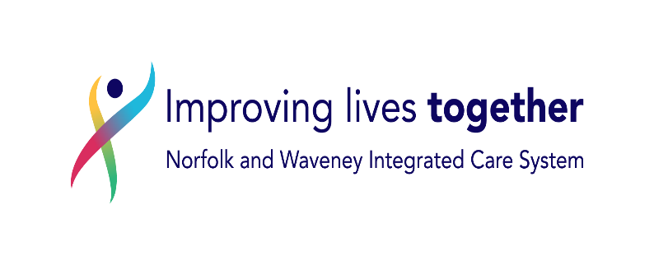
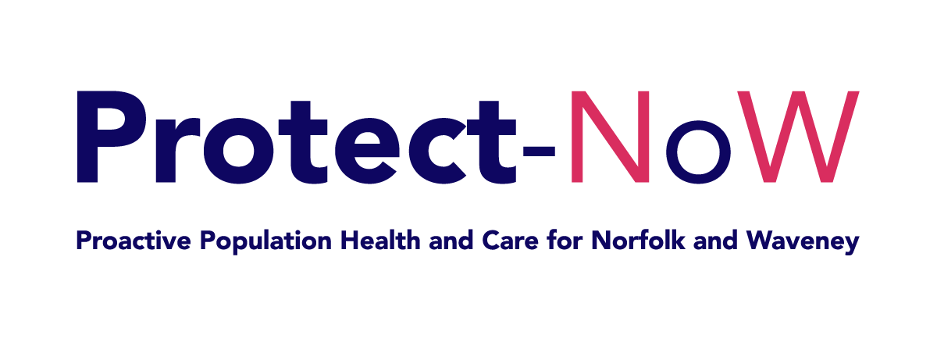

Dear <<fullname>> <<date>>

<<Address1>>

RE: T2Day (Type 2 Diabetes in the Young) Information and Support

We know that being diagnosed and living with type 2 diabetes at a young age can be overwhelming, and considering how busy life can be, we know that it can be challenging to prioritise your diabetes care.

Being diagnosed with type 2 diabetes at a younger age increases the likelihood of developing complications with your vision, movement, life expectancy and ability to have a family. However, with the right treatment, support and self-management, the chances of developing these complications can be reduced.

Having a yearly diabetes review with your usual diabetes healthcare professional at your general practice (GP) is important to help reduce your risk of developing complications associated with younger onset diabetes.

This year, GP practice teams are offering additional reviews to people with young onset type 2 diabetes between the ages of 18-39 years.

Please phone your GP surgery to arrange this appointment. The appointment will be an opportunity to talk about any concerns you have about diabetes. For more information about what to expect at your review, please head to T2Day - Type 2 Diabetes Support Videos - Norfolk & Waveney Integrated Care System (ICS

We know life can be busy, but we encourage you to arrange a review to talk to someone about managing and living well with your diabetes.

To check the authenticity of this letter, please search for letter on https://improvinglivesnw.org.uk/type-2-diabetes-in-the-young-t2day/

Kind regards

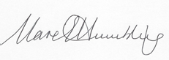

Dr Clare Hambling
Diabetes and Obesity Clinical Lead
NHS Norfolk and Waveney Integrated Care Board

Why are you receiving this letter?

 | Every year, your GP (doctor) should invite you to an appointment to check on your type 2 diabetes
 | We understand being diagnosed with type 2 diabetes can be overwhelming and it can be hard to know how to manage your health
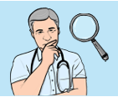 | Type 2 diabetes at a younger age can lead to health issues if they are not found and treated before they get worse
 | Your healthcare team wants to see you even if you feel well. Health problems do not always make you feel poorly
 | If you have a job, your healthcare team may be able to offer you an appointment that fits in with it
 | Check-ups are important because with the right treatment and support, your healthcare team can help you stay healthy
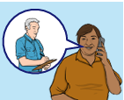 | The appointment will be an opportunity to talk about any concerns you have about diabetes.

 | You can learn more about the service on the website: T2Day - Type 2 Diabetes Support Videos - Norfolk & Waveney Integrated Care System (ICS
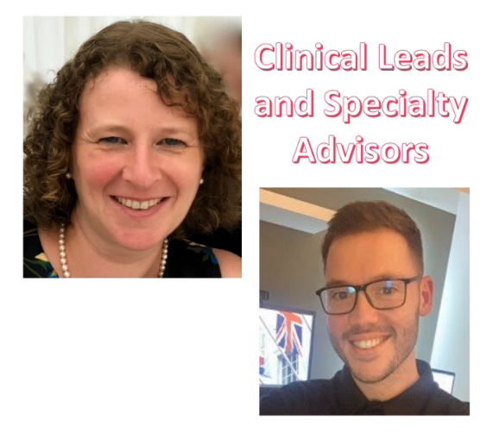 | This letter was sent from Callum Metcalfe O’Shea and Dr Clare Hambling  We work for the NHS in Norfolk and Waveney helping people with their diabetes health

