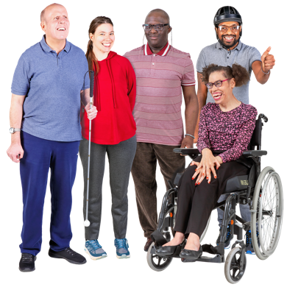 | Survey about Talking Therapy

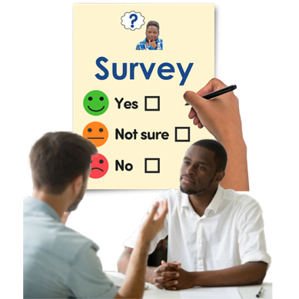 | This survey is for people that have used NHS Talking Therapy service.

 | What are talking therapies?

 | Talking therapies are for people who have mental and emotional problems like:

Stress |  | 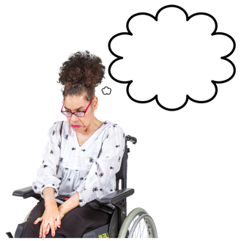 Anxiety |  | Depression

 | Talking therapies involve you being helped by a therapist.

 | A therapist is a health professional who is trained to help people understand and cope with mental and emotional problems.

 | Talking therapies are things such as:

- Cognitive behavioural therapy can help you manage your problems by changing the way you think and behave over time.

 | - Counselling is where a therapist listens to you and helps you find ways to deal with emotional issues

 | - Mindfulness-based therapy helps us to become more aware of our thoughts and feelings. This helps us to see our thoughts more clearly.

 | Norfolk and Waveney Talking Therapy Service

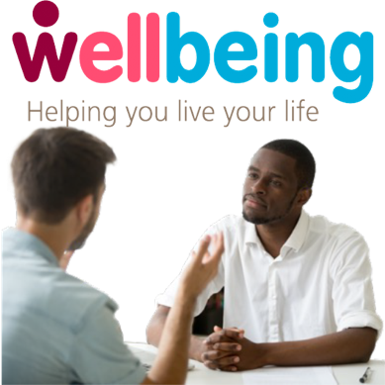 | Our talking therapy service is called Wellbeing in Norfolk and Waveney.

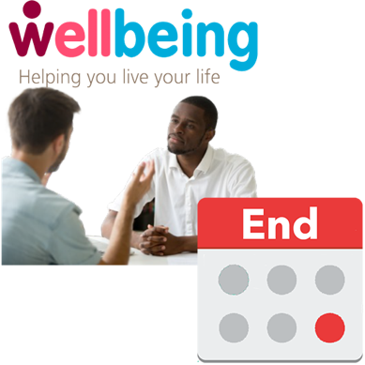 | The agreed amount of time for Wellbeing service doing talking therapies is ending.

 | There will then be another agreed amount of time for an organisation to do a talking therapy service.

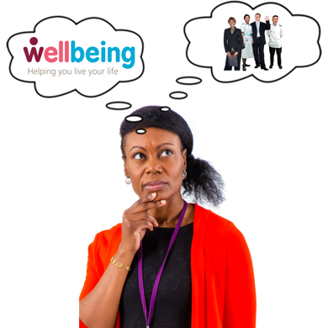 | We need to decide whether we want to continue working with Wellbeing or work with someone else.

 | We will be asking organisations that do talking therapy to tell us how they would run this service

 | We want your help to plan and develop how this talking therapy service is delivered.

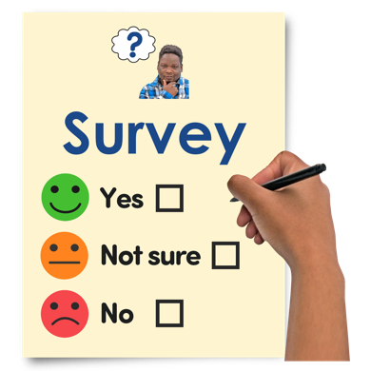 | Why are we doing this survey?

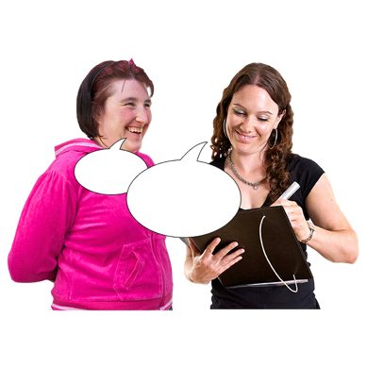 | We will be asking you questions in this survey about:

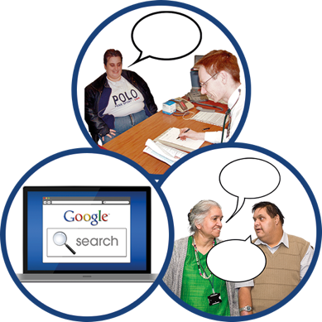 | - Where would you go to find out about talking therapies

 | - What will help you to access talking therapies if you need it

 | - How would you want a talking therapy service to contact you

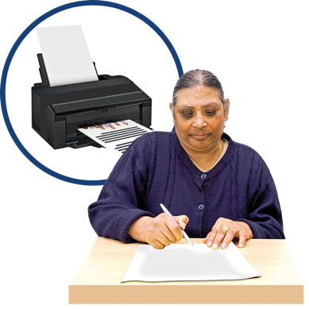 | You can print out the survey and fill it in.

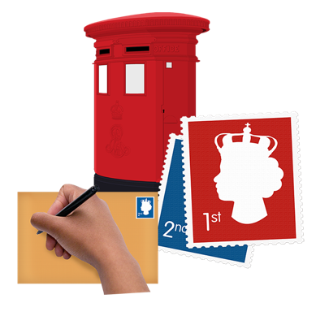 | You can then post back to:  FAO Talking Therapies feedback survey, NHS Norfolk and Waveney ICB, County Hall, Martineau Lane, Norwich, NR1 2DH

 | You can fill out the survey on your computer.

 | You can click on the boxes that are  correct for you.

 | You can type your answers in the  grey boxes after clicking on them.

 | You then save the survey on your computer and send it to:  nwicb.talkabouttalkingtherapies@nhs.net

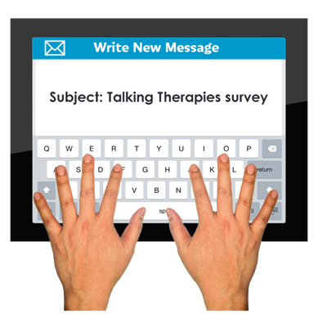 | Give your email the subject title “Talking Therapies survey”

Survey Questions

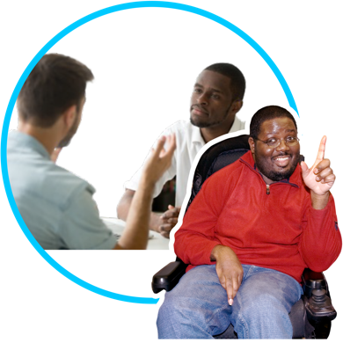 | Question 1.  How did you find out about talking therapies?  (Tick one box that applies to you)

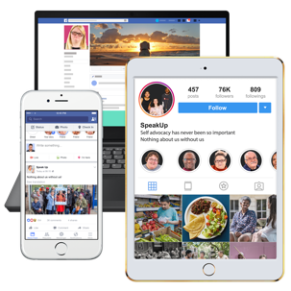 |  | On social media

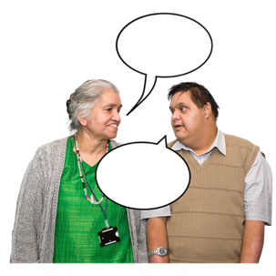 |  | Friends or family told me

 |  | Searching the internet

 |  | My doctor (GP) or another health professional told me

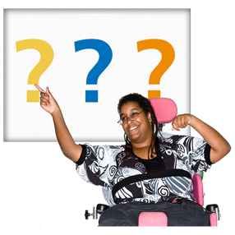 |  | Other – please write how you found out

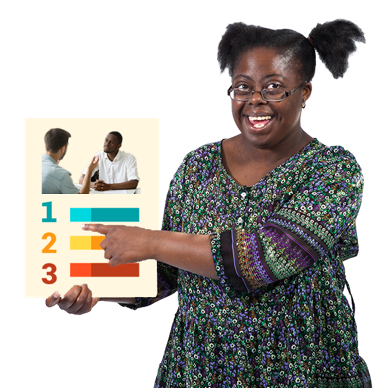 | Question 2.  How did you access Talking therapies?  (Tick one box that applies to you)

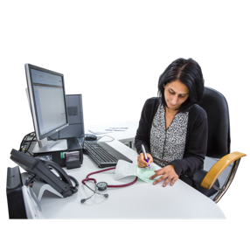 |  | My Doctor (GP) or other professional at my doctor’s surgery referred me

 |  | Another healthcare professional referred me. For example, doctor at a hospital.

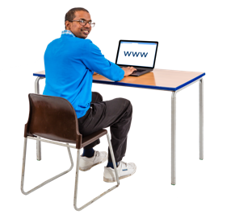 |  | I referred myself online or got someone supporting me to refer me online

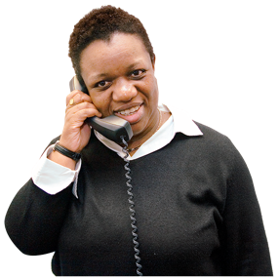 |  | I referred myself by telephone or got someone supporting me to do it for me

 | Question 3.  Did you access any additional support from the list below for your mental health and wellbeing?  (Tick all boxes that apply to you)

 |  | No, I accessed any support instead of going to NHS Talking Therapies

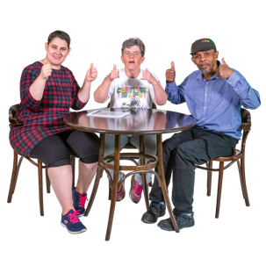 |  | Community groups in my local area, such as; faith groups, parent support groups, men’s sheds or lunch groups

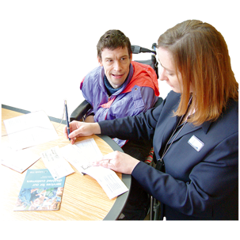 |  | Support with other things that were worrying me, such as money and housing

Doctor (GP) or other professional at your doctor’s surgery (e.g., social prescribers)

 |  | Community based mental health support, such as Community Mental Health Teams (CMHTs) or Crisis Resolution and Home Treatment Teams (CRHTs)

 |  | Private counselling – counselling you pay for that is not done by NHS

 |  | Social care

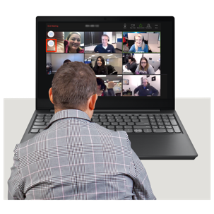 |  | Online support such as virtual workshops, events and forums to help support your mental wellbeing

Other – please write details

Question 4.
How would you want an NHS Talking Therapy service to contact you about your appointments, the support they will provide and what will happen next? (Tick all boxes that apply to you)

 |  | Send me a letter

 |  | Email me

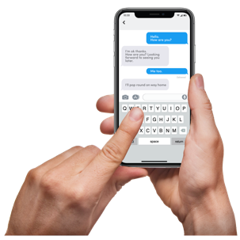 |  | Text me

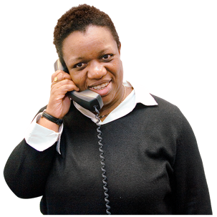 |  | Telephone me

 |  | Online portal - a website where you can easily access information about appointments and help available to you.

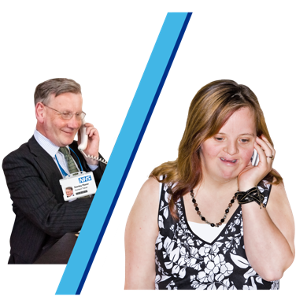 | Question 5.  How often would you want an NHS Talking Therapy service to contact you about your appointments, the support they will provide and what will happen next? (Tick one box that applies to you)

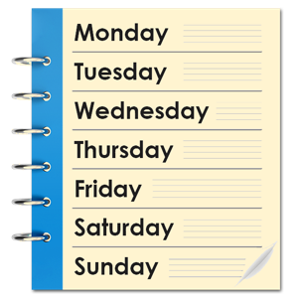 |  | Weekly

 |  | Every 2 weeks

 |  | Monthly

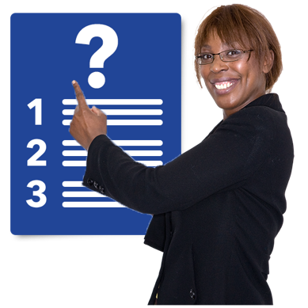 | Question 6.  What would you want an NHS Talking Therapy service to contact you about? (Tick all boxes that apply to you)

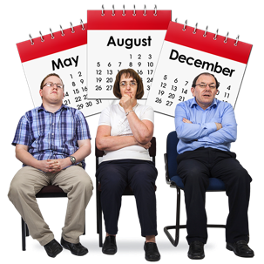 |  | Waiting times

 |  | Other services that may be able to help me e.g., financial support, housing advice, social prescribing

 |  | How you are feeling and information about support available to help your wellbeing.

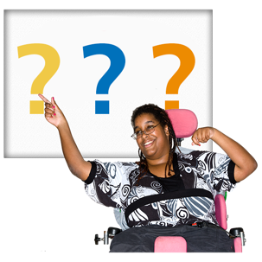 |  | Something else – please write details below.

 | It is important that services are joined up and talk to each other.

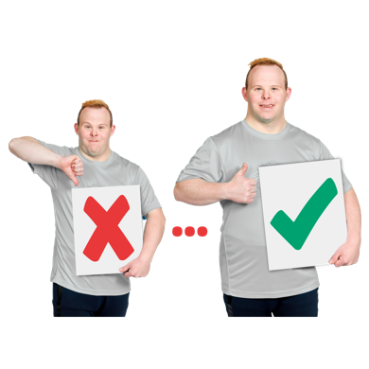 | This is because you get better care when services work together.

Question 7.
Which of these services is it most important for the NHS Talking Therapies service to be most connected to or joined up with? (Tick all boxes that applies to you)

My GP (your doctor)

 |  | Social Care services or Social Worker

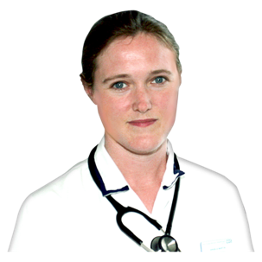 |  | Other NHS professionals supporting my physical health Such as physiotherapist

 |  | Other NHS professionals supporting my mental health such as community mental health teams

 |  | My carer or the person who supports me day-to-day

 |  | Other community or voluntary organisations that support me with things such as housing and finances

 | Question 8.  What would make it easy for you to access support from a talking therapy service?  (Tick all boxes that apply to you)

 |  | Support offered face-to-face

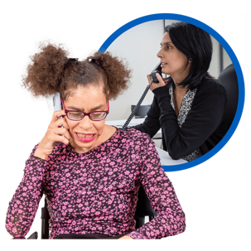 |  | Support offered by phone

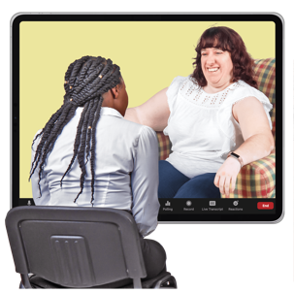 |  | Support offered by video call

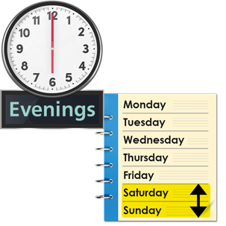 |  | Support is available in the evenings or at weekends if you are not available during the day.

 |  | Live online workshops - An online session that includes a professional talking to you individually or as part of a group

Pre-recorded online workshops - A video of online session where a professional talks and offers help and support

 |  | Being seen quickly

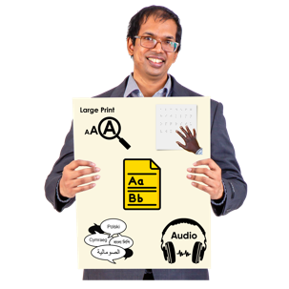 |  | Information available in different formats and/or languages – e.g. Easy Read, Braille, Audio or languages other than English

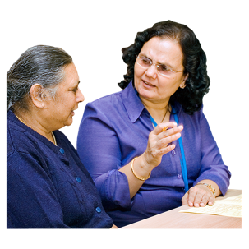 |  | Therapists available who speak other languages

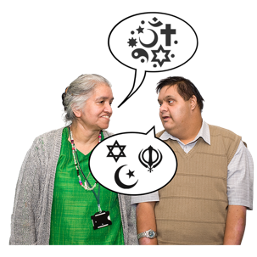 |  | Being aware of my religious and cultural beliefs

 |  | Staff finding out why someone doesn’t go to their appointment

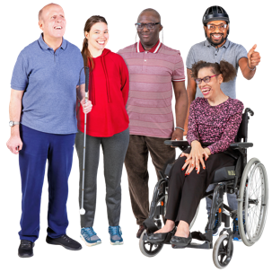 |  | A therapist who is similar to me in terms of age, gender, or ethnic background

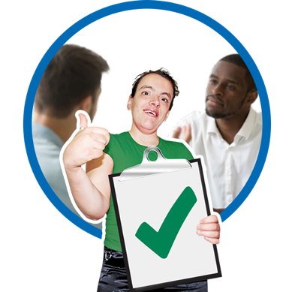 | Question 9.  When arranging a face to face appointment which of the options below are most important to you?  (Tick all boxes that apply to you)

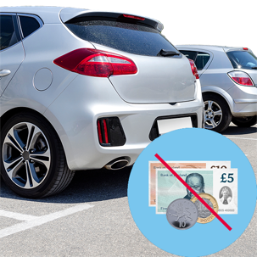 |  | Free car parking

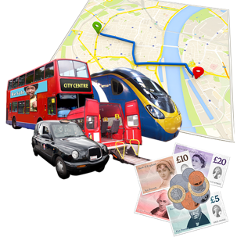 |  | Help paying transport costs to get you to your appointment

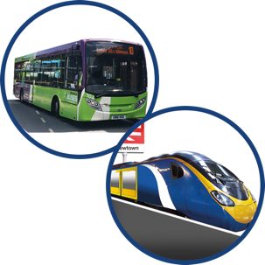 |  | Public transport available to get you to your appointment

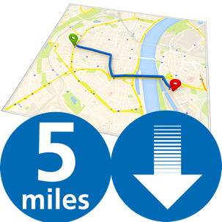 |  | A location less than 5 miles from home

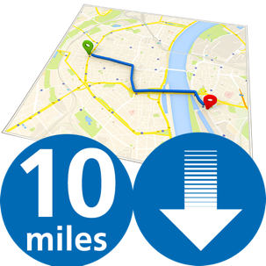 |  | A location less than 10 miles from home

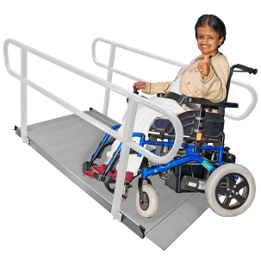 |  | Settings that meet my physical needs e.g., ramps and lifts for wheelchair access

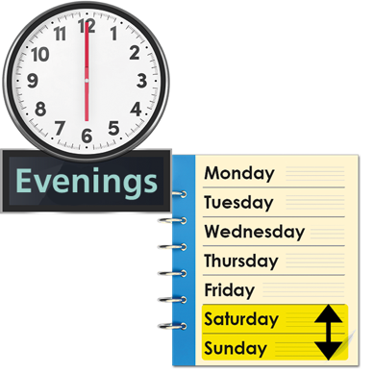 | Question 10.  If it would be easier for you to access support out of hours which of the two options would be most suitable for you? (Tick one box that applies to you)

 |  | Evenings – after 5:00pm

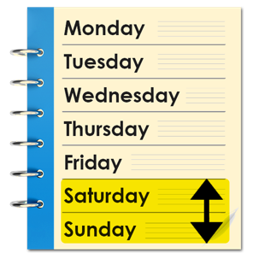 |  | Weekends – Saturday or Sunday

 | Survey Questions About You

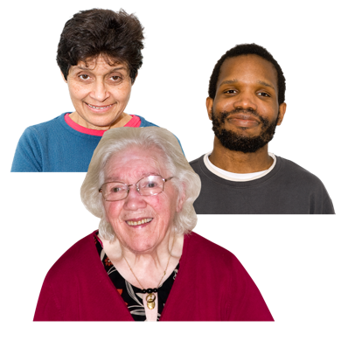 | Question 11.  What is your age?  (Tick one box that applies to you)

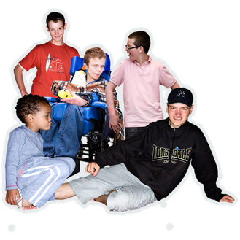  Under 18 |  | 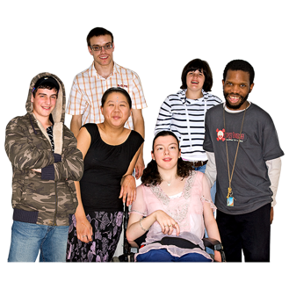  18 – 24 |  | 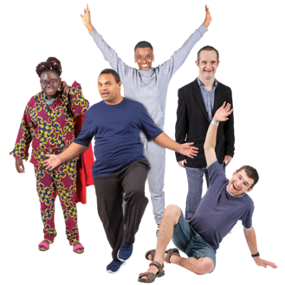  25 – 34

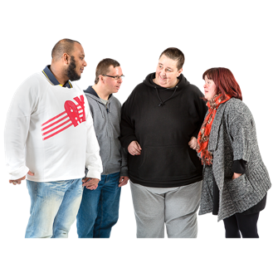  35 - 44 |  | 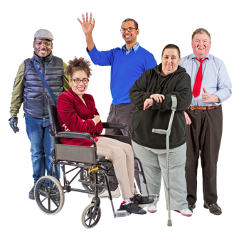  45 - 54 |  | 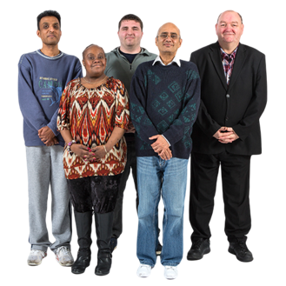  55 - 64

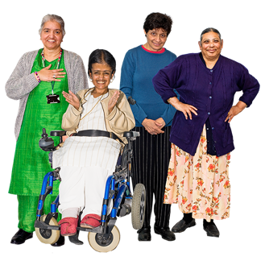  65 - 74 |  | 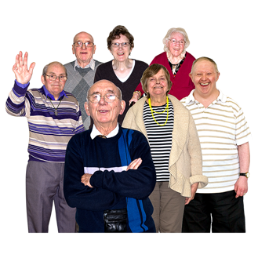  75 and over |  | 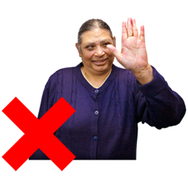  Prefer not to say

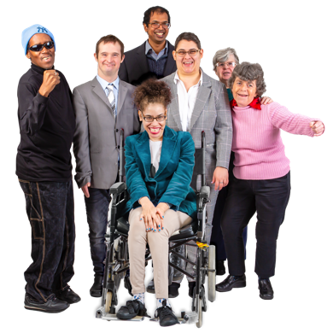 | Question 12.  Which of the following would you use to describe yourself?  (Tick one box that applies to you)

  Male |  |   Female

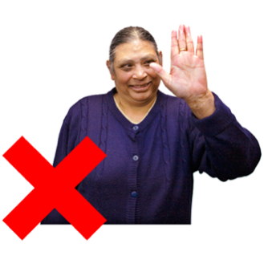
Prefer not to say

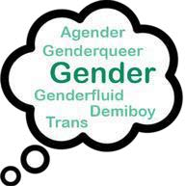 |  | I use a different word to describe myself.  I am  ……………………………………………….

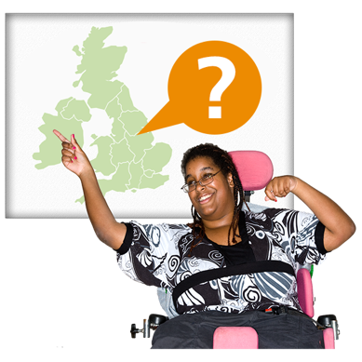 | Question 13.  Where do you live?  (Tick one box that applies to you)

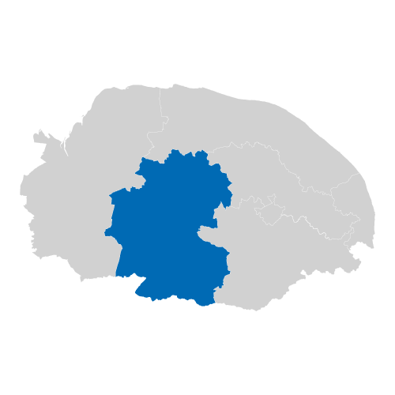  Breckland |  | 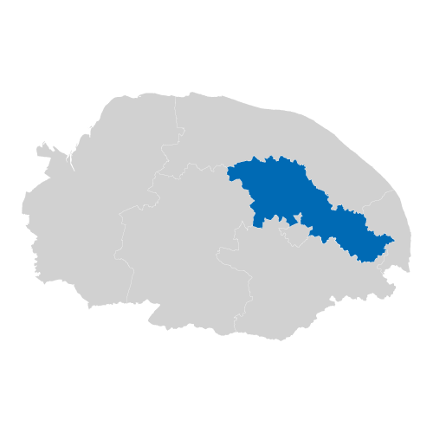  Broadland

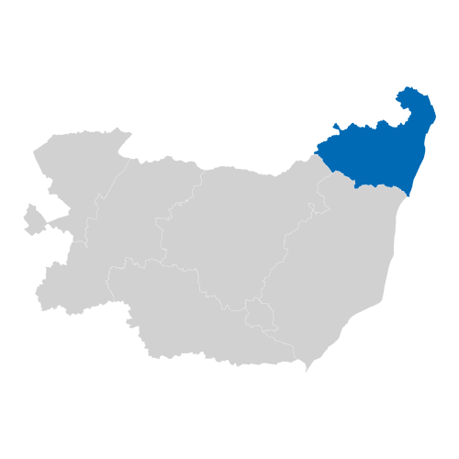  Waveney |  | 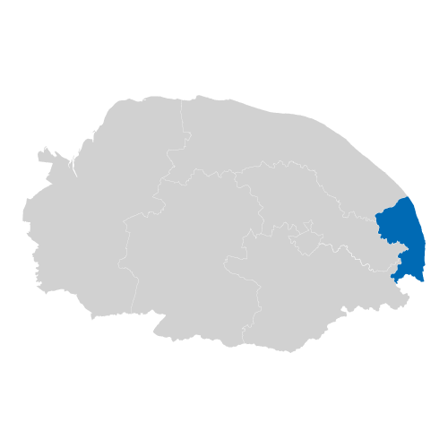  Great Yarmouth

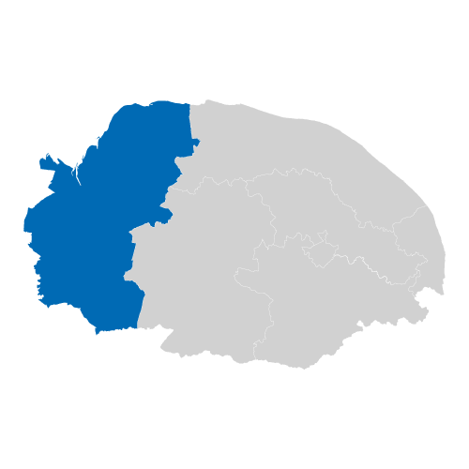  West Norfolk |  | 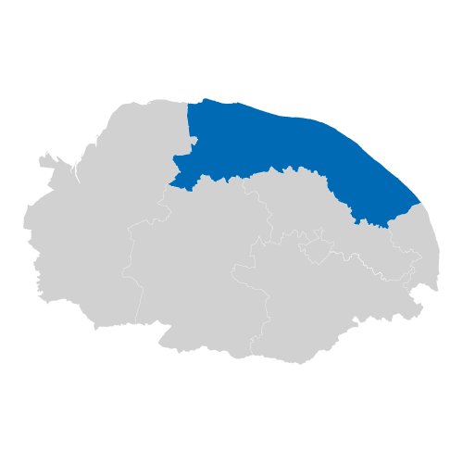  North Norfolk

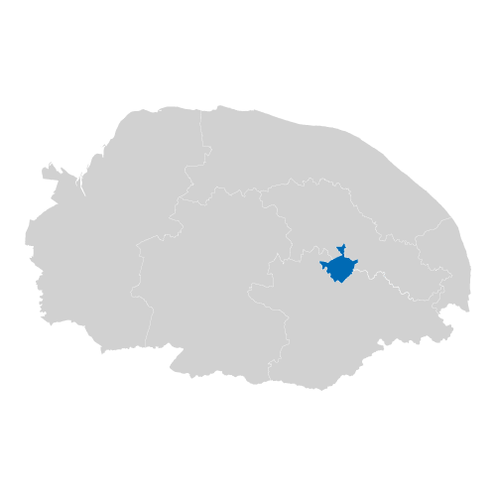  Norwich |  | 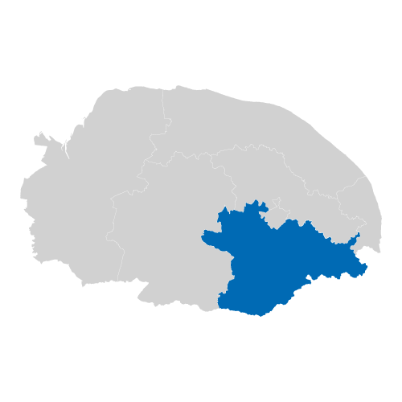  South Norfolk

Prefer not to say

 |  | I live somewhere else.  I live in  ……………………………………………….

 | Question 14.  What is your ethnic group?  (Tick one box that applies to you)

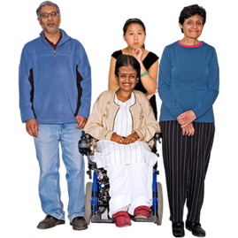 | Asian / Asian British
 | Bangladeshi | Chinese
 | Indian | Pakistani

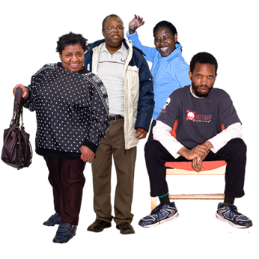 | Black / African / Caribbean / Black British
 | African | Caribbean

 | Mixed / Multiple ethnic
 | Asian and White | Black Caribbean and White
 | Black African and White

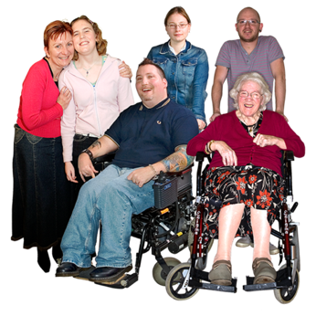 | White
 | British | Irish
 | Gypsy or Irish Traveller | Roma

 | Other Ethnic Background
 | Arab

Prefer not to say

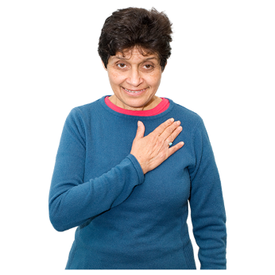 |  | I am from a different ethnic background that is not on the list.  I am  ……………………………………….

